RUSH logo for emails

**TOBRAMYCIN**

**SERUM OR PLASMA**

**ABBOTT ARCHITECT**

**Intended Use**

The MULTIGENT Tobramycin assay is intended for the quantitative determination of tobramycin in human serum or plasma on the ARCHITECT *c* Systems.

**Clinical Significance**

Tobramycin sulfate is an aminoglycoside derived from *Streptomyces tenebrarius*. This aminoglycoside antibiotic is used to treat seriousbacterial infections by inhibiting the growth of the bacterium byintervening in the protein synthesis thereby killing the bacterium.Tobramycin is absorbed minimally from the gastrointestinal tract.In the first 24 hours after intravenous dosing, the usual route ofadministration, about 99% of the tobramycin is excreted unchanged bythe kidneys. The average half-life in patients with normal renal functionis about 2 to 3 hours. Therapeutic serum levels vary depending onthe microorganism involved and the patient’s tolerance to the drug.

Tobramycin serum or plasma concentrations are monitored to help guide therapy, since individual patient differences require dose changes that are difficult to predict. Monitoring serum or plasma levels of tobramycin decreases the frequency of serious toxic effects

**Principle**

The MULTIGENT Tobramycin assay is a homogeneous particle-enhanced turbidimetric inhibition immunoassay (PETINIA). The assay is based on competition between drug in the sample and drug coated onto a microparticle for antibody binding sites of the tobramycin antibody reagent. The tobramycin-coated microparticle reagent is rapidly agglutinated in the presence of the anti-tobramycin antibody reagent and in the absence of any competing drug in the sample.

The rate of absorbance change is measured photometrically and is directly proportional to the rate of agglutination of the particles. When a sample containing tobramycin is added, the agglutination reaction

is partially inhibited, slowing down the rate of absorbance change. A concentration-dependent classic agglutination inhibition curve can be obtained, with maximum rate of agglutination at the lowest tobramycin concentration and the lowest agglutination rate at the highest tobramycin concentration.

**Methodology:** Particle-enhanced turbidimetric inhibition immunoassay (PETINIA)

**Specimen Collection and Handling**

• **Serum:** Use serum collected by standard venipuncture techniques into glass or plastic tubes with or without gel barriers and with or without clot activators. Ensure complete clot formation has taken place prior to centrifugation. Centrifuge according to tube manufacturer’s instructions to ensure proper separation of serum from blood cells.

Some specimens, especially those from patients receiving anticoagulant or thrombolytic therapy, may take longer to complete their clotting processes. Fibrin clots may subsequently form in these sera and the clots could cause erroneous test results.

• **Plasma:** Use plasma collected by standard venipuncture techniques into glass or plastic tubes. Acceptable anticoagulants are lithium heparin (with or without gel barrier), sodium heparin, K2-EDTA, or K3-EDTA. Ensure centrifugation is adequate to remove platelets. Centrifuge according to tube manufacturer’s instructions to ensure proper separation of plasma from blood cells.

**Specimen Storage**

Samples for the MULTIGENT Tobramycin assay should be drawn just prior to a dose (trough level) to confirm that an adequate dose has been prescribed. Peak specimen should be drawn 30 minutes after a

30-minute IV infusion.12 Separated samples may be stored for up to 7 days at 2 to 8°C prior to being tested. If testing will be delayed more than 7 days, separated samples may be stored frozen at < -10°C for up to 14 days.

**NOTE:** Samples containing carbenicillin or piperacillin should be stored frozen if a delay in analysis of more than 8 hours is anticipated. Failure to freeze samples containing these antibiotics may result in falsely low tobramycin levels due to in vitro inactivation.

**NOTE:** Stored specimens must be inspected for particulates. If present, mix and centrifuge the specimen to remove particulates prior to testing.

**Materials and Equipment Required**

**TEST INSTRUMENT**: Abbott ARCHITECT System

**MATERIALS PROVIDED**

7F93-20 MULTIGENT Tobramycin

**MATERIALS REQUIRED BUT NOT PROVIDED**

• 7F93-01 MULTIGENT Tobramycin Calibrators

• Control Material

**Reagent Handling and Storage:**

***CAUTION*:**

1. For in vitro diagnostic use.

2. Do not use components beyond the expiration date.

3. Do not mix materials from different kit lot numbers.

• Do not mix fresh reagents with in-use reagents.

**CAUTION:** This product requires the handling of human specimens.

It is recommended that all human sourced materials be considered

potentially infectious and be handled in accordance with the OSHA

Standard on Bloodborne Pathogens. Biosafety Level 2 or other appropriate biosafety practices should be used for materials that contain or are suspected of containing infectious agents.

• The following warning and precaution apply to R1 and R2:

Contains sodium azide.

EUH032 Contact with acids liberates very toxic gas.

P501 Dispose of contents/container in accordance with local regulations.

These materials and their containers must be disposed of in a safe way.

**Reagent Handling**

• R1 Ready for use. Before use invert several times, avoiding the formation of bubbles.

• R2 Ready for use. Before use invert several times, avoiding the formation of bubbles.

• Remove air bubbles, if present in the reagent cartridge, with a new applicator stick. Alternatively, allow the reagent to sit at the appropriate storage temperature to allow the bubbles to dissipate.

To minimize volume depletion, do not use a transfer pipette to remove the bubbles.

**CAUTION:** Reagent bubbles may interfere with proper detection of reagent level in the cartridge, causing insufficient reagent aspiration that could impact results.

• Do not mix materials from different kit lot numbers.

• When either the R1 or R2 reagent cartridge becomes empty, replace both cartridges.

**Reagent Storage**

• Reagent stability is 32 days if the reagent is uncapped and onboard.

• Unopened reagents are stable until the expiration date when stored at 2 to 8°C.

• **Do not freeze reagents or expose reagents to temperatures above 32°C.**

Reagent Preparation:

7F93-20 MULTIGENT Tobramycin is supplied as a liquid, ready-to-use, two-reagent kit which contains: **R1 & R2**

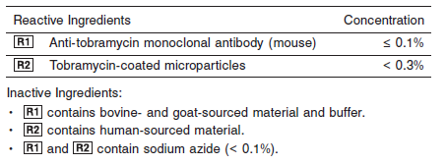

**Calibrator:** 7F93-01 MULTIGENT Tobramycin Calibrators

**Quality Control:** Minimum 2 levels of ChemistryControl (Normal and Abnormal)

**Calibration**

**Frequency:**

Calibration is stable for 7 days (168 hours) for any one lot. Calibration is required with each change in reagent lot number.

**A new calibration is required:**

1. If quality control results do not meet acceptance criteria defined by your laboratory, patient values may be suspect. Follow the established quality control procedures for your laboratory. Recalibration may be necessary.
2. Review quality control results and acceptance criteria following a change of reagent or calibrator lot.

**Calibrator Required:** 7F93-01 MULTIGENT Tobramycin Calibrators

**Reagents:**

7F93-01 MULTIGENT Tobramycin Calibrators consist of human serum and sodium azide (≤ 0.1%) as preservative, with the following concentrations of tobramycin:

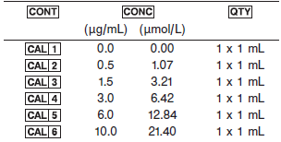

**Calibrator Preparation:**

The calibrator is supplied in liquid form and is ready to use.

**Calibration Procedure:**

Before performing the assay, refer to the ASSAY PARAMETERS which are included in the MULTIGENT Tobramycin reagent package insert. For further instructions, refer to the CALIBRATION and QUALITY CONTROL sections of the MULTIGENT Tobramycin reagent package insert.

Tobramycin calibration is performed by running.

1. Verify that the calibrator values are correct in the instrument parameter files.

2. Mix thoroughly but gently to avoid the formation of bubbles.

3. Open the bottles, place appropriate amounts of the required calibrators in separate sample cups, and place in the assigned positions.

4. Cap bottles tightly and return to refrigerated storage after use.

5. Calibrate as outlined in *Section 6* of the **ARCHITECT System Operations Manual**.

6. Follow the established quality control procedures for your laboratory and the instructions found in *Section 5* of the **ARCHITECT System** **Operations Manual**.

7. Verify control results are within acceptable limits before reporting patient results.

**Troubleshooting and Overall Acceptance Criteria Failure**

See ARCHITECT Operations Manual for further calibration troubleshooting.

**Quality Control:**

Abbott recommends, refer to your laboratory standard operating procedure(s) and/or quality assurance plan for additional quality control requirements and potential corrective actions:

• Two levels of controls (normal and abnormal) are to be run every 24 hours.

• If more frequent control monitoring is required, follow the established quality control procedures for your laboratory.

• If quality control results do not meet the acceptance criteria defined by your laboratory, patient values may be suspect. Follow the established quality control procedures for your laboratory.

Recalibration may be necessary.

• Review quality control results and acceptance criteria following a change of reagent or calibrator lot.

**Procedure**

For a detailed description of how to run an assay, refer to *Section 5* of the **ARCHITECT System Operations Manual**.

**Calculations**

Refer to *Appendix C* of the **ARCHITECT System Operations Manual** for information on results calculations.

**Reporting Results**

The result unit for the MULTIGENT Tobramycin assay can be reported as μg/mL or μmol/L.

**Specific Performance Characteristics**

**Reference Ranges**

It is recommended that each laboratory determine its own reference range based upon its particular locale and population characteristics.

**Serum/Plasma:**

**Peak:** 2.0 – 8.0 μg/mL

**Trough:** 0 – 2.0 μg/mL

Periodic measurements of both peak and trough concentrations of tobramycin are recommended to ensure adequate drug levels and prevent toxic side effects. The therapeutic range for moderate infections is 2 to 8 μg/mL (4.28 to 17.12 μmol/L). Trough levels greater than 2 μg/mL (4.28 μmol/L) have been associated with toxicity effects, particularly ototoxicity and nephrotoxicity. The susceptibility of the infecting organism, the severity of the infection, and the general health of the patient should be considered when determining an adequate drug level for patients.

**Example Peak and Trough**

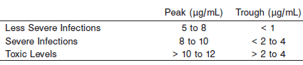

**Critical Values:**

**Peak:** < 2 months: > 10.0

< 150 years: > 12.0

**Trough:** < 2 months: <1.0 and >2.0

< 150 years: > 2.0

**Performance Characteristics**

**Reportable Range**

The reportable range of the assay is 0.2 to 10.0 μg/mL (0.43 to 21.40 μmol/L).

**Limit of Quantitation (LOQ)**

The LOQ for the MULTIGENT Tobramycin assay was calculated to be 0.2 μg/mL (0.43 μmol/L).

**Dilution:**

Specimens with tobramycin values exceeding 10.0 μg/mL (21.40 μmol/L) are flagged and may be diluted by following the Manual Dilution Procedure.

***Manual Dilution Procedure***

**NOTE:** Use only Tobramycin CAL 1 to dilute patient samples; saline is not an appropriate diluent.

A manual dilution can be performed on patient samples with tobramycin concentrations reported as greater than 10.0 μg/mL (21.40 μmol/L) by making a dilution of the specimen with Tobramycin CAL 1 (0 μg/mL) before pipetting the sample into the sample cup. The dilution must be performed so the diluted test results read greater than the assay sensitivity of 0.2 μg/mL (0.43 μmol/L).



The operator must enter the manual dilution factor (2) in the patient or control order screen. The system uses this dilution factor to automatically correct the concentration by multiplying the result by the entered factor. The printed result is the reportable result if no errors are present.

**NOTE:** If the operator does not enter the manual dilution factor, the printed result must be multiplied by the manual dilution factor before reporting the result.

**Precision:**

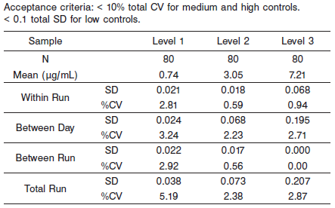

#### Limitations of Procedure

In very rare cases, patient samples may contain heterophile antibodies, which may produce low results with the MULTIGENT Tobramycin assay. Interfering heterophile antibodies occur at a low frequency in the general population. These antibodies can cause autoagglutination of the microparticle reagent leading to undetected erroneously low results. For diagnostic purposes, the test findings should always be assessed in conjunction with the patient’s medical history, clinical examinations, and other findings.

Patient samples which contain the drugs amikacin, kanamycin A, kanamycin B, and/or 3',4'-dideoxykanamycin B may yield falsely elevated values for tobramycin. Refer to the Specificity section for further explanation. However, these drugs are not usually co-administered with tobramycin. High concentrations of penicillins or cephalosporins have been shown to inactivate tobramycin in vitro. The degree of inactivation is dependent on the particular aminoglycoside being measured, the

type and concentration of the penicillin or cephalosporin that is also present, and the storage conditions of the sample. Samples from patients receiving additional antibiotics of these types should be assayed immediately or stored frozen.

**Interfering Substances**

The following compounds, when tested with the MULTIGENT Tobramycin assay at the concentrations indicated, resulted in less than 10% error in detecting tobramycin. Interference effects were assessed by Dose Response method. The results are shown below.

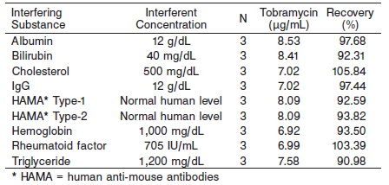

**Specificity**

***Cross-Reactivity***

Amikacin, kanamycin A, and kanamycin B cross-react with the Tobramycin assay due to their structural similarity. These compounds were added to serum containing tobramycin and tested with the MULTIGENT Tobramycin assay. The results of this assay cannot be used to accurately quantitate tobramycin serum or plasma levels in patients receiving any of these drugs in combination with tobramycin.

Representative results are shown below.

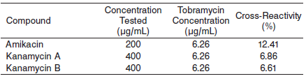

***Drug Interference***

Cross-reactivity was tested with drugs that are routinely administered with tobramycin. Testing also determined whether these compounds affect the quantitation of tobramycin concentrations. Cross-reactants were analyzed in a serum pool spiked with tobramycin. The samples were assayed and the tobramycin concentrations of the spiked samples were compared to a control serum.

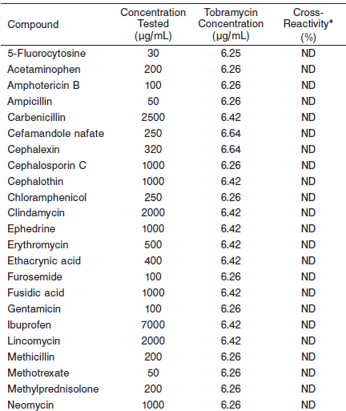

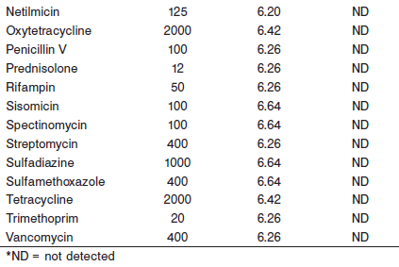

**References:**

1. ABBOTT ARCHITECT Tobramycin package insert

Abbott Laboratories

Diagnostics Division

Abbott Park, IL 60064

Sept 2016 307042/R06

1. ABBOTT ARCHITECT Tobramycin Calibrator package insert

Abbott Laboratories

Diagnostics Division

Abbott Park, IL 60064

1. Abbott ARCHITECT Operator’s Guide

**Related Documents:**

**Attachments:**