RUSH logo for emails

**VANCOMYCIN**

**SERUM OR PLASMA**

**ABBOTT ARCHITECT**

**Intended Use**

The MULTIGENT Vancomycin assay is intended for the quantitative determination of vancomycin in human serum or plasma on the ARCHITECT *c* Systems.

The results obtained are used in the diagnosis and treatment of vancomycin overdose and in monitoring levels of vancomycin to help ensure appropriate therapy.

**Clinical Significance**

Vancomycin hydrochloride is a tricyclic glycopeptide derived from *Amycolatopsis orientalis*. It is commonly used in the treatment of methicillin-resistant *Staphylococcus aureus* infections. This glycopeptide inhibits the growth of the bacterium by intervening in the cell wall synthesis, thereby killing the bacterium. The peak therapeutic range for vancomycin is between 20 to 40 μg/mL and the trough is 5 to 10 μg/mL. Side effects of vancomycin are deafness (ototoxicity) and renal failure (nephrotoxicity) at levels above therapeutic range.

Extensive review articles have been published which fully examine vancomycin’s effectiveness and pharmacokinetics. Vancomycin is absorbed minimally from the gastrointestinal tract. In the first 24 hours after intravenous dosing, the usual route of administration, about 90% of the vancomycin is excreted unchanged by the kidneys.

The average half-life in patients with normal renal function is about 6 hours. Vancomycin is approximately 55% bound to plasma proteins. Therapeutic serum levels vary depending on the microorganism involved and the patient’s tolerance to the drug. Vancomycin serum or plasma concentrations are monitored to guide therapy, since individual patient differences require dose changes that are difficult to predict. Monitoring serum or plasma levels of vancomycin decreases the frequency of serious toxic effects.

**Principle**

The MULTIGENT Vancomycin assay is a homogeneous particle-enhanced turbidimetric inhibition immunoassay (PETINIA). The assay is based on competition between drug in the sample and drug coated onto a microparticle for antibody binding sites of the vancomycin antibody reagent. The vancomycin-coated microparticle reagent is rapidly agglutinated in the presence of the anti-vancomycin antibody reagent and in the absence of any competing drug in the sample. The rate of absorbance change is measured photometrically and is directly proportional to the rate of agglutination of the particles. When a sample containing vancomycin is added, the agglutination reaction is partially inhibited, slowing down the rate of absorbance change. A concentration-dependent classic agglutination inhibition curve can be obtained with maximum rate of agglutination at the lowest vancomycin concentration and the lowest agglutination rate at the highest vancomycin concentration.

**Methodology:** Particle-enhanced turbidimetric inhibition immunoassay (PETINIA)

**Specimen Collection and Handling**

• **Serum:** Use serum collected by standard venipuncture techniques into glass or plastic tubes with or without gel barriers and with or without clot activators. Ensure complete clot formation has taken place prior to centrifugation. Centrifuge according to tube manufacturer’s instructions to ensure proper separation of serum from blood cells.

Some specimens, especially those from patients receiving anticoagulant or thrombolytic therapy, may take longer to complete their clotting processes. Fibrin clots may subsequently form in these sera and the clots could cause erroneous test results.

• **Plasma:** Use plasma collected by standard venipuncture techniques into glass or plastic tubes. Acceptable anticoagulants are sodium heparin, lithium heparin, K2-EDTA, and K3-EDTA. Ensure centrifugation is adequate to remove platelets. Centrifuge according to tube manufacturer’s instructions to ensure proper separation of plasma from blood cells.

**NOTE:** Some gel separation tubes may not be suitable for use with therapeutic drug monitoring assays; refer to information provided by the tube manufacturer.

**Specimen Storage**

Samples for the MULTIGENT Vancomycin assay should be drawn just prior to a dose (trough level), usually early in the morning, to confirm that an adequate dose has been prescribed. The trough concentration is most indicative of the therapeutic level of vancomycin. Separated samples may be stored for up to 7 days at 2 to 8°C prior to being tested. If testing will be delayed more than 7 days, separated samples may be stored frozen at < -10°C for up to 14 days.

**NOTE:** Stored specimens must be inspected for particulates. If present, mix and centrifuge the specimen to remove particulates prior to testing.

**Materials and Equipment Required**

**TEST INSTRUMENT**: Abbott ARCHITECT System

**MATERIALS PROVIDED**

6E44-21 MULTIGENT Vancomycin

**MATERIALS REQUIRED BUT NOT PROVIDED**

• 5P04-01 TDM Multiconstituent Calibrator (TDM MCC)

• Control Material

• Saline (0.85% to 0.90% NaCl) for specimens that require dilution

**Reagent Handling and Storage:**

***CAUTION*:**

1. For in vitro diagnostic use.

2. Do not use components beyond the expiration date.

3. Do not mix materials from different kit lot numbers.

• Do not mix fresh reagents with in-use reagents.

**CAUTION:** This product requires the handling of human specimens.

It is recommended that all human sourced materials be considered

potentially infectious and be handled in accordance with the OSHA

Standard on Bloodborne Pathogens. Biosafety Level 2 or other appropriate biosafety practices should be used for materials that contain or are suspected of containing infectious agents.

• The following warning and precaution apply to R1 and R2:

Contains sodium azide.

EUH032 Contact with acids liberates very toxic gas.

These materials and their containers must be disposed of in a safe way.

**Reagent Handling**

• R1 Ready for use. Before use, invert several times, avoiding the formation of bubbles.

• R2 Ready for use. Before use, invert several times, avoiding the formation of bubbles.

• Remove air bubbles, if present in the reagent cartridge, with a new applicator stick. Alternatively, allow the reagent to sit at the appropriate storage temperature to allow the bubbles to dissipate.

To minimize volume depletion, do not use a transfer pipette to remove the bubbles.

**CAUTION:** Reagent bubbles may interfere with proper detection of reagent level in the cartridge, causing insufficient reagent aspiration that could impact results.

• Do not mix materials from different kit lot numbers.

• When either the R1 or the R2 reagent cartridge becomes empty, replace both cartridges and verify with controls according to the established quality control requirements for your laboratory.

**Reagent Storage**

• Reagent stability is 45 days if the reagent is uncapped and onboard.

• Unopened reagents are stable until the expiration date when stored at 2 to 8°C.

• **Do not freeze reagents or expose reagents to temperatures above 32°C.**

Reagent Preparation:

6E44-21 MULTIGENT Vancomycin is supplied as a liquid, ready-to-use, two-reagent kit which contains: **R1 & R2**

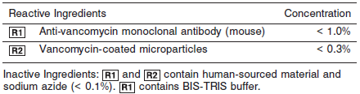

**Calibrator:** 5P04-01 TDM Multiconstituent Calibrator (TDM MCC)

**Quality Control:** Minimum 2 levels of ChemistryControl (Normal and Abnormal)

**Calibration**

**Frequency:**

Calibration is stable for 45 days (1080 hours) for any one lot.

**A new calibration is required:**

1. If quality control results do not meet acceptance criteria defined by your laboratory, patient values may be suspect. Follow the established quality control procedures for your laboratory. Recalibration may be necessary.
2. Review quality control results and acceptance criteria following a change of reagent or calibrator lot.

**Calibrator Required:** 5P04-01 TDM Multiconstituent Calibrator (TDM MCC)

**Reagents:**

**NOTE:** TDM MCC CAL 1 is the calibration blank for this assay. TDM MCC is prepared from a bovine serum matrix and contains the following analytes: amikacin, carbamazepine, digoxin, gentamicin, phenobarbital, phenytoin, quinidine, theophylline, valproic acid, and vancomycin. Sodium azide and ProClin are present as preservatives.

**Calibrator Preparation:**

TDM MCC requires no preparation prior to use.

**Calibration Procedure:**

1. Verify that the lot number listed on each calibrator carton agrees with the lot number printed on the value sheet.

2. Verify that the correct calibrator values have been entered into the calibration file.

3. Mix several times by gentle inversion to ensure homogeneity of the solution. Avoid the formation of foam.

4. Place an appropriate amount of calibrator in a sample cup, and place in the assigned position.

5. Cap bottle tightly and return to refrigerated storage immediately after use.

6. Perform calibration as indicated in *Section 6* of the **ARCHITECT System Operations Manual**.

**Troubleshooting and Overall Acceptance Criteria Failure**

See ARCHITECT Operations Manual for further calibration troubleshooting.

**Quality Control:**

Abbott recommends, refer to your laboratory standard operating procedure(s) and/or quality assurance plan for additional quality control requirements and potential corrective actions:

• Two levels of controls (normal and abnormal) are to be run every 24 hours.

• If more frequent control monitoring is required, follow the established quality control procedures for your laboratory.

• If quality control results do not meet the acceptance criteria defined by your laboratory, patient values may be suspect. Follow the established quality control procedures for your laboratory.

Recalibration may be necessary.

• Review quality control results and acceptance criteria following a change of reagent or calibrator lot.

**Procedure**

For a detailed description of how to run an assay, refer to *Section 5* of the **ARCHITECT System Operations Manual**.

**Calculations**

Refer to *Appendix C* of the **ARCHITECT System Operations Manual** for information on results calculations.

**Reporting Results**

The result unit for the MULTIGENT Vancomycin assay can be reported as μg/mL or μmol/L.

**Specific Performance Characteristics**

**Reference Ranges**

It is recommended that each laboratory determine its own reference range based upon its particular locale and population characteristics.

**Serum/Plasma:**

**Peak:** 20 – 40 μg/mL

**Trough:** 5 – 10 μg/mL

Therapeutic peak serum levels of 20 to 40 μg/mL (13.80 to 27.60 μmol/L) and trough levels of 5 to 10 μg/mL (3.45 to 6.90 μmol/L) have been reported to be effective for most strains of *staphylococci*

and *streptococci*. However, therapeutic levels of vancomycin must be individually established based on patient differences and bacterial susceptibility. The risk of toxicity is appreciably increased by high concentration or prolonged therapy in patients with renal insufficiency. Toxic effects, such as ototoxicity and nephrotoxicity, have resulted when serum concentrations of vancomycin reach 80 to 100 μg/mL (55.20 to 69.00 μmol/L) and are rarely seen when serum levels are maintained below 30 μg/mL (20.70 μmol/L). If an aminoglycoside is being used concurrently, the potential for toxicity is additive.

**Critical Values:**

**Peak: >50** μg/mL

**Trough: >15** μg/mL

**Performance Characteristics**

**Assay Range**

The linear range of the assay is 1.1 to 100.0 μg/mL (0.76 to 69.00 μmol/L).

**Limit of Quantitation (LOQ)**

The LOQ for the MULTIGENT Vancomycin assay was calculated to be 1.1 μg/mL (0.76 μmol/L).

**Dilution:**

Specimens with vancomycin values exceeding 100.0 μg/mL (69.00 μmol/L) or the highest calibrator are flagged and may be diluted by following either the Automated Dilution Protocol or the Manual Dilution Procedure.

***Automated Dilution Protocol***

If using the Automated Dilution Protocol, the system performs a 1:4 dilution of the specimen and automatically corrects the concentration by multiplying the result by the appropriate dilution factor.

***Manual Dilution Procedure***

A manual dilution can be performed on patient samples with vancomycin concentrations reported as greater than 100.0 μg/mL (69.00 μmol/L) or the highest calibrator by making a dilution of the specimen with saline before pipetting the sample into the sample cup. The dilution must be performed so the diluted test results read greater than the assay sensitivity of 1.1 μg/mL (0.76 μmol/L).



The operator must enter the manual dilution factor in the patient or control order screen. The system uses this dilution factor to automatically correct the concentration by multiplying the result by the entered factor. The printed result is the reportable result if no errors are present.

**NOTE:** If the operator does not enter the manual dilution factor, the printed result must be multiplied by the manual dilution factor before reporting the result.

**Precision:**

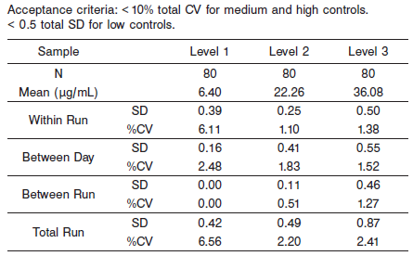

#### Limitations of Procedure

In very rare cases, patient samples may contain heterophile antibodies, which may produce low results with the MULTIGENT Vancomycin assay. Interfering heterophile antibodies occur at a low frequency in the general population. These antibodies can cause autoagglutination of the microparticle reagent leading to undetected erroneously low results.

**Interfering Substances**

The following compounds, when tested with the MULTIGENT Vancomycin assay at the concentrations indicated, resulted in less than 10% error in detecting vancomycin. Interference effects were assessed by Dose Response method. Representative results are shown below.

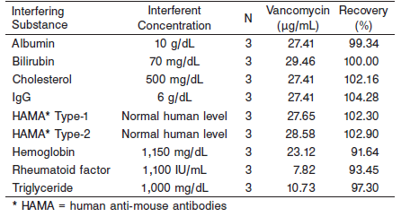

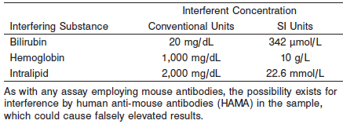

**Specificity**

***Cross-Reactivity***

The cross-reactivity of the vancomycin antibody to teicoplanin, a structurally similar compound, was examined. Teicoplanin was tested at 100 μg/mL in serum containing 25 μg/mL vancomycin. Teicoplanin showed < 0.99% cross-reactivity.

***Metabolite Cross-Reactivity***

Vancomycin slowly degrades to its metabolite CDP-I (Crystalline Degradation Product-I). The metabolite is structurally similar to vancomycin. CDP-I was tested at 100 μg/mL in serum containing 25 μg/mL vancomycin. Results show that the metabolite exhibits < 5% cross-reactivity.

***Drug Interference***

Cross-reactivity was tested with drugs that are routinely administered with vancomycin. Testing also determined whether these compounds affect the quantitation of vancomycin concentrations. Cross-reactants were analyzed in a serum pool spiked with 25 μg/mL of vancomycin.

Cross-reactants were analyzed at 500 μg/mL. The samples were assayed and the vancomycin concentrations of the spiked samples were compared to a control serum. All of the following cross-reactants showed < 0.3% cross-reactivity.

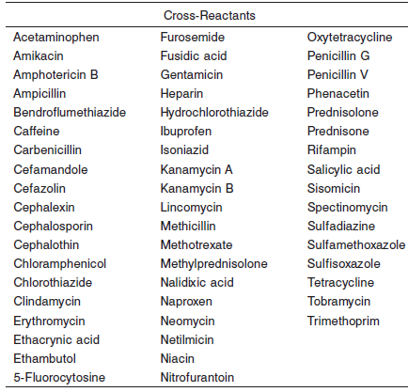

**References:**

1. ABBOTT ARCHITECT Vancomycin package insert

Abbott Laboratories

Diagnostics Division

Abbott Park, IL 60064

May 2014 306426/R03

1. ABBOTT ARCHITECT TDM Multiconstituent Calibrator package insert

Abbott Laboratories

Diagnostics Division

Abbott Park, IL 60064

1. Abbott ARCHITECT Operator’s Guide

**Related Documents:**

**Attachments:**