RUSH logo for emails

**LITHIUM**

**SERUM OR PLASMA**

**ABBOTT ARCHITECT**

**Intended Use**

The MULTIGENT Lithium assay is intended for the quantitation of lithium in serum or plasma using the ARCHITECT *c* Systems.

**Clinical Significance**

Lithium is used in the treatment of manic depressive psychosis. Lithium acts on the neurotransmitters and produces a sedative effect on the central nervous system. Elevated lithium levels can cause toxicity. Early symptoms of toxicity include apathy, sluggishness, drowsiness, lethargy, speech difficulties, tremor, muscle weakness, and ataxia. Long-term lithium therapy has been reported to cause hyperparathyroidism in some individuals, with resulting hypercalcemia.

**Principle**

The MULTIGENT Lithium assay (Lith) uses a spectrophotometric method. Lithium present in the sample reacts with a substituted porphyrin compound at an alkaline pH, resulting in a change of absorbance which is directly proportional to the concentration of lithium in the sample.

**Methodology:** Colorimetric

**Specimen Collection and Handling**

It is recommended that a standardized 12 hour post dose lithium concentration be used to assess adequate therapy. Peak concentration is reached 2 to 4 hours after oral dose.

• **Serum:** Use serum collected by standard venipuncture techniques into plastic tubes with or without gel barriers. Ensure complete clot formation has taken place prior to centrifugation. Centrifuge according to tube manufacturer’s instructions to ensure proper separation of serum from blood cells. Glass tubes were not tested.

Some specimens, especially those from patients receiving anticoagulant or thrombolytic therapy, may take longer to complete their clotting processes. Fibrin clots may subsequently form in these sera and the clots could cause erroneous test results.

• **Plasma:** Use plasma collected by standard venipuncture techniques into plastic tubes. Acceptable anticoagulants are sodium heparin and K2-EDTA. **Do not use lithium heparin.** Ensure centrifugation is adequate to remove platelets. Centrifuge according to tube manufacturer’s instructions to ensure proper separation of plasma from blood cells. Glass tubes were not tested.

**Specimen Storage**

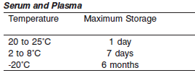

**NOTE:** Stored specimens must be inspected for particulates. If present, mix and centrifuge the specimen to remove particulates prior to testing.

**Materials and Equipment Required**

**TEST INSTRUMENT**: Abbott ARCHITECT System

**MATERIALS PROVIDED**

8L25-30 MULTIGENT Lithium

**MATERIALS REQUIRED BUT NOT PROVIDED**

• 6K30-10 MULTIGENT Clin Chem Cal

• Controls

• Saline (0.85% to 0.90% NaCl) for specimens that require dilution

**Reagent Handling and Storage:**

***CAUTION*:**

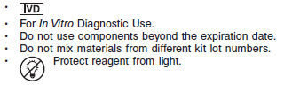.

**CAUTION:** This product requires the handling of human specimens.

It is recommended that all human sourced materials be considered

potentially infectious and be handled in accordance with the OSHA

Standard on Bloodborne Pathogens. Biosafety Level 2 or other appropriate biosafety practices should be used for materials that contain or are suspected of containing infectious agents.

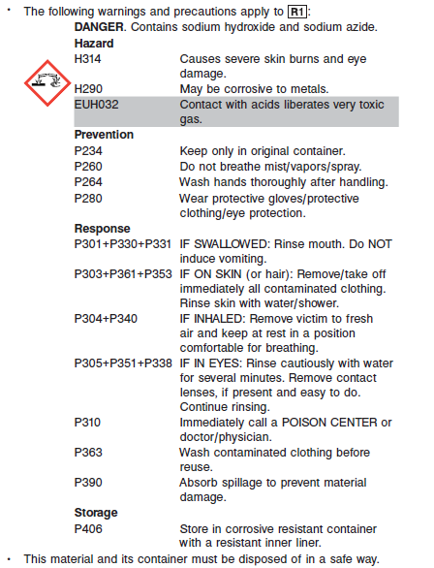

**Reagent Handling**

•R1 Ready for use.

• Remove air bubbles, if present in the reagent cartridge, with a new applicator stick. Alternatively, allow the reagent to sit at the appropriate storage temperature to allow the bubbles to dissipate.

To minimize volume depletion, do not use a transfer pipette to remove the bubbles.

**CAUTION:** Reagent bubbles may interfere with proper detection of reagent level in the cartridge, causing insufficient reagent aspiration that could impact results.

**Reagent Storage**

• Reagent stability is 18 days if the reagent is uncapped and onboard. Store MULTIGENT Lithium reagent in the box

• Unopened reagents are stable until the expiration date when stored at 2 to 8°C.

• The reagent should be clear and dark orange to red.

• Discard reagent if it is turbid or light purple.

Reagent Preparation:

8L25-30 MULTIGENT Lithium is supplied as a liquid, ready-to-use, single reagent kit which contains: **R1**

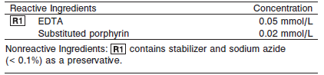

**Calibrator:** 6K30-10 MULTIGENT Clin Chem Cal

**Quality Control:** Chemistry Controls

**Calibration**

**Frequency:**

Calibration is stable for 5 days for any one lot. Calibration is required with each change in reagent lot number.

**A new calibration is required:**

1. If quality control results do not meet acceptance criteria defined by your laboratory, patient values may be suspect. Follow the established quality control procedures for your laboratory. Recalibration may be necessary.
2. Review quality control results and acceptance criteria following a change of reagent or calibrator lot.

**Calibrator Required:** 6K30-10 MULTIGENT Clin Chem Cal

**Reagents:**

6K30-10 MULTIGENT Clin Chem Cal is a lyophilized calibrator containing human serum, pancreatic amylase (porcine), cholinesterase (human), creatinine, lithium, α-hydroxybutyrate dehydrogenase, and a preservative.

**Calibrator Preparation:**

1. Gently remove the stopper to avoid loss of the lyophilized pellet.

2. Reconstitute using exactly 3.0 mL of deionized water. Replace stopper and gently swirl.

3. Allow to stand at room temperature for 30 minutes before use.

4. Gently invert the bottle to ensure no lyophilized material remains unreconstituted.

**Calibrator Procedure:**

Calibration is performed by running a water blank and the MULTIGENT Clin Chem Cal. Water is provided by the instrument.

1. Verify that the correct calibrator values have been entered into the calibration file.

2. Mix bottle or prepared aliquot several times by gentle inversion to ensure homogeneity of the solution. Avoid the formation of foam.

3. Place an appropriate amount in a sample cup, and place in the assigned position.

4. Cap bottle tightly and return to refrigerated storage immediately after use, or aliquot in small volumes (300 to 600 μL) and store at -20°C. Each aliquot should be thawed only once and discarded after use.

5. Perform calibration as indicated in *Section 6* of the **ARCHITECT System Operations Manual**.

**Troubleshooting and Overall Acceptance Criteria Failure**

See ARCHITECT Operations Manual for further calibration troubleshooting.

**Quality Control:**

Abbott recommends, refer to your laboratory standard operating procedure(s) and/or quality assurance plan for additional quality control requirements and potential corrective actions:

• Two levels of controls (normal and abnormal) are to be run every 24 hours.

• If more frequent control monitoring is required, follow the established quality control procedures for your laboratory.

• If quality control results do not meet the acceptance criteria defined by your laboratory, patient values may be suspect. Follow the established quality control procedures for your laboratory.

Recalibration may be necessary.

• Review quality control results and acceptance criteria following a change of reagent or calibrator lot.

**Procedure**

For a detailed description of how to run an assay, refer to *Section 5* of the **ARCHITECT System Operations Manual**.

The MULTIGENT Lithium assay uses a standard dilution of approximately 1:20 to achieve optimum analyte levels in the reaction mixture and to minimize potential interference.

**Calculations**

Refer to *Appendix C* of the **ARCHITECT System Operations Manual** for information on results calculations.

**Reporting Results**

Results for the MULTIGENT Lithium assay are reported in mmol/L, which are numerically equivalent to mEq/L.

**Specific Performance Characteristics**

**Reference Ranges**

It is recommended that each laboratory determine its own reference range based upon its particular locale and population characteristics.

**Serum/Plasma:**

12 hour post dose: 1.0 – 1.2 mmol/L

Toxic: > 1.5 mmol/L

**Critical Values:** > 1.5 mmol/L

**Performance Characteristics**

**Linearity**

MULTIGENT Lithium is linear from 0.10 to 3.51 mmol/L.

**Limit of Quantitation (LOQ)**

The LOQ for MULTIGENT Lithium is 0.10 mmol/L.

**Dilution:**

**Serum and Plasma:** Specimens with lithium values exceeding 3.51 mmol/L are flagged and may be diluted by following either the Automated Dilution Protocol or the Manual Dilution Procedure.

***Automated Dilution Protocol***

If using the Automated Dilution Protocol, the system performs an approximate 1:40 dilution of the specimen and automatically corrects the concentration by multiplying the result by the appropriate dilution factor.

***Manual Dilution Procedure***

• Use saline (0.85% to 0.90% NaCl) to dilute the sample.

**Example:** A manual 1:4 dilution that is run using the Standard dilution will result in an approximate 1:80 dilution of the sample.

• The operator must enter the manual dilution factor in the patient or control order screen. The system uses this dilution factor to automatically correct the concentration by multiplying the result by the entered factor.

• If the operator does not enter the dilution factor, the result must be multiplied by the appropriate manual dilution factor before reporting the result.

**NOTE:** If the diluted sample result is flagged indicating it is less than the linear low limit, do not report the result. Rerun using an appropriate dilution.

**Precision:**

The precision of the MULTIGENT Lithium assay is ≤ 5% Total CV or ≤ 0.075 SD, whichever is greater.

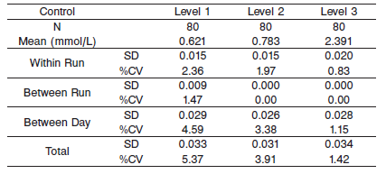

#### Limitations of Procedure

N/A

**Interfering Substances**

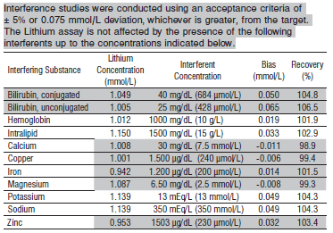

**References:**

1. ABBOTT ARCHITECT Lithium package insert

Abbott Laboratories

Diagnostics Division

Abbott Park, IL 60064

Dec 2015 306735/R03

1. ABBOTT ARCHITECT Clin Chem Calibrator package insert

Abbott Laboratories

Diagnostics Division

Abbott Park, IL 60064

1. Abbott ARCHITECT Operator’s Guide

**Related Documents:**

**Attachments:**