RUSH logo for emails

***i*PHENOBARBITAL**

**SERUM OR PLASMA**

**ABBOTT ARCHITECT**

**Intended Use**

The ARCHITECT *i* Phenobarbital assay is an *in vitro* chemiluminescent microparticle immunoassay (CMIA) for the quantitative measurement of phenobarbital, an anticonvulsant and sedative-hypnotic drug, in human serum or plasma on the ARCHITECT iSystem with STAT protocol capability. The measurements obtained are used in the diagnosis and treatment of phenobarbital overdose and in monitoring levels of phenobarbital to help ensure appropriate therapy.

**Clinical Significance**

Phenobarbital was introduced in 1912 for the treatment of epilepsy, particularly for controlling focal motor or sensory seizures and grand mal seizures. Phenobarbital is bound to both plasma and tissue proteins. Monitoring serum concentrations of phenobarbital has been shown to improve patient therapy by providing physicians with a tool for adjusting dosage. In addition, because of the narrow therapeutic index and wide inter-individual variability in the rate of phenobarbital metabolism and clearance, the determination of blood levels of phenobarbital for patients receiving therapy is essential.

**Principle**

The ARCHITECT *i* Phenobarbital assay is a one-step STAT immunoassay for the quantitative measurement of phenobarbital in human serum or plasma using CMIA technology with flexible assay protocols, referred to as Chemiflex.

1. Sample, anti-phenobarbital coated paramagnetic microparticles, and phenobarbital acridinium-labeled conjugate are combined to create a reaction mixture. The anti-phenobarbital coated microparticles bind to phenobarbital present in the sample and to the phenobarbital acridinium-labeled conjugate.

2. After washing, Pre-Trigger and Trigger Solutions are added to the reaction mixture.

3. The resulting chemiluminescent reaction is measured as relative light units (RLUs). There is an indirect relationship between the amount of phenobarbital in the sample and the RLUs detected by the ARCHITECT iSystem optics.

For additional information on system and assay technology, refer to the ARCHITECT System Operations Manual, Section 3.

**Specimen Collection and Handling**

**Suitable Specimens**

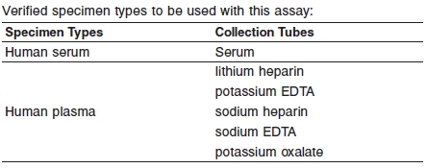

. **•** Liquid anticoagulants may have a dilution effect resulting in lower concentrations for individual patient specimens

Do not use specimens with the following conditions:

**•** heat-inactivated

**•** pooled

**•** grossly hemolyzed

**•** obvious microbial contamination

**•** cadaver specimens or body fluids other than human serum or plasma

**Specimen Storage**

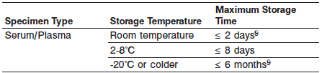

Specimens may be stored on or off the clot or red blood cells for up to two days at room temperature.

Specimens removed from the clot or red blood cells may be stored up to eight days refrigerated at 2-8°C.

Serum or plasma specimens can be stored up to six months at -20°C or colder.

**NOTE:** Stored specimens must be inspected for particulates. If present, mix and centrifuge the specimen to remove particulates prior to testing.

**Materials and Equipment Required**

**TEST INSTRUMENT**: Abbott ARCHITECT System

**MATERIALS PROVIDED**

1P33 ARCHITECT *i* Phenobarbital Reagent Kit

**MATERIALS REQUIRED BUT NOT PROVIDED**

**•** ARCHITECT *i* System

**•** ARCHITECT *i* Phenobarbital Assay file, may be obtained from:

**•** ARCHITECT *i* System e-Assay CD-ROM found on www.abbottdiagnostics.com

**•** ARCHITECT *i* System Assay CD-ROM

**•** 1P33-01 ARCHITECT *i* Phenobarbital Calibrators

**•** Commercially available control material

**•** ARCHITECT *i* Pretrigger

**•** ARCHITECT *i* Trigger

**•** ARCHITECT *i i* Wash Buffer

**•** ARCHITECT *i* Reaction Vessels

**•** ARCHITECT *i* Sample Cups

**•** ARCHITECT *i* Septums

**•** ARCHITECT *i* Replacement Caps

**•** Pipettes or pipette tips (optional) to deliver the specified volumes.

**Reagent Handling and Storage:**

***CAUTION*:**

* For in vitro diagnostic use.

**CAUTION:** This product requires the handling of human specimens.

It is recommended that all human sourced materials be considered

potentially infectious and be handled in accordance with the OSHA

Standard on Bloodborne Pathogens. Biosafety Level 2 or other appropriate biosafety practices should be used for materials that contain or are suspected of containing infectious agents.

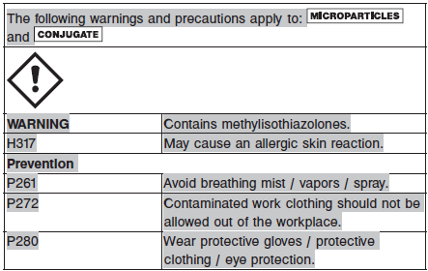

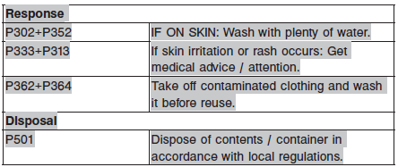

**Reagent Handling**

* Do not use reagent kits beyond the expiration date.
* **Do not pool reagents within a kit or between reagent kits.**
* Before loading the ARCHITECT Reagent Kit on the system for the first time, the microparticle bottle requires mixing to resuspend microparticles that have settled during shipment.
* **Septums MUST be used to prevent reagent evaporation and contamination and to ensure reagent integrity. Reliability of assay results cannot be guaranteed if septums are not used according to the instructions in the package insert.**
* To avoid contamination, wear clean gloves when placing a septum on an uncapped reagent bottle.
* Once a septum has been placed on the reagent bottle, **do not invert the bottle** as this will result in reagent leakage and maycompromise assay results.
* Over time, residual liquids may dry on the septum surface. These are typically dried salts and have no effect on assay efficacy.
* For a detailed discussion of handling precautions during system operation, refer to the ARCHITECT System Operations Manual, Section 7.

**Reagent Storage**

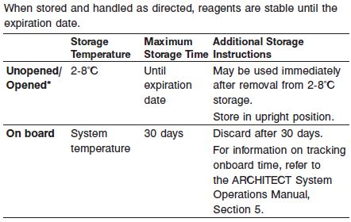

* Reagents may be stored on or off the ARCHITECT *i* System. If reagents are removed from the system, store them at 2-8°C (with septums and replacement caps) in an upright position. For reagents stored off the system, it is recommended that they be stored in their original trays and boxes to ensure they remain upright. **If the microparticle bottle does** **not remain upright (with a septum installed) while in refrigerated** **storage off the system, the reagent kit must be discarded.** For information on unloading reagents, refer to the ARCHITECT System Operations Manual, Section 5.

Reagents

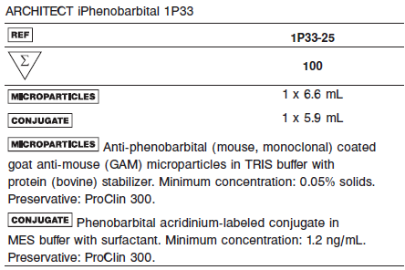

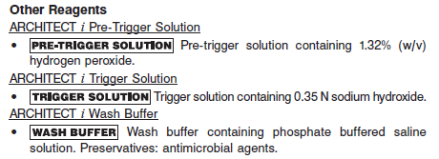

**Calibrator:** 1P33-01 ARCHITECT *i* Phenobarbital Calibrators

**Quality Control:** Commercially available controls

**Calibration**

**Frequency:**

Recalibration is required with each new reagent lot number.

**A new calibration is required:**

1. If quality control results do not meet acceptance criteria defined by your laboratory, patient values may be suspect. Follow the established quality control procedures for your laboratory. Recalibration may be necessary.
2. Review quality control results and acceptance criteria following a change of reagent or calibrator lot.

**Calibrator Required:**

1P33-01 ARCHITECT *i* Phenobarbital Calibrators

**Reagents:**

6 Bottles (4 mL each) of ARCHITECT *i* Phenobarbital Calibrators. Calibrator A contains human serum. Calibrators B-F contain phenobarbital in human serum. Preservative: sodium azide.

**Calibrator Preparation:**

**•** Calibrators may be used immediately after removal from 2-8°C storage.

**•** Prior to use, mix by gentle inversion (5-10 times). After each use, tightly close the caps and return the calibrators to 2-8°C storage.

**Calibration Procedure:**

**•** Test Calibrators A-F in duplicate. The calibrators should be priority loaded.

A single sample of each control level must be tested to evaluate the assay calibration. Ensure that assay control values are within the ranges specified in the respective control package insert.

**•** Calibration Range: 0.0 - 80.00 μg/mL.

.

**Troubleshooting and Overall Acceptance Criteria Failure**

See ARCHITECT Operations Manual for further calibration troubleshooting.

**Quality Control:**

Abbott recommends, refer to your laboratory standard operating procedure(s) and/or quality assurance plan for additional quality control requirements and potential corrective actions:

• At a minimum a single level of quality control is to be run every 24 hours

• If more frequent control monitoring is required, follow the established quality control procedures for your laboratory.

• If quality control results do not meet the acceptance criteria defined by your laboratory, patient values may be suspect. Follow the established quality control procedures for your laboratory.

Recalibration may be necessary.

• Review quality control results and acceptance criteria following a change of reagent or calibrator lot.

**Instrument Procedure**

* The ARCHITECT *i* Phenobarbital assay is designed for use on the ARCHITECT *i* System.
* The ARCHITECT *i* Phenobarbital assay file must be installed on the ARCHITECT *i* System from an ARCHITECT *i* System Assay CD-ROM prior to performing the assay. For detailed information on assay file installation and on viewing and editing assay parameters, refer to the ARCHITECT System Operations Manual, Section 2.
* For detailed information on assay file installation and viewing and editing assay parameters, refer to the ARCHITECT System Operations Manual, Section 2.
* For information on printing assay parameters, refer to the ARCHITECT System Operations Manual, Section 5.
* For a detailed description of system procedures, refer to the ARCHITECT System Operations Manual.

**Assay Procedure**

For a detailed description of how to run an assay, refer to *Section 5* of the **ARCHITECT System Operations Manual**.

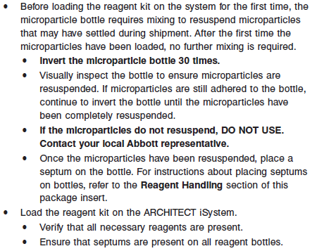

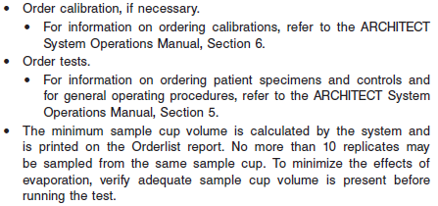

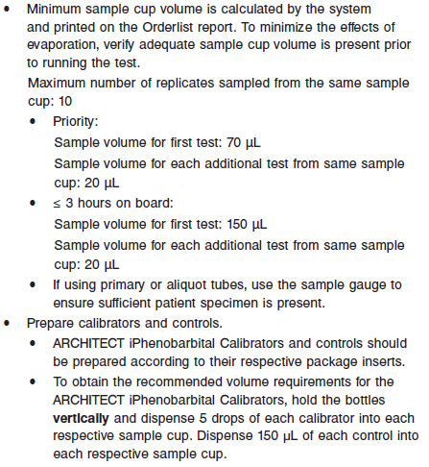

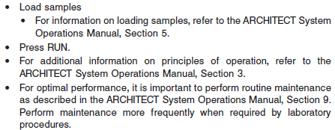

**Results**

The default result unit for the ARCHITECT *i* Phenobarbital assay is μg/mL or μmol/L

**Flags**

Some results may contain information in the Flags field. For a description of the flags that may appear in this field, refer to the ARCHITECT System Operations Manual, Section 5.

:

**Specific Performance Characteristics**

**Expected Values**

It is recommended that each laboratory determine its own reference range based upon its particular locale and population characteristics.

**Serum/Plasma:** 15 – 40μg/mL.

**CAUTION:** Values obtained with different assay methods should not be used interchangeably due to differences in assay methods and cross-reactivity with metabolites, nor should correction factors be applied. Therefore, consistent use of one assay for individual patients is recommended. Each user should verify their own Expected Values range based on clinical experience.

Strong correlations have been shown between serum levels of phenobarbital and both therapeutic effect and toxicity. Clinical observations indicate that toxicity of phenobarbital is increased in patients with renal disease. Phenobarbital toxicity primarily affects the central nervous system. Toxic levels can lead to nystagmus, vertigo, and ataxia. A small number of patients develop hypersensitivity to the drug. Some patients under chronic treatment develop macrocytosis and megaloblastic anemia as well as osteomalacia. Most patients will receive maximum seizure control when serum levels of phenobarbital are in the range of 15-40 μg/mL.

Refer to the drug manufacturer’s package insert or the Physicians’ Desk Reference (PDR) for proper drug dosage and for phenobarbital measurement sampling time.

**Critical Values: N/A**

**Performance Characteristics**

**Measuring Interval (Reportable Range)**

The measurement range for the ARCHITECT *i* Phenobarbital assay is 1.10 μg/mL to 80.00 μg/mL.

**Linearity**

See reagent package insert for information.

**Sensitivity**

The ARCHITECT *i* Phenobarbital assay is designed to have a sensitivity of ≤ 1.10 μg/mL.

Limit of Blank and Limit of Detection

See Reagent Package insert

**Dilution:**

Specimens with a phenobarbital value exceeding 80.00 μg/mL are flagged with the code “> 80.00” and may be diluted using the Manual Dilution Procedure.

**Manual Dilution Procedure**

Suggested dilution: 1:10

1. Add 10 μL of the patient specimen to 90 μL of ARCHITECT *i* Phenobarbital Calibrator A.

2. The operator must enter the dilution factor in the Patient or Control order screen. The system will use this dilution factor to automatically calculate the concentration of the sample before dilution and report the result.

For detailed information on ordering dilutions, refer to the ARCHITECT System Operations Manual, Section 5.

**Precision:**

The ARCHITECT *i* Phenobarbital assay is designed to have an assay precision of ≤ 10% total CV.

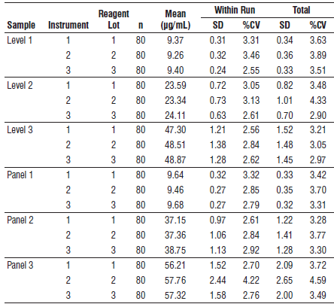

#### Limitations of Procedure

* Specimens from patients who have received preparations of mouse monoclonal antibodies for diagnosis or therapy may contain human anti-mouse antibodies (HAMA). Specimens containing HAMA may produce anomalous values when tested with assay kits that employ mouse monoclonal antibodies.
* Heterophilic antibodies in human serum can react with reagent immunoglobulins, interfering with *in vitro* immunoassays. Patients routinely exposed to animals or to animal serum products can be prone to this interference and anomalous results may be observed. Additional information may be required for diagnosis.
* Amobarbital and mephobarbital are drugs structurally similar to phenobarbital. These drugs may interfere with the ARCHITECT *i* Phenobarbital assay.

**Interfering Substances**

Potential interference in the ARCHITECT *i* Phenobarbital assay from the following compounds is designed to have a mean recovery of 100 +/- 10% of the control results at the levels indicated.

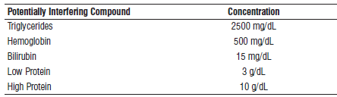

See the reagent package insert for further information on other potentially interfering substances.

**Specificity**

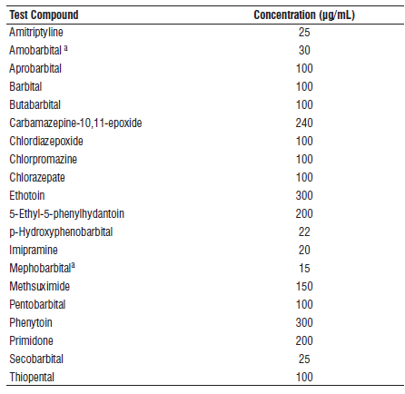

**References:**

1. ABBOTT ARCHITECT *i* Phenobarbital package insert

Abbott Laboratories

Diagnostics Division

Abbott Park, IL 60064

Jan 2015 F5-Y304-2/R04

1. ABBOTT ARCHITECT *i* Phenobarbital Calibrator package insert

Abbott Laboratories

Diagnostics Division

Abbott Park, IL 60064

1. Abbott ARCHITECT Operator’s Guide

**Related Documents:**

**Attachments:**