RUSH logo for emails

**STAT MYOGLOBIN**

**SERUM OR PLASMA**

**ABBOTT ARCHITECT**

**Intended Use**

ARCHITECT STAT Myoglobin is a chemiluminescent microparticle immunoassay (CMIA) for the quantitative determination of myoglobin in human serum and plasma on the ARCHITECT iSystem with STAT protocol capability. Myoglobin values are used to assist in the diagnosis of myocardial infarction (MI).

**Clinical Significance**

Myoglobin is a tightly folded, globular heme-protein located in the cytoplasm of both skeletal and cardiac muscle cells. Its function is to store and supply oxygen to muscle cells. The molecular weight of myoglobin is approximately 17,800 daltons. The relatively low molecular weight and the location of storage accounts for the rapid release from damaged muscle cells and earlier rises in concentration measured above baseline in blood as compared to other cardiac markers.

In ischemic heart disease, such as myocardial infarction (MI), a temporal pattern of increased release of myoglobin into the blood stream is observed. The serum or plasma myoglobin level will start to show an increase between 2-4 hours after an MI has occurred, peaking at approximately 8-10 hours, and returning to baseline after 24 hours. Measurement of myoglobin between 2-12 hours after an MI can be a good adjunct to electrocardiography (ECG) in improving the efficiency of early diagnosis of MI. Monitoring the myoglobin levels can also help in evaluating the success of thrombolytic therapy.

Since myoglobin is present in both cardiac and skeletal muscle, any damage to either of these muscle types results in its release into the blood stream. Elevated serum levels of myoglobin have been observed under the following conditions: skeletal muscle damage, skeletal muscle or neuromuscular disorders, cardiac bypass surgery, renal failure, strenuous exercise. Therefore, serum myoglobin levels should be used in conjunction with other aspects of the patient assessment to aid in the diagnosis of an MI. Myoglobin may also rise moderately above the reference range in chronic ischemic heart disease (i.e. unstable angina). For diagnostic purposes, the ARCHITECT STAT Myoglobin assay results should be used in conjunction with other data; e.g., other clinical testing, ECG, symptoms, clinical observations.

**Principle**

The ARCHITECT STAT Myoglobin assay is a two-step immunoassay for the quantitative determination of myoglobin in human serum and plasma using CMIA technology with flexible assay protocols, referred to as Chemiflex.

1. Sample and anti-myoglobin coated paramagnetic microparticles are combined and incubated. The myoglobin present in the sample binds to the anti-myoglobin coated microparticles.

2. After washing, anti-myoglobin acridinium-labeled conjugate is added to create a reaction mixture.

3. Following another incubation and wash cycle, Pre-Trigger and Trigger Solutions are added to the reaction mixture.

4. The resulting chemiluminescent reaction is measured as relative light units (RLUs). There is a direct relationship between the amount of myoglobin in the sample and the RLUs detected by the ARCHITECT iSystem optics.

For additional information on system and assay technology, refer to the ARCHITECT System Operations Manual, Section 3.

**Specimen Collection and Handling**

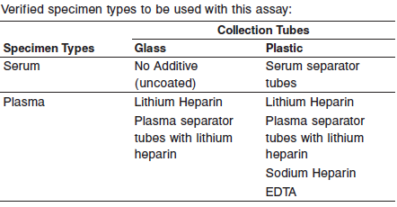

**•** When serial specimens are being evaluated, the same type of specimen should be used throughout the study.

Do not use specimens with the following conditions:

**•** heat-inactivated

• obvious microbial contamination

• cadaver specimens or body fluids other than human serum

* For optimal results, serum and plasma specimens should be free of fibrin, red blood cells or other particulate matter.

**Storage**

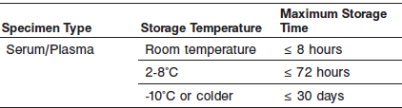

If testing will be delayed for more than 8 hours, remove plasma or serum from the serum or plasma separator, red blood cells or clot. Specimens removed from the separator gel, cells or clot may be stored up to 72 hours at 2-8°C.

Specimens can be stored up to 30 days frozen at -10°C or colder.

All samples (patient specimens, controls, and calibrators) should be tested within 3 hours of being placed on board the ARCHITECT System.

**Materials and Equipment Required**

**TEST INSTRUMENT**: Abbott ARCHITECT System

**MATERIALS PROVIDED**

2K43 ARCHITECT STAT Myoglobin Reagent Kit

**MATERIALS REQUIRED BUT NOT PROVIDED**

**•** ARCHITECT *i* System with *STAT* protocol

**•** ARCHITECT STAT Myoglobin Assay file, may be obtained from:

**•** ARCHITECT *i* System e-Assay CD-ROM found on www.abbottdiagnostics.com

**•** ARCHITECT *i* System Assay CD-ROM

**•** 2K43-01 ARCHITECT STAT Myoglobin Calibrators

**•** 2K43-10 ARCHITECT STAT Myoglobin Controls

**•** ARCHITECT *i* Pretrigger

**•** ARCHITECT *i* Trigger

**•** ARCHITECT *i i* Wash Buffer

**•** ARCHITECT *i* Reaction Vessels

**•** ARCHITECT *i* Sample Cups

**•** ARCHITECT *i* Septums

**•** ARCHITECT *i* Replacement Caps

**•** Pipettes or pipette tips (optional) to deliver the specified volumes.

**Reagent Handling and Storage:**

***CAUTION*:**

* For in vitro diagnostic use.

**CAUTION:** This product requires the handling of human specimens.

It is recommended that all human sourced materials be considered

potentially infectious and be handled in accordance with the OSHA

Standard on Bloodborne Pathogens. Biosafety Level 2 or other appropriate biosafety practices should be used for materials that contain or are suspected of containing infectious agents.

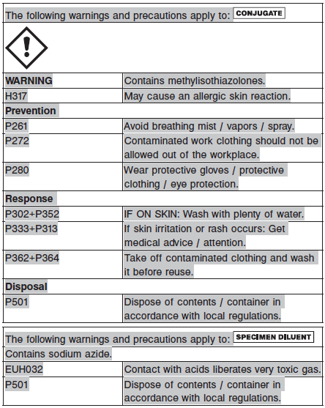

**Reagent Handling**

* Do not use reagent kits beyond the expiration date.
* **Do not pool reagents within a kit or between reagent kits.**
* Before loading the ARCHITECT Reagent Kit on the system for the first time, the microparticle bottle requires mixing to resuspend microparticles that have settled during shipment.
* **Septums MUST be used to prevent reagent evaporation and contamination and to ensure reagent integrity. Reliability of assay results cannot be guaranteed if septums are not used according to the instructions in the package insert.**
* To avoid contamination, wear clean gloves when placing a septum on an uncapped reagent bottle.
* Once a septum has been placed on the reagent bottle, **do not invert the bottle** as this will result in reagent leakage and maycompromise assay results.
* Over time, residual liquids may dry on the septum surface. These are typically dried salts and have no effect on assay efficacy.
* For a detailed discussion of handling precautions during system operation, refer to the ARCHITECT System Operations Manual, Section 7.

**Reagent Storage**

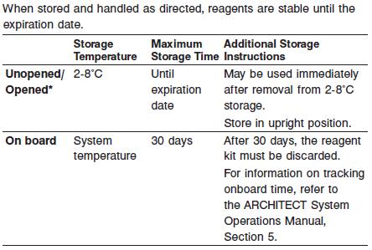

* Reagents may be stored on or off the ARCHITECT *i* System. If reagents are removed from the system, store them at 2-8°C (with septums and replacement caps) in an upright position. For reagents stored off the system, it is recommended that they be stored in their original trays and boxes to ensure they remain upright.
* For information on unloading reagents, refer to the ARCHITECT System Operations Manual, Section 5.

Reagents

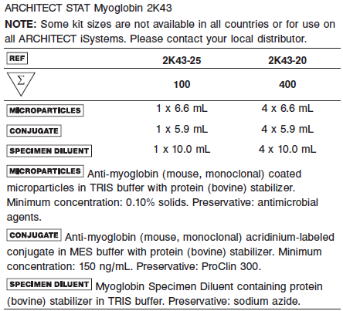

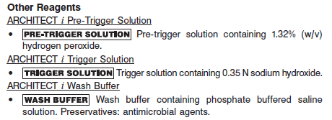

**Calibrator:** 2K43-01 ARCHITECT STAT Myoglobin Calibrators

**Quality Control:** 2K43-10 ARCHITECT STAT Myoglobin Controls

**Calibration**

**Frequency:**

Recalibration is required with each new reagent lot number.

**A new calibration is required:**

1. If quality control results do not meet acceptance criteria defined by your laboratory, patient values may be suspect. Follow the established quality control procedures for your laboratory. Recalibration may be necessary.
2. Review quality control results and acceptance criteria following a change of reagent or calibrator lot.

**Calibrator Required:**

2K43-01 ARCHITECT STAT Myoglobin Calibrators

**Reagents:**

6 Bottles (4.0 mL each) of ARCHITECT *STAT* Myoglobin Calibrators. Calibrator A contains TRIS buffer with protein (bovine) stabilizer. Calibrators B - F contain human myoglobin in TRIS buffer with protein (bovine) stabilizer. Preservative: sodium azide.

**Calibrator Preparation:**

Calibrators may be used immediately after removal from 2-8°C storage.

Prior to use, mix by gentle inversion 5-10 times. After each use, tightly close the caps and return the calibrators to 2-8°C storage.

**Calibration Procedure:**

Test Calibrators A-F in duplicate. The calibrators should be priority loaded.

A single sample of each control level must be tested to evaluate the assay calibration. Ensure that assay control values are within the ranges specified in the respective control package insert.

**•** Calibration Range: 0.0 – 1200.0 ng/mL.

**Troubleshooting and Overall Acceptance Criteria Failure**

See ARCHITECT Operations Manual for further calibration troubleshooting.

**Quality Control:**

Abbott recommends, refer to your laboratory standard operating procedure(s) and/or quality assurance plan for additional quality control requirements and potential corrective actions:

• At a minimum a single control of each quality control level is to be run every 24 hours

• If more frequent control monitoring is required, follow the established quality control procedures for your laboratory.

• If quality control results do not meet the acceptance criteria defined by your laboratory, patient values may be suspect. Follow the established quality control procedures for your laboratory.

Recalibration may be necessary.

• Review quality control results and acceptance criteria following a change of reagent or calibrator lot.

**Instrument Procedure**

* The ARCHITECT STAT Myoglobin assay file must be installed on the ARCHITECT iSystem with STAT protocol capability prior to performing the assay.
* For detailed information on assay file installation and viewing and editing assay parameters, refer to the ARCHITECT System Operations Manual, Section 2.
* For information on printing assay parameters, refer to the ARCHITECT System Operations Manual, Section 5.
* For a detailed description of system procedures, refer to the ARCHITECT System Operations Manual.

**Assay Procedure**

For a detailed description of how to run an assay, refer to *Section 5* of the **ARCHITECT System Operations Manual**.

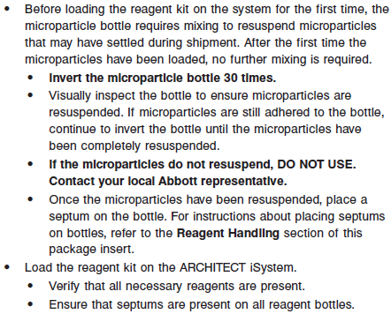

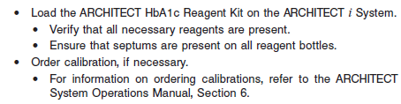

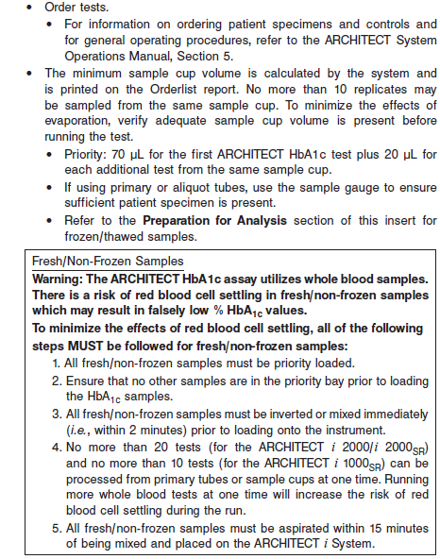

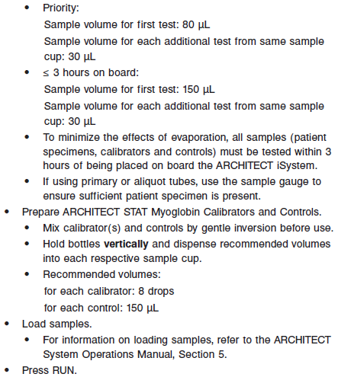

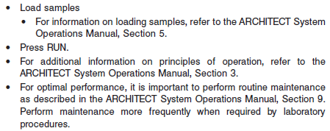

**Results**



**Flags**

Some results may contain information in the Flags field. For a description of the flags that may appear in this field, refer to the ARCHITECT System Operations Manual, Section 5.

**Specific Performance Characteristics**

**Expected Values**

It is recommended that each laboratory determine its own reference range based upon its particular locale and population characteristics.

**Serum/Plasma:**

**Female:** <106.0

**Male:** <154.9

**Critical Values: N/A**

**Performance Characteristics**

**Sensitivity**

The ARCHITECT STAT Myoglobin analytical sensitivity is ≤ 1.0 ng/mL at the 95% level of confidence (n = 36 runs, 10 replicates of Calibrator A and 4 replicates of Calibrator B per run).

**Linearity**

The ARCHITECT STAT Myoglobin assay is designed to be linear across the measurement range of 1.0 to 1200 ng/mL. See information in the **SPECIFIC PERFORMANCE CHARACTERISTICS** section of the package insert.

**Dilution:**

Specimens with a myoglobin value exceeding 1200.0 ng/mL are flagged with the code “> 1200.0” and may be diluted using either the Automated Dilution Protocol or the Manual Dilution Procedure.

**Automated Dilution Protocol**

The system performs a 1:10 dilution of the specimen and automatically calculates the concentration of the specimen before dilution and reports the result.

Specimens with a myoglobin value exceeding 12000.0 ng/mL are flagged with the code “>12000.0” when run using the Automated Dilution Protocol. These specimens may be diluted by following the Manual Dilution Procedure.

**Manual Dilution Procedure**

Suggested dilution: 1:20

1. Prior to diluting the specimen, dispense approximately 10 drops of ARCHITECT *STAT* Myoglobin Calibrator A into a clean test tube for use in the next step.

2. Transfer 190 μL of ARCHITECT STAT Myoglobin Calibrator A from the test tube prepared in the prior step into another clean test tube and add 10 μL of the patient specimen.

3. The operator must enter the dilution factor in the Patient or Control order screen. The system will use this dilution factor to automatically calculate the concentration of the sample before dilution and report the result. The result should be > 40.0 ng/mL.

For detailed information on ordering dilutions, refer to the ARCHITECT System Operations Manual, Section 5.

**Precision:**

The ARCHITECT STAT Myoglobin assay precision is ≤ 10% total CV for samples ≥ 40.0 ng/mL.

See information in the **SPECIFIC PERFORMANCE CHARACTERISTICS** section of the package insert.

#### Limitations of Procedure

* Specimens from patients who have received preparations of mouse monoclonal antibodies for diagnosis or therapy may contain human anti-mouse antibodies (HAMA). Specimens containing HAMA may produce anomalous values when tested with assay kits that employ mouse monoclonal antibodies.
* Heterophilic antibodies in human serum can react with reagent immunoglobulins, interfering with *in vitro* immunoassays. Patients routinely exposed to animals or to animal serum products can be prone to this interference and anomalous results may be observed. Additional information may be required for diagnosis. Immunoassays are nonspecific and cross react with metabolites.
* ARCHITECT STAT Myoglobin is not intended to be used on an ARCHITECT iSystem without STAT protocol capability.

**Specificity**

The ARCHITECT STAT Myoglobin assay analytical specificity is ≤ 0.0001% cross-reactivity with hemoglobin.



**Interference**

Potential interference from elevated levels of bilirubin, hemoglobin, triglycerides, and total protein in the ARCHITECT STAT Myoglobin assay is ≤ 15% at the levels indicated in the following table.

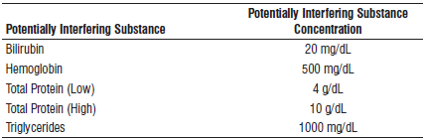

Evaluation of Other Potential Interferents

Potential interference from HAMA and rheumatoid factor (RF) in the ARCHITECT STAT Myoglobin assay is ≤ 15%.

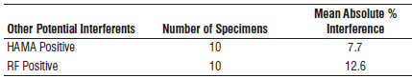

**References:**

1. ABBOTT ARCHITECT STAT Myoglobin package insert

Abbott Laboratories

Diagnostics Division

Abbott Park, IL 60064

April 2015 G1-0455/ R07

1. ABBOTT ARCHITECT STAT Myoglobin Calibrator package insert

Abbott Laboratories

Diagnostics Division

Abbott Park, IL 60064

1. Abbott ARCHITECT Operator’s Guide

**Related Documents:**

**Attachments:**