RUSH logo for emails

**DIRECT BILIRUBIN**

**SERUM OR PLASMA**

**ABBOTT ARCHITECT**

**Intended Use**

The Direct Bilirubin assay is used for the quantitative analysis of direct bilirubin in human serum or plasma.

**Clinical Significance**

Red blood cells at the end of their circulating life are broken down in the reticuloendothelial system, mainly the spleen. The resulting heme, once the iron is removed, is then converted to bilirubin. This process accounts for about 80% of the 500 μmol (300 mg) of bilirubin formed daily. Other sources of bilirubin include the breakdown of myoglobin and cytochromes and the catabolism of immature red blood cells in the bone marrow.

Once formed, bilirubin is transported to the liver bound to albumin. This fraction of bilirubin is referred to as indirect or unconjugated bilirubin. In the liver, bilirubin is conjugated to glucuronic acid (mono- and diglucuronides) to form conjugated bilirubin by the enzyme uridyl diphosphate glucuronyl transferase. Conjugated bilirubin or direct bilirubin is excreted via the biliary system into the intestine, where it is metabolized by bacteria to a group of products known collectively as stercobilinogen. Elimination is almost complete and serum levels are normally negligible.

Direct bilirubin is the sum of the conjugated fractions. Direct bilirubin is elevated in conditions causing hepatic obstruction, hepatitis, cirrhosis, several inherited enzyme deficiencies, and inherited defects in canalicular excretion.

**Principle**

Bilirubin determination is generally based on the reaction of bilirubin with a diazotized sulfanilic acid, described by Ehrlich.1 In this method, direct (conjugated fractions) bilirubin couples with a diazonium salt in the presence of sulfamic acid to form the colored compound azobilirubin.

The increase in absorbance at 548 nm due to azobilirubin is proportional to the direct bilirubin concentration.

**Methodology:** Diazo Reaction

**Specimen Collection and Handling**

Use serum or plasma specimens without visible hemolysis or lipemia.

.

Abbott Laboratories has not verified the assay performance characteristics with neonatal specimens.

**NOTE:** Abbott Laboratories recommends the use of sample interference indices in the semi-quantitative mode to assist in the determination of sample integrity for all specimens. Refer to the Sample Interference Indices (HIL) application sheets.

• **Serum:** Use serum collected by standard venipuncture techniques into glass or plastic tubes with or without gel barriers. Ensure complete clot formation has taken place prior to centrifugation.

Centrifuge according to tube manufacturer’s instructions to ensure proper separation of serum from blood cells.

Some specimens, especially those from patients receiving anticoagulant or thrombolytic therapy, may take longer to complete their clotting processes. Fibrin clots may subsequently form in these sera and the clots could cause erroneous test results.

• **Plasma:** Use plasma collected by standard venipuncture techniques into glass or plastic tubes. Acceptable anticoagulants are lithium heparin (with or without gel barrier), sodium heparin, and EDTA. The use of tubes containing sodium fluoride/potassium oxalate is not recommended due to the potential of hemolysis formation with this anticoagulant. Ensure centrifugation is adequate to remove platelets.

Centrifuge according to tube manufacturer’s instructions to ensure proper separation of plasma from blood cells.

**Specimen Storage**

**Serum and Plasma:** Specimens should be protected from bright light as bilirubin is photolabile.6 Direct bilirubin is stable in serum and plasma as follows:

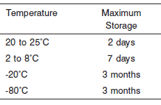

**NOTE:** Stored specimens must be inspected for particulates. If present, mix and centrifuge the specimen to remove particulates prior to testing.

**Materials and Equipment Required**

**TEST INSTRUMENT**: Abbott ARCHITECT System

**MATERIALS PROVIDED**

8G63-21 Direct Bilirubin

**MATERIALS REQUIRED BUT NOT PROVIDED**

• 1E66 Bilirubin Calibrator

• Control Material

• Saline (0.85% to 0.90% NaCl) for specimens that require dilution

**Reagent Handling and Storage:**

***CAUTION*:**

1. For in vitro diagnostic use.

2. Do not use components beyond the expiration date.

3. Do not mix materials from different kit lot numbers.

• Protect reagents from direct sunlight.

• Do not freeze reagents.

**CAUTION:** This product requires the handling of human specimens.

It is recommended that all human sourced materials be considered

potentially infectious and be handled in accordance with the OSHA

Standard on Bloodborne Pathogens. Biosafety Level 2 or other appropriate biosafety practices should be used for materials that contain or are suspected of containing infectious agents.

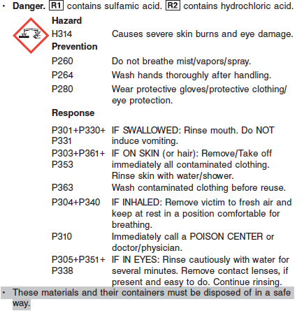

**Reagent Handling**

• Remove air bubbles, if present in the reagent cartridge, with a new applicator stick. Alternatively, allow the reagent to sit at the appropriate storage temperature to allow the bubbles to dissipate.

To minimize volume depletion, do not use a transfer pipette to remove the bubbles.

**CAUTION:** Reagent bubbles may interfere with proper detection of reagent level in the cartridge, causing insufficient reagent aspiration that could impact results.

**Reagent Storage**

• Reagent stability is 28 (672 hours) days if the reagent is uncapped and onboard.

• Unopened reagents are stable until the expiration date when stored at 2 to 8°C.

Reagent Preparation:

8G63-21 Direct Bilirubin is supplied as a liquid, ready-to-use, two-reagent kit which contains: **R1 & R2**

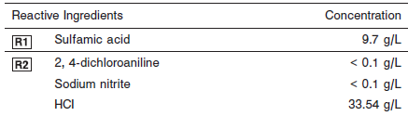

**Calibrator:** 1E66 Bilirubin Calibrator

**Quality Control:** Minimum 2 levels of ChemistryControl (Normal and Abnormal)

**Calibration**

**Frequency:**

Calibration is stable for 14 days for any one lot. Calibration is required with each change in reagent lot number.

**A new calibration is required:**

1. If quality control results do not meet acceptance criteria defined by your laboratory, patient values may be suspect. Follow the established quality control procedures for your laboratory. Recalibration may be necessary.
2. Review quality control results and acceptance criteria following a change of reagent or calibrator lot.

**Calibrator Required:** 1E66 Bilirubin Calibrator

**Reagents:**

Bilirubin Calibrator is prepared in a bovine serum-based solution. Analyte levels are adjusted with bilirubin extracts and synthetic derivatives. Preservatives are also present.

**Calibrator Preparation:**

Bilirubin Calibrator requires no preparation prior to use.

**Calibration Procedure:**

Calibration is performed by running a water blank and the Bilirubin Calibrator set. Water for the blank is provided by the instrument.

1. Verify that the correct calibrator values have been entered into the calibration file.

2. Allow calibrator to come to room temperature.

3. Mix bottle several times by gentle inversion.

4. Open bottle, place an appropriate amount of each calibrator in a separate sample cup, and place in the assigned positions.

5. Cap bottle tightly and return to refrigerated storage immediately after use.

6. Perform calibration as indicated in the **ARCHITECT System Operations Manual**.

**Troubleshooting and Overall Acceptance Criteria Failure**

See ARCHITECT Operations Manual for further calibration troubleshooting.

**Quality Control:**

Abbott recommends, refer to your laboratory standard operating procedure(s) and/or quality assurance plan for additional quality control requirements and potential corrective actions:

• Two levels of controls (normal and abnormal) are to be run every 24 hours.

• If more frequent control monitoring is required, follow the established quality control procedures for your laboratory.

• If quality control results do not meet the acceptance criteria defined by your laboratory, patient values may be suspect. Follow the established quality control procedures for your laboratory.

Recalibration may be necessary.

• Review quality control results and acceptance criteria following a change of reagent or calibrator lot.

**Procedure**

For a detailed description of how to run an assay, refer to *Section 5* of the **ARCHITECT System Operations Manual**.

**Calculations**

Refer to *Appendix C* of the **ARCHITECT System Operations Manual** for information on results calculations.

**Reporting Results**

The result unit for the MULTIGENT Direct Bilirubin assay can be reported as mg/dL or umol/L.

**Specific Performance Characteristics**

**Reference Ranges**

It is recommended that each laboratory determine its own reference range based upon its particular locale and population characteristics.

**Serum/Plasma:** 0.0 – 0.5 mg/dL

**Critical Values: >**2.0 mg/dL

**Performance Characteristics**

**Linearity**

Linearity for Direct Bilirubin is 0.1 to 15.0 mg/dL (1.7 to 256.5 μmol/L), with recovery within 10% or within the 95% confidence level of the predicted value.

**Limit of Detection (LOD)** study performed on an ARCHITECT *c* System produced and LOD for Direct Bilirubin of 0.04 mg/dL (0.69 μmol/L).

**Limit of Quantitation (LOQ)**

The LOQ for Direct Bilirubin is ≤ 0.10 mg/dL (1.71 μmol/L).

**Dilution:**

**Serum and Plasma:** Specimens with direct bilirubin value exceeding 15.0 mg/dL (256.5 μmol/L) are flagged and may be diluted by following the Manual Dilution Procedure.

**Automated Dilution Protocol**

If using the Automated Dilution Protocol, the system performs a dilution of the specimen and automatically corrects the concentration by multiplying the result by the appropriate dilution factor. To set up the automatic dilution feature, refer to *Section 2* of the **ARCHITECT System** **Operations Manual** for additional information.

**Manual Dilution Procedure**

Manual dilutions should be performed as follows:

• Use saline (0.85% to 0.90% NaCl) to dilute the sample.

• The operator must enter the dilution factor in the patient or control order screen. The system uses this dilution factor to automatically correct the concentration by multiplying the result by the entered factor.

• If the operator does not enter the dilution factor, the result must be multiplied by the appropriate dilution factor before reporting the result.

**NOTE:** If a diluted sample result is flagged indicating it is less than the linear low limit, do not report the result. Rerun using an appropriate dilution.

For detailed information on ordering dilutions, refer to *Section 5* of the **ARCHITECT System Operations Manual**.

**Precision:**

The imprecision of the Direct Bilirubin assay is ≤ 5% Total CV.

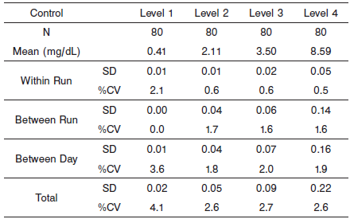

#### Limitations of Procedure

Some specimens may give a direct bilirubin result slightly greater than the total bilirubin result. During internal testing at Abbott Laboratories, specimens with total bilirubin concentrations of 0.2 mg/dL (3.4 μmol/L) or less occasionally gave a direct bilirubin result that slightly exceeded their respective total bilirubin result. This may be observed when nearly all reacting bilirubin is direct bilirubin.

**Interfering Substances**

Potential interference in the Direct Bilirubin assay from 62 mg/dL hemoglobin, 125 mg/dL Intralipid, or 0.50 mmol/L Indican (indoxyl sulfate) is ≤ 10% or +/- 0.1 mg/dL, whichever is greater, at the medical decision level of the analyte.

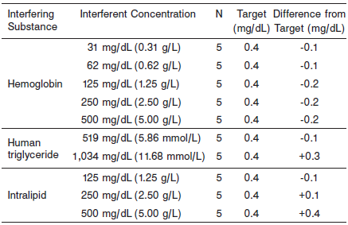

**References:**

1. ABBOTT ARCHITECT Direct Bilirubin package insert

Abbott Laboratories

Diagnostics Division

Abbott Park, IL 60064

Oct 2012 305018/R02

1. ABBOTT ARCHITECT Bilirubin Calibrator package insert

Abbott Laboratories

Diagnostics Division

Abbott Park, IL 60064

1. Abbott ARCHITECT Operator’s Guide

**Related Documents:**

**Attachments:**