RUSH logo for emails

**URINE/CSF PROTEIN (UPRO)**

**URINE OR CSF**

**ABBOTT ARCHITECT**

**Intended Use**

The Urine/CSF Protein (UPro) assay is used for the quantitation of protein in human urine or cerebrospinal fluid (CSF). CSF protein measurements are used in the diagnosis and treatment of conditions such as meningitis, brain tumors, and infections of the central nervous system

**Clinical Significance**

The role of the renal system in the conservation of plasma proteins has been recognized for some time. Under normal physiological conditions small molecular weight proteins, such as insulin, pass through the glomeruli in relatively large amounts. Intermediate size proteins, such as transferrin and albumin, also pass through in relatively small amounts. Most of these proteins are reabsorbed in the renal tubules.

Most CSF protein originates by diffusion from plasma across the blood-CSF barrier. Elevated levels occur as a result of increased permeability of the blood-CSF barrier or with increased local synthesis of immunoglobulins.

**Principle**

The UPro assay is a turbidimetric procedure in which benzethonium chloride is used as the protein denaturing agent. Proteins present in the urine or CSF are denatured by benzethonium chloride, resulting in the formation of a fine suspension which is quantitated turbidimetrically at 404 nm.

**Methodology:** Benzethonium Chloride

**Specimen Collection and Handling**

Urine and cerebrospinal fluid are acceptable specimens. Samples for urinary/CSF protein should be collected before fluorescein is given or at least 24 hours later.

• **Urine:** 24 hour timed urine specimens are preferred, with no preservative. Keep specimen on ice during collection. Centrifuge prior to analysis. Analyze fresh, or store as indicated below.

Avoid collection of specimens within 24 hours of intense exercise since this can falsely elevate protein excretion.

• **Cerebrospinal Fluid:** Centrifuge specimen before analysis. Analyze fresh or store as indicated below. Specimen should not contain blood.

**Specimen Storage**

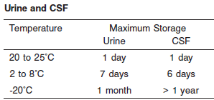

**NOTE:** Stored specimens must be inspected for particulates. If present, mix and centrifuge the specimen to remove particulates prior to testing.

**Materials and Equipment Required**

**TEST INSTRUMENT**: Abbott ARCHITECT System

**MATERIALS PROVIDED**

7D79 Urine/CSF Protein Reagent Kit

**MATERIALS REQUIRED BUT NOT PROVIDED**

• 1E71 Urine/CSF Protein Calibrator

• Control material

• Saline (0.85% to 0.90% NaCl) for specimens that require dilution

**Reagent Handling and Storage:**

***CAUTION*:**

1. For in vitro diagnostic use.

2. Do not use components beyond the expiration date.

3. Do not mix materials from different kit lot numbers.

**CAUTION:** This product requires the handling of human specimens.

It is recommended that all human sourced materials be considered

potentially infectious and be handled in accordance with the OSHA

Standard on Bloodborne Pathogens. Biosafety Level 2 or other appropriate biosafety practices should be used for materials that contain or are suspected of containing infectious agents.

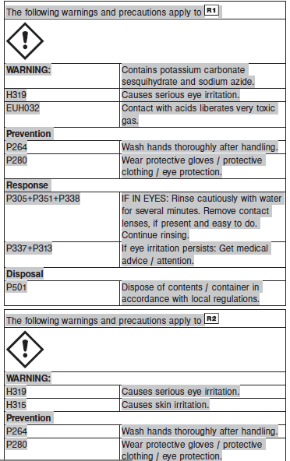

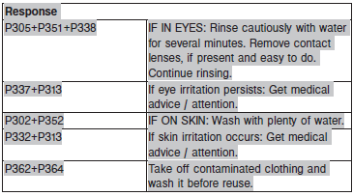

**Reagent Handling**

Remove air bubbles, if present in the reagent cartridge, with a new applicator stick. Alternatively, allow the reagent to sit at the appropriate storage temperature to allow the bubbles to dissipate. To minimize volume depletion, do not use a transfer pipette to remove the bubbles.

**CAUTION:** Reagent bubbles may interfere with proper detection of reagent level in the cartridge, causing insufficient reagent aspiration which could impact results.

**Reagent Storage**

Unopened reagents are stable until the expiration date when stored at 15 to 30°C.

Reagent stability is 41 days if the reagent is uncapped and onboard.

Reagent Preparation:

Urine/CSF Protein is supplied as a liquid, ready-to-use, two-reagent kit which contains: R1 & R2

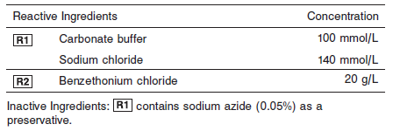

**Calibrator:** 1E71 Urine/CSF Protein Calibrator

**Quality Control:** Chemistry Urine/CSF Controls

**Calibration**

**Frequency:**

Calibration is stable for 41 Days for any one lot. Calibration is required with each change in reagent lot number.

**A new calibration is required:**

1. If quality control results do not meet acceptance criteria defined by your laboratory, patient values may be suspect. Follow the established quality control procedures for your laboratory. Recalibration may be necessary.
2. Review quality control results and acceptance criteria following a change of reagent or calibrator lot.

**Calibrator Required:** 1E71 Urine/CSF Protein Calibrator

**Reagents:**

1E71-02 Urine/CSF Protein Calibrator is a human protein-based solution. Preservatives are also present.

**Calibrator Preparation & Procedure:**

Caps are color coded and should not be interchanged.

Calibration is performed by running a water blank and the Urine/CSF Protein Calibrator set. Water for the blank is provided by the instrument.

1. Verify that the correct calibrator values have been entered into the calibration file.

2. Allow calibrator to come to room temperature.

3. Mix bottle several times by gentle inversion.

4. Open bottle, place an appropriate amount of each calibrator in a separate sample cup, and place in the assigned positions.

5. Cap bottle tightly and return to refrigerated storage immediately after use.

6. Perform calibration as indicated in the **ARCHITECT System Operations Manual**.

**Troubleshooting and Overall Acceptance Criteria Failure**

See ARCHITECT Operations Manual for further calibration troubleshooting.

**Quality Control:**

Abbott recommends, refer to your laboratory standard operating procedure(s) and/or quality assurance plan for additional quality control requirements and potential corrective actions:

• Two levels of controls (normal and abnormal) are to be run every 24 hours.

• If more frequent control monitoring is required, follow the established quality control procedures for your laboratory.

• If quality control results do not meet the acceptance criteria defined by your laboratory, patient values may be suspect. Follow the established quality control procedures for your laboratory.

Recalibration may be necessary.

• Review quality control results and acceptance criteria following a change of reagent or calibrator lot.

**Procedure**

For a detailed description of how to run an assay, refer to *Section 5* of the **ARCHITECT System Operations Manual**.

**Calculations**

Refer to *Appendix C* of the **ARCHITECT System Operations Manual** for information on results calculations.

**Reporting Results**

Results are expressed in mg/dL.

**Specific Performance Characteristics**

**Reference Ranges**

It is recommended that each laboratory determine its own reference range based upon its particular locale and population characteristics.

**Reference Range:**

**Urine:**

**Random:** 1 – 14 mg/dL

**24 hour excretion:** <300mg/24 hours

**CSF:**

**0 – 2 months:** 40 – 120 mg/dL

**Adult:** 15 – 40 mg/dL

**Critical Values: N/A**

**Performance Characteristics**

**Reportable Range**

The reportable range for Urine/CSF Protein is 6.8 mg/dL (68 mg/L)

to 200.0 mg/dL (2,000 mg/L).

**Limit of Quantitation (LOQ)**

The LOQ for Urine/CSF Protein is 6.75 mg/dL (67.5 mg/L).

**Dilution:**

**Urine and CSF:** Specimens with protein values exceeding 200.0 mg/dL (2,000 mg/L) are flagged and may be diluted by following either the Automated Dilution Protocol or the Manual Dilution Procedure.

**Automated Dilution Protocol**

If using the Automated Dilution Protocol, the system performs a 1:2 or 1:10 dilution of the specimen and automatically corrects the concentration by multiplying the result by the appropriate dilution factor.

**Manual Dilution Procedure**

Manual dilutions should be performed as follows:

• Use saline (0.85% to 0.90% NaCl) to dilute the sample.

• The operator must enter the dilution factor in the patient or control order screen. The system uses this dilution factor to automatically correct the concentration by multiplying the result by the entered factor.

• If the operator does not enter the dilution factor, the result must be multiplied by the appropriate dilution factor before reporting the result.

**NOTE:** If a diluted sample result is flagged indicating it is less than the linear low limit, do not report the result. Rerun using an appropriate dilution.

For detailed information on ordering dilutions, refer to *Section 5* of the **ARCHITECT System Operations Manual**.

**Precision:**

The imprecision of the Urine/CSF Protein assay is ≤ 7.8% Total CV.

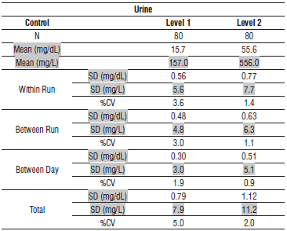

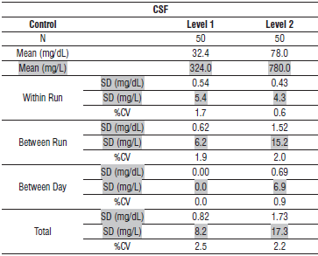

#### Limitations of Procedure

N/A

**Interfering Substances**

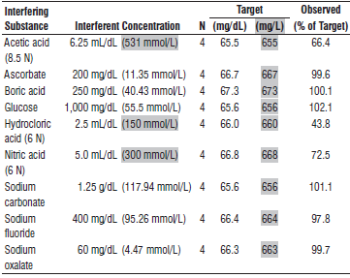

**References:**

1. ABBOTT ARCHITECT Urine CSF Protein package insert

Abbott Laboratories

Diagnostics Division

Abbott Park, IL 60064

Jan 2016 306752 / R03

1. ABBOTT ARCHITECT Urine CSF Protein Calibrator package insert

Abbott Laboratories

Diagnostics Division

Abbott Park, IL 60064

1. Abbott ARCHITECT Operator’s Guide

**Related Documents:**

**Attachments:**