RUSH logo for emails

**ALKALINE PHOSPHATASE**

**SERUM OR PLASMA**

**ABBOTT ARCHITECT**

**Intended Use**

The Alkaline Phosphatase assay is used for the quantitation of alkaline phosphatase in human serum or plasma.

**Clinical Significance**

Human alkaline phosphatase (AlkP, EC.3.1.3.1) consists of a group of at least five tissue-specific isoenzymes which catalyzes the hydrolysis of phosphate mono-esters at alkaline pH. A variety of disease processes can result in the release of increased quantities of alkaline phosphatase into the blood.

**Principle**

Several substrates have been used to measure alkaline phosphatase activity such as glycerophosphate, phenyl phosphate, and *p*nitrophenyl phosphate. Bowers and McComb improved the method

of Bessey et al. to include a kinetic measurement. Tietz et al. optimized this method to include a chelated metal-ion buffer of zinc, magnesium, and HEDTA. This Alkaline Phosphatase procedure is

a modification of this method. Alkaline phosphatase in the sample catalyzes the hydrolysis of colorless *p*-nitrophenyl phosphate (*p*- NPP) to give *p*-nitrophenol and inorganic phosphate. At the pH of the

assay (alkaline), the *p*-nitrophenol is in the yellow phenoxide form. The rate of absorbance increase at 404 nm is directly proportional to the alkaline phosphatase activity in the sample. Optimized

concentrations of zinc and magnesium ions are present to activate the alkaline phosphatase in the sample.

Methodology: Para-nitrophenyl Phosphate

For additional information on system and assay technology, refer to the ARCHITECT System Operations Manual, Section 3.

**Specimen Collection and Handling**

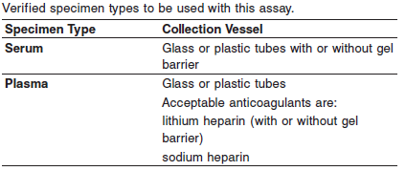

**Specimen Conditions**

Liquid anticoagulants may have a dilution effect resulting in lower concentrations for individual patient specimens.

**Specimen Storage**

Analyze fresh specimens if possible.

Avoid repeated freeze/thaw cycles.

Allow specimens to reach room temperature prior to analysis

**Serum and Plasma:**

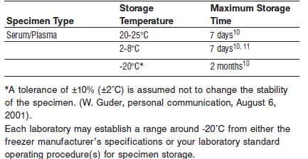

**NOTE:** Stored specimens must be inspected for particulates. If present, mix and centrifuge the specimen to remove particulates prior to testing.

**Materials and Equipment Required**

**TEST INSTRUMENT**: Abbott ARCHITECT System

**MATERIALS PROVIDED**

7D55 Alkaline Phosphatase Reagent Kit

**MATERIALS REQUIRED BUT NOT PROVIDED**

• Control Material

• Saline (0.85% to 0.90% NaCl) for specimens that require dilution

**Reagent Handling and Storage:**

***CAUTION*:**

For in vitro diagnostic use.

**CAUTION:** This product requires the handling of human specimens.

It is recommended that all human sourced materials be considered potentially infectious and be handled in accordance with the OSHA Standard on Bloodborne Pathogens. Biosafety Level 2 or other appropriate biosafety practices should be used for materials that contain or are suspected of containing infectious agents.

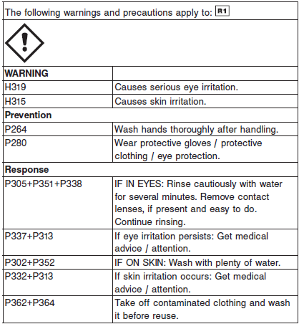

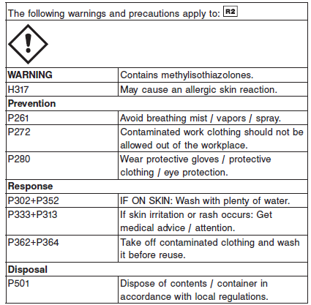

**Reagent Handling**

**•** Do not use reagents beyond the expiration date.

**•** Do not pool reagents within a kit or between kits.

**•** Do not use components from one lot with components from another lot.

**•** Remove any air bubbles present in the reagents with a new applicator stick, or allow the reagents to sit at the appropriate storage temperature to allow the bubbles to dissipate. To minimize volume depletion, do not use a transfer pipette to remove bubbles.

**CAUTION:** Bubbles may interfere with proper detection of reagent level in the cartridge and cause insufficient reagent aspiration which could impact results.

For a detailed discussion of handling precautions during system operation, refer to the ARCHITECT System Operations Manual, Section 7.

**Reagent Storage**

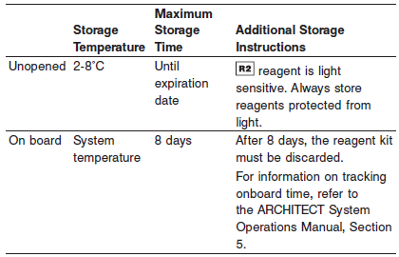

Reagents may be stored on or off the ARCHITECT cSystem.

If reagents are removed from the system, store at 2-8°C (with replacement caps) in their original boxes. When reagent is placed back on the system, run controls and if appropriate criteria are not met, recalibration may be required. For information on unloading reagents, refer to the ARCHITECT System Operations Manual, Section 5.

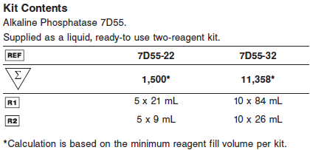

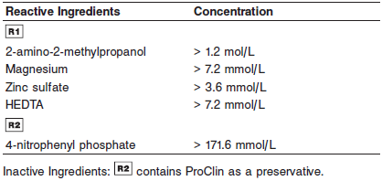

**Quality Control:** Minimum 2 levels of ChemistryControl (Normal and Abnormal)

**Calibration**

**Frequency:**

Calibration is stable for 8 days (192 hours) for any one lot.

**A new calibration is required:**

1. If quality control results do not meet acceptance criteria defined by your laboratory, patient values may be suspect. Follow the established quality control procedures for your laboratory. Recalibration may be necessary.
2. Review quality control results and acceptance criteria following a change of reagent or calibrator lot.

**Calibration Procedure:**

Calibration is stable for approximately 8 days (192 hours), but is required with each change in reagent lot. Verify calibration with at least two levels of controls according to the established quality control requirements for your laboratory. If control results fall outside

acceptable ranges, recalibration may be necessary.

A calibration factor must be entered on the Configure assay parameters window, Calibration view.

An optional IFCC (International Federation of Clinical Chemistry) factor is provided. See note in Assay Parameters. The IFCC factor provides traceability of serum and plasma sample results to the IFCC reference method.

See ARCHITECT Operations Manual for further calibration troubleshooting.

**Quality Control:**

Abbott Recommends:

**•** Two levels of controls normal and abnormal are to be run every 24 hours.

**•** If more frequent control monitoring is required, follow the established quality control procedures for your laboratory.

**•** If quality control results do not meet the acceptance criteria defined by your laboratory, patient values may be suspect. Follow the established quality control procedures for your laboratory. Recalibration may be necessary.

**•** Review quality control results and acceptance criteria following a change of reagent or calibrator lot.

**Procedure**

For a detailed description of how to run an assay, refer to *Section 5* of the **ARCHITECT System Operations Manual**.

The Alkaline Phosphatase assay file must be installed on the ARCHITECT cSystem prior to performing the assay.

For detailed information on assay file installation and viewing and editing assay parameters, refer to the ARCHITECT System Operations Manual, Section 2.

For information on printing assay parameters or for a detailed description of system procedures, refer to the ARCHITECT System Operations Manual, Section 5.

**Calculations**

Refer to *Appendix C* of the **ARCHITECT System Operations Manual** for information on results calculations.

**Reporting Results**

The Conventional result unit for the Alkaline Phosphatase assay is U/L. The corresponding SI result unit is U/L.

When converting to units other than those listed, refer to the ARCHITECT System Operations Manual, Section 2.

**Specific Performance Characteristics**

**Reference Ranges**

It is recommended that each laboratory determine its own reference range based upon its locale and population characteristics.

**Serum/Plasma:**

**0-14 days:** 83 – 248 U/L

**15 days to 11 months:** 122 – 469 U/L

**Male,**

1 to 12 years: <500 U/L

12 to 15 years: <750 U/L

>20 years 40-150 U/L

**Female**

1 to 12 years: <500 U/L

>15 years**:** 40–150 U/L

**Critical Values: N/A**

**Performance Characteristics**

**Linearity**

Alkaline Phosphatase is linear up to 2,200 U/L (2,343 U/L using IFCC factor).

Flex Rate Linearity is 4,555 U/L (4,851 U/L using IFCC factor). To use Flex Rate Linearity, the operator must edit the linear high value to 4,555 U/L (4,851 U/L if using IFCC factor) on the Configure assay parameters window, Results view.

**Dilution:**

Specimens with alkaline phosphatase values exceeding the 2,200 U/L (4,555 U/L for Flex Rate Linearity) are flagged and may be diluted by following the Manual Dilution Procedure, or the Automatic Dilution Protocol provided in the assay parameters. If an Automatic Dilution Protocol is not provided, refer to the ARCHITECT System Operations Manual, Section 2 for configuration information, and verify results according to your laboratory’s standard operating procedures.

**Automated Dilution Protocol**

When using the Automated Dilution Protocol, the system performs a dilution of the specimen and automatically corrects the enzyme activity value by multiplying the result by the appropriate dilution

factor.

**Manual Dilution Procedure**

1. Dilute the specimen with saline (0.85% to 0.90% NaCl).

2. Enter the dilution factor in the Patient or Control order screen. The system uses this dilution factor to automatically correct the concentration by multiplying the result by the entered factor. If

the operator does not enter the dilution factor, the result must be manually multiplied by the appropriate dilution factor before reporting the result.



**NOTE:** If a diluted specimen result is flagged indicating it is less than the linear low limit, do not report the result. Rerun using an appropriate dilution.

For detailed information on ordering dilutions, refer to the ARCHITECT System Operations Manual, Section 5.

**Limit of Quantitation (LOQ):** The LOQ for Alkaline Phosphatase is 5.0 U/L.

**Limit of Detection (LOD):** The LOD for Alkaline Phosphatase is 5.0 U/L.

**Limitation of Procedure:**

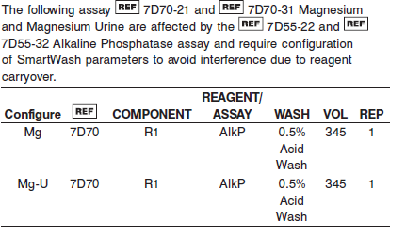

**Precision:**

The imprecision of the Alkaline Phosphatase assay is ≤ 6.2% Total CV.

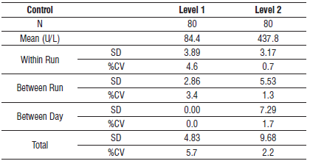

#### Interfering Substances:

**Interfering Substances**

Interference studies were conducted using CLSI protocol NCCLS EP7-P. Interference effects were assessed by Dose Response and Paired Difference methods, at the medical decision level of the analyte.

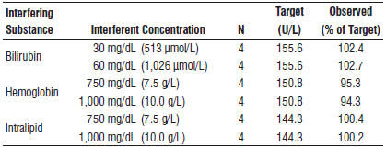

**References:**

1. ABBOTT ARCHITECT Alkaline Phosphatase package insert

Abbott Laboratories

Diagnostics Division

Abbott Park, IL 60064

March 2017 307217 / R01

1. Abbott ARCHITECT Operator’s Guide

**Related Documents:**

**Attachments:**