RUSH logo for emails

**AMYLASE**

**SERUM, PLASMA OR URINE**

**ABBOTT ARCHITECT**

**Intended Use**

The Amylase assay is used for the quantitation of amylase in human serum, plasma, or urine.

**Clinical Significance**

Normal individuals have low but measurable serum and urine α‑amylase activity which is produced in the pancreas and parotid glands.

Measurement of α-amylase activity is of value in diagnosing pancreatitis and other pancreatic disorders which result in elevation of serum and urine α-amylase activity. Numerous methods have been used for clinical analysis.

**Principle**

α-Amylase hydrolyzes the 2-chloro-4-nitrophenyl-α-*D*-maltotrioside (CNPG3) to release 2-chloro-4-nitrophenol (CPNP) and form 2‑chloro‑4‑nitrophenyl‑α‑*D*‑maltoside (CNPG2), maltotriose, and glucose. The rate of formation of the 2-chloro-4-nitrophenol can be detected spectrophotometrically at 404 nm to give a direct measurement of α‑amylase activity in the sample.

**Methodology:** CNPG3 Substrate

**Specimen Collection and Handling**

**Suitable Specimens**

Serum, plasma, and urine are acceptable specimens.

• **Serum:** Use serum collected by standard venipuncture techniques into glass or plastic tubes with or without gel barriers. Ensure complete clot formation has taken place prior to centrifugation.

Centrifuge according to tube manufacturer’s instructions to ensure proper separation of serum from blood cells.

Some specimens, especially those from patients receiving anticoagulant or thrombolytic therapy, may take longer to complete their clotting processes. Fibrin clots may subsequently form in these sera and the clots could cause erroneous test results.

• **Plasma:** Use plasma collected by standard venipuncture techniques into glass or plastic tubes. Acceptable anticoagulants are lithium heparin (with or without gel barrier) and sodium heparin. Ensure centrifugation is adequate to remove platelets. Centrifuge according to tube manufacturer’s instructions to ensure proper separation of plasma from blood cells.

• **Urine:** Collect random or timed urine specimens with no preservatives

**Specimen Storage**

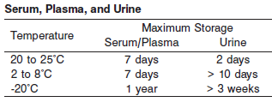

**NOTE:** Stored specimens must be inspected for particulates. If present, mix and centrifuge the specimen to remove particulates prior to testing.

**Materials and Equipment Required**

**TEST INSTRUMENT**: Abbott ARCHITECT System

**MATERIALS PROVIDED**

7D58 Amylase Reagent Kit

**MATERIALS REQUIRED BUT NOT PROVIDED**

• Control Material

• Saline (0.85% to 0.90% NaCl) for specimens that require dilution

**Reagent Handling and Storage:**

***CAUTION*:**

1. For in vitro diagnostic use.

2. Do not use components beyond the expiration date.

3. 4. Do not mix reagents prepared at different times.

**CAUTION:** This product requires the handling of human specimens.

It is recommended that all human sourced materials be considered potentially infectious and be handled in accordance with the OSHA Standard on Bloodborne Pathogens. Biosafety Level 2 or other appropriate biosafety practices should be used for materials that contain or are suspected of containing infectious agents.

The following warning and precaution apply to R1:

Contains sodium azide and potassium thiocyanate.

EUH032 Contact with acids liberates very toxic gas.

This material and its container must be disposed of in a safe way.

**Reagent Handling**

Remove air bubbles, if present in the reagent cartridge, with a new applicator stick. Alternatively, allow the reagent to sit at the appropriate storage temperature to allow the bubbles to dissipate. To minimize volume depletion, do not use a transfer pipette to remove the bubbles.

**CAUTION:** Reagent bubbles may interfere with proper detection of reagent level in the cartridge, causing insufficient reagent aspiration which could impact results.

**Reagent Storage**

Unopened reagents are stable until the expiration date when stored at 2 to 8°C.

Reagent stability is 19 days if the reagent is uncapped and onboard.

Reagent Preparation:

Amylase is supplied as a liquid, ready-to-use, reagent kit which contains: R1

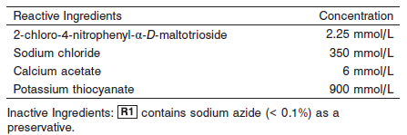

**Quality Control:** Minimum 2 levels of ChemistryControl (Normal and Abnormal), Urine Controls

**Calibration**

**Frequency:**

Calibration is stable for 19 days (456 hours) for any one lot.

**A new calibration is required:**

1. If quality control results do not meet acceptance criteria defined by your laboratory, patient values may be suspect. Follow the established quality control procedures for your laboratory. Recalibration may be necessary.
2. Review quality control results and acceptance criteria following a change of reagent or calibrator lot.

**Calibration Procedure:**

A calibration factor must be entered in the **Configure assay parameters** window, **Calibration** view.

An optional IFCC (International Federation of Clinical Chemistry) factor is provided. See note in Assay Parameters. The IFCC factor provides traceability of serum and plasma sample results to the IFCC reference method

**Troubleshooting and Overall Acceptance Criteria Failure**

See ARCHITECT Operations Manual for further calibration troubleshooting.

**Quality Control:**

Abbott recommends, refer to your laboratory standard operating procedure(s) and/or quality assurance plan for additional quality control requirements and potential corrective actions:

• Two levels of controls (normal and abnormal) are to be run every 24 hours.

Some controls may require addition of Liquid Stabilizer.

• If more frequent control monitoring is required, follow the established quality control procedures for your laboratory.

• If quality control results do not meet the acceptance criteria defined by your laboratory, patient values may be suspect. Follow the established quality control procedures for your laboratory.

Recalibration may be necessary.

• Review quality control results and acceptance criteria following a change of reagent or calibrator lot.

**Procedure**

For a detailed description of how to run an assay, refer to *Section 5* of the **ARCHITECT System Operations Manual**.

**Calculations**

Refer to *Appendix C* of the **ARCHITECT System Operations Manual** for information on results calculations.

**Reporting Results**

The result unit for the Amylase assay can be reported as U/L

**Specific Performance Characteristics**

**Reference Ranges**

It is recommended that each laboratory determine its own reference range based upon its particular locale and population characteristics.

**Serum/Plasma:**

**< 2 months:** 5.0 – 65.0 U/L

**Adult:** 23.0 – 96.0 U/L

**Urine:**

**Random:** 32.0 – 641.0 U/L

**24 hour:** 59.0 – 401.0 U/L

**Critical Values: N/A**

**Performance Characteristics**

**Linearity**

Amylase is linear up to 3,010 U/L (3,338 U/L using IFCC factor).

Flex Rate Linearity is 6,554 U/L (7,270 U/L using IFCC factor). To use Flex Rate Linearity, the operator must edit the linear high value to 4,202 on the **Configure assay** **parameters** window, **Results** view.

**Dilution:**

**Serum, Plasma, and Urine:** Specimens with amylase values exceeding 3,010 U/L (6,554 U/L for Flex Rate Linearity) are flagged and may be diluted by following either the Automated Dilution Protocol or the Manual Dilution Procedure.

**Serum/Plasma Automated Dilution Protocol**

If using the Automated Dilution Protocol, the system performs a 1:2 dilution of the specimen and automatically corrects the enzyme activity value by multiplying the result by the appropriate dilution factor.

**Urine Automated Dilution Protocol**

If using the Automated Dilution Protocol, the system performs a dilution of the specimen and automatically corrects the enzyme activity value by multiplying the result by the appropriate dilution factor. To set up the automatic dilution feature, refer to *Section 2* of the **ARCHITECT System**

**Operations Manual** for additional information. **Manual Dilution Procedure**

Manual dilutions should be performed as follows:

• Use saline (0.85% to 0.90% NaCl) to dilute the sample.

• The operator must enter the dilution factor in the patient or control order screen. The system uses this dilution factor to automatically correct the enzyme activity value by multiplying the result by the entered factor.

• If the operator does not enter the dilution factor, the result must be multiplied by the appropriate dilution factor before reporting the result.

**NOTE:** If a diluted sample result is flagged indicating it is less than the linear low limit, do not report the result. Rerun using an appropriate dilution.

For detailed information on ordering dilutions, refer to *Section 5* of the **ARCHITECT System Operations Manual**.

**Limit of Quantitation (LOQ):** The LOQ for Amylase is 2.4 U/L..

**Limit of Detection (LOD):** The LOD for Amylase is 2.0 U/L.

**Limitation of Procedure:**

N/A

**Precision:**

The imprecision of the Amylase assay is ≤ 4.6% Total CV.

Serum/Plasma:

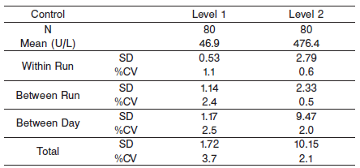

#### Urine

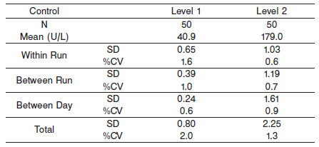

#### Interfering Substances:

**Interfering Substances**

Interference studies were conducted using CLSI protocol NCCLS EP7-P. Interference effects were assessed by Dose Response and Paired Difference methods, at the medical decision level of the analyte.

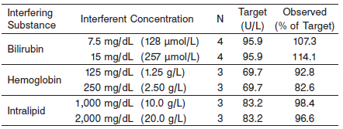

**References:**

1. ABBOTT ARCHITECT Amylase package insert

Abbott Laboratories

Diagnostics Division

Abbott Park, IL 60064

Aug 2015 306719/R04

1. Abbott ARCHITECT Operator’s Guide

**Related Documents:**

**Attachments:**