RUSH logo for emails

**UREA NITROGEN**

**SERUM, PLASMA OR URINE**

**ABBOTT ARCHITECT**

**Intended Use**

The Urea Nitrogen assay is used for the quantitation of urea nitrogen in human serum, plasma, or urine.

**Clinical Significance**

Measurements obtained by this test are used in the diagnosis of certain renal and metabolic diseases. The determination of serum urea nitrogen is a widely used test for the evaluation of kidney function. The test is frequently requested in conjunction with the serum creatinine test for the differential diagnosis of prerenal (cardiac decompensation, water depletion, increased protein catabolism), renal (glomerulonephritis, chronic nephritis, polycystic kidney, nephrosclerosis, tubular necrosis), and postrenal (obstructions of the urinary tract) hyperuremia.

**Principle**

The Urea Nitrogen assay is a modification of a totally enzymatic procedure first described by Talke and Schubert. The test is performed as a kinetic assay in which the initial rate of the reaction is linear for a limited period of time. Urea in the sample is hydrolyzed by urease to ammonia and carbon dioxide. The second reaction, catalyzed by glutamate dehydrogenase (GLD) converts ammonia and α-ketoglutarate to glutamate and water with the concurrent oxidation of reduced nicotinamide adenine dinucleotide (NADH) to nicotinamide adenine dinucleotide (NAD). Two moles of NADH are oxidized for each mole of urea present. The initial rate of decrease in absorbance at 340 nm is proportional to the urea concentration in the sample.

**Methodology:** Urease

**Specimen Collection and Handling**

Serum, plasma, and urine are acceptable specimens.

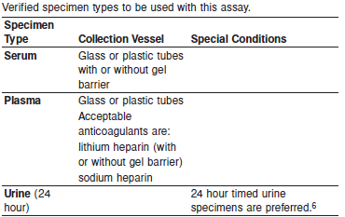

**Specimen Storage**

Analyze fresh specimens if possible.

Avoid repeated freeze/thaw cycles.

**Serum, Plasma and Urine:**

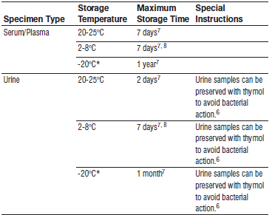

Frozen specimens must be completely thawed before mixing.

Mix thawed specimens thoroughly.

Visually inspect thawed specimens. If layering or stratification is observed, mix until specimens are visibly homogeneous. If specimens are not mixed thoroughly, inconsistent results may be obtained.

*A tolerance of +/- 10% (+/- 2°C) is assumed not to change the stability of the specimen. (W. Guder, personal communication, August 6, 2001).

Each laboratory may establish a range around -20°C from either the freezer manufacturer’s specifications or your laboratory standard operating procedure(s) for specimen storage

**NOTE:** Stored specimens must be inspected for particulates. If present, mix and centrifuge the specimen to remove particulates prior to testing.

**Materials and Equipment Required**

**TEST INSTRUMENT**: Abbott ARCHITECT System

**MATERIALS PROVIDED**

7D75 Urea Nitrogen Reagent Kit

**MATERIALS REQUIRED BUT NOT PROVIDED**

• 1E65 Multiconstituent Calibrator

• Control Material

• Saline (0.85% to 0.90% NaCl) for specimens that require dilution

**Reagent Handling and Storage:**

***CAUTION*:**

1. For in vitro diagnostic use.

2. Do not use components beyond the expiration date.

3. Do not mix reagents prepared at different times.

4. Do not pool reagents within a kit or between kits.

**CAUTION:** This product requires the handling of human specimens.

It is recommended that all human sourced materials be considered potentially infectious and be handled in accordance with the OSHA Standard on Bloodborne Pathogens. Biosafety Level 2 or other appropriate biosafety practices should be used for materials that contain or are suspected of containing infectious agents.

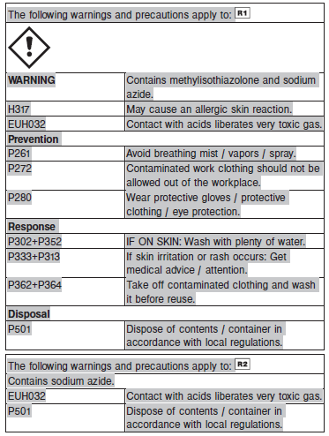

**Reagent Handling**

Remove air bubbles, if present in the reagent cartridge, with a new applicator stick. Alternatively, allow the reagent to sit at the appropriate storage temperature to allow the bubbles to dissipate. To minimize volume depletion, do not use a transfer pipette to remove the bubbles.

**CAUTION:** Reagent bubbles may interfere with proper detection of reagent level in the cartridge, causing insufficient reagent aspiration which could impact results.

**Reagent Storage**

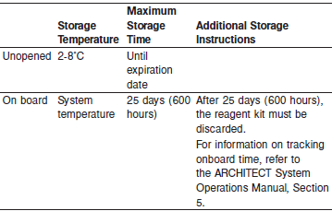

Reagents may be stored on or off the ARCHITECT cSystem.

If reagents are removed from the system, store at 2-8°C (with replacement caps) in their original boxes. When reagent is placed back on the system, run controls and if appropriate criteria are not met, recalibration may be required. For information on unloading reagents, refer to the ARCHITECT System Operations Manual, Section 5.

Reagent Preparation:

Urea Nitrogen is supplied as a liquid, ready-to-use, reagent kit which contains: R1 & R2

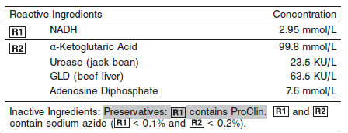

**Calibrator:** 1E65 Multiconstituent Calibrator

**Quality Control:** Minimum 2 levels of ChemistryControl (Normal and Abnormal), Urine controls

**Calibration**

**Frequency:**

Calibration is stable for 7 days (168 hours) recalibration required for each reagent lot and with each reagent cartridge change.

**A new calibration is required:**

1. If quality control results do not meet acceptance criteria defined by your laboratory, patient values may be suspect. Follow the established quality control procedures for your laboratory. Recalibration may be necessary.
2. Review quality control results and acceptance criteria following a change of reagent or calibrator lot.

**Calibration Procedure:**

Calibration is performed by running a water blank and the Multiconstituent Calibrator set. Water for the blank is provided by the instrument.

1. Verify that the correct calibrator values have been entered into the calibration file.

2. Allow calibrator to come to room temperature.

3. Mix bottle five times by gentle inversion.

4. Open bottle, place an appropriate amount of each calibrator in a separate sample cup, and place in the assigned positions.

5. Cap bottle tightly and return to refrigerated storage immediately after use.

6. Perform calibration as indicated in the **ARCHITECT System Operations Manual**.

**Troubleshooting and Overall Acceptance Criteria Failure**

See ARCHITECT Operations Manual for further calibration troubleshooting.

**Quality Control:**

Abbott recommends, refer to your laboratory standard operating procedure(s) and/or quality assurance plan for additional quality control requirements and potential corrective actions:

• Two levels of controls (normal and abnormal) are to be run every 24 hours.

Some controls may require addition of Liquid Stabilizer.

• If more frequent control monitoring is required, follow the established quality control procedures for your laboratory.

• If quality control results do not meet the acceptance criteria defined by your laboratory, patient values may be suspect. Follow the established quality control procedures for your laboratory.

Recalibration may be necessary.

• Review quality control results and acceptance criteria following a change of reagent or calibrator lot.

**Procedure**

For a detailed description of how to run an assay, refer to *Section 5* of the **ARCHITECT System Operations Manual**.

The Urea Nitrogen assay file must be installed on the ARCHITECT cSystem prior to performing the assay.

For detailed information on assay file installation and viewing and editing assay parameters, refer to the ARCHITECT System Operations Manual, Section 2.

For information on printing assay parameters or for a detailed description of system procedures, refer to the ARCHITECT System Operations Manual, Section 5.

**Calculations**

Refer to *Appendix C* of the **ARCHITECT System Operations Manual** for information on results calculations.

**Reporting Results**

The Conventional result unit for the urea nitrogen assay is mg/ dL urea nitrogen. The corresponding SI result unit is mmol/L urea.

To convert mg/dL urea nitrogen to mmol/L urea, multiply mg/dL urea nitrogen by 0.357. To convert mmol/L urea to mg/dL urea nitrogen, divide mmol/L urea by 0.357.

**Specific Performance Characteristics**

**Reference Ranges**

It is recommended that each laboratory determine its own reference range based upon its particular locale and population characteristics.

**Serum/Plasma:**

**< 3 years:** 5.1 – 16.8 mg/dL

**< 13 years:** 7.0 – 16.8 mg/dL

**< 19 years:** 8.4 – 21.0 mg/dL

**Adult, Female <50 years:** 7.0 – 18.7 mg/dL

**Adult, Female >50 years:** 9.8 – 20.1 mg/dL

**Adult, Male <50 years:** 8.9 – 20.6 mg/dL

**Adult, Male >50 years:** 8.4 – 25.7 mg/dL

**Urine:** 1200 – 2000 mg/24 hours

**Critical Values: N/A**

**Performance Characteristics**

**Linearity**

Urea Nitrogen serum is linear up to 125 mg/dL (44.6 mmol/L urea). Urea Nitrogen urine is linear up to 1,991 mg/dL (710.8 mmol/L urea).

**Dilution:**

**Serum and Plasma:** Specimens with urea nitrogen values exceeding 125 mg/dL (44.6 mmol/L urea) are flagged and may be diluted by following either the Automated Dilution Protocol or the Manual Dilution Procedure.

**Urine:** Urine samples are automatically diluted 1:20 by the system using the Standard dilution option, then the system automatically corrects the concentration by multiplying the result by the appropriate dilution factor. This dilution extends urine urea nitrogen linearity to 1,991 mg/dL

(710.8 mmol/L urea). Samples exceeding this concentration are flagged and may be diluted by following either the Automated Dilution Protocol or the Manual Dilution Procedure.

**Serum/Plasma Automated Dilution Protocol**

If using the Automated Dilution Protocol, the system performs a 1:5 dilution of the specimen and automatically corrects the concentration by multiplying the result by the appropriate dilution factor.

**Urine Automated Dilution Protocol**

If using the Automated Dilution Protocol, the system performs a dilution of the specimen and automatically corrects the concentration by multiplying the result by the appropriate dilution factor. To set up the automatic dilution feature, refer to *Section 2* of the **ARCHITECT System**

**Operations Manual** for additional information.

**Manual Dilution Procedure**

Manual dilutions should be performed as follows:

• Use saline (0.85% to 0.90% NaCl) to dilute the sample.

• The operator must enter the dilution factor in the patient or control order screen. The system uses this dilution factor to automatically correct the concentration by multiplying the result by the entered factor.

• If the operator does not enter the dilution factor, the result must be multiplied by the appropriate dilution factor before reporting the result.

**NOTE:** If a diluted sample result is flagged indicating it is less than the linear low limit, do not report the result. Rerun using an appropriate dilution.

**Limit of Detection (LOD):** The LOD for Urea Nitrogen serum is 0.7 mg/dL (0.25 mmol/L urea).

The LOD for Urea Nitrogen urine is 15.0 mg/dL (5.4 mmol/L urea).

**Limit of Quantitation (LOQ):** The LOQ for Urea Nitrogen serum is 1.4 mg/dL (0.50 mmol/L urea). The LOQ for Urea Nitrogen urine is 40.0 mg/dL (14.28 mmol/L urea).

**Limitation of Procedure:**

N/A

**Precision:**

**Serum/Plasma**

The imprecision of the Urea Nitrogen serum assay is ≤ 4.5% Total CV.

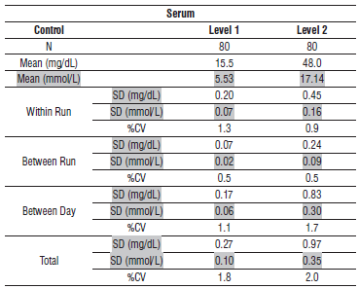

**Urine**

The imprecision of the Urea Nitrogen urine assay is ≤ 4.5% Total CV.

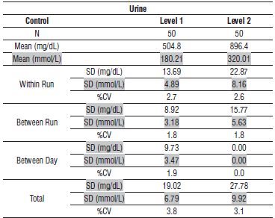

#### Interfering Substances:

**Interfering Substances**

Interference studies were conducted using CLSI protocol NCCLS EP7‑P. Interference effects were assessed by Dose Response and Paired Difference methods, at the medical decision level of the analyte.

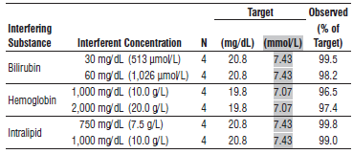

**References:**

1. ABBOTT ARCHITECT Urea Nitrogen package insert

Abbott Laboratories

Diagnostics Division

Abbott Park, IL 60064

Nov 2015 306779 / R04

1. ABBOTT Multiconstituent Calibrator

Abbott Laboratories

Diagnostics Division

Abbott Park, IL 60064

June 2013 306297/R04

1. Abbott ARCHITECT Operator’s Guide

**Related Documents:**

**Attachments:**