RUSH logo for emails

**TOTAL BILIRUBIN**

**SERUM OR PLASMA**

**ABBOTT ARCHITECT**

**Intended Use**

The Total Bilirubin assay is used for the quantitation of total bilirubin in human serum or plasma of adults and neonates on the ARCHITECT cSystems.

Measurement of total bilirubin, an organic compound formed during the normal and abnormal destruction of red blood cells, is used in the diagnosis and treatment of liver, hemolytic, hematological and metabolic disorders, including hepatitis and disorders of the biliary tract.

Total bilirubin in neonates is also known as neonatal bilirubin. The Total Bilirubin assay is intended to measure the levels of bilirubin in the serum or plasma of newborn infants for use in the diagnosis and management of neonatal jaundice and hemolytic disease of the newborn.

**Clinical Significance**

Bilirubin is a degradation product of hemoglobin and other hemecontaining compounds. There are four principle forms of bilirubin in the serum: unconjugated, mono-, and di-glucuronide conjugated, and δ-bilirubin. The unconjugated form, which is mostly insoluble in water, is transported to the liver by albumin. Once in the liver, unconjugated bilirubin is made water soluble by conjugation with glucuronic acid, forming the mono- and di-glucuronide conjugated species.

These conjugated species are mostly excreted with bile. However, conjugated bilirubin can also react with albumin forming δ-bilirubin.

Conjugated bilirubin is often called direct bilirubin. Unconjugated bilirubin, which is the difference between total and direct bilirubin, is often referred to as indirect bilirubin. Direct bilirubin assays measure conjugated bilirubin fractions (mono- and di-glucuronide, and δ-bilirubin). However, when the concentration of unconjugated bilirubin is high the direct assay may overestimate the conjugated bilirubin concentration due to cross-reactions within the assay.

Neonatal bilirubin quantitation is used to monitor diseases causing jaundice in the newborn. Physiologic jaundice is seen at serum bilirubin concentrations from 7 to 17 mg/dL (119.7 to 290.7 μmol/L), and serum bilirubin concentrations greater than 17 mg/dL (290.7 μmol/L) may be pathologic for an average full-term newborn infant. In addition, there is concern for bilirubin encephalopathy or kernicterus (the yellow staining of the basal ganglia observed in infants), and erythroblastosis fetalis (also called hemolytic disease of the newborn or HDN) which is caused by maternal alloimmunization to RhD, antibodies involving additional blood groups, and ABO incompatibility.

Additional causes of neonatal jaundice are hematoma/hemorrhage, hypothyroidism, Crigler-Najjar syndrome, obstructive jaundice, galactosemia, sepsis, syphilis, toxoplasmosis, cytomegalovirus, rubella, glucose‑6‑phosphate dehydrogenase (G-6-PDH) deficiency, pyruvate kinase deficiency, and spherocytosis.

**Principle**

Total (conjugated and unconjugated) bilirubin couples with a diazo reagent in the presence of a surfactant which acts as a solubilizing agent to form azobilirubin. The increase in absorbance at

548 nm due to azobilirubin is directly proportional to the total bilirubin concentration.

**Methodology:** Diazonium Salt

**Specimen Collection and Handling**

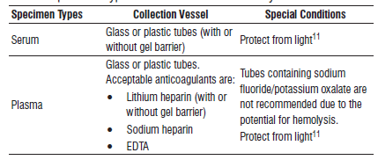

**•** Some specimens, especially those from patients receiving anticoagulant or thrombolytic therapy, may take longer to complete the clotting processes. Fibrin clots may subsequently form in these specimens, and the clots could cause erroneous test results.

**•** Liquid anticoagulants may have a dilution effect resulting in lower concentrations for individual patient samples.

**•** Tubes containing sodium fluoride/potassium oxalate are not recommended due to the potential for hemolysis.

**•** Other specimen types, collection tube types, and anticoagulants have not been verified with this assay.

Do not use specimens with fibrin.

**Specimen Storage**

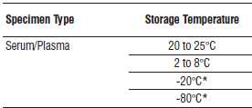

* Limitations of laboratory equipment make it necessary, in practice, for clinical laboratories to establish a range around -20°C and/or -80 °C for specimen storage.

**NOTE:** Stored specimens must be inspected for particulates. If present, mix and centrifuge the specimen to remove particulates prior to testing.

**Materials and Equipment Required**

**TEST INSTRUMENT**: Abbott ARCHITECT System

**MATERIALS PROVIDED**

Total Bilirubin 7P32 Reagent Kit

**MATERIALS REQUIRED BUT NOT PROVIDED**

**•** 1E66 Bilirubin Calibrator

**•** Control Material

**•** Saline (0.85% to 0.90% NaCl) for specimens that require dilution

**Reagent Handling and Storage:**

***CAUTION*:**

For in vitro diagnostic use.

**CAUTION:** This product requires the handling of human specimens.

It is recommended that all human sourced materials be considered

potentially infectious and be handled in accordance with the OSHA

Standard on Bloodborne Pathogens. Biosafety Level 2 or other appropriate biosafety practices should be used for materials that contain or are suspected of containing infectious agents.

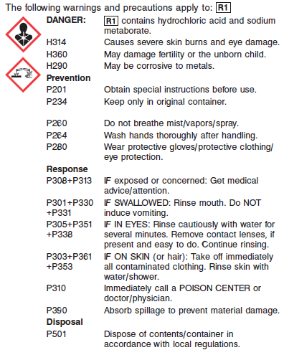

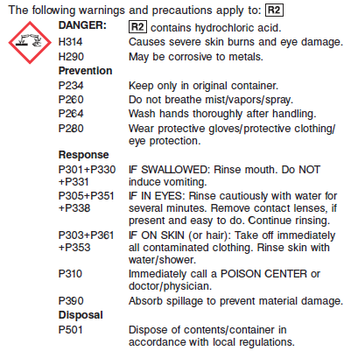

**Reagent Handling**

**•** Do not use reagent kits beyond the expiration date.

**•** Do not pool reagents within a kit or between kits.

**•** Do not use components from one lot with components from another lot.

**•** When either the R1 or R2 reagent cartridge becomes empty, replace both cartridges and validate the system by analyzing controls.

**• Do not invert reagent cartridges prior to use. Reagents are susceptible to the formation of foam.**

**•** Remove any air bubbles present in the reagent cartridge with a new applicator stick, or allow the reagents to sit at the appropriate storage temperature to allow the bubbles to dissipate.

To minimize volume depletion, do not use a transfer pipette to remove bubbles.

**CAUTION:** Bubbles may interfere with proper detection of reagent level in the cartridge and cause insufficient reagent aspiration which could impact results.

**Reagent Storage**

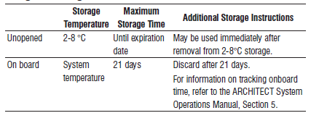

Reagent Preparation:

Total Bilirubin 7P32 Supplied as liquid, ready-to-use, two-reagent kit.

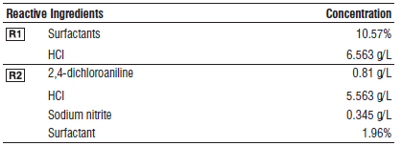

**Calibrator:** 1E66 Bilirubin Calibrator

**Quality Control:** Minimum 2 levels of ChemistryControl (Normal and Abnormal)

**Calibration**

**Frequency:**

Calibration is stable for 21 days (504 hours) for any one lot. Calibration is required with each change in reagent lot number.

**A new calibration is required:**

1. If quality control results do not meet acceptance criteria defined by your laboratory, patient values may be suspect. Follow the established quality control procedures for your laboratory. Recalibration may be necessary.
2. Review quality control results and acceptance criteria following a change of reagent or calibrator lot.

**Calibrator Required:** 1E66 Bilirubin Calibrator

**Reagents:**

Bilirubin Calibrator is prepared in a bovine serum-based solution. Analyte levels are adjusted with bilirubin extracts and synthetic derivatives. Preservatives are also present.

**Calibrator Preparation:**

Bilirubin Calibrator requires no preparation prior to use.

**Calibration Procedure:**

Calibration is performed by running a water blank and the Bilirubin Calibrator set. Water for the blank is provided by the instrument.

1. Verify that the correct calibrator values have been entered into the calibration file.

2. Allow calibrator to come to room temperature.

3. Mix bottle several times by gentle inversion.

4. Open bottle, place an appropriate amount of each calibrator in a separate sample cup, and place in the assigned positions.

5. Cap bottle tightly and return to refrigerated storage immediately after use.

6. Perform calibration as indicated in the **ARCHITECT System Operations Manual**.

**Troubleshooting and Overall Acceptance Criteria Failure**

See ARCHITECT Operations Manual for further calibration troubleshooting.

**Quality Control:**

Abbott recommends, refer to your laboratory standard operating procedure(s) and/or quality assurance plan for additional quality control requirements and potential corrective actions:

• Two levels of controls (normal and abnormal) are to be run every 24 hours.

• If more frequent control monitoring is required, follow the established quality control procedures for your laboratory.

• If quality control results do not meet the acceptance criteria defined by your laboratory, patient values may be suspect. Follow the established quality control procedures for your laboratory.

Recalibration may be necessary.

• Review quality control results and acceptance criteria following a change of reagent or calibrator lot.

**Procedure**

For a detailed description of how to run an assay, refer to *Section 5* of the **ARCHITECT System Operations Manual**.

**Calculations**

Refer to *Appendix C* of the **ARCHITECT System Operations Manual** for information on results calculations.

**Reporting Results**

The result unit for the Total Bilirubin assay can be reported as mg/dL or umol/L.

**Specific Performance Characteristics**

**Reference Ranges**

It is recommended that each laboratory determine its own reference range based upon its particular locale and population characteristics.

**Serum/Plasma:**

**< 1 day:** 0.0 – 6.0 mg/dL

**< 2 days:** 0.0 – 10.0 mg/dL

**< 5 days:** 0.0 – 12.0 mg/dL

**< 1 week:** 0.0 – 10.0 mg/dL

**Adult:** 0.2 – 1.2 mg/dL

**Critical Values:**

**< 1 day:** >8.0

**< 2 days:** >18

**< 5 days:** >18

**< 1 week:** >18

**Adult:** >30

**Performance Characteristics**

**Measuring Interval**

The measuring interval for Total Bilirubin is 0.3 to 25.0 mg/dL (5.1 to 427.5 μmol/L).

**Linearity**

Total Bilirubin is linear through the measuring interval of 0.3 to 25.0 mg/dL (5.1 to 427.5 μmol/L).

**Sensitivity**

The limit of quantitation (LoQ) of the Total Bilirubin assay is < 0.3 mg/dL (5.1 μmol/L)

**Dilution:**

Serum and plasma specimens with total bilirubin values exceeding 25.0 mg/dL (427.5 μmol/L) are flagged and may be diluted by following either the Automated Dilution Protocol or the Manual Dilution Procedure.

**Automated Dilution Protocol**

If using the Automated Dilution Protocol, the system performs a 1:5 dilution of the specimen and automatically corrects the concentration by multiplying the result by the appropriate dilution factor. For more information on setting up the automatic dilution feature, refer to the

ARCHITECT System Operations Manual, Section 2.

**Manual Dilution Procedure**

Manual dilutions should be performed as follows:

1. Dilute the sample using saline (0.85% to 0.90% NaCl).

2. Enter the dilution factor in the patient or control order screen. The system uses this dilution factor to automatically correct the concentration by multiplying the result by the entered factor. If the dilution factor is not entered in the patient or control order screen, multiply the result by the appropriate dilution factor before reporting the result.

If a diluted sample result is flagged indicating it is less than the linear low limit, do not report the result. Rerun using an appropriate dilution.

For detailed information on ordering dilutions, refer to the ARCHITECT System Operations Manual, Section 5.

**Precision:**

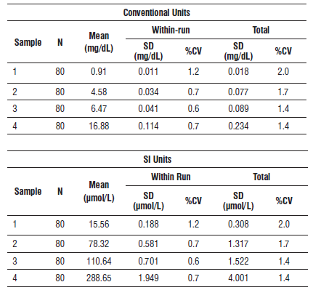

#### Limitations of Procedure

Tubes containing sodium fluoride/potassium oxalate are not recommended due to the potential for hemolysis.

Additionally, in very rare cases certain paraproteins, particularly IgM, in patients with Waldenstrom macroglobulinemia may cause unreliable and artificially elevated results. Furthermore, for patients undergoing evaluations involving the administration of indocyanine green (ICG), it is recommended that samples are drawn after ICG has been eliminated. See the Interfering substances section for additional information.

In samples where the concentration of bilirubin is low, or where conjugated bilirubin is the predominant form, the Direct Bilirubin assay may report results that are greater than results obtained using the Total Bilirubin assay. Under these circumstances, report the Total Bilirubin results for both the Total Bilirubin and Direct Bilirubin assays.

**Interfering Substances**

A bias outside of +/-10% or +/-0.2 mg/dL (+/-3.4 μmol/L) is considered significant interference.

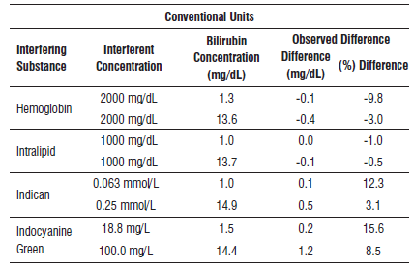

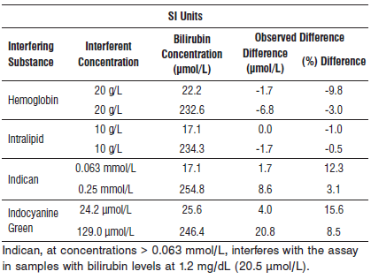

**References:**

1. ABBOTT ARCHITECT Total Bilirubin package insert

Abbott Laboratories

Diagnostics Division

Abbott Park, IL 60064

Feb 2017 G10666/R04

1. ABBOTT ARCHITECT Bilirubin Calibrator package insert

Abbott Laboratories

Diagnostics Division

Abbott Park, IL 60064

1. Abbott ARCHITECT Operator’s Guide

**Package Insert Bibliography referenced in charts:**

11. Young DS. Effects of Preanalytical Variables on Clinical Laboratory Tests, 3rd ed. Washington, DC: AACC Press; 2007:176-182.

16. Goldman L, Ausiello D editors. Cecil Medicine, 23rd ed. Philadelphia, PA: Saunders Elsevier; 2008:2984.

18. Jacobs DS, Oxley DK, editors. Laboratory Test Handbook, 5th ed. Hudson, OH: Lexi-Comp; 2001:117–118.

**Related Documents:**

**Attachments:**