RUSH logo for emails

**LACTIC ACID**

**PLASMA**

**ABBOTT ARCHITECT**

**Intended Use**

The Lactic Acid assay is used for the quantitation of lactic acid in human plasma.

**Clinical Significance**

Lactic acid and lactate are often used interchangeably, though it is understood that lactate is the deprotonated form (or conjugate base) of lactic acid. In the neutral pH of healthy persons, lactate is generally found. Lactate is a byproduct of glucose metabolism. The intermediary step in this pathway is the conversion of pyruvate to lactate by lactate dehydrogenase. Lactate is generated in red blood cells, muscle, the brain and the gut. Under normal circumstances, there is a small amount of lactate in the blood. Type A lactic acidosis is caused by insufficient oxygenation of tissues. In the decreased oxygen environment, anaerobic metabolism results. Causes include circulatory failure, trauma, and profound anemia. Type B lactic acidosis is due to overproduction of lactate or inadequate oxygen utilization. The former is most commonly associated with strenuous exertion while causes of the latter include malignancies, diabetes, severe infection and several drugs. It is worth noting that while the L isomer is generally measured in clinical practice, the D isomer which is produced by bacteria, may also be associated with clinical disease. Most clinical laboratory analyzers do not measure D-lactate.

**Principle**

Lactic acid is converted to pyruvate and hydrogen peroxide (H2O2) by lactate oxidase. Peroxidase catalyzes the oxidation of chromogen precursor by H2O2 to produce a colored dye. The increase in

absorbance at 572 nm is directly proportional to the lactic acid concentration in the sample.

Methodology: Lactic Acid to Pyruvate

For additional information on system and assay technology, refer to the ARCHITECT System Operations Manual, Section 3.

**Specimen Collection and Handling**

**Suitable Specimens**

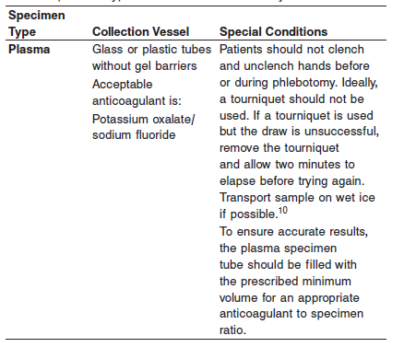

Liquid anticoagulants may have a dilution effect resulting in lower concentrations for individual patient specimens. For accurate results, plasma specimens should be free of platelets and other particulate matter. Ensure centrifugation is adequate to remove platelets.

Separated plasma may be analyzed immediately, stored at 2 to 8°C, or frozen. Store up to 3 days at 2 to 8°C or -20°C, if not analyzing immediately.

**NOTE:** Stored specimens must be inspected for particulates. If present, mix and centrifuge the specimen to remove particulates prior to testing.

**Materials and Equipment Required**

**TEST INSTRUMENT**: Abbott ARCHITECT System

**MATERIALS PROVIDED**

9P18 Lactic Acid Reagent Kit

**MATERIALS REQUIRED BUT NOT PROVIDED**

**•** 1E65 Multiconstituent Calibrator

**•** Control material

**•** Saline (0.85% to 0.90% NaCl) for specimen dilution

**Reagent Handling and Storage:**

***CAUTION*:**

1. For in vitro diagnostic use.

**CAUTION:** This product requires the handling of human specimens.

It is recommended that all human sourced materials be considered

potentially infectious and be handled in accordance with the OSHA

Standard on Bloodborne Pathogens. Biosafety Level 2 or other

appropriate biosafety practices should be used for materials that contain or are suspected of containing infectious agents.

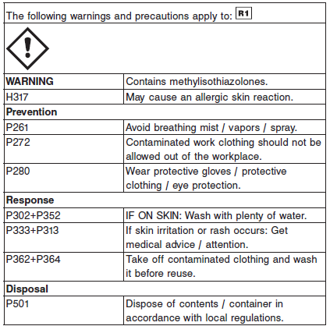

**Reagent Handling**

**•** Do not use reagents beyond the expiration date.

**•** Do not pool reagents within a kit or between kits.

**•** When the R1 reagent cartridge becomes empty, replace the cartridge and validate the system by analyzing controls.

**•** Do not invert reagent cartridges prior to use. Reagents are susceptible to the formation of foam and bubbles.

**•** Remove any air bubbles present in the reagents with a new applicator stick, or allow the reagents to sit at the appropriate storage temperature to allow the bubbles to dissipate. To minimize volume depletion, do not use a transfer pipette to remove bubbles.

**CAUTION:** Bubbles may interfere with proper detection of reagent level in the cartridge and cause insufficient reagent aspiration which could impact results.

For a detailed discussion of handling precautions during system operation, refer to the ARCHITECT System Operations Manual, Section 7.

**Reagent Storage**

Unopened reagents are stable until the expiration date when stored and handled as direct.

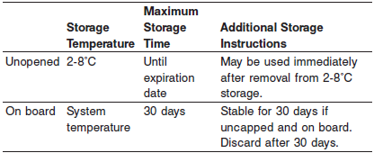

Reagent Preparation:

9P18 Lactic Acid Reagent Kit is supplied as a liquid, ready-to-use, single reagent kit

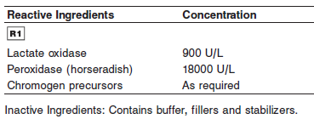

**Calibrator:** 1E65 Multiconstituent Calibrator

**Quality Control:** Minimum 2 levels of ChemistryControl

**Calibration**

**Frequency:**

Calibration is stable for 30 days (720 hours) for any one lot.

**A new calibration is required:**

1. If quality control results do not meet acceptance criteria defined by your laboratory, patient values may be suspect. Follow the established quality control procedures for your laboratory. Recalibration may be necessary.
2. Review quality control results and acceptance criteria following a change of reagent or calibrator lot.

**Calibrator Required:** 1E65 Multiconstituent Calibrator

Multiconstituent Calibrator requires no preparation prior to use.

**Reagents:**



**Calibrator Preparation:**

Non required

Store unopened Multiconstituent Calibrator upright at 2 to 8°C.

Unopened calibrator is stable until the expiration date when stored at 2 to 8°C.

Opened calibrator is stable for 7 days at 2 to 8°C or for 24 hours at 15 to 30°C if kept tightly capped.

**Calibration Procedure:**

Calibration is performed by running a water blank and the Multiconstituent Calibrator set. Water for the blank is provided by the instrument.

1. Verify that the correct calibrator values have been entered into the calibration file.

2. Allow calibrator to come to room temperature.

3. Mix bottle five times by gentle inversion.

4. Open bottle, place an appropriate amount of each calibrator in a separate sample cup, and place in the assigned positions.

5. Cap bottle tightly and return to refrigerated storage immediately after use.

6. Perform calibration as indicated in the **ARCHITECT System Operations Manual**.

**Troubleshooting and Overall Acceptance Criteria Failure**

See ARCHITECT Operations Manual for further calibration troubleshooting.

**Quality Control:**

Abbott recommends, refer to your laboratory standard operating procedure(s) and/or quality assurance plan for additional quality control requirements and potential corrective actions:

• Two levels of controls (normal and abnormal) are to be run every 24 hours.

• If more frequent control monitoring is required, follow the established quality control procedures for your laboratory.

• If quality control results do not meet the acceptance criteria defined by your laboratory, patient values may be suspect. Follow the established quality control procedures for your laboratory.

Recalibration may be necessary.

• Review quality control results and acceptance criteria following a change of reagent or calibrator lot.

**Procedure**

For a detailed description of how to run an assay, refer to *Section 5* of the **ARCHITECT System Operations Manual**.

**Calculations**

Refer to *Appendix C* of the **ARCHITECT System Operations Manual** for information on results calculations.

**Reporting Results**

ARCHITECT Lactic Acid can be reported in mg/dL or mmol/L

**Specific Performance Characteristics**

**Reference Ranges**

It is recommended that each laboratory determine its own reference range based upon its particular locale and population characteristics.

**Serum/Plasma:**

**< 2 months:** 0.6 – 6.7 mmol/L

**Adult :** 0.5 – 2.2 mmol/L

**Critical Values: < 150 years: >4.0**

**Performance Characteristics**

**Measuring Interval (Abbott Package Insert)**

The measuring interval of Lactic Acid assay is 1.5 to 120.0 mg/dL (0.17 to 13.32 mmol/L).

The measuring interval is defined as the range of values across which the limits of acceptable performance for imprecision and bias are met.

**Dilution:**

Specimens with lactic acid values exceeding 120.0 mg/dL (13.32 mmol/L) are flagged and may be diluted by following the Manual Dilution Procedure, or the Automatic Dilution Protocol provided in the assay parameters.

**Automated Dilution Protocol**

When using the Automated Dilution Protocol, the system performs a dilution of the specimen and automatically corrects the concentration by multiplying the result by the appropriate dilution factor.

**Manual Dilution Procedure**

1. Dilute the specimen with saline (0.85% to 0.90% NaCl).

2. Enter the dilution factor in the Patient or Control order screen.

The system uses this dilution factor to automatically correct the concentration by multiplying the result by the entered factor. If the operator does not enter the dilution factor, the result must be manually multiplied by the appropriate dilution factor before reporting the result.

Manual Dilution Factor =

(Volume of Specimen + Volume of Dilution Reagent)

Volume of Specimen

If a diluted specimen result is flagged indicating it is less than the linear low limit (1.5 mg/dL or 0.17 mmol/L), do not report the result. Rerun using an appropriate dilution.

For detailed information on ordering dilutions, refer to the ARCHITECT System Operations Manual, Section 5.

**Limit of Quantitation (LOQ):**

The LOQ for Lactic Acid is ≤ 1.5 mg/dL (0.17 mmol/L).

**Precision:**

The imprecision of the Lactic Acid assay is ≤ 4.0% Total CV or ≤ 0.36 mg/dL SD.

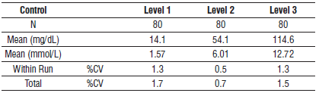

#### Limitations of Procedure

Do not use hemolyzed samples.

Samples containing elevated levels of bilirubin displayed significant interference and should not be used.

Samples containing glycolic acid displayed significant interference and should not be used. Samples containing high levels of N-acetyl- L-cysteine displayed significant interference and should not be used.

#### Interfering Substances:

**Interfering Substances**

Interference studies were conducted using some acceptance criteria of +/-10% deviation or 0.9 mg/dL (0.10 mmol/L) from the target value. Results are provided below in separate tables per conventional and SI units.

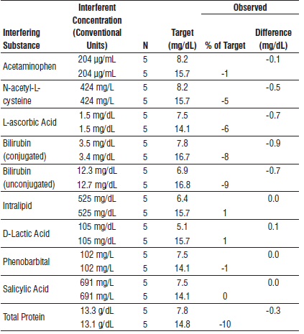

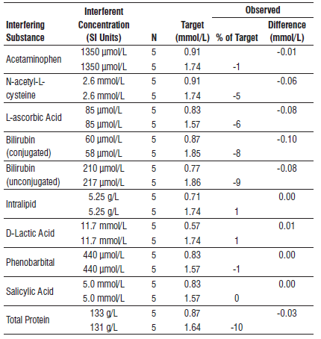

**References:**

1. ABBOTT ARCHITECT Lactic Acid package insert

Abbott Laboratories

Diagnostics Division

Abbott Park, IL 60064

Jan 2016 3036882/R03

1. ABBOTT ARCHITECT Multiconstituent Calibrator package insert

Abbott Laboratories

Diagnostics Division

Abbott Park, IL 60064

June 2013 306297/R04

1. Abbott ARCHITECT Operator’s Guide

**Related Documents:**

**Attachments:**