RUSH logo for emails

**CORE-M (IGM ANTI-HBc)**

**SERUM OR PLASMA**

**ABBOTT ARCHITECT**

**Intended Use**

The ARCHITECT CORE-M assay is a chemiluminescent microparticle immunoassay (CMIA) for the qualitative detection of IgM antibody to hepatitis B core antigen (IgM anti-HBc) in human adult and pediatric serum or plasma (dipotassium EDTA, lithium heparin, and sodium heparin) and neonatal serum. A test for IgM anti-HBc is indicated as an aid in the diagnosis of acute or recent hepatitis B virus (HBV) infection in conjunction with other laboratory results and clinical information.

**Warning: Not intended for use in screening blood, plasma, or tissue donors.** The effectiveness of ARCHITECT CORE-M for use in screening blood, plasma,or tissue donors has not been established.

Assay performance characteristics have not been established when the ARCHITECT CORE-M assay is used in conjunction with other manufacturers’ assays for specific hepatitis markers. Users are responsible for establishing their own performance characteristics. Assay performance characteristics have not been established for immunocompromised or immunosuppressed patients. The user is responsible for establishing their own assay performance characteristics in these populations.

**Clinical Significance**

Virus specific IgM antibody has been detected in most acute viral infections and is a reliable marker for acute viral disease. High levels of IgM anti-HBc have been detected in patients with acute HBV infection and low levels have been detected in some patients with chronic HBV infection. Differentiation of acute and chronic HBV infection on the basis of viral markers such as HBsAg, anti-HBs, HBeAg, anti-HBe, and anti-HBc is difficult because most of these markers are seen during both acute and chronic disease. In cases where these markers are present, acute illness with other agents such as hepatitis C, non-A, non-B, non-C hepatitis, and delta hepatitis may confuse the diagnosis. Several studies have demonstrated that IgM anti-HBc is the only specific marker for the diagnosis of acute HBV infection.

**Principle**

The ARCHITECT CORE-M assay is a two-step immunoassay for the qualitative detection of IgM anti-HBc in human serum and plasma using CMIA technology with flexible assay protocols, referred to as Chemiflex. In the first step, sample is prediluted with wash buffer. The prediluted sample and anti-human IgM (mouse monoclonal) coated paramagnetic microparticles are combined. Human IgM present in the sample binds to the anti-human IgM (mouse monoclonal) coated microparticles. After washing, the anti-HBc specific IgM binds to the acridinium-labeled recombinant hepatitis B virus core antigen (rHBcAg) conjugate that is added in the second step. Following another wash cycle, pre-trigger and trigger solutions are added to the reaction mixture. The resulting chemiluminescent reaction is measured as relative light units (RLUs). A relationship exists between the amount of IgM anti-HBc in the sample and the RLUs detected by the ARCHITECT *i* optics.

The presence or absence of IgM anti-HBc in the specimen is determined by comparing the chemiluminescent signal in the reaction to the cutoff signal determined from an active ARCHITECT CORE-M calibration curve. For additional information on system and assay technology, refer to the ARCHITECT System Operations Manual, Section 3.

**Specimen Collection and Handling**

**Suitable Specimens**

Verified Specimen types:

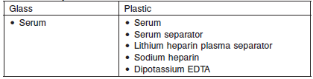

Do not use specimens with the following conditions:

• heat-inactivated

• pooled

• grossly hemolyzed

• obvious microbial contamination

• Performance has not been established for the use of cadaveric specimens or the use of body fluids other than human serum and plasma.

**Specimen Storage**

Specimens may be stored on or off the clot, red blood cells, or separator gel for

**•** up to 3 days at room temperature (study performed at 24 to 30°C) or

**•** up to 7 days at 2-8°C.

**•** If testing will be delayed more than 3 days for specimens stored at room temperature or more than 7 days for specimens stored at 2-8°C, remove serum or plasma from the clot, red blood cells, or separator gel and store at -20°C or colder.

**•** Avoid more than three freeze/thaw cycles.

**NOTE:** Stored specimens must be inspected for particulates. If present, mix and centrifuge the specimen to remove particulates prior to testing.

**Materials and Equipment Required**

**TEST INSTRUMENT**: Abbott ARCHITECT System

**MATERIALS PROVIDED**

6L23 ARCHITECT CORE-M Reagent Kit

**MATERIALS REQUIRED BUT NOT PROVIDED**

**•** ARCHITECT *i* System

**•** ARCHITECT CORE-M Assay file, may be obtained from:

**•** ARCHITECT *i* System e-Assay CD-ROM found on www.abbottdiagnostics.com

**•** ARCHITECT *i* System Assay CD-ROM

**•** 6L23-01 ARCHITECT CORE-M Calibrators

**•** 6L23-10 ARCHITECT CORE-M Controls

**•** ARCHITECT *i* Pretrigger

**•** ARCHITECT *i* Trigger

**•** ARCHITECT *i i* Wash Buffer

**•** ARCHITECT *i* Reaction Vessels

**•** ARCHITECT *i* Sample Cups

**•** ARCHITECT *i* Septums

**•** ARCHITECT *i* Replacement Caps

**•** Pipettes or pipette tips (optional) to deliver the specified volumes.

**Reagent Handling and Storage:**

***CAUTION*:**

* For in vitro diagnostic use.

**CAUTION:** This product requires the handling of human specimens.

It is recommended that all human sourced materials be considered

potentially infectious and be handled in accordance with the OSHA

Standard on Bloodborne Pathogens. Biosafety Level 2 or other appropriate biosafety practices should be used for materials that contain or are suspected of containing infectious agents.

The Microparticles contain sodium azide. Contact with acids liberates very toxic gas. This material and its container must be disposed of in a safe way.

**Reagent Handling**

* Do not use reagent kits beyond the expiration date.
* **Do not pool reagents within a kit or between reagent kits.**
* Before loading the reagent kit on the system for the first time, the microparticle bottle requires mixing to resuspend microparticles that have settled during shipment.
* **Septums MUST be used to prevent reagent evaporation and contamination and to ensure reagent integrity. Reliability of assay results cannot be guaranteed if septums are not used according to the instructions in the package insert.**
* To avoid contamination, wear clean gloves when placing a septum on an uncapped reagent bottle.
* Once a septum has been placed on the reagent bottle, **do not invert the bottle** as this will result in reagent leakage and maycompromise assay results.
* Over time, residual liquids may dry on the septum surface. These are typically dried salts and have no effect on assay efficacy.
* For a detailed discussion of handling precautions during system operation, refer to the ARCHITECT System Operations Manual, Section 7.

**Reagent Storage**

**•** The ARCHITECT CORE-M Reagent Kit must be stored at 2‑8°C in an upright position and may be used immediately after removal from 2‑8°C storage.

**•** When stored and handled as directed, the reagents are stable until the expiration date.

**•** The ARCHITECT CORE-M Reagent Kit may be stored on board the ARCHITECT *i* System for a maximum of 30 days. After 30 days, the reagent kit must be discarded. For information on tracking onboard time, refer to the ARCHITECT System Operations Manual, Section 5.

* Reagents may be stored on or off the ARCHITECT *i* System. If reagents are removed from the system, store them at 2-8°C (with septums and replacement caps) in an upright position. For reagents stored off the system, it is recommended that they be stored in their original trays and boxes to ensure they remain upright. **If the microparticle bottle does** **not remain upright (with a septum installed) while in refrigerated** **storage off the system, the reagent kit must be discarded.** For information on unloading reagents, refer to the ARCHITECT System Operations Manual, Section 5.

Reagents

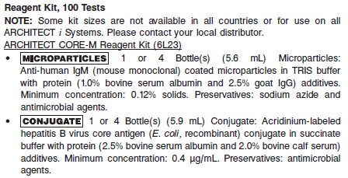

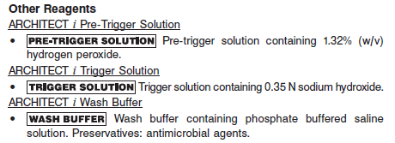

**Calibrator:** 6L23-01 ARCHITECT CORE-M Calibrators

**Quality Control:** 6L23-10 ARCHITECT CORE-M Controls or other control material

**Calibration**

**Frequency:**

Recalibration is required with each new reagent lot number.

**A new calibration is required:**

1. If quality control results do not meet acceptance criteria defined by your laboratory, patient values may be suspect. Follow the established quality control procedures for your laboratory. Recalibration may be necessary.
2. Review quality control results and acceptance criteria following a change of reagent or calibrator lot.

**Calibrator Required:** 6L23-01 ARCHITECT CORE-M Calibrators

The ARCHITECT *i* System calculates the cutoff Relative Light Units (RLU) from the mean chemiluminescent signal of three replicates each of calibrator 1 and calibrator 2. The acceptability of the calibration is assessed against a parameter. If the calibration is acceptable, the cutoff RLU is calculated as follows:

Cutoff RLU = [(Calibrator 2 Mean RLU - Calibrator 1 Mean RLU) x 0.75] + Calibrator 1 Mean RLU

The acceptable calibration is stored by the ARCHITECT *i* System for use with any reagent kit of that lot. The calibration should be used in conjunction with control ranges to determine the validity of the calibration.

**Reagents:**

2 Bottles (4 mL each) ARCHITECT CORE-M Calibrators (1 bottle of calibrator 1 and 1 bottle of calibrator 2).

**•** Calibrator 1 is recalcified IgM anti-HBc negative human plasma. Preservatives: ProClin 950, ProClin 300, and other antimicrobial agents.

**•** Calibrator 2 is IgM anti-HBc positive human plasma in recalcified IgM anti-HBc negative human plasma. Preservatives: ProClin 950, ProClin 300, and other antimicrobial agents.

**Calibrator Preparation:**

The calibrator is liquid ready-to-use. No preparation is required.

**Calibration Procedure:**

To perform an ARCHITECT Core-M calibration, test calibrator 1 and 2 inreplicates of 3. The calibrator should be priority loaded.

* A single sample of each control level must be tested to evaluate the assay calibration.
* Order controls as described in the Assay Procedure section.
* Ensure that assay control values are within the ranges specified in the control package insert.

**Troubleshooting and Overall Acceptance Criteria Failure**

See ARCHITECT Operations Manual for further calibration troubleshooting.

**Quality Control:**

The ARCHITECT Core-M Controls are in a serum matrix made from recalcified plasma.

Abbott recommends, refer to your laboratory standard operating procedure(s) and/or quality assurance plan for additional quality control requirements and potential corrective actions:

• At a minimum a single level of quality control are to be run every 24 hours

• If more frequent control monitoring is required, follow the established quality control procedures for your laboratory.

• If quality control results do not meet the acceptance criteria defined by your laboratory, patient values may be suspect. Follow the established quality control procedures for your laboratory.

Recalibration may be necessary.

• Review quality control results and acceptance criteria following a change of reagent or calibrator lot.

**Instrument Procedure**

* The ARCHITECT Core-M assay is designed for use on the ARCHITECT *i* System.
* The ARCHITECT Core-M assay file must be installed on the ARCHITECT *i* System from an ARCHITECT *i* System Assay CD-ROM prior to performing the assay. For detailed information on assay file installation and on viewing and editing assay parameters, refer to the ARCHITECT System Operations Manual, Section 2.
* For detailed information on assay file installation and viewing and editing assay parameters, refer to the ARCHITECT System Operations Manual, Section 2.
* For information on printing assay parameters, refer to the ARCHITECT System Operations Manual, Section 5.
* For a detailed description of system procedures, refer to the ARCHITECT System Operations Manual.

**Assay Procedure**

For a detailed description of how to run an assay, refer to *Section 5* of the **ARCHITECT System Operations Manual**.

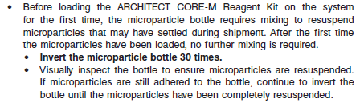

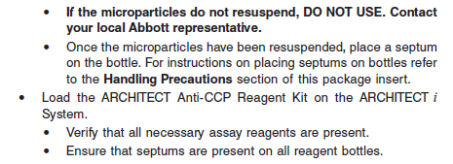

**•** Load the reagent kit on the ARCHITECT *i* System.

**•** Verify that all necessary reagents are present.

**•** Ensure that septums are present on all reagent bottles.

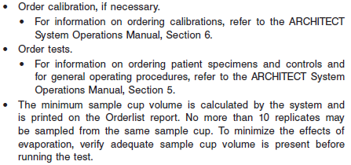

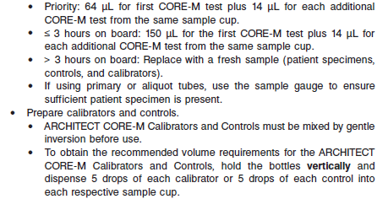

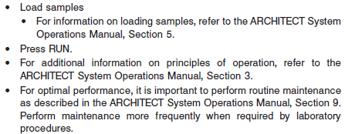

**Results**

**Calculations**

The ARCHITECT *i* System calculates the cutoff RLU from the mean chemiluminescent signal of three CORE-M Calibrator 1 and Calibrator 2 replicates and stores the result.

Cutoff RLU = [(Calibrator 2 Mean RLU - Calibrator 1 Mean RLU) x 0.75] + Calibrator 1 Mean RLU

**•** The ARCHITECT *i* System calculates the S/CO result for each specimen and control as follows:

S/CO = Sample RLU/Cutoff RLU ratio

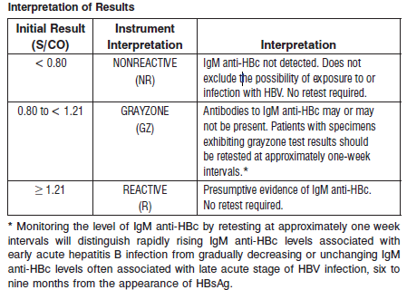

**Flags**

Some results may contain information in the Flags field. For a description of the flags that may appear in this field, refer to the ARCHITECT System Operations Manual, Section 5.

**Specific Performance Characteristics**

**Expected Values**

It is recommended that each laboratory determine its own reference range based upon its particular locale and population characteristics.

**Serum/Plasma:**

< 0.8 = Non reactive

0.8 – 1.20 = Indeterminant

> 1.21 = Reactive

**Critical Values: N/A**

**Performance Characteristics**

**Reportable Range**

See Data in the **SPECIFIC PERFORMANCE CHARACTERISTICS** section of the package insert

**Linearity**

See Data in the **SPECIFIC PERFORMANCE CHARACTERISTICS** section of the package insert

**Sensitivity/Limit of Detection (LOD)**

See Data in the **SPECIFIC PERFORMANCE CHARACTERISTICS** section of the package insert

**Dilution:**

Specimens cannot be diluted for the ARCHITECT Core-M assay.

**Precision:**

The ARCHITECT CORE-M assay is designed to have a Total CV of < 10% for the ARCHITECT CORE-M Positive Control and a low positive panel targeted to 1.20 S/CO, and less than or equal to a total SD of 0.10 S/CO for a high negative panel targeted to 0.80 S/CO.. See reagent package insert for tables and more information.

#### Limitations of Procedure

* Specimens from patients who have received preparations of mouse monoclonal antibodies for diagnosis or therapy may contain human anti-mouse antibodies (HAMA). Specimens containing HAMA may produce anomalous values when tested with assay kits such that employ mouse monoclonal antibodies.
* Heterophilic antibodies in human serum can react with reagent immunoglobulins, interfering with *in vitro* immunoassays. Patients routinely exposed to animals or to animal serum products can be prone to this interference and anomalous results may be observed. Additional information may be required for diagnosis.
* Current methods for the detection of IgM anti-HBc may not detect all infected individuals. A nonreactive test result does not exclude the possibility of exposure to or infection with HBV.
* The ARCHITECT CORE-M assay is limited to the detection of IgM anti-HBc in human serum or plasma. It can be used to determine whether a patient has, or has recently had, acute or subclinical hepatitis B infection. Supportive clinical information, including other hepatitis B markers, should also be evaluated. The test cannot determine a patient’s immune status to hepatitis B.
* Specimens from patients with high levels of IgM (*e.g.*, specimens from patients with multiple myeloma) may show depressed values when tested with assay kits (such as ARCHITECT CORE-M) that use reagents containing anti‑human IgM.

**Interfering Substances**

At the concentrations listed below, bilirubin (conjugated and unconjugated), hemoglobin, total protein, and triglycerides showed less than 10% interference in the ARCHITECT CORE-M assay for high negative samples (S/CO range: 0.60 to 0.99) and low positive samples (S/CO range: 1.00 to 1.40):

**•** Bilirubin ≤ 20 mg/dL

**•** Hemoglobin ≤ 500 mg/dL

**•** Total Protein ≤ 12 g/dL

**•** Triglycerides ≤ 3000 mg/dL

**Specificity**

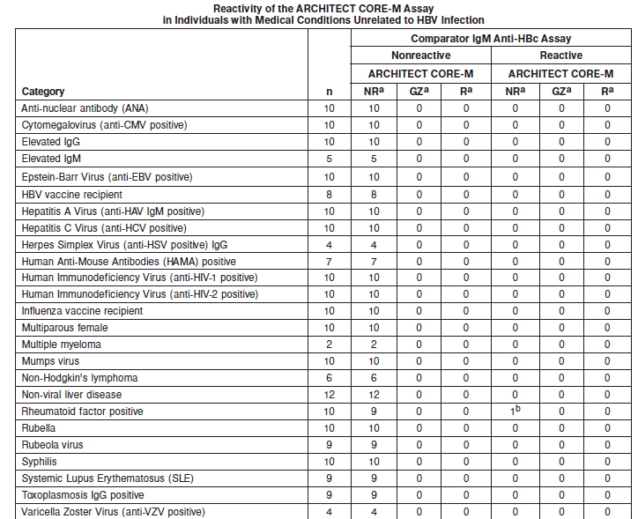

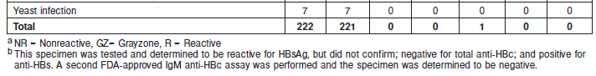

**References:**

1. ABBOTT ARCHITECT Core-M package insert

Abbott Laboratories

Diagnostics Division

Abbott Park, IL 60064

May 2012 G2-6110/ R05

1. ABBOTT ARCHITECT Core-M Calibrator package insert

Abbott Laboratories

Diagnostics Division

Abbott Park, IL 60064

1. Abbott ARCHITECT Operator’s Guide

**Related Documents:**

**Attachments:**