RUSH logo for emails

**IMMUNOGLOBULIN A (IGA)**

**SERUM OR PLASMA**

**ABBOTT ARCHITECT**

**Intended Use**

The Immunoglobulin A (IgA) assay is used for the quantitation of IgA in human serum or plasma.

**Clinical Significance**

Approximately 10% to 15% of serum immunoglobulin is IgA. Serum IgA is predominantly in a monomeric form with 10% to 15% as a dimer. Secretory IgA, found in tears, sweat, saliva, milk, colostrum, and gastrointestinal and bronchial secretions, is synthesized mainly by plasma cells in gastrointestinal and bronchial mucous membranes and lactating breast ductules. Secretory IgA is composed of two monomers linked by a secretory molecule. This secretory component protects the IgA polymer from proteolytic enzymatic degradation. IgA can initiate complement activation by the alternative pathway. Secretory IgA plays a major role in the protection of the respiratory, genitourinary, and gastrointestinal tracts against infection. The specific role of serum IgA is still unclear; it may be important in virus neutralization. Indications for serum IgA quantitation include recurrent infections, especially of the lower respiratory or gastrointestinal tract; anaphylactic transfusion reaction; diagnosis of ataxia telangiectasia; differentiation of M-components in myeloma; and evaluation of progression of IgA myeloma.

IgA does not cross the placenta and, as a result, IgA levels in infants’ sera are very low.2 Serum IgA levels do not reach adult concentrations until 12 years of age.3 Approximately one out of every 700 caucasians is genetically IgA deficient. Of these individuals, about one-fourth develop anti-IgA antibodies and are at risk of undergoing severe anaphylactic reactions to plasma or other blood product transfusions. Inherited IgA deficiency is also seen in ataxia telangiectasia and in combined immunodeficiency disorders. Individuals with absent IgA have a higher than expected incidence of rheumatic disorders and lymphoma. Secondary IgA deficiency is seen with non-IgA multiple myeloma or macroglobulinemia, and with nephrotic syndrome.

Elevated IgA levels are associated with both polyclonal (more than IgA affected) as well as monoclonal increases. Polyclonal increases include: chronic liver disease, chronic infections (especially of GI and respiratory tracts), neoplasia of lower GI tract, inflammatory bowel disease, and autoimmune diseases such as rheumatoid arthritis. Monoclonal increases include: IgA multiple myeloma and, occasionally, other lymphomas.

**Principle**

The IgA assay is an immunoturbidimetric procedure that measures increasing sample turbidity caused by the formation of insoluble immune complexes when antibody to IgA is added to the sample. Sample containing IgA is incubated with a buffer (R1) and a sample blank detefarmination is performed prior to the addition of IgA antibody (R2). In the presence of an appropriate antibody in excess, the IgA concentration is measured as a function of turbidity.

**Methodology:** Immunoturbidimetric

**Specimen Collection and Handling**

**Suitable Specimens**

Serum and plasma are acceptable specimens.

• **Serum:** Use serum collected by standard venipuncture techniques into glass or plastic tubes with or without gel barriers. Ensure complete clot formation has taken place prior to centrifugation.

Centrifuge according to tube manufacturer’s instructions to ensure proper separation of serum from blood cells.

Some specimens, especially those from patients receiving anticoagulant or thrombolytic therapy, may take longer to complete their clotting processes. Fibrin clots may subsequently form in these sera and the clots could cause erroneous test results.

• **Plasma:** Use plasma collected by standard venipuncture techniques into glass or plastic tubes. Acceptable anticoagulants are lithium heparin (with or without gel barrier), sodium heparin, and EDTA.

Ensure centrifugation is adequate to remove platelets. Centrifuge according to tube manufacturer’s instructions to ensure proper separation of plasma from blood cells.

**Specimen Storage**

**Serum and Plasma:** Analyze fresh specimens if possible. Repeated freeze/thaw cycles should be avoided to minimize potential protein degradation.

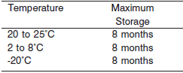

**NOTE:** Stored specimens must be inspected for particulates. If present, mix and centrifuge the specimen to remove particulates prior to testing.

**Materials and Equipment Required**

**TEST INSTRUMENT**: Abbott ARCHITECT System

**MATERIALS PROVIDED**

9D98 Immunoglobulin A Reagent Kit

**MATERIALS REQUIRED BUT NOT PROVIDED**

• 1E78 Specific Proteins Multiconstituent Calibrator

• Control Material

• Saline (0.85% to 0.90% NaCl) for specimens that require dilution

**Reagent Handling and Storage:**

***CAUTION*:**

1. For in vitro diagnostic use.

2. Do not use components beyond the expiration date.

3. Do not mix materials from different kit lot numbers.

Do not mix fresh reagent with in-use reagents.

**CAUTION:** This product requires the handling of human specimens.

It is recommended that all human sourced materials be considered

potentially infectious and be handled in accordance with the OSHA

Standard on Bloodborne Pathogens. Biosafety Level 2 or other appropriate biosafety practices should be used for materials that contain or are suspected of containing infectious agents.

• The following warning and precaution apply to R1 and R2:

Contains sodium azide.

EUH032 Contact with acids liberates very toxic gas.

P501 Dispose of contents/container in accordance with local regulations.

These materials and their containers must be disposed of in a safe way.

**Reagent Handling**

• Remove air bubbles, if present in the reagent cartridge, with a new applicator stick. Alternatively, allow the reagent to sit at the appropriate storage temperature to allow the bubbles to dissipate.

To minimize volume depletion, do not use a transfer pipette to remove the bubbles.

**CAUTION:** Reagent bubbles may interfere with proper detection of reagent level in the cartridge, causing insufficient reagent aspiration that could impact results.

**Reagent Storage**

• Reagent stability is 28 days if the reagent is uncapped and onboard.

• Unopened reagents are stable until the expiration date when stored at 2 to 8°C.

Reagent Preparation:

9D98-21 Immunoglobulin A is supplied as a liquid, ready-to-use, two-reagent kit which contains: **R1 & R2**

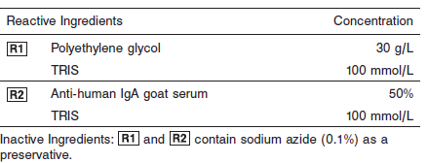

**Calibrator:** 1E78 Specific Proteins Multiconstituent Calibrator

**Quality Control:** Chemistry Controls

**Calibration**

**Frequency:**

Calibration is stable for 25 days for any one lot. Recalibration required with change in reagent lot number.

**A new calibration is required:**

1. If quality control results do not meet acceptance criteria defined by your laboratory, patient values may be suspect. Follow the established quality control procedures for your laboratory. Recalibration may be necessary.
2. Review quality control results and acceptance criteria following a change of reagent or calibrator lot.

**Calibrator Required:** 1E78 Specific Proteins Multiconstituent Calibrator

**Reagents:**

Specific Proteins Multiconstituent Calibrator is prepared from human IgA, IgG, IgM, C3, C4, haptoglobin, and transferrin fractions in human serum.

**Calibrator Preparation:**

Specific Proteins Multiconstituent Calibrator requires no preparation prior to use.

**Calibration Procedure:**

Calibration is performed by running a water blank and the Specific Proteins Multiconstituent Calibrator set. Water for the blank is provided by the instrument.

1. Verify that the correct calibrator values have been entered into the calibration file.

2. Mix bottle several times by gentle inversion.

3. Open bottle, place an appropriate amount of each calibrator in a separate sample cup, and place in the assigned positions.

4. Cap bottle tightly and return to refrigerated storage immediately after use.

5. Perform calibration as indicated in the **ARCHITECT System Operations Manual**.

**Troubleshooting and Overall Acceptance Criteria Failure**

See ARCHITECT Operations Manual for further calibration troubleshooting.

**Quality Control:**

Abbott recommends, refer to your laboratory standard operating procedure(s) and/or quality assurance plan for additional quality control requirements and potential corrective actions:

• Three levels of quality control are to be run every 24 hours

• Run three levels of quality control with each cartridge change.

• If more frequent control monitoring is required, follow the established quality control procedures for your laboratory.

• If quality control results do not meet the acceptance criteria defined by your laboratory, patient values may be suspect. Follow the established quality control procedures for your laboratory.

Recalibration may be necessary.

• Review quality control results and acceptance criteria following a change of reagent or calibrator lot.

**Procedure**

For a detailed description of how to run an assay, refer to *Section 5* of the **ARCHITECT System Operations Manual**.

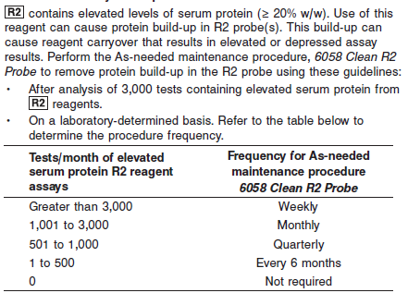

**NOTE:** Non-Abbott R2 reagents must be evaluated for inclusion in the test count calculation. This procedure is available beginning with ARCHITECT System Software v8.00. Refer to *Section 9* of the

**ARCHITECT System Operations Manual**.

Due to the genetic heterogeneity of human IgA, its reaction with antibodies is variable at higher concentrations. This affects the IgA concentration at which the phenomenon of antigen excess, or prozone, may be observed. The IgA assay uses a standard 1:5 sample dilution to avoid antigen excess. Samples with low IgA concentrations are rerun undiluted.

IgA is analyzed as follows:

• The sample is run using a 1:5 dilution.

• If a patient result flag “<” is generated, the system can be configured to automatically rerun the sample undiluted.

Refer to the Configuration instructions that follow and *Section 2* of the **ARCHITECT System Operations Manual**.

• If the system is not configured to automatically rerun the sample, a rerun must be ordered by the operator using the UNDILUTED dilution protocol.

**Configuration**

To automatically rerun the sample undiluted, perform the following steps. Refer to *Section 2* of the **ARCHITECT System Operations Manual** for additional information.

1. Select **System** from the menu bar, and then select **Configuration**.

2. Select the **Assay settings** option.

The Configuration screen - Assay settings - Assay Parameters view displays.

3. Select **Retest rules** from the **Assay categories** list on the Configuration screen.

4. Select **IgA** from the **Assays** list, and then select **F6 - Configure**.

5. Select **Add rule**.

6. Enter a name in the **Rule name** data entry box.

7. Enter the number of replicates in the **Replicates** data entry box, or leave as 1.

8. Ensure the **Result range** option is selected.

• Edit the first **Result range** data entry box to be blank.

• Enter **25** mg/dL (**0.25** g/L) in the second **Result range** data entry box.

**NOTE:** If the reporting units are changed, the Result range values must be edited with the appropriate conversion factor.

9. Select **STD (1:5)** as the **Original dilution** option.

10. Select **UNDILUTED** as the **Retest dilution** option.

11. Select **Done** to return to the Add/edit assay retest rules window.

12. Select **Done** to save your changes.

**Calculations**

Refer to *Appendix C* of the **ARCHITECT System Operations Manual** for information on results calculations.

**Reporting Results**

The result unit for the IgA assay can be reported in mg/dL.

**Specific Performance Characteristics**

**Reference Ranges**

It is recommended that each laboratory determine its own reference range based upon its particular locale and population characteristics.

**Serum/Plasma (Abbott Package Insert)**

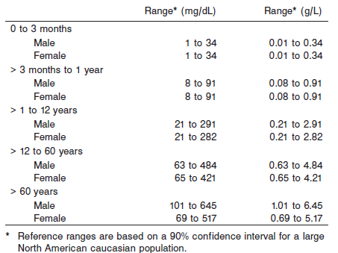

**Critical Values: N/A**

**Performance Characteristics**

**Reportable Range**

The IgA assay reportable range (analytical measurement range) is from 5 mg/dL (0.05 g/L) to five times the highest calibrator concentration.

**Limit of Quantitation (LOQ)**

The LOQ for IgA with undiluted samples is ≤ 3 mg/dL (0.03 g/L).

**Dilution: (For Samples above reportable range)**

**Serum and Plasma:** Using the Standard (1:5) sample dilution, specimens with IgA values exceeding five times the highest calibrator are flagged and may be diluted by following either the Automated Dilution Protocol or the Manual Dilution Procedure.

**Automated Dilution Protocol**

If using the Automated Dilution Protocol, the system performs a 1:10 dilution of the specimen and automatically corrects the concentration by multiplying the result by the appropriate dilution factor.

**Manual Dilution Procedure**

Manual dilutions should be performed as follows:

• Use saline (0.85% to 0.90% NaCl) to dilute the sample.

**Example:** A manual 1:4 dilution performed using the Standard 1:5 dilution will result in a 1:20 diluted sample.

• The operator must enter the manual dilution factor in the patient or control order screen. The system uses this dilution factor to automatically correct the concentration by multiplying the result by the entered factor.

• If the operator does not enter the dilution factor, the result must be multiplied by the appropriate manual dilution factor before reporting the result.

**NOTE:** If a diluted sample result is flagged indicating it is less than the linear low limit, do not report the result. Rerun using an appropriate dilution.

For detailed information on ordering dilutions, refer to *Section 5* of the **ARCHITECT System Operations Manual**.

The patient result flag “>” or error code 1054 may indicate antigen excess. Dilute sample and rerun. Samples were tested for antigen excess up to 6,270 mg/dL (62.70 g/L).

**NOTE:** Error code 1054 may result from using the Reaction Check function which is used to detect antigen excess. Refer to *Section 10* of the **ARCHITECT System Operations Manual**.

**Precision:**

The imprecision of the IgA assay is ≤ 4.1% Total CV.

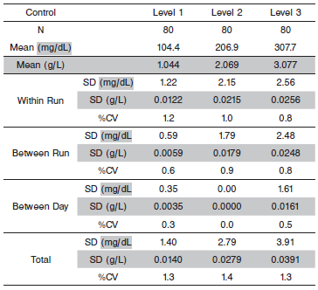

#### Limitations of Procedure

The performance characteristics of IgA on an analyzer other than the ARCHITECT *c* Systems must be validated and verified. Results from samples containing paraproteins (abnormal monoclonal antibodies) may incorrectly fall within the reference range. Samples with elevated total protein concentrations or samples from patients with suspected paraproteinemia can be screened using other laboratory methods such as protein electrophoresis. In addition, analysis of one or more diluted samples should be performed to ensure that consistent results are obtained.

Elevated fibrinogen levels in EDTA plasma samples may yield a depressed result. IgA results should be evaluated by comparing to other clinically relevant information.

R2 contains elevated levels of serum protein (≥ 20% w/w). Use of this reagent can cause protein build-up in R2 probe(s). This build-up can cause reagent carryover that results in elevated or depressed assay results. To remove protein build-up, perform the As-needed maintenance procedure, *6058 Clean R2 Probe.* Refer to the PROCEDURE section of the package insert.

**Interfering Substances**

Interference effects were assessed by Dose Response and Paired Difference methods, at two medical decision levels of the analyte.

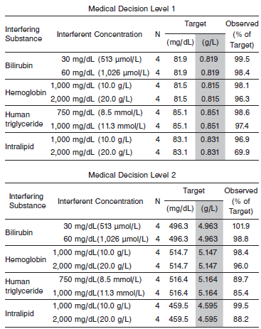

**References:**

1. ABBOTT ARCHITECT IgA package insert

Abbott Laboratories

Diagnostics Division

Abbott Park, IL 60064

Jan 2016 306774/R04

1. ABBOTT ARCHITECT Specific Proteins Multiconstituent Calibrator package insert

Abbott Laboratories

Diagnostics Division

Abbott Park, IL 60064

1. Abbott ARCHITECT Operator’s Guide

**Related Documents:**

**Attachments:**