RUSH logo for emails

**IMMUNOGLOBULIN G (IGG)**

**SERUM OR PLASMA**

**ABBOTT ARCHITECT**

**Intended Use**

The Immunoglobulin G (IgG) assay is used for the quantitation of IgG in human serum or plasma.

**Clinical Significance**

IgG is the major immunoglobulin in the blood and is produced in copious amounts during secondary immune responses. IgG molecules bind to specific receptors on phagocytic cells, such as macrophages

and polymorphonuclear leukocytes, thereby increasing the efficiency with which the phagocytic cells can ingest and destroy infecting microorganisms that have become coated with IgG antibodies in response to the infection. Additionally, IgG molecules can bind to and thereby activate the first component of the complement system, which under these circumstances unleashes a biochemical attack that kills the microorganisms. IgG molecules are the only antibodies that can pass from mother to fetus. The ability of IgG to cross the placenta provides a major line of defense against infection for the first weeks of an infant’s life. IgG is the predominant extravascular immunoglobulin and functions

to neutralize bacterial toxins and bind most types of microorganisms to\ facilitate phagocytosis. Additionally, IgG antibodies can bind to target cells such as tumor cells to sensitize them for destruction by killer (K) cells that have IgG-specific receptor sites.

Quantitation of IgG can be used to evaluate humoral immunity; establish diagnosis and monitor therapy in IgG myeloma; and evaluate patients, especially children and those with lymphoma, with propensity to infections. Reduction of IgG, usually less than 300 mg/dL (3.0 g/L), leads to susceptibility to infection due to encapsulated bacteria. IgG deficiencies may be genetic or acquired. Conditions associated with acquired IgG deficiency include thermal burns, pemphigus, nephrotic syndrome, protein-losing enteropathies, non-IgG myelomas or macroglobulinemia, pregnancy, Wiskott-Aldrich syndrome, myotonic dystrophy, anti-immunoglobulin antibodies, immunosuppressive therapy, and monoclonal gammopathies involving non-IgG immunoglobulins. IgG values in AIDS and AIDS-related complex can span the range from severe immunodeficiency to hyperimmunoglobulinemia, depending on clinical state and disease stage. Elevated IgG levels can be polyclonal, oligoclonal, or monoclonal.

Elevated polyclonal IgG levels are associated with autoimmune diseases (systemic lupus erythematosus, rheumatoid arthritis, Sjogren’s syndrome), sarcoidosis, chronic liver disease, some parasitic diseases, chronic or recurrent infections, and intrauterine contraceptive devices. Increased oligoclonal IgG levels are associated with malignancies, infections (especially in the elderly), some dysgammaglobulinemias, and autoimmune disorders. Increased monoclonal IgG levels are associated with multiple myeloma (IgG type), lymphomas, and leukemia.

**Principle**

The IgG assay is an immunoturbidimetric procedure that measures increasing sample turbidity caused by the formation of insoluble immune complexes when antibody to IgG is added to the sample. Sample containing IgG is incubated with a buffer (R1) and a sample blank determination is performed prior to the addition of IgG antibody (R2). In the presence of an appropriate antibody in excess, the IgG concentration is measured as a function of turbidity.

**Methodology:** Immunoturbidimetric

**Specimen Collection and Handling**

**Suitable Specimens**

Serum and plasma are acceptable specimens.

• **Serum:** Use serum collected by standard venipuncture techniques into glass or plastic tubes with or without gel barriers. Ensure complete clot formation has taken place prior to centrifugation.

Centrifuge according to tube manufacturer’s instructions to ensure proper separation of serum from blood cells.

Some specimens, especially those from patients receiving anticoagulant or thrombolytic therapy, may take longer to complete their clotting processes. Fibrin clots may subsequently form in these sera and the clots could cause erroneous test results.

• **Plasma:** Use plasma collected by standard venipuncture techniques into glass or plastic tubes. Acceptable anticoagulants are lithium heparin (with or without gel barrier), sodium heparin, and EDTA.

Ensure centrifugation is adequate to remove platelets. Centrifuge according to tube manufacturer’s instructions to ensure proper separation of plasma from blood cells.

**Specimen Storage**

**Serum and Plasma:** Analyze fresh specimens if possible. Repeated freeze/thaw cycles should be avoided to minimize potential protein degradation.

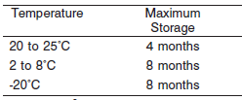

**NOTE:** Stored specimens must be inspected for particulates. If present, mix and centrifuge the specimen to remove particulates prior to testing.

**Materials and Equipment Required**

**TEST INSTRUMENT**: Abbott ARCHITECT System

**MATERIALS PROVIDED**

9D99 Immunoglobulin G Reagent Kit

**MATERIALS REQUIRED BUT NOT PROVIDED**

• 1E78 Specific Proteins Multiconstituent Calibrator

• Control Material

• Saline (0.85% to 0.90% NaCl) for specimens that require dilution

**Reagent Handling and Storage:**

***CAUTION*:**

1. For in vitro diagnostic use.

2. Do not use components beyond the expiration date.

3. Do not mix materials from different kit lot numbers.

Do not mix fresh reagent with in-use reagents.

**CAUTION:** This product requires the handling of human specimens.

It is recommended that all human sourced materials be considered

potentially infectious and be handled in accordance with the OSHA

Standard on Bloodborne Pathogens. Biosafety Level 2 or other appropriate biosafety practices should be used for materials that contain or are suspected of containing infectious agents.

• The following warning and precaution apply to R1 and R2:

Contains sodium azide.

EUH032 Contact with acids liberates very toxic gas.

P501 Dispose of contents/container in accordance with local regulations.

These materials and their containers must be disposed of in a safe way.

**Reagent Handling**

• Remove air bubbles, if present in the reagent cartridge, with a new applicator stick. Alternatively, allow the reagent to sit at the appropriate storage temperature to allow the bubbles to dissipate.

To minimize volume depletion, do not use a transfer pipette to remove the bubbles.

**CAUTION:** Reagent bubbles may interfere with proper detection of reagent level in the cartridge, causing insufficient reagent aspiration that could impact results.

**Reagent Storage**

• Reagent stability is 23 days if the reagent is uncapped and onboard.

• Unopened reagents are stable until the expiration date when stored at 2 to 8°C.

Reagent Preparation:

9D99-21 Immunoglobulin G is supplied as a liquid, ready-to-use, two-reagent kit which contains: **R1 & R2**

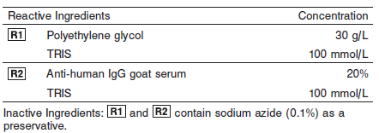

**Calibrator:** 1E78 Specific Proteins Multiconstituent Calibrator

**Quality Control:** Chemistry Controls

**Calibration**

**Frequency:**

Calibration is stable for 23 days for any one lot. Recalibration is required with each new reagent lot number.

**A new calibration is required:**

1. If quality control results do not meet acceptance criteria defined by your laboratory, patient values may be suspect. Follow the established quality control procedures for your laboratory. Recalibration may be necessary.
2. Review quality control results and acceptance criteria following a change of reagent or calibrator lot.

**Calibrator Required:** 1E78 Specific Proteins Multiconstituent Calibrator

**Reagents:**

Specific Proteins Multiconstituent Calibrator is prepared from human IgA, IgG, IgM, C3, C4, haptoglobin, and transferrin fractions in human serum.

**Calibrator Preparation:**

Specific Proteins Multiconstituent Calibrator requires no preparation prior to use.

**Calibration Procedure:**

Calibration is performed by running a water blank and the Specific Proteins Multiconstituent Calibrator set. Water for the blank is provided by the instrument.

1. Verify that the correct calibrator values have been entered into the calibration file.

2. Mix bottle several times by gentle inversion.

3. Open bottle, place an appropriate amount of each calibrator in a separate sample cup, and place in the assigned positions.

4. Cap bottle tightly and return to refrigerated storage immediately after use.

5. Perform calibration as indicated in the **ARCHITECT System Operations Manual**.

**Troubleshooting and Overall Acceptance Criteria Failure**

See ARCHITECT Operations Manual for further calibration troubleshooting.

**Quality Control:**

Abbott recommends, refer to your laboratory standard operating procedure(s) and/or quality assurance plan for additional quality control requirements and potential corrective actions:

• Three levels of quality control are to be run every 24 hours

• Run three levels of quality control with each cartridge change.

• If more frequent control monitoring is required, follow the established quality control procedures for your laboratory.

• If quality control results do not meet the acceptance criteria defined by your laboratory, patient values may be suspect. Follow the established quality control procedures for your laboratory.

Recalibration may be necessary.

• Review quality control results and acceptance criteria following a change of reagent or calibrator lot.

**Procedure**

For a detailed description of how to run an assay, refer to *Section 5* of the **ARCHITECT System Operations Manual**.

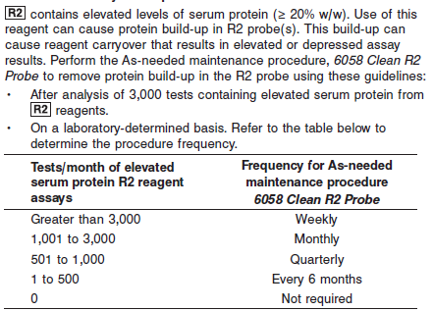

**NOTE:** Non-Abbott R2 reagents must be evaluated for inclusion in the test count calculation. This procedure is available beginning with ARCHITECT System Software v8.00. Refer to *Section 9* of the

**ARCHITECT System Operations Manual**.

The IgG assay uses a standard undiluted sample. Samples with low IgG concentrations are rerun using a 3:1 dilution (three times the sample volume).

IgG is analyzed as follows:

• The sample is run undiluted.

• If the patient result flag “<” is generated, the system can be configured to automatically rerun the sample 3:1.

Refer to the Configuration instructions that follow and *Section 2* of the **ARCHITECT System Operations Manual**.

• If the system is not configured to automatically rerun the sample, a rerun must be ordered by the operator using 3:1 dilution protocol.

**Configuration**

To automatically rerun the sample 3:1, perform the following steps.

Refer to *Section 2* of the **ARCHITECT System Operations Manual** for additional information.

1. Select **System** from the menu bar, and then select **Configuration**.

2. Select the **Assay settings** option. The Configuration screen - Assay settings - Assay Parameters view displays.

3. Select **Retest rules** from the **Assay categories** list on the Configuration screen.

4. Select **IgG** from the **Assays** list, and then select **F6 - Configure**.

5. Select **Add rule**.

6. Enter a name in the **Rule name** data entry box.

7. Enter the number of replicates in the **Replicates** data entry box, or leave as 1.

8. Ensure that the **Result range** option is selected.

• Edit the fi rst **Result range** data entry box to be blank.

• Enter **320** mg/dL (**3.20** g/L) in the second **Result range** data entry box.

**NOTE:** If the reporting units are changed, the Result range values must be edited with the appropriate conversion factor.

9. Select **STANDARD** as the **Original dilution** option.

10. Select **3:1** as the **Retest dilution** option.

11. Select **Done** to return to the Add / edit assay retest rules window.

12. Select **Done** to save your changes.

**Calculations**

Refer to *Appendix C* of the **ARCHITECT System Operations Manual** for information on results calculations.

**Reporting Results**

The result unit for the IgG assay can be reported in mg/dL.

**Specific Performance Characteristics**

**Reference Ranges**

It is recommended that each laboratory determine its own reference range based upon its particular locale and population characteristics.

**Serum/Plasma:**

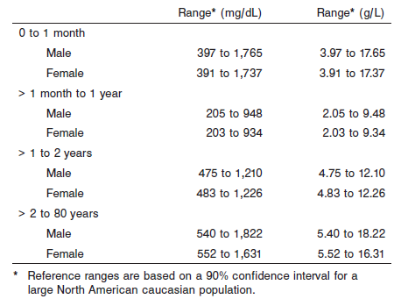

**Critical Values: N/A**

**Performance Characteristics**

**Reportable Range**

The IgG assay reportable range (analytical measurement range) is from 109 mg/dL (1.09 g/L) to 320 mg/dL (3.20 g/L) using the Dil 1 sample mode and from 320 mg/dL (3.20 g/L) to the highest calibrator concentration when using the Standard sample mode.

**Limit of Quantitation (LOQ)**

The LOQ for IgG is ≤ 61 mg/dL (0.61 g/L).

**Dilution: (For Samples above reportable range)**

**Serum and Plasma:** Specimens with IgG values exceeding the highest calibrator are flagged and may be diluted by following either the Automated Dilution Protocol or the Manual Dilution Procedure.

**Automated Dilution Protocol**

If using the Automated Dilution Protocol, the system performs a 1:4 dilution of the specimen using 1:4 and automatically corrects the concentration by multiplying the result by the appropriate dilution factor.

**Manual Dilution Procedure**

Manual dilutions should be performed as follows:

• Use saline (0.85% to 0.90% NaCl) to dilute the sample.

• The operator must enter the dilution factor in the patient or control order screen. The system uses this dilution factor to automatically correct the concentration by multiplying the result by the entered factor.

• If the operator does not enter the dilution factor, the result must be multiplied by the appropriate dilution factor before reporting the result.

**NOTE:** If a diluted sample result is flagged indicating it is less than the linear low limit, do not report the result. Rerun using an appropriate dilution.

For detailed information on ordering dilutions, refer to *Section 5* of the **ARCHITECT System Operations Manual**.

The patient result flag “>” may indicate antigen excess. Dilute sample and rerun. Samples were tested for antigen excess up to 9,482 mg/dL (94.82 g/L).

**Precision:**

The imprecision of the IgG assay is ≤ 3.4% Total CV.

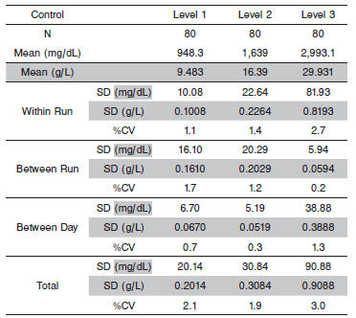

#### Limitations of Procedure

The performance characteristics of IgG on an analyzer other than the ARCHITECT *c* Systems must be validated and verified. Results from samples containing paraproteins (abnormal monoclonal antibodies) may incorrectly fall within the reference range. Samples with elevated total protein concentrations or samples from patients with suspected paraproteinemia can be screened using other laboratory methods such as protein electrophoresis. In addition, analysis of one or more diluted samples should be performed to ensure that consistent results are obtained.

Elevated fibrinogen levels in EDTA plasma samples may yield a depressed result. IgG results should be evaluated by comparing to other clinically relevant information. R2 contains elevated levels of serum protein (≥ 20% w/w). Use of this reagent can cause protein build-up in R2 probe(s). This build-up can cause reagent carryover that results in elevated or depressed assay results. To remove protein build-up, perform the As-needed maintenance procedure, *6058 Clean R2 Probe.* Refer to the PROCEDURE section of the package insert.

Turbidity and particles in the samples can interfere with the assay. Therefore, particulate matter should be removed by centrifugation prior to running the assay.

**Interfering Substances**

Interference effects were assessed by Dose Response and Paired Difference methods, at two medical decision levels of the analyte.

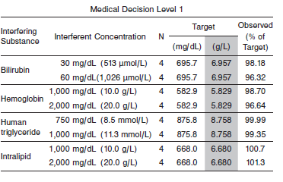

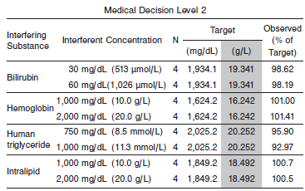

**References:**

1. ABBOTT ARCHITECT IgG package insert

Abbott Laboratories

Diagnostics Division

Abbott Park, IL 60064

Nov 2015 306775/R04

1. ABBOTT ARCHITECT Specific Proteins Multiconstituent Calibrator package insert

Abbott Laboratories

Diagnostics Division

Abbott Park, IL 60064

1. Abbott ARCHITECT Operator’s Guide

**Related Documents:**

**Attachments:**