RUSH logo for emails

**IMMUNOGLOBULIN M (IGM)**

**SERUM OR PLASMA**

**ABBOTT ARCHITECT**

**Intended Use**

The Immunoglobulin M (IgM) assay is used for the quantitation of IgM in human serum or plasma.

**Clinical Significance**

IgM, primarily present as a pentamer, is the first immunoglobulin class produced during an initial immune response and antigen-IgM complexes actively fix complement. The large molecular size of the pentamer enables direct cross-linking and agglutination of particulate and cellular antigens. Because IgM is involved in primary immune response, presence of IgM is useful in assessing whether a particular infection is acute (IgM present) or chronic (IgG predominate class present).

Additionally, IgM is the first immunoglobulin class to be synthesized by a fetus or newborn and IgM antibodies do not cross the placenta.

Polyclonal IgM increases may indicate a viral infection, such as viral hepatitis or infectious mononucleosis, or the early response to bacterial or parasitic infection. Levels are often increased in rheumatoid arthritis, chronic hepatocellular disease, and other chronic disorders.

Elevated levels are also seen with hyper-IgM dysgammaglobulinemia, active sarcoidosis, collagen vascular disease, and nephrotic syndrome. Monoclonal IgM increases are seen in Waldenstrom’s

macroglobulinemia, malignant lymphoma, reticulosis, and cold agglutinin hemolysis disease. Small IgM monoclonal bands can accompany a variety of neoplasms, particularly of the GI tract. Decreased IgM levels are usually not due to primary IgM deficiency. Secondary IgM deficiency may be associated with IgA or IgG type multiple myeloma, protein-losing enteropathies, burns, or immunosuppressive therapy. IgM deficiency is associated with increased, recurrent infections.

**Principle**

The IgM assay is an immunoturbidimetric procedure that measures increasing sample turbidity caused by the formation of insoluble immune complexes when antibody to IgM is added to the sample.

Sample containing IgM is incubated with a buffer (R1) and a sample blank determination is performed prior to the addition of IgM antibody (R2). In the presence of an appropriate antibody in excess, the IgM concentration is measured as a function of turbidity.

**Methodology:** Immunoturbidimetric

**Specimen Collection and Handling**

**Suitable Specimens**

Serum and plasma are acceptable specimens.

• **Serum:** Use serum collected by standard venipuncture techniques into glass or plastic tubes with or without gel barriers. Ensure complete clot formation has taken place prior to centrifugation.

Centrifuge according to tube manufacturer’s instructions to ensure proper separation of serum from blood cells. Some specimens, especially those from patients receiving anticoagulant or thrombolytic therapy, may take longer to complete their clotting processes. Fibrin clots may subsequently form in these sera and the clots could cause erroneous test results.

• **Plasma:** Use plasma collected by standard venipuncture techniques into glass or plastic tubes. Acceptable anticoagulants are lithium heparin (with or without gel barrier), sodium heparin, and EDTA.

Ensure centrifugation is adequate to remove platelets. Centrifuge according to tube manufacturer’s instructions to ensure proper separation of plasma from blood cells.

**Specimen Storage**

**Serum and Plasma:** Analyze fresh specimens if possible. Repeated freeze/thaw cycles should be avoided to minimize potential protein degradation.

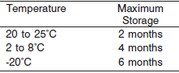

Frozen specimens must be completely thawed before mixing.

Mix thawed specimens thoroughly.

Visually inspect thawed specimens. If layering or stratification is observed, mix until specimens are visibly homogeneous. If specimens are not mixed thoroughly, inconsistent results may be obtained.

**NOTE:** Stored specimens must be inspected for particulates. If present, mix and centrifuge the specimen to remove particulates prior to testing.

**Materials and Equipment Required**

**TEST INSTRUMENT**: Abbott ARCHITECT System

**MATERIALS PROVIDED**

1E01-21 Immunoglobulin M Reagent Kit

**MATERIALS REQUIRED BUT NOT PROVIDED**

• 1E78 Specific Proteins Multiconstituent Calibrator

• Control Material

• Saline (0.85% to 0.90% NaCl) for specimens that require dilution

**Reagent Handling and Storage:**

***CAUTION*:**

1. For in vitro diagnostic use.

2. Do not use components beyond the expiration date.

3. Do not mix materials from different kit lot numbers.

Do not mix fresh reagent with in-use reagents.

**CAUTION:** This product requires the handling of human specimens.

It is recommended that all human sourced materials be considered

potentially infectious and be handled in accordance with the OSHA

Standard on Bloodborne Pathogens. Biosafety Level 2 or other appropriate biosafety practices should be used for materials that contain or are suspected of containing infectious agents.

• The following warning and precaution apply to R1 and R2:

Contains sodium azide.

EUH032 Contact with acids liberates very toxic gas.

These materials and their containers must be disposed of in a safe way.

**Reagent Handling**

• Remove air bubbles, if present in the reagent cartridge, with a new applicator stick. Alternatively, allow the reagent to sit at the appropriate storage temperature to allow the bubbles to dissipate.

To minimize volume depletion, do not use a transfer pipette to remove the bubbles.

**CAUTION:** Reagent bubbles may interfere with proper detection of reagent level in the cartridge, causing insufficient reagent aspiration that could impact results.

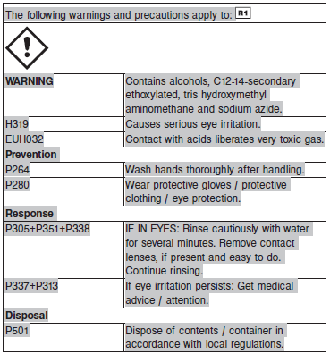

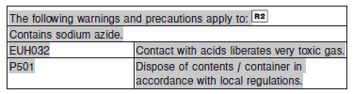

**Reagent Storage**

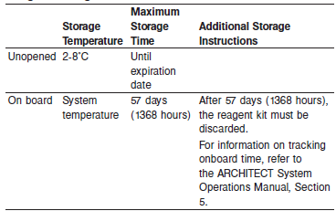

Reagents may be stored on or off the ARCHITECT cSystem.

If reagents are removed from the system, store at 2-8°C (with replacement caps) in their original boxes. When reagent is placed back on the system, run controls and if appropriate criteria are not met, recalibration may be required. For information on unloading reagents, refer to the ARCHITECT System Operations Manual, Section 5.

Reagent Preparation:

1E01-21 Immunoglobulin M is supplied as a liquid, ready-to-use, two-reagent kit which contains: **R1 & R2**

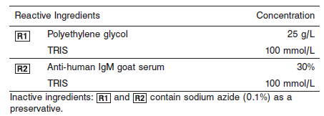

**Calibrator:** 1E78 Specific Proteins Multiconstituent Calibrator

**Quality Control:** Chemistry Controls

**Calibration**

**Frequency:**

Calibration is stable for 57 days for any one lot. Recalibration is required with each new reagent lot number.

**A new calibration is required:**

1. If quality control results do not meet acceptance criteria defined by your laboratory, patient values may be suspect. Follow the established quality control procedures for your laboratory. Recalibration may be necessary.
2. Review quality control results and acceptance criteria following a change of reagent or calibrator lot.

**Calibrator Required:** 1E78 Specific Proteins Multiconstituent Calibrator

**Reagents:**

Specific Proteins Multiconstituent Calibrator is prepared from human IgA, IgG, IgM, C3, C4, haptoglobin, and transferrin fractions in human serum.

**Calibrator Preparation:**

Specific Proteins Multiconstituent Calibrator requires no preparation prior to use.

**Calibration Procedure:**

Calibration is performed by running a water blank and the Specific Proteins Multiconstituent Calibrator set. Water for the blank is provided by the instrument.

1. Verify that the correct calibrator values have been entered into the calibration file.

2. Mix bottle several times by gentle inversion.

3. Open bottle, place an appropriate amount of each calibrator in a separate sample cup, and place in the assigned positions.

4. Cap bottle tightly and return to refrigerated storage immediately after use.

5. Perform calibration as indicated in the **ARCHITECT System Operations Manual**.

**Troubleshooting and Overall Acceptance Criteria Failure**

See ARCHITECT Operations Manual for further calibration troubleshooting.

**Quality Control:**

Abbott recommends, refer to your laboratory standard operating procedure(s) and/or quality assurance plan for additional quality control requirements and potential corrective actions:

• Three levels of quality control are to be run every 24 hours

• Run three levels of quality control with each cartridge change.

• If more frequent control monitoring is required, follow the established quality control procedures for your laboratory.

• If quality control results do not meet the acceptance criteria defined by your laboratory, patient values may be suspect. Follow the established quality control procedures for your laboratory.

Recalibration may be necessary.

• Review quality control results and acceptance criteria following a change of reagent or calibrator lot.

**Procedure**

For a detailed description of how to run an assay, refer to *Section 5* of the **ARCHITECT System Operations Manual**.

The IgM assay file must be installed on the ARCHITECT cSystem prior to performing the assay.

For detailed information on assay file installation and viewing and editing assay parameters, refer to the ARCHITECT System Operations Manual, Section 2.

For information on printing assay parameters or for a detailed description of system procedures, refer to the ARCHITECT System Operations Manual, Section 5.

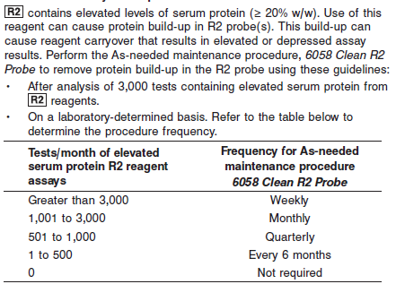

**NOTE:** Non-Abbott R2 reagents must be evaluated for inclusion in the test count calculation. This procedure is available beginning with ARCHITECT System Software v8.00. Refer to *Section 9* of the

**ARCHITECT System Operations Manual**.

Due to the genetic heterogeneity of human IgM, its reaction with antibodies is variable at higher concentrations. This affects the IgM concentration at which the phenomenon of antigen excess, or prozone, may be observed. The IgM assay uses a standard 1:5 sample dilution

to avoid antigen excess. Samples with low IgM concentrations are rerun undiluted.

IgM is analyzed as follows:

• The sample is run using a 1:5 dilution.

• If the patient result flag “<” is generated, the system can be configured to automatically rerun the sample undiluted. Refer to the Configuration instructions that follow and *Section 2* of the **ARCHITECT System Operations Manual**.

• If the system is not configured to automatically rerun the sample, a rerun must be ordered by the operator by following the UNDILUTED dilution protocol.

**Configuration**

To automatically rerun the sample undiluted, perform the following steps. Refer to *Section 2* of the **ARCHITECT System Operations Manual** for additional information.

1. Select **System** from the menu bar, and then select **Configuration**.

2. Select the **Assay settings** option. The Configuration screen - Assay settings - Assay Parameters view displays.

3. Select **Retest rules** from the **Assay categories** list on the Configuration screen.

4. Select **IgM** from the **Assays** list, and then select **F6 - Configure**.

5. Select **Add rule**.

6. Enter a name in the **Rule name** data entry box.

7. Enter the number of replicates in the **Replicates** data entry box, or leave as 1.

8. Ensure the **Result range** option is selected.

• Edit the first **Result range** data entry box to be blank.

• Enter **25** mg/dL (**0.25** g/L) in the second **Result range** data entry box.

**NOTE:** If the reporting units are changed, the Result range values must be edited with the appropriate conversion factor.

9. Select **STD (1:5)** as the **Original dilution** option.

10. Select **UNDILUTED** as the **Retest dilution** option.

11. Select **Done** to return to the Add/edit assay retest rules window.

12. Select **Done** to save your changes.

**Calculations**

Refer to *Appendix C* of the **ARCHITECT System Operations Manual** for information on results calculations.

**Reporting Results**

The result unit for the IgM assay can be reported in mg/dL or g/L.

**Specific Performance Characteristics**

**Reference Ranges**

It is recommended that each laboratory determine its own reference range based upon its particular locale and population characteristics.

**Serum/Plasma:**

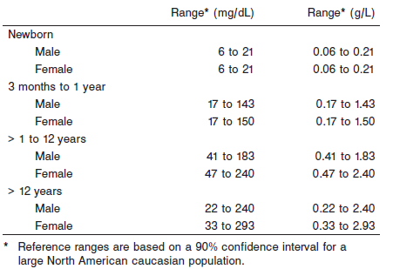

**Critical Values: N/A**

**Performance Characteristics**

**Reportable Range**

The IgM assay reportable range (analytical measurement range) is from 5 mg/dL (0.05 g/L) to five times the highest calibrator concentration.

**Limit of Quantitation (LOQ)**

The LOQ for IgM is ≤ 2 mg/dL (0.02 g/L).

**Dilution: (For Samples above reportable range)**

**Serum and Plasma:** Using the Standard (1:5) sample dilution, specimens with IgM values exceeding five times the highest calibrator are flagged and may be diluted by following either the Automated Dilution Protocol or the Manual Dilution Procedure.

**Automated Dilution Protocol**

If using the Automated Dilution Protocol, the system performs a 1:10 dilution of the specimen and automatically corrects the concentration by multiplying the result by the appropriate dilution factor.

**Manual Dilution Procedure**

Manual dilutions should be performed as follows:

• Use saline (0.85% to 0.90% NaCl) to dilute the sample.

**Example:** A manual 1:4 dilution performed using the Standard 1:5 dilution will result in a 1:20 diluted sample.

• The operator must enter the manual dilution factor in the patient or control order screen. The system uses this dilution factor to automatically correct the concentration by multiplying the result by the entered factor.

• If the operator does not enter the dilution factor, the result must be multiplied by the appropriate manual dilution factor before reporting the result.

**NOTE:** If a diluted sample result is flagged indicating it is less than the linear low limit, do not report the result. Rerun using an appropriate dilution.

For detailed information on ordering dilutions, refer to *Section 5* of the **ARCHITECT System Operations Manual**.

The patient result flag “>” or error code 1054 may indicate antigen excess. Dilute sample and rerun. Samples were tested for antigen excess up to 7,005 mg/dL (70.05 g/L).

**NOTE:** Error code 1054 may result from using the Reaction Check function which is used to detect antigen excess. Refer to *Section 10* of the **ARCHITECT System Operations Manual**.

**Precision:**

The imprecision of the IgM assay is ≤ 4.4% Total CV.

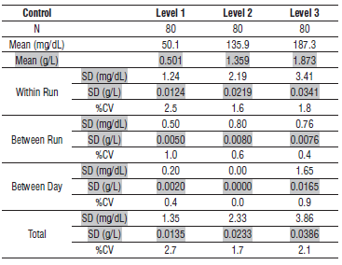

#### Limitations of Procedure

The performance characteristics of IgM on an analyzer other than the ARCHITECT *c* Systems must be validated and verified. Results from samples containing paraproteins (abnormal monoclonal antibodies) may incorrectly fall within the reference range. Samples with elevated total protein concentrations or samples from patients with suspected paraproteinemia can be screened using other laboratory methods such as protein electrophoresis. In addition, analysis of one or more diluted samples should be performed to ensure that consistent results are obtained.

Elevated fibrinogen levels in EDTA plasma samples may yield a depressed result. IgM results should be evaluated by comparing to other clinically relevant information. R2 contains elevated levels of serum protein (≥ 20% w/w). Use of this reagent can cause protein build-up in R2 probe(s). This build-up can cause reagent carryover that results in elevated or depressed assay results. To remove protein build-up, perform the As-needed maintenance procedure, *6058 Clean R2 Probe.* Refer to the PROCEDURE section of the package insert.

Turbidity and particles in the samples can interfere with the assay. Therefore, particulate matter should be removed by centrifugation prior to running the assay.

**Interfering Substances**

Interference effects were assessed by Dose Response and Paired Difference methods, at two medical decision levels of the analyte.

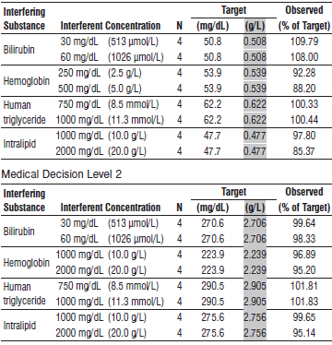

**References:**

1. ABBOTT ARCHITECT IgM package insert

Abbott Laboratories

Diagnostics Division

Abbott Park, IL 60064

Oct 2015 306777 / R06

1. ABBOTT ARCHITECT Specific Proteins Multiconstituent Calibrator package insert

Abbott Laboratories

Diagnostics Division

Abbott Park, IL 60064

1. Abbott ARCHITECT Operator’s Guide

**Related Documents:**

**Attachments:**