RUSH logo for emails

**COMPLEMENT C3**

**SERUM OR PLASMA**

**ABBOTT ARCHITECT**

**Intended Use**

The Complement C3 (C3) assay is used for the quantitation of C3 in human serum or plasma.

**Clinical Significance**

All complement proteins are acute phase reactants and rise rapidly in concentrations during inflammatory episodes. Conversely, the rates of complement protein catabolism may greatly increase in various autoimmune diseases. Because complement component determinations represent a static measurement of the net concentrations that result from a dynamic balance between component synthesis and catabolism, serial sample quantitations are more clinically useful.

In most disease states, complement functions “normally” in producing inflammation and tissue damage. When complement plays a role in the development of a disease, it is often due to activation by an “abnormal” antibody, immune complex, or foreign material.

Increased C3 levels are associated with acute phase reaction, rheumatic disease, viral hepatitis, myocardial infarction, cancer, diabetes, pregnancy, sarcoidosis, amyloidosis, thyroiditis, inflammatory bowel disease, typhoid fever, and pneumococcal pneumonia. The magnitude of C3 increase is rarely more than two-fold and may mask decreases in levels due to concurrent consumption.

Decreased levels of C3 occur in individuals with congenital deficiency or immunologic diseases (where complement is consumed at an increased rate). C3 and/or complement C4 (C4) levels may be decreased in cases of: systemic lupus erythematosus (SLE) (especially with lupus nephritis), acute and chronic hypocomplementemic nephritis, infective endocarditis, disseminated intravascular coagulation (DIC) (especially with hemolytic uremic syndrome form), and partial lipodystrophy (with associated nephritis-like activity in serum). Cases of hereditary C3 deficiency, while rare, are characterized clinically by recurrent infection and by immune complex disease, in particular, membranoproliferative glomerulonephritis. The central role of C3 in both classical and alternate pathways, results in C3 deficient patients being at risk for especially severe infections by encapsulated bacteria such as *S. pneumoniae*, *H. influenzae*, and *N. meningitidis*. Bacteremia, sinopulmonary infections, meningitis, paronychia, and impetigo may occur. Deficient C3 levels have also been found in cases of uremia,

chronic liver diseases, anorexia nervosa, and celiac disease. Refer to the following table for a general guide to evaluation of C3 and C4 protein levels in the presence of decreased hemolytic complement activity:

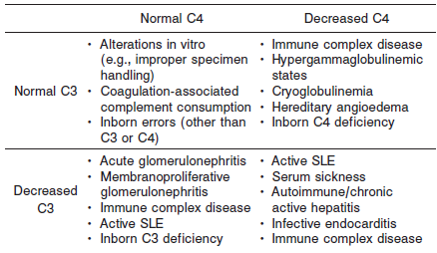

**Principle**

The C3 assay is an immunoturbidimetric procedure that measures increasing sample turbidity caused by the formation of insoluble immune complexes when antibody to C3 is added to the sample. Sample containing C3 is incubated with a buffer (R1 ) and a sample blank determination is performed prior to the addition of C3 antibody (R2 ). In the presence of an appropriate antibody in excess, the C3 concentration is measured as a function of turbidity.

**Methodology:** Immunoturbidimetric

**Specimen Collection and Handling**

**Suitable Specimens**

Serum and plasma are acceptable specimens.

• **Serum:** Use serum collected by standard venipuncture techniques into glass or plastic tubes with or without gel barriers. Ensure complete clot formation has taken place prior to centrifugation.

Centrifuge according to tube manufacturer’s instructions to ensure proper separation of serum from blood cells.

Some specimens, especially those from patients receiving anticoagulant or thrombolytic therapy, may take longer to complete their clotting processes. Fibrin clots may subsequently form in these sera and the clots could cause erroneous test results.

• **Plasma:** Use plasma collected by standard venipuncture techniques into glass or plastic tubes. Acceptable anticoagulants are lithium heparin (with or without gel barrier), sodium heparin, and EDTA.

Ensure centrifugation is adequate to remove platelets. Centrifuge according to tube manufacturer’s instructions to ensure proper separation of plasma from blood cells.

**Specimen Storage**

**Serum and Plasma:** Analyze fresh specimens if possible. Repeated freeze/thaw cycles should be avoided to minimize potential protein degradation.

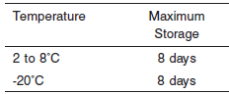

**NOTE:** Stored specimens must be inspected for particulates. If present, mix and centrifuge the specimen to remove particulates prior to testing.

**Materials and Equipment Required**

**TEST INSTRUMENT**: Abbott ARCHITECT System

**MATERIALS PROVIDED**

9D96 Complement C3 Kit

**MATERIALS REQUIRED BUT NOT PROVIDED**

• 1E78 Specific Proteins Multiconstituent Calibrator

• Control Material

• Saline (0.85% to 0.90% NaCl) for specimens that require dilution

**Reagent Handling and Storage:**

***CAUTION*:**

1. For in vitro diagnostic use.

2. Do not use components beyond the expiration date.

3. Do not mix materials from different kit lot numbers.

**CAUTION:** This product requires the handling of human specimens.

It is recommended that all human sourced materials be considered

potentially infectious and be handled in accordance with the OSHA

Standard on Bloodborne Pathogens. Biosafety Level 2 or other appropriate biosafety practices should be used for materials that contain or are suspected of containing infectious agents.

• The following warning and precaution apply to R1 and R2:

Contains sodium azide.

EUH032 Contact with acids liberates very toxic gas.

P501 Dispose of contents/container in accordance with local regulations.

These materials and their containers must be disposed of in a safe way.

**Reagent Handling**

• Remove air bubbles, if present in the reagent cartridge, with a new applicator stick. Alternatively, allow the reagent to sit at the appropriate storage temperature to allow the bubbles to dissipate.

To minimize volume depletion, do not use a transfer pipette to remove the bubbles.

**CAUTION:** Reagent bubbles may interfere with proper detection of reagent level in the cartridge, causing insufficient reagent aspiration that could impact results.

**Reagent Storage**

• Reagent stability is 57 days if the reagent is uncapped and onboard.

• Unopened reagents are stable until the expiration date when stored at 2 to 8°C.

Reagent Preparation:

9D96-21 Complement C3 is supplied as a liquid, ready-to-use, two-reagent kit which contains: **R1 & R2**

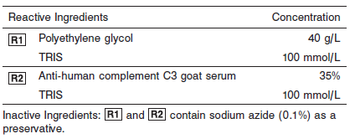

**Calibrator:** 1E78 Specific Proteins Multiconstituent Calibrator

**Quality Control:** Chemistry Controls

**Calibration**

**Frequency:**

Calibration is stable for 57 days (1368 hours) for any one lot.

**A new calibration is required:**

1. If quality control results do not meet acceptance criteria defined by your laboratory, patient values may be suspect. Follow the established quality control procedures for your laboratory. Recalibration may be necessary.
2. Review quality control results and acceptance criteria following a change of reagent or calibrator lot.

**Calibrator Required:** 1E78 Specific Proteins Multiconstituent Calibrator

**Reagents:**

Specific Proteins Multiconstituent Calibrator is prepared from human IgA, IgG, IgM, C3, C4, haptoglobin, and transferrin fractions in human serum.

**Calibrator Preparation:**

Specific Proteins Multiconstituent Calibrator requires no preparation prior to use.

**Calibration Procedure:**

Calibration is performed by running a water blank and the Specific Proteins Multiconstituent Calibrator set. Water for the blank is provided by the instrument.

1. Verify that the correct calibrator values have been entered into the calibration file.

2. Mix bottle several times by gentle inversion.

3. Open bottle, place an appropriate amount of each calibrator in a separate sample cup, and place in the assigned positions.

4. Cap bottle tightly and return to refrigerated storage immediately after use.

5. Perform calibration as indicated in the **ARCHITECT System Operations Manual**.

**Troubleshooting and Overall Acceptance Criteria Failure**

See ARCHITECT Operations Manual for further calibration troubleshooting.

**Quality Control:**

Abbott recommends, refer to your laboratory standard operating procedure(s) and/or quality assurance plan for additional quality control requirements and potential corrective actions:

• Three levels of quality control are to be run every 24 hours

• Run three levels of quality control with each cartridge change.• If more frequent control monitoring is required, follow the established quality control procedures for your laboratory.

• If quality control results do not meet the acceptance criteria defined by your laboratory, patient values may be suspect. Follow the established quality control procedures for your laboratory.

Recalibration may be necessary.

• Review quality control results and acceptance criteria following a change of reagent or calibrator lot.

**Procedure**

For a detailed description of how to run an assay, refer to *Section 5* of the **ARCHITECT System Operations Manual**.

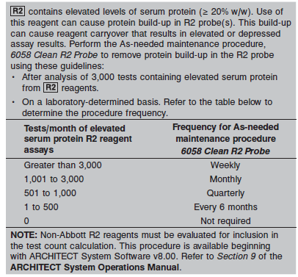

**Calculations**

Refer to *Appendix C* of the **ARCHITECT System Operations Manual** for information on results calculations.

**Reporting Results**

The result unit for the Complement C3 assay can be reported in mg/dL or g/L.

**Specific Performance Characteristics**

**Reference Ranges**

It is recommended that each laboratory determine its own reference range based upon its particular locale and population characteristics.

**Serum/Plasma:**

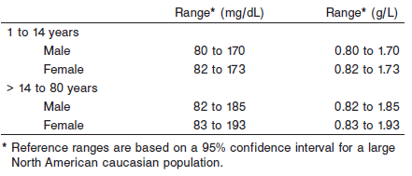

**Critical Values: N/A**

**Performance Characteristics**

**Reportable Range**

The C3 assay reportable range (analytical measurement range) is from 11 mg/dL (0.11 g/L) to the highest calibrator concentration.

**Limit of Quantitation (LOQ)**

The LOQ for C3 is ≤ 5 mg/dL (0.05 g/L).

**Dilution:**

**Serum and Plasma:** Specimens with C3 values exceeding the highest calibrator are flagged and may be diluted by following either the Automated Dilution Protocol or the Manual Dilution Procedure.

**Automated Dilution Protocol**

If using the Automated Dilution Protocol, the system performs a 1:2 dilution of the specimen and automatically corrects the concentration by multiplying the result by the appropriate dilution factor.

**Manual Dilution Procedure**

Manual dilutions should be performed as follows:

• Use saline (0.85% to 0.90% NaCl) to dilute the sample.

• The operator must enter the dilution factor in the patient or control order screen. The system uses this dilution factor to automatically correct the concentration by multiplying the result by the entered factor.

• If the operator does not enter the dilution factor, the result must be multiplied by the appropriate dilution factor before reporting the result.

**NOTE:** If a diluted sample result is flagged indicating it is less than the linear low limit, do not report the result. Rerun using an appropriate dilution. For detailed information on ordering dilutions, refer to *Section 5* of the **ARCHITECT System Operations Manual**.

The patient result flag “>” may indicate antigen excess. Dilute sample and rerun. Samples were tested for antigen excess up to 1,065 mg/dL (10.65 g/L).

**Precision:**

The imprecision of the C3 assay is ≤ 3.9% Total CV.

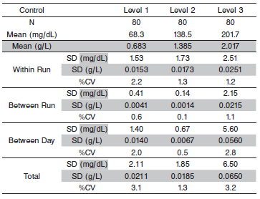

#### Limitations of Procedure

Samples containing paraproteins (abnormal monoclonal antibodies) may interfere with test results. Samples with elevated total protein concentrations or samples from patients with suspected paraproteinemia can be screened using other laboratory methods such as protein electrophoresis.

Elevated fibrinogen levels in EDTA plasma samples may yield a depressed result. C3 results should be evaluated by comparing to other clinically relevant information.

R2 contains elevated levels of serum protein (≥ 20% w/w). Use of this reagent can cause protein build-up in R2 probe(s). This build-up can cause reagent carryover that results in elevated or depressed assay results. To remove protein build-up, perform the As-needed maintenance procedure, *6058 Clean R2 Probe.* Refer to the PROCEDURE section of the package insert.

**Interfering Substances**

Interference effects were assessed by Dose Response and Paired Difference methods, at two medical decision levels of the analyte.

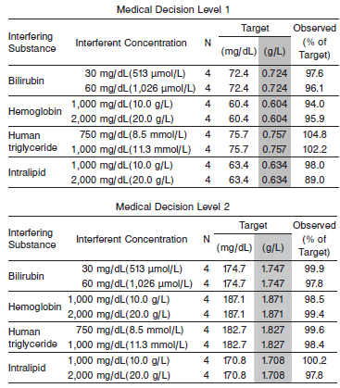

**References:**

1. ABBOTT ARCHITECT Complement C3 package insert

Abbott Laboratories

Diagnostics Division

Abbott Park, IL 60064

Nov 2015 306765/R04

1. ABBOTT ARCHITECT Specific Proteins Multiconstituent Calibrator package insert

Abbott Laboratories

Diagnostics Division

Abbott Park, IL 60064

1. Abbott ARCHITECT Operator’s Guide

**Related Documents:**

**Attachments:**