RUSH logo for emails

**PHOSPHORUS**

**SERUM, PLASMA OR URINE**

**ABBOTT ARCHITECT**

**Intended Use**

The Phosphorus assay is used for the quantitation of phosphorus in human serum, plasma, or urine.

**Clinical Significance**

The majority of the body phosphorus (80% to 85%) is present in the bones as hydroxyapatite. The remainder of the phosphate is present as inorganic phosphorus and phosphate esters. Calcium and phosphorus in serum usually exhibit a reciprocal relationship. Increased serum phosphorus may occur in hypervitaminosis D, hypoparathyroidism, and renal failure. Reduced serum phosphorus levels are seen in rickets (Vitamin D deficiency), hyperparathyroidism, and Fanconi’s syndrome.

**Principle**

Inorganic phosphate reacts with ammonium molybdate to form a heteropolyacid complex. The use of a surfactant eliminates the need to prepare a protein-free filtrate. The absorbance at 340 nm is directly proportional to the inorganic phosphorus level in the sample. Sample blanks must be run to correct for any non-specific absorbance in the sample.

**Methodology:** Phosphomolybdate

**Specimen Collection and Handling**

**Suitable Specimens**

Serum, plasma, and urine are acceptable specimens.

• **Serum:** Use serum collected by standard venipuncture techniques into glass or plastic tubes with or without gel barriers. Ensure complete clot formation has taken place prior to centrifugation.

Centrifuge according to tube manufacturer’s instructions to ensure proper separation of serum from blood cells. Some specimens, especially those from patients receiving anticoagulant or thrombolytic therapy, may take longer to complete their clotting processes. Fibrin clots may subsequently form in these sera and the clots could cause erroneous test results.

• **Plasma:** Use plasma collected by standard venipuncture techniques into glass or plastic tubes. Acceptable anticoagulants are lithium heparin (with or without gel barrier) and sodium heparin. Ensure centrifugation is adequate to remove platelets. Centrifuge according to tube manufacturer’s instructions to ensure proper separation of plasma from blood cells.

• **Urine:** Urine specimens should be collected in 6 mol/L HCl, 20 to 30 mL for a 24 hour specimen, to avoid precipitation of phosphate complexes.

**Specimen Storage**

Analyze fresh specimens if possible.

Avoid repeated freeze/thaw cycles.

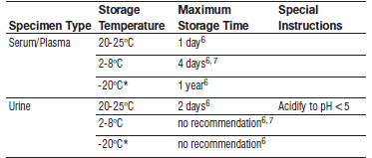

Frozen specimens must be completely thawed before mixing.

Mix thawed specimens thoroughly.

*A tolerance of +/- 10% +/- 2°C) is assumed not to change the stability of the specimen. (W. Guder, personal communication, August 6, 2001).

Each laboratory may establish a range around -20°C from either the freezer manufacturer’s specifications or your laboratory standard operating procedure(s) for specimen storage.

Visually inspect thawed specimens. If layering or stratification is observed, mix until specimens are visibly homogeneous. If specimens are not mixed thoroughly, inconsistent results may be obtained.

**NOTE:** Stored specimens must be inspected for particulates. If present, mix and centrifuge the specimen to remove particulates prior to testing.

**Materials and Equipment Required**

**TEST INSTRUMENT**: Abbott ARCHITECT System

**MATERIALS PROVIDED**

7D71 Phosphorus Reagent Kit

**MATERIALS REQUIRED BUT NOT PROVIDED**

• 1E65 Multiconstituent Calibrator

• Control Material

• Saline (0.85% to 0.90% NaCl) for specimens that require dilution

**Reagent Handling and Storage:**

***CAUTION*:**

1. For in vitro diagnostic use.

2. Do not use components beyond the expiration date.

3. Do not mix reagents prepared at different times.

4. Do not pool reagents within a kit or between kits.

**CAUTION:** This product requires the handling of human specimens.

It is recommended that all human sourced materials be considered potentially infectious and be handled in accordance with the OSHA Standard on Bloodborne Pathogens. Biosafety Level 2 or other appropriate biosafety practices should be used for materials that contain or are suspected of containing infectious agents.

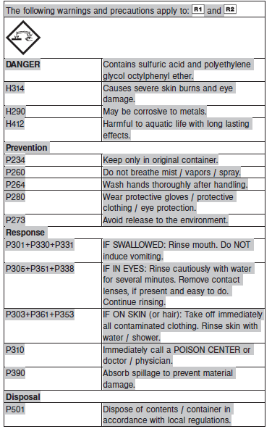

**Reagent Handling**

**NOTE:** Reagents are susceptible to the formation of foam and bubbles.

Remove air bubbles, if present in the reagent cartridge, with a new applicator stick. Alternatively, allow the reagent to sit at the appropriate storage temperature to allow the bubbles to dissipate. To minimize volume depletion, do not use a transfer pipette to remove the bubbles.

**CAUTION:** Reagent bubbles may interfere with proper detection of reagent level in the cartridge, causing insufficient reagent aspiration which could impact results.

**Reagent Storage**

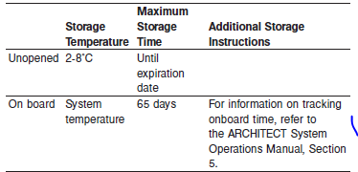

The R2 reagent may be colorless, yellow, green, or blue in appearance.

Reagents may be stored on or off the ARCHITECT cSystem.

If reagents are removed from the system, store at 2-8°C (with replacement caps) in their original boxes. When reagent is placed back on the system, run controls and if appropriate criteria are not met, recalibration may be required. For information on unloading reagents, refer to the ARCHITECT System Operations Manual, Section 5.

Reagent Preparation:

Phosphorus is supplied as a liquid, ready-to-use, reagent kit which contains: R1 & R2

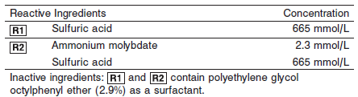

**Calibrator:** 1E65 Multiconstituent Calibrator

**Quality Control:** Minimum 2 levels of ChemistryControl (Normal and Abnormal), Urine Controls

**Calibration**

**Frequency:**

Calibration is stable for 41 days (984 hours) for any one lot.

**A new calibration is required:**

1. If quality control results do not meet acceptance criteria defined by your laboratory, patient values may be suspect. Follow the established quality control procedures for your laboratory. Recalibration may be necessary.
2. Review quality control results and acceptance criteria following a change of reagent or calibrator lot.

**Calibration Procedure:**

Calibration is performed by running a water blank and the Multiconstituent Calibrator set. Water for the blank is provided by the instrument.

1. Verify that the correct calibrator values have been entered into the calibration file.

2. Allow calibrator to come to room temperature.

3. Mix bottle five times by gentle inversion.

4. Open bottle, place an appropriate amount of each calibrator in a separate sample cup, and place in the assigned positions.

5. Cap bottle tightly and return to refrigerated storage immediately after use.

6. Perform calibration as indicated in the **ARCHITECT System Operations Manual**.

**Troubleshooting and Overall Acceptance Criteria Failure**

See ARCHITECT Operations Manual for further calibration troubleshooting.

**Quality Control:**

Abbott recommends, refer to your laboratory standard operating procedure(s) and/or quality assurance plan for additional quality control requirements and potential corrective actions:

• Two levels of controls (normal and abnormal) are to be run every 24 hours.

Some controls may require addition of Liquid Stabilizer.

• If more frequent control monitoring is required, follow the established quality control procedures for your laboratory.

• If quality control results do not meet the acceptance criteria defined by your laboratory, patient values may be suspect. Follow the established quality control procedures for your laboratory.

Recalibration may be necessary.

• Review quality control results and acceptance criteria following a change of reagent or calibrator lot.

**Procedure**

For a detailed description of how to run an assay, refer to *Section 5* of the **ARCHITECT System Operations Manual**.

The Phosphorus assay file must be installed on the ARCHITECT cSystem prior to performing the assay.

For detailed information on assay file installation and viewing and editing assay parameters, refer to the ARCHITECT System Operations Manual, Section 2.

For information on printing assay parameters or for a detailed description of system procedures, refer to the ARCHITECT System Operations Manual, Section 5.

**Calculations**

Refer to *Appendix C* of the **ARCHITECT System Operations Manual** for information on results calculations.

**Reporting Results**

The Conventional result unit for the Phosphorus assay is mg/dL. The corresponding SI result unit is mmol/L. To convert mg/dL to mmol/L, multiply mg/dL by 0.323. To convert mmol/L to mg/dL, divide mmol/L by 0.323.

To convert results from g/day to mmol/day, multiply g/day by 32.3.

**Specific Performance Characteristics**

**Reference Ranges**

It is recommended that each laboratory determine its own reference range based upon its particular locale and population characteristics.

**Serum/Plasma:** Adult 2.3 – 4.7 mg/dL

**Urine:** 400 – 1300 mg/24 hours

**Critical Values:**

**Serum/Plasma:** For all ages < 1.0 and > 99 mg/dL

**Urine: N/A**

**Performance Characteristics**

**Linearity**

Phosphorus serum is linear up to 25.3 mg/dL (8.17 mmol/L).

Phosphorus urine is linear up to 186.2 mg/dL (60.14 mmol/L).

**Dilution:**

**Serum and Plasma:** Specimens with phosphorus values exceeding 25.3 mg/dL (8.17 mmol/L) are flagged and may be diluted by following either the Automated Dilution Protocol or the Manual Dilution Procedure.

**Urine:** Urine samples are automatically diluted 1:10 by the system using the Standard dilution option, then the system automatically corrects the concentration by multiplying the result by the appropriate dilution factor. This dilution extends urine Phosphorus linearity to 186.2 mg/dL (60.14 mmol/L). Samples exceeding this concentration are flagged and may be diluted by following either the Automated Dilution Protocol or the Manual Dilution Procedure.

**Automated Dilution Protocol**

If using the Automated Dilution Protocol, the system performs a dilution of the specimen and automatically corrects the concentration by multiplying the result by the appropriate dilution factor. To set up the automatic dilution feature, refer to *Section 2* of the **ARCHITECT System** **Operations Manual** for additional information.

**Manual Dilution Procedure**

Manual dilutions should be performed as follows:

• Use saline (0.85% to 0.90% NaCl) to dilute the sample.

• The operator must enter the dilution factor in the patient or control order screen. The system uses this dilution factor to automatically correct the concentration by multiplying the result by the entered factor.

• If the operator does not enter the dilution factor, the result must be multiplied by the appropriate dilution factor before reporting the result.

**NOTE:** If a diluted sample result is flagged indicating it is less than the linear low limit, do not report the result. Rerun using an appropriate dilution.

For detailed information on ordering dilutions, refer to *Section 5* of the **ARCHITECT System Operations Manual**.

**Limit of Detection (LOD):** The LOD for Phosphorus serum is 0.25 mg/dL (0.08 mmol/L). The

LOD for Phosphorus urine is 2.5 mg/dL (0.8 mmol/L).

**Limit of Quantitation (LOQ):** The LOQ for Phosphorus serum is 0.62 mg/dL (0.201 mmol/L). The

LOQ for Phosphorus urine is 4.39 mg/dL (1.418 mmol/L).

**Limitation of Procedure:**

N/A

**Precision:**

**Serum**

The imprecision of the Phosphorus serum assay is ≤ 4.6% Total CV.

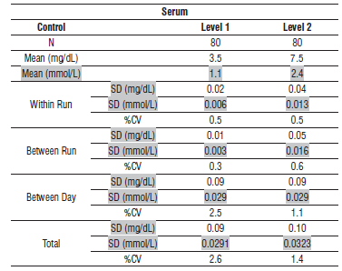

**Urine**

The imprecision of the Phosphorus urine assay is ≤ 4.6% Total CV.

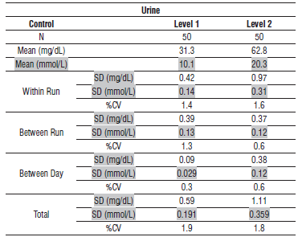

#### Interfering Substances:

**Interfering Substances**

Interference studies were conducted using CLSI protocol NCCLS EP7‑P. Interference effects were assessed by Dose Response and Paired Difference methods, at the medical decision level of the analyte.

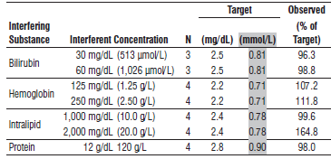

**References:**

1. ABBOTT ARCHITECT Phosphorus package insert

Abbott Laboratories

Diagnostics Division

Abbott Park, IL 60064

Jan 2016 306349 / R05

1. ABBOTT Multiconstituent Calibrator

Abbott Laboratories

Diagnostics Division

Abbott Park, IL 60064

June 2013 306297/R04

1. Abbott ARCHITECT Operator’s Guide

**Related Documents:**

**Attachments:**