RUSH logo for emails

**UNSATURATED IRON-BINDING CAPACITY (UIBC)**

**SERUM OR PLASMA**

**ABBOTT ARCHITECT**

**Intended Use**

The MULTIGENT UIBC Liquid assay is intended for the quantitative determination of unsaturated iron-binding capacity (UIBC) in serum or plasma on the ARCHITECT *c* Systems.

**Clinical Significance**

Transferrin is the carrier protein in blood, normally 20% to 50% saturated in its two iron-binding sites. The additional amount of iron that can be bound is the unsaturated iron-binding capacity (UIBC). The sum of serum iron and UIBC represents the total iron-binding capacity (TIBC).

UIBC is usually determined directly by saturating the transferrin at an alkaline pH with a known excess of iron. UIBC measurements are used in the diagnosis and treatment of anemia.

**Principle**

Sample is added to an alkaline buffer/reducing agent solution containing a known concentration of iron to saturate the available binding sites on transferrin. The iron that remains free after transferrin saturation is reduced to a ferrous state and then complexed by Ferene-S* to form a stable complex, of which the color intensity is measured at 580 to 600 nm. UIBC is therefore determined by subtracting the quantity of unbound iron from the total added quantity.

*Ferene-S = 3-(2-pyridyl)-5,6-bis- [2-(5-furylsulfonic acid)]-1,2,4-triazine

**Methodology:** Ferene

**Specimen Collection and Handling**

• **Serum:** Use nonhemolyzed serum collected by standard venipuncture techniques. Ensure complete clot formation has taken place prior to centrifugation. Centrifuge according to tube manufacturer’s instructions to ensure proper separation of serum from blood cells.

Some specimens, especially those from patients receiving anticoagulant or thrombolytic therapy, may take longer to complete their clotting processes. Fibrin clots may subsequently form in these sera and the clots could cause erroneous test results.

• **Plasma:** Use nonhemolyzed plasma collected by standard venipuncture techniques. Acceptable anticoagulants are lithium heparin (with or without gel barrier) and sodium heparin. Ensure centrifugation is adequate to remove platelets. Centrifuge according to tube manufacturer’s instructions to ensure proper separation of plasma from blood cells.

**Specimen Storage**

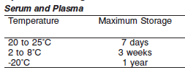

**NOTE:** Stored specimens must be inspected for particulates. If present, mix and centrifuge the specimen to remove particulates prior to testing.

**Materials and Equipment Required**

**TEST INSTRUMENT**: Abbott ARCHITECT System

**MATERIALS PROVIDED**

4P79-30 MULTIGENT UIBC Liquid Kit

**MATERIALS REQUIRED BUT NOT PROVIDED**

• Control material

• Saline (0.85% to 0.90% NaCl) for specimens that require dilution

**Reagent Handling and Storage:**

***CAUTION*:**

1. For in vitro diagnostic use.

2. Do not use components beyond the expiration date.

3. Do not mix materials from different kit lot numbers.

**CAUTION:** This product requires the handling of human specimens.

It is recommended that all human sourced materials be considered

potentially infectious and be handled in accordance with the OSHA

Standard on Bloodborne Pathogens. Biosafety Level 2 or other appropriate biosafety practices should be used for materials that contain or are suspected of containing infectious agents.

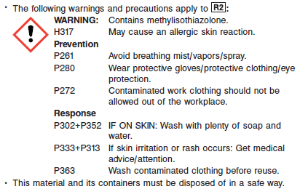

**Reagent Handling**

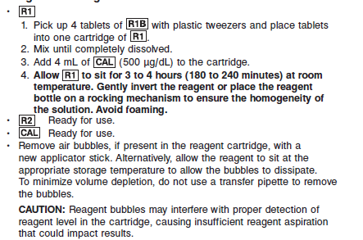

**Reagent Storage**

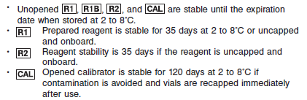

Reagent Preparation:

4P79-30 MULTIGENT UIBC Liquid is supplied as a four-component kit which contains:

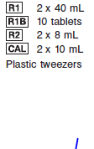

**NOTE: Tablets must only be handled with plastic tweezers included in the kit.**

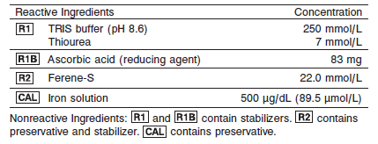

**Calibrator:** Provided in the reagent kit

**Quality Control:** Chemistry Controls

**Calibration**

**Frequency:**

Calibration is stable for 24 hours for any one lot. Calibration is required with each change in reagent lot number.

**A new calibration is required:**

1. If quality control results do not meet acceptance criteria defined by your laboratory, patient values may be suspect. Follow the established quality control procedures for your laboratory. Recalibration may be necessary.
2. Review quality control results and acceptance criteria following a change of reagent or calibrator lot.

**Calibrator Required:** Provided in the reagent kit

**Reagents:**

The calibrator value is verified using a NIST (National Institute of Standards and Technology), SRM 3126a.

**Calibrator Preparation & Procedure:**

The MULTIGENT UIBC Liquid assay must be calibrated using the calibrator included in the kit.

**NOTE:** The calibrator value for the MULTIGENT UIBC Liquid Calibrator must be entered as a negative number. Refer to the ASSAY PARAMETERS section of the package insert.

**Troubleshooting and Overall Acceptance Criteria Failure**

See ARCHITECT Operations Manual for further calibration troubleshooting.

**Quality Control:**

Abbott recommends, refer to your laboratory standard operating procedure(s) and/or quality assurance plan for additional quality control requirements and potential corrective actions:

• Two levels of controls (normal and abnormal) are to be run every 24 hours.

• If more frequent control monitoring is required, follow the established quality control procedures for your laboratory.

• If quality control results do not meet the acceptance criteria defined by your laboratory, patient values may be suspect. Follow the established quality control procedures for your laboratory.

Recalibration may be necessary.

• Review quality control results and acceptance criteria following a change of reagent or calibrator lot.

**Procedure**

For a detailed description of how to run an assay, refer to *Section 5* of the **ARCHITECT System Operations Manual**.

**Calculations**

Refer to *Appendix C* of the **ARCHITECT System Operations Manual** for information on results calculations.

**Reporting Results**

Results are expressed in μg/dL

**Specific Performance Characteristics**

**Reference Ranges**

It is recommended that each laboratory determine its own reference range based upon its particular locale and population characteristics.



The circulated iron level can show a 30% diurnal variation, with a peak early in the morning.

**Critical Values: N/A**

**Performance Characteristics**

**Reportable Range**

The reportable range (analytical measurement range) for MULTIGENT

UIBC Liquid is 41 to 500 μg/dL (7.3 to 89.5 μmol/L).

**Limit of Detection**

The LOD for MULTIGENT UIBC Liquid is 41 μg/dL (7.3 μmol/L).

**Dilution:**

**Serum and Plasma:** Specimens with UIBC values exceeding 500 μg/dL (89.5 μmol/L) are flagged and may be diluted by following either the Automated Dilution Protocol or the Manual Dilution Procedure.

***Automated Dilution Protocol***

If using the Automated Dilution Protocol, the system performs a dilution of the specimen and automatically corrects the concentration by multiplying the result by the appropriate dilution factor. To set up the automatic dilution feature, refer to *Section 2* of the **ARCHITECT System** **Operations Manual** for additional information.

***Manual Dilution Procedure***

• Use saline (0.85% to 0.90% NaCl) to dilute the sample.

• The operator must enter the dilution factor in the patient or control order screen. The system uses this dilution factor to automatically correct the concentration by multiplying the result by the entered factor.

• If the operator does not enter the dilution factor, the result must be multiplied by the appropriate dilution factor before reporting the result.

**NOTE:** If a diluted sample result is flagged indicating it is less than the linear low limit, do not report the result. Rerun using an appropriate dilution.

For detailed information on ordering dilutions, refer to *Section 5* of the **ARCHITECT System Operations Manual**.

**Precision:**

The precision of the MULTIGENT UIBC Liquid assay is ≤ 13.3% Total CV.

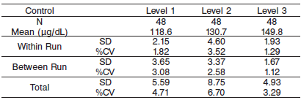

#### Limitations of Procedure

N/A

**Interfering Substances**

MULTIGENT UIBC Liquid is not affected (less than 10% difference) by the presence of the following interferents up to the concentrations indicated below.

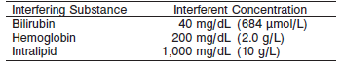

**References:**

1. ABBOTT ARCHITECT UIBC package insert

Abbott Laboratories

Diagnostics Division

Abbott Park, IL 60064

Oct 2012 304963/R03

1. Abbott ARCHITECT Operator’s Guide

**Related Documents:**

**Attachments:**