RUSH logo for emails

**CA 125**

**SERUM OR PLASMA**

**ABBOTT ARCHITECT**

**Intended Use**

The ARCHITECT CA 125 II assay is a chemiluminescent microparticle immunoassay (CMIA) for the quantitative determination of OC 125 defined antigen in human serum and plasma on the ARCHITECT *i* System. The ARCHITECT CA 125 II assay is to be used as an aid in monitoring response to therapy for patients with epithelial ovarian cancer. Serial testing for patient CA 125 II assay values should be used in conjunction with other clinical methods used for monitoring ovarian cancer.

**Clinical Significance**

CA 125 II assay values are defined by using the OC 125 monoclonal antibody. OC 125 was generated through the hybridization of mouse myeloma cells to spleen cells from a mouse immunized with a human serous cystadenocarcinoma cell line called OVCA 433. ARCHITECT CA 125 II is a second-generation assay for the detection of OC 125 defined antigen. The assay utilizes the OC 125 monoclonal antibody, as the capture antibody coated onto paramagnetic microparticles that bind molecules containing OC 125 defined antigen. These defined antigens are quantified using acridinium-labeled M11 antibody. The OC 125 monoclonal antibody is reactive with repeating OC 125 defined antigen expressed by a high percentage of nonmucinous ovarian carcinomas (serous, endometrioid, clear cell, and undifferentiated histologies) and epithelial ovarian carcinoma cell lines. OC 125 defined antigens were originally detected in normal peritoneal, pleural and pericardial tissues of both fetus and adult. In the fetus, OC 125 defined antigens have been localized in amniotic and umbilical epithelial and Mullerian epithelial tissues. In the adult, localization has been identified in endocervical and endometrial tissues and ovarian inclusion cysts and papillary excrescences. However, OC 125 defined antigens were not detected in fetal ovarian tissue or other normal adult ovarian tissues or benign mucinous ovarian tumors. In serum, the OC 125 defined antigens are associated with high molecular weight glycoproteins heterogeneous in size and charge. The structure of the CA 125 molecule, including closely situated repeating epitopes for OC 125 and M11 antibodies has been proposed. Serum CA 125 II assay values are useful for monitoring the course of disease in patients with invasive epithelial ovarian cancer. In a review of nine published studies, the overall correlation reported between CA 125 serum levels and the course of the disease was 87%.Persistently rising CA 125 assay values may be associated with malignant disease and poor response to therapy, whereas decreasing CA 125 assay values may indicate a favorable response to therapy.

A second-look, exploratory laparotomy may have been performed previously to assess response to therapy. The benefit has recently come into question because of high morbidity and low sensitivity in detecting residual or recurrent carcinoma. In women with primary epithelial ovarian carcinoma who had undergone first-line therapy and were candidates for diagnostic second-look procedures, a CA 125 assay value greater than or equal to 35 U/mL was found to be indicative of the presence of residual

tumor. However, a CA 125 assay value below 35 U/mL does not indicate the absence of residual ovarian cancer because patients with histopathologic evidence of ovarian carcinoma may have CA 125 assay values within the range of normal individuals.

Elevations of CA 125 assay values have been reported in approximately 1-2% of healthy individuals, and in individuals with nonmalignant conditions such as cirrhosis, hepatitis, endometriosis, first

trimester pregnancy, ovarian cysts, and pelvic inflammatory disease. Elevations of CA 125 assay values during the menstrual cycle have also been reported. Non-ovarian malignancies in which

CA 125 assay values have been reported include endocervical, liver, pancreatic, lung, colon, stomach, biliary tract, uterine, fallopian tube, breast, and endometrial carcinomas. The CA 125 assay is not recommended as a screening procedure to detect cancer in the general population; however, the use of CA 125 assay values as an aid in the management of ovarian cancer patients has been reported.

**Principle**

The ARCHITECT CA 125 II assay is a two-step immunoassay to determine the presence of OC 125 defined antigen in human serum and plasma, using CMIA technology with flexible assay protocols, referred to as Chemiflex.

In the first step, sample and OC 125 coated paramagnetic microparticles are combined. OC 125 defined antigen present in the sample binds to the OC 125 coated microparticles. After washing, M11 acridinium-labeled conjugate is added in the second step. Pre-Trigger and Trigger Solutions are then added to the reaction mixture; the resulting chemiluminescent reaction is measured as relative light units (RLUs). A direct relationship exists between the amount of OC 125 defined antigen in the sample and the RLUs detected by the ARCHITECT *i\** optical system. For additional information on system and assay technology, refer to the ARCHITECT System Operations Manual, Section 3.

*\* i* = immunoassay

**Specimen Collection and Handling**

**Suitable Specimens**

**•** Only human serum (including serum collected in separator tubes [SST]) or plasma (collected in tripotassium EDTA, sodium heparin, or lithium heparin collection tubes) may be used in the ARCHITECT CA 125 II assay. Other anticoagulants have not been validated for use with the ARCHITECT CA 125 II assay. Follow the tube manufacturer’s processing instructions for collection tubes.

**•** When serial specimens are being evaluated, the same type of specimen should be used throughout the study.

**•** The ARCHITECT *i* System does not provide the capability to verify specimen type. It is the responsibility of the operator to verify that the correct specimen type is used in the ARCHITECT CA 125 II assay.

**•** Use caution when handling patient specimens to prevent cross contamination. Use of disposable pipettes or pipette tips is recommended.

**•** Do not use grossly hemolyzed specimens.

**•** Do not use heat-inactivated specimens.

**•** Inspect all samples for bubbles. Remove bubbles with an applicator stick prior to analysis. Use a new applicator stick for each sample to prevent cross contamination.

**•** Serum and plasma specimens should be free of fibrin, red blood cell or other particulate matter.

**•** Ensure that complete clot formation in serum specimens has taken place prior to centrifugation. Some specimens, especially those from patients receiving anticoagulant or thrombolytic therapy, may exhibit increased clotting time. If the specimen is centrifuged before a complete clot forms, the presence of fibrin may cause erroneous results.

**•** If testing will be delayed more than 24 hours, remove serum or plasma from the clot, serum separator, or red blood cells. Specimens may be stored for up to 7 days at 2-8°C prior to being tested. If testing will be delayed more than 7 days, serum or plasma should be stored frozen at -20°C or colder.

**•** Multiple freeze/thaw cycles of specimens should be avoided. Specimens must be mixed THOROUGHLY after thawing, by LOW speed vortexing or by gently inverting, and centrifuged prior to use to remove red blood cells or particulate matter to ensure consistency in the results. Sample from the middle of the tube to avoid any particulate on the top or bottom of the sample.

**•** Performance has not been established using body fluids other than human serum and plasma.

**•** Specimens with obvious microbial contamination should not be used.

**NOTE:** Stored specimens must be inspected for particulates. If present, mix and centrifuge the specimen to remove particulates prior to testing.

**Materials and Equipment Required**

**TEST INSTRUMENT**: Abbott ARCHITECT System

**MATERIALS PROVIDED**

2K45 ARCHITECT CA 125 II Reagent Kit

**MATERIALS REQUIRED BUT NOT PROVIDED**

**•** ARCHITECT *i* System with *STAT* Protocol

**•** ARCHITECT CA 125 II Assay file, may be obtained from:

**•** ARCHITECT *i* System e-Assay CD-ROM found on www.abbottdiagnostics.com

**•** ARCHITECT *i* System Assay CD-ROM

**•** 2K45-01 ARCHITECT CA 125 II Calibrators

**•** 2K45-10 ARCHITECT CA 125 II Controls

**•** 7D82-50 ARCHITECT *I*Multi-assay diluent

**•** ARCHITECT *i* Pretrigger

**•** ARCHITECT *i* Trigger

**•** ARCHITECT *i i* Wash Buffer

**•** ARCHITECT *i* Reaction Vessels

**•** ARCHITECT *i* Sample Cups

**•** ARCHITECT *i* Septums

**•** ARCHITECT *i* Replacement Caps

**•** Pipettes or pipette tips (optional) to deliver the specified volumes.

**Reagent Handling and Storage:**

***CAUTION*:**

* For in vitro diagnostic use.

**CAUTION:** This product requires the handling of human specimens.

It is recommended that all human sourced materials be considered

potentially infectious and be handled in accordance with the OSHA

Standard on Bloodborne Pathogens. Biosafety Level 2 or other appropriate biosafety practices should be used for materials that contain or are suspected of containing infectious agents.

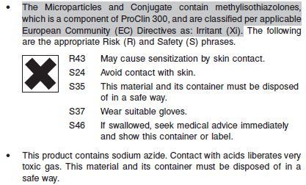

**Reagent Handling**

* Do not use reagent kits beyond the expiration date.
* **Do not pool reagents within a kit or between reagent kits.**
* Before loading the ARCHITECT reagent kit on the system for the first time, the microparticle bottle requires mixing to resuspend microparticles that may have settled during shipment. For microparticle mixing instructions, refer to the **PROCEDURE, Assay Procedure** section of the package insert.
* **Septums MUST be used to prevent reagent evaporation and contamination and to ensure reagent integrity. Reliability of assay results cannot be guaranteed if septums are not used according to the instructions in the package insert.**
* To avoid contamination, wear clean gloves when placing a septum on an uncapped reagent bottle.
* Once a septum has been placed on the reagent bottle, **do not invert the bottle** as this will result in reagent leakage and maycompromise assay results.
* Over time, residual liquids may dry on the septum surface. These are typically dried salts and have no effect on assay efficacy.
* For a detailed discussion of handling precautions during system operation, refer to the ARCHITECT System Operations Manual, Section 7.

**Reagent Storage**

* The ARCHITECT CA 125 Reagent Kit must be stored at 2-8°C in an upright position and may be used immediately after removal from 2-8°C storage.
* When stored and handled as directed, the reagents are stable until the expiration date.
* The ARCHITECT CA 125 Reagent Kit may be stored on board the ARCHITECT *i* System for a maximum of 30 days. After 30 days, the reagent kit must be discarded. For information on tracking onboard time, refer to the ARCHITECT System Operations Manual, Section 5.
* Reagents may be stored on or off the ARCHITECT *i* System. If reagents are removed from the system, store them at 2-8°C (with septums and replacement caps) in an upright position. For reagents stored off the system, it is recommended that they be stored in their original trays and boxes to ensure they remain upright. **If the microparticle bottle does** **not remain upright (with a septum installed) while in refrigerated** **storage off the system, the reagent kit must be discarded.** For information on unloading reagents, refer to the ARCHITECT System Operations Manual, Section 5.

Reagents

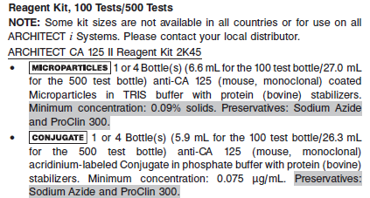

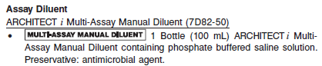

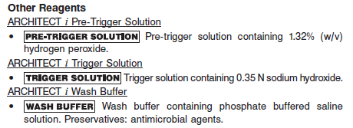

**Calibrator:** 2K45-01 ARCHITECT CA 125 II Calibrators

**Quality Control:** 2K45-10 ARCHITECT CA 125 II Controls or other control material

**Calibration**

**Frequency:**

Recalibration is required with each new reagent lot number.

**A new calibration is required:**

1. If quality control results do not meet acceptance criteria defined by your laboratory, patient values may be suspect. Follow the established quality control procedures for your laboratory. Recalibration may be necessary.
2. Review quality control results and acceptance criteria following a change of reagent or calibrator lot.

**Calibrator Required:** 2K45-01 ARCHITECT CA 125 II Calibrators

**Reagents:**

6 Bottles (4 mL each) of ARCHITECT CA 125 II Calibrators. Calibrator A contains TRIS buffer with protein (bovine) stabilizers. Calibrators B-F contain OC125 defined antigen (human) prepared in

TRIS buffer with protein (bovine) stabilizers. Preservatives: Sodium Azide and ProClin 300.

**Calibrator Preparation:**

**•** ARCHITECT CA 125 II Calibrators may be used immediately after removal from 2-8°C storage. Prior to use, mix by gentle inversion (5-10 times).

**•** After each use, tightly close the caps and return the calibrators to 2-8°C storage

**Calibration Procedure:**

To perform an ARCHITECT CA 125 II calibration, test calibrators A, B, C, D, E and F in duplicate. A single sample of all levels of CA 125 II controls must be tested to evaluate the assay calibration. Ensure that assay control values are within the concentration ranges specified in the control package insert. Calibrators should be priority loaded.

**•** Calibrator Range: 0 - 1000 U/mL.

**Troubleshooting and Overall Acceptance Criteria Failure**

See ARCHITECT Operations Manual for further calibration troubleshooting.

**Quality Control:**

Abbott recommends, refer to your laboratory standard operating procedure(s) and/or quality assurance plan for additional quality control requirements and potential corrective actions:

• At a minimum a single level of all quality control are to be run every 24 hours

• If more frequent control monitoring is required, follow the established quality control procedures for your laboratory.

• If quality control results do not meet the acceptance criteria defined by your laboratory, patient values may be suspect. Follow the established quality control procedures for your laboratory.

Recalibration may be necessary.

• Review quality control results and acceptance criteria following a change of reagent or calibrator lot.

**Instrument Procedure**

* The ARCHITECT CA 125 assay is designed for use on the ARCHITECT *i* System.
* The ARCHITECT CA 125 assay file must be installed on the ARCHITECT *i* System with *STAT* capabilities before performing the assay.
* For detailed information on assay file installation and viewing and editing assay parameters, refer to the ARCHITECT System Operations Manual, Section 2.
* For information on printing assay parameters, refer to the ARCHITECT System Operations Manual, Section 5.
* For a detailed description of system procedures, refer to the ARCHITECT System Operations Manual.

**Assay Procedure**

For a detailed description of how to run an assay, refer to *Section 5* of the **ARCHITECT System**

**Operations Manual**.

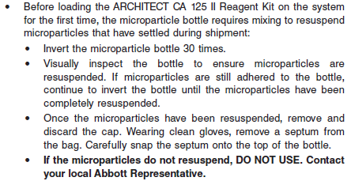

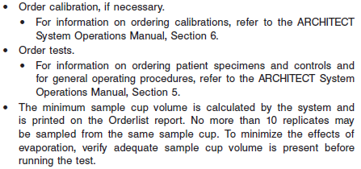

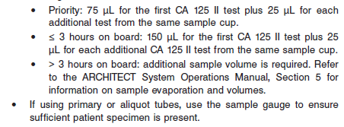

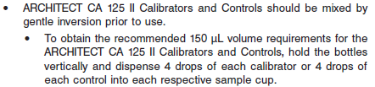

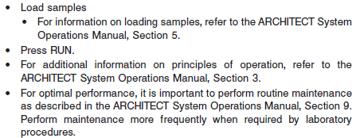

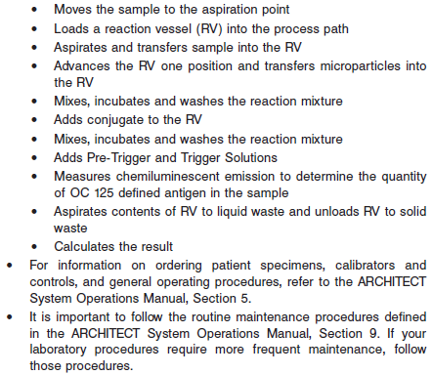

**Results**

The default result unit for the ARCHITECT Ca 125 assay is U/mL.

**Flags**

Some results may contain information in the Flags field. For a description of the flags that may appear in this field, refer to the ARCHITECT System Operations Manual, Section 5.

**Specific Performance Characteristics**

**Expected Values**

It is recommended that each laboratory determine its own reference range based upon its particular locale and population characteristics.

**Serum/Plasma:** < 35 IU/mL

**Critical Values: N/A**

**Performance Characteristics**

**Reportable Range:**

The measurement range for the ARCHITECT CA 125 II assay is 1.0 U/mL to 1000 U/mL.

**Analytical Sensitivity**

The sensitivity of the ARCHITECT CA 125 II assay is ≤ 1.0 U/mL.

**Dilution:**

**•** Specimens with a CA 125 II assay value exceeding 1000 U/mL are flagged with the code “ >1000.0” and may be diluted using either the Automated Dilution Protocol or the Manual Dilution Procedure.

**•** If using the Automated Dilution Protocol, the system performs a 1:10 dilution of the specimen and automatically calculates the concentration of the sample before dilution and reports the result.

**•** Manual dilutions should be performed as follows:

**•** The suggested dilution for the ARCHITECT CA 125 II assay is 1:10. An additional 1:10 dilution may be made if needed.

**•** For a 1:10 dilution, add 50 μL of the patient specimen to 450 μL of ARCHITECT *i* Multi-Assay Manual Diluent (7D82-50).

**•** The operator must enter the dilution factor in the Patient or Control order screen. All assays selected for that order will be diluted. The system will use this dilution factor to automatically calculate the concentration of the sample before dilution and report the result. The dilution should be performed so that the diluted result reads greater than 20 U/mL.

**•** For detailed information on ordering dilutions, refer to the ARCHITECT System Operations Manual, Section 5.

**Precision:**

The ARCHITECT CA 125 II assay precision is ≤ 10% total CV.

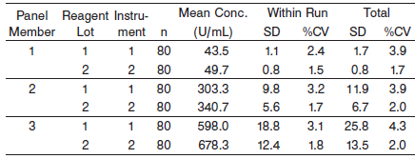

#### Limitations of Procedure

**•** Patients with confirmed ovarian carcinoma may have pretreatment CA 125 assay values in the same range as healthy individuals. Elevations in circulating OC 125 defined antigen may be observed in patients with nonmalignant disease. For these reasons, a CA 125 assay value, regardless of level, should not be interpreted as absolute evidence for the presence or absence of malignant disease. The CA 125 assay value should be used in conjunction with information available from clinical evaluation and other diagnostic procedures. **The ARCHITECT** **CA 125 II assay should not be used as a cancer screening test.**

**•** Heterophilic antibodies in human serum can react with reagent immunoglobulins, interfering with *in vitro* immunoassays. Patients routinely exposed to animals or to animal serum products can be prone to this interference and anomalous results may be observed. Additional information may be required for diagnosis.

**•** Specimens from patients who have received preparations of mouse monoclonal antibodies for diagnosis or therapy may contain human anti-mouse antibodies (HAMA). Such specimens may show either falsely elevated or depressed values when tested with assay kits which employ mouse monoclonal antibodies. ARCHITECT BNP reagents contain a component that reduces the effect of HAMA reactive specimens. Additional clinical or diagnosis information may be required to determine patient status.

**Analytical Specificity**

The ARCHITECT CA 125 II mean assay specificity is ≤ 12%. Recovery studies were performed to compare sera containing the following compounds at the indicated concentrations with control sera.*

INTERFERING SUBSTANCE

Test Compound Test Concentration

Bilirubin 20 mg/dL

Hemoglobin 500 mg/dL

Total Protein 12 g/dL

Triglycerides 3 g/dL

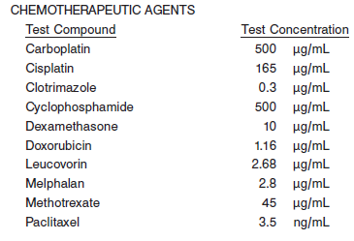

POTENTIALLY INTERFERING CLINICAL CONDITIONS

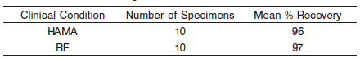

**References:**

1. ABBOTT ARCHITECT CA 125 package insert

Abbott Laboratories

Diagnostics Division

Abbott Park, IL 60064

Nov 2012 602-030 6/12

1. ABBOTT ARCHITECT CA 125 Calibrator package insert

Abbott Laboratories

Diagnostics Division

Abbott Park, IL 60064

1. Abbott ARCHITECT Operator’s Guide

**Related Documents:**

**Attachments:**