RUSH logo for emails

**ALBUMIN BCG**

**SERUM OR PLASMA**

**ABBOTT ARCHITECT**

**Intended Use**

The Albumin BCG assay is used for the quantitation of albumin in human serum or plasma.

**Clinical Significance**

Albumin is the most abundant protein in human serum/plasma. Elevated serum albumin levels are usually the result of dehydration. Decreased albumin levels are found in a wide variety of conditions, including kidney disease, liver disease, malabsorption, malnutrition, severe burns, infections, and cancer.

**Principle**

The Albumin BCG procedure is based on the binding of bromcresol green specifically with albumin to produce a colored complex. The absorbance of the complex at 628 nm is directly proportional to the albumin concentration in the sample.

**Methodology:** Bromcresol Green

**Specimen Collection and Handling**

**Suitable Specimens**

Serum and plasma are acceptable specimens.

• **Serum:** Use serum collected by standard venipuncture techniques into glass or plastic tubes with or without gel barriers. Ensure complete clot formation has taken place prior to centrifugation.

Centrifuge according to tube manufacturer’s instructions to ensure proper separation of serum from blood cells.

Some specimens, especially those from patients receiving anticoagulant or thrombolytic therapy, may take longer to complete their clotting processes. Fibrin clots may subsequently form in these sera and the clots could cause erroneous test results.

• **Plasma:** Use plasma collected by standard venipuncture techniques into glass or plastic tubes. Acceptable anticoagulants are lithium heparin (with or without gel barrier) and sodium heparin. Ensure centrifugation is adequate to remove platelets. Centrifuge according to tube manufacturer’s instructions to ensure proper separation of plasma from blood cells.

**Specimen Storage**

**Serum and Plasma:**

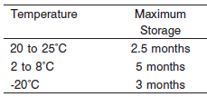

*A tolerance of +/-10% (+/- 2°C) is assumed not to change the stability of the specimen. (W. Guder, personal communication, August 6, 2001).

Frozen specimens must be completely thawed before mixing.

Mix thawed specimens thoroughly.

Visually inspect thawed specimens. If layering or stratification is observed, mix until specimens are visibly homogeneous. If specimens are not mixed thoroughly, inconsistent results may be obtained.

**NOTE:** Stored specimens must be inspected for particulates. If present, mix and centrifuge the specimen to remove particulates prior to testing.

**Materials and Equipment Required**

**TEST INSTRUMENT**: Abbott ARCHITECT System

**MATERIALS PROVIDED**

7D53 Albumin BCG Reagent Kit

**MATERIALS REQUIRED BUT NOT PROVIDED**

• 1E65 Multiconstituent Calibrator

• Control Material

• Saline (0.85% to 0.90% NaCl) for specimens that require dilution

**Reagent Handling and Storage:**

***CAUTION*:**

1. For in vitro diagnostic use.

2. Do not use components beyond the expiration date.

3. 4. Do not mix reagents prepared at different times.

**CAUTION:** This product requires the handling of human specimens.

It is recommended that all human sourced materials be considered potentially infectious and be handled in accordance with the OSHA Standard on Bloodborne Pathogens. Biosafety Level 2 or other appropriate biosafety practices should be used for materials that contain or are suspected of containing infectious agents.

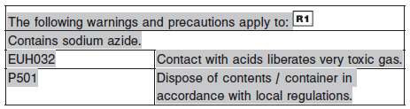

**Reagent Handling**

Remove air bubbles, if present in the reagent cartridge, with a new applicator stick. Alternatively, allow the reagent to sit at the appropriate storage temperature to allow the bubbles to dissipate. To minimize volume depletion, do not use a transfer pipette to remove the bubbles.

**CAUTION:** Reagent bubbles may interfere with proper detection of reagent level in the cartridge, causing insufficient reagent aspiration which could impact results.

**Reagent Storage**

Unopened reagents are stable until the expiration date when stored at 15 to 30°C.

Reagent stability is 42 days if the reagent is uncapped and onboard.

Reagent Preparation:

7D53-23 Albumin BCG is supplied as a liquid, ready-to-use, single reagent kit which contains: R1

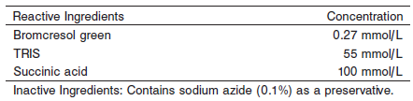

**Calibrator:** 1E65 Multiconstituent Calibrator

**Quality Control:** Minimum 2 levels of ChemistryControl (Normal and Abnormal)

**Calibration**

**Frequency:**

Calibration is stable for 41 days (984 hours) for any one lot.

**A new calibration is required:**

1. If quality control results do not meet acceptance criteria defined by your laboratory, patient values may be suspect. Follow the established quality control procedures for your laboratory. Recalibration may be necessary.
2. Review quality control results and acceptance criteria following a change of reagent or calibrator lot.

**Calibration Procedure:**

Calibration is performed by running a water blank and the Multiconstituent Calibrator set. Water for the blank is provided by the instrument.

1. Verify that the correct calibrator values have been entered into the calibration file.

2. Allow calibrator to come to room temperature.

3. Mix bottle five times by gentle inversion.

4. Open bottle, place an appropriate amount of each calibrator in a separate sample cup, and place in the assigned positions.

5. Cap bottle tightly and return to refrigerated storage immediately after use.

6. Perform calibration as indicated in the **ARCHITECT System Operations Manual**.

**Troubleshooting and Overall Acceptance Criteria Failure**

See ARCHITECT Operations Manual for further calibration troubleshooting.

**Quality Control:**

Abbott recommends, refer to your laboratory standard operating procedure(s) and/or quality assurance plan for additional quality control requirements and potential corrective actions:

• Two levels of controls (normal and abnormal) are to be run every 24 hours.

Some controls may require addition of Liquid Stabilizer.

• If more frequent control monitoring is required, follow the established quality control procedures for your laboratory.

• If quality control results do not meet the acceptance criteria defined by your laboratory, patient values may be suspect. Follow the established quality control procedures for your laboratory.

Recalibration may be necessary.

• Review quality control results and acceptance criteria following a change of reagent or calibrator lot.

**Procedure**

For a detailed description of how to run an assay, refer to *Section 5* of the **ARCHITECT System Operations Manual**.

**Calculations**

Refer to *Appendix C* of the **ARCHITECT System Operations Manual** for information on results calculations.

**Reporting Results**

The result unit for the Albumin BCG assay can be reported as g/L or g/dL

**Specific Performance Characteristics**

**Reference Ranges**

It is recommended that each laboratory determine its own reference range based upon its particular locale and population characteristics.

**Serum/Plasma:**

**0 – 4 days:** 2.8 – 4.4 g/dL

**4 – 14 days:** 3.8 – 4.4 g/dL

**14 days – 18 years:** 3.2 – 4.5 g/dL

**18 – 60 years:** 3.5 – 5.2 g/dL

**60 – 90 years:** 3.2 – 4.6 g/dL

**> 90 years:** 2.9 – 4.5 g/dL

**Critical Values: N/A**

**Performance Characteristics**

**Measuring Interval**

The measuring interval of Albumin BCG is 0.4 to 10.5 g/dL (4.0 to 105 g/L).

**Linearity**

Albumin BCG is linear up to 10.5 g/dL (105 g/L).

**Dilution:**

**Serum and Plasma:** Specimens with albumin values exceeding 10.5 g/dL (105 g/L) are flagged and may be diluted by following either the Automated Dilution Protocol or the Manual Dilution Procedure.

**Automated Dilution Protocol**

If using the Automated Dilution Protocol, the system performs a dilution of the specimen and automatically corrects the concentration by multiplying the result by the appropriate dilution factor. To set up the automatic dilution feature, refer to *Section 2* of the **ARCHITECT System** **Operations Manual** for additional information.

**Manual Dilution Procedure**

Manual dilutions should be performed as follows:

• Use saline (0.85% to 0.90% NaCl) to dilute the sample.

• The operator must enter the dilution factor in the patient or control order screen. The system uses this dilution factor to automatically correct the concentration by multiplying the result by the entered factor.

• If the operator does not enter the dilution factor, the result must be multiplied by the appropriate dilution factor before reporting the result.

**NOTE:** If a diluted sample result is flagged indicating it is less than the linear low limit, do not report the result. Rerun using an appropriate dilution.

For detailed information on ordering dilutions, refer to *Section 5* of the **ARCHITECT System Operations Manual**.

**Limit of Quantitation (LOQ):** The LOQ for Albumin BCG is 0.31 g/dL (3.1 g/L).

**Limit of Detection (LOD):** The LOD for Albumin BCG is 0.3 g/dL (3 g/L).

**Limitation of Procedure:**

N/A

**Precision:**

The imprecision of the Albumin BCG assay is ≤ 3.3% Total CV.

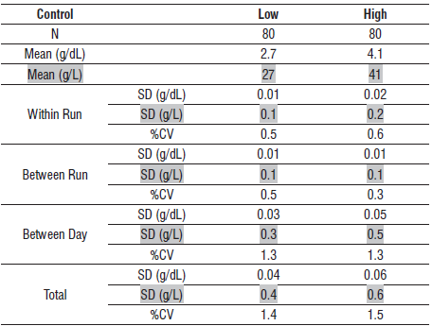

**Accuracy**

The bias for Albumin BCG serum or plasma is ≤ 5%. Representative data from a study using IFCC traceable ERM-DA470 are summarized below.

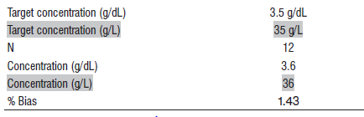

#### Interfering Substances:

**Interfering Substances**

Interference studies were conducted using CLSI protocol NCCLS EP7-P. Interference effects were assessed by Dose Response and Paired Difference methods, at the medical decision level of the analyte.

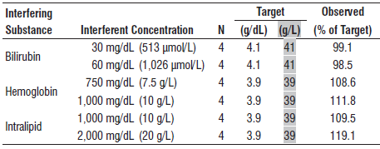

**References:**

1. ABBOTT ARCHITECT Active AST package insert

Abbott Laboratories

Diagnostics Division

Abbott Park, IL 60064

Dec 2015 306758 / R03

1. ABBOTT Multiconstituent Calibrator

Abbott Laboratories

Diagnostics Division

Abbott Park, IL 60064

June 2013 306297/R04

1. Abbott ARCHITECT Operator’s Guide

**Related Documents:**

**Attachments:**