RUSH logo for emails

**ESTRADIOL**

**SERUM OR PLASMA**

**ABBOTT ARCHITECT**

**Intended Use**

The ARCHITECT Estradiol assay is a Chemiluminescent Microparticle Immunoassay (CMIA) for the quantitative determination of estradiol in human serum and plasma.

**Clinical Significance**

Estradiol is the most potent natural estrogen in humans. It regulates reproductive function in females, and, with progesterone, maintains pregnancy. Most estradiol is secreted by the ovaries (non-pregnant women), although the testes (in men) and adrenal cortex (in men and women) secrete small amounts. During pregnancy, the placenta produces most of the circulating estradiol. Estradiol and estrone interconvert *in vivo*. In normal non-pregnant women, estradiol synthesized by the ovary is the predominant source of both estrone and estriol.

Virtually all circulating estradiol is protein-bound. Reported association constants for estradiol with sex hormone binding globulin and serum albumin are, respectively, 6.8 x 108 and 6 x 104. One consequence of this binding is that the conditions of any assay for serum estradiol must release this steroid quantitatively from its binding partners. The amount and proportion of protein-bound and free estradiol vary by gender, and with pregnancy and menstrual phase in women.

Normal estradiol levels are lowest at menses and into the early follicular phase (25-75 pg/mL) and then rise in the late follicular phase to a peak of 200-600 pg/mL just before the LH surge, which is normally followed immediately by ovulation. As LH peaks, estradiol begins to decrease before rising again during the luteal phase (100-300 pg/mL). If conception does not take place, estradiol falls further to its lowest levels, and menses begins shortly thereafter. If conception occurs, estradiol levels continue to rise, reaching levels of 1,000-5,000 pg/mL during the first trimester, 5,000-15,000 pg/mL during second trimester, and 10,000-40,000 pg/mL during third trimester. At menopause, estradiol levels remain low.

Because the ovaries produce most estradiol in normal women, estimation of this hormone is sometimes a gauge of ovarian function. In addition, monitoring estradiol levels is important in evaluating amenorrhea, precocious puberty, the onset of menopause, and infertility in men and women. Monitoring estradiol levels is essential during *in vitro* fertilization, because the timing of recovery of oocytes depends on follicular development, which in turn depends on the estradiol level.

**Principle**

The ARCHITECT Estradiol assay is a delayed one step immunoassay to determine the presence of estradiol in human serum and plasma using Chemiluminescent Microparticle Immunoassay (CMIA) technology with flexible assay protocols, referred to as Chemiflex. In the first step, sample, specimen diluent, assay diluent, and anti-estradiol (rabbit, monoclonal) coated paramagnetic microparticles are combined. Estradiol present in the sample binds to the anti-estradiol coated microparticles. After an incubation, estradiol acridinium labeled conjugate is added to the reaction mixture. After a second incubation, and washing, Pre-Trigger and Trigger Solutions are then added and the resulting chemiluminescent reaction is measured as relative light units (RLUs). An inverse relationship exists between the amount of estradiol in the sample and the RLUs detected by the ARCHITECT *i* optical system.

For additional information on system and assay technology, refer to the ARCHITECT System Operations Manual, Section 3.

**Specimen Collection and Handling**

**Suitable Specimens**

Human serum (including serum collected in serum separator tubes) or plasma collected in lithium heparin (including plasma separator tubes) or potassium EDTA collected in glass or plastic may be used in the ARCHITECT Estradiol assay. Other anticoagulants have not been validated for use with the ARCHITECT Estradiol assay.

Do not use specimens with the following conditions:

**•** heat-inactivated

**•** obvious microbial contamination

**•** cadaver specimens or any other body fluids

**Storage**

If testing will be delayed more than 24 hours, remove serum or plasma from the clot, separator, or red blood cells and store at 2-8°C. Specimens may be stored for up to 7 days at 2-8°C prior to being tested. If testing will be delayed more than 7 days, specimens should be frozen at -20°C or colder.

**•** Multiple freeze-thaw cycles of specimens should be avoided. Specimens must be mixed THOROUGHLY after thawing, by LOW speed vortexing or by gently inverting, and centrifuged prior to use to remove red blood cells or particulate matter to ensure consistency in the results. Sample from the middle of the tube to avoid any particulates on the top or bottom of the specimen.

**NOTE:** Stored specimens must be inspected for particulates. If present, mix and centrifuge the specimen to remove particulates prior to testing.

**Materials and Equipment Required**

**TEST INSTRUMENT**: Abbott ARCHITECT System

**MATERIALS PROVIDED**

7K72 ARCHITECT Estradiol Reagent Kit

**MATERIALS REQUIRED BUT NOT PROVIDED**

**•** ARCHITECT *i* System

**•** ARCHITECT Estradiol Assay file, may be obtained from:

**•** ARCHITECT *i* System e-Assay CD-ROM found on www.abbottdiagnostics.com

**•** ARCHITECT *i* System Assay CD-ROM

**•** 7K72-01 ARCHITECT Estradiol Calibrators

**•** 7K72-10 ARCHITECT Estradiol Controls

**•** 7K72-50 ARCHITECT Estradiol Manual Diluent

**•** ARCHITECT *i* Pretrigger

**•** ARCHITECT *i* Trigger

**•** ARCHITECT *i i* Wash Buffer

**•** ARCHITECT *i* Reaction Vessels

**•** ARCHITECT *i* Sample Cups

**•** ARCHITECT *i* Septums

**•** ARCHITECT *i* Replacement Caps

**•** Pipettes or pipette tips (optional) to deliver the specified volumes.

**Reagent Handling and Storage:**

***CAUTION*:**

* For in vitro diagnostic use.

**CAUTION:** This product requires the handling of human specimens.

It is recommended that all human sourced materials be considered

potentially infectious and be handled in accordance with the OSHA

Standard on Bloodborne Pathogens. Biosafety Level 2 or other appropriate biosafety practices should be used for materials that contain or are suspected of containing infectious agents.

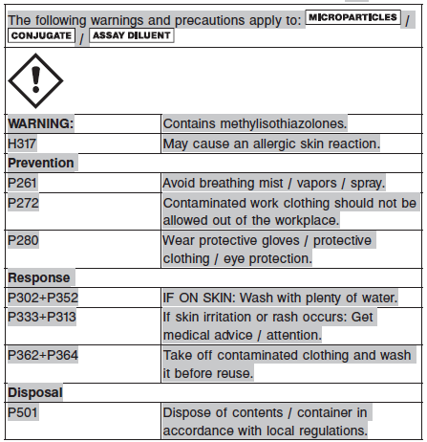

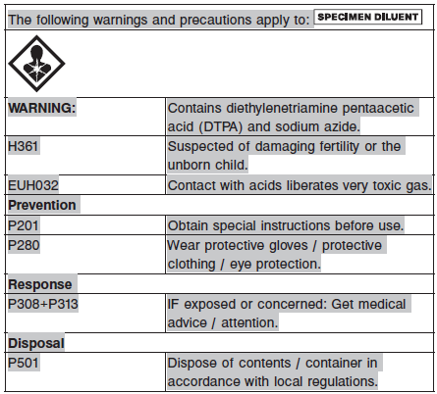

**Reagent Handling**

* Do not use reagent kits beyond the expiration date.
* **Do not pool reagents within a kit or between reagent kits.**
* Before loading the ARCHITECT Reagent Kit on the system for the first time, the microparticle bottle requires mixing to resuspend microparticles that have settled during shipment.
* **Septums MUST be used to prevent reagent evaporation and contamination and to ensure reagent integrity. Reliability of assay results cannot be guaranteed if septums are not used according to the instructions in the package insert.**
* To avoid contamination, wear clean gloves when placing a septum on an uncapped reagent bottle.
* Once a septum has been placed on the reagent bottle, **do not invert the bottle** as this will result in reagent leakage and maycompromise assay results.

**ARCHITECT Estradiol requires the use of List Number 4D18-02 or higher septums.**

* Over time, residual liquids may dry on the septum surface. These are typically dried salts and have no effect on assay efficacy.
* For a detailed discussion of handling precautions during system operation, refer to the ARCHITECT System Operations Manual, Section 7.

**Mixing Instructions**

* Before loading the ARCHITECT Estradiol Reagent Kit on the system for the first time, the microparticle bottle requires mixing to resuspend microparticles that have settled during shipment:
* Invert the microparticle bottle 30 times.
* Visually inspect the bottle to ensure microparticles are resuspended. If microparticles are still adhered to the bottle, continue to invert the bottle until the microparticles have been completely resuspended.
* **If the microparticles do not resuspend, DO NOT USE. Contact your local Abbott representative.**
* Once the microparticles have been resuspended, remove and discard the cap. Wearing clean gloves, remove a septum from the bag. Carefully snap the septum onto the top of the bottle.
* ARCHITECT Estradiol Calibrators and Controls should be mixed by gentle inversion prior to use.

**Reagent Storage**

* The ARCHITECT Estradiol Reagent Kit must be stored at 2-8°C and may be used immediately after removal from 2-8°C storage.
* When stored and handled as directed, reagents are stable until the expiration date.
* The ARCHITECT Estradiol Reagent Kit may be stored on-board the ARCHITECT *i* System for a maximum of 30 days. After 30 days, the reagent kit must be discarded. For information on tracking on-board time, refer to the ARCHITECT System Operations Manual, Section 5.
* Reagents may be stored on or off the ARCHITECT *i* System. If reagents are removed from the system, store them at 2-8°C (with septums and replacement caps) in an upright position. For reagents stored off the system, it is recommended that they be stored in their original trays and boxes to ensure they remain upright.
* For information on unloading reagents, refer to the ARCHITECT System Operations Manual, Section 5.

Reagents

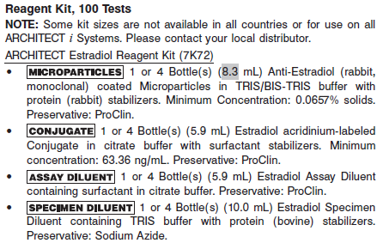

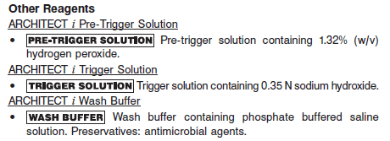

**Calibrator:** 7K72-01 ARCHITECT Estradiol Calibrators

**Quality Control:** 7K72-10 ARCHITECT Estradiol Controls

**Calibration**

**Frequency:**

Recalibration is required with each new reagent lot number.

**A new calibration is required:**

1. If quality control results do not meet acceptance criteria defined by your laboratory, patient values may be suspect. Follow the established quality control procedures for your laboratory. Recalibration may be necessary.
2. Review quality control results and acceptance criteria following a change of reagent or calibrator lot.

**Calibrator Required:**

7K72-01 ARCHITECT Estradiol Calibrators

**Reagents:**

6 Bottles (5 mL each) of ARCHITECT Estradiol Calibrators. Calibrator A contains TRIS buffer with protein (bovine) stabilizers and Calibrators B through F contain estradiol in TRIS buffer with protein (bovine) stabilizers to yield the following concentrations.

**Calibrator Preparation:**

Calibrators may be used immediately after removal from 2-8°C storage.

Prior to each use, mix by gentle inversion. After each use, tightly close the caps, place bottles in carton to protect from light and return the calibrators to 2-8°C storage.

**Calibration Procedure:**

To perform an ARCHITECT Estradiol calibration, test Calibrators A through F in duplicate. A single sample of all levels of estradiol controls must be tested to evaluate the assay calibration. Ensure that assay control values are within the concentration ranges specified in the control package insert. Calibrators should be priority loaded.

**•** Calibration Range: 0 - 1000 pg/mL.

**Troubleshooting and Overall Acceptance Criteria Failure**

See ARCHITECT Operations Manual for further calibration troubleshooting.

**Quality Control:**

Abbott recommends, refer to your laboratory standard operating procedure(s) and/or quality assurance plan for additional quality control requirements and potential corrective actions:

• At a minimum a single level of quality control are to be run every 24 hours

• If more frequent control monitoring is required, follow the established quality control procedures for your laboratory.

• If quality control results do not meet the acceptance criteria defined by your laboratory, patient values may be suspect. Follow the established quality control procedures for your laboratory.

Recalibration may be necessary.

• Review quality control results and acceptance criteria following a change of reagent or calibrator lot.

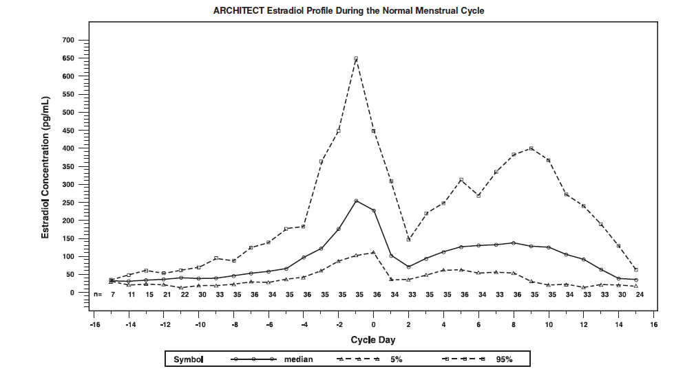

**Instrument Procedure**

* **The ARCHITECT Estradiol assay requires that ARCHITECT *i* Trigger Solution be stored on-board for no longer than 10 days after the day it is installed. Write the on-board expiration date on the trigger bottle (install date plus 10 days is the on-board expiration date).**
  + **NOTE: Trigger can be used through the on-board expiration date. This date must not exceed the printed expiration date of the ARCHITECT *i* Trigger Solution.**
* The ARCHITECT Estradiol assay is designed for use on the ARCHITECT *i* System
* The ARCHITECT Estradiol assay file must be installed on the ARCHITECT *i* System from an ARCHITECT *i* System Assay CD-ROM prior to performing the assay. For detailed information on assay file installation and on viewing and editing assay parameters, refer to the ARCHITECT System Operations Manual, Section 2.
* For detailed information on assay file installation and viewing and editing assay parameters, refer to the ARCHITECT System Operations Manual, Section 2.
* For information on printing assay parameters, refer to the ARCHITECT System Operations Manual, Section 5.
* For a detailed description of system procedures, refer to the ARCHITECT System Operations Manual.

**Assay Procedure**

For a detailed description of how to run an assay, refer to *Section 5* of the **ARCHITECT System Operations Manual**.

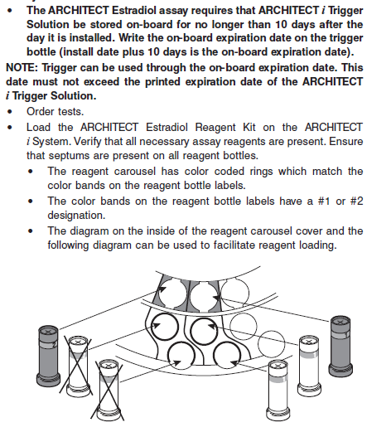

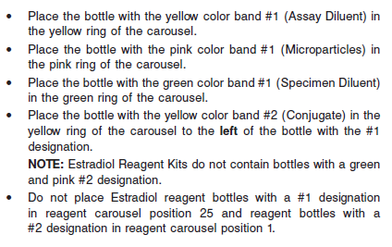

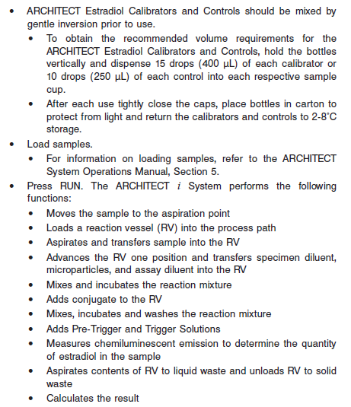

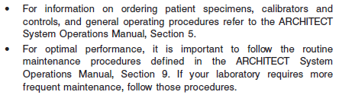

**Results**

The default result unit for the ARCHITECT Estradiol assay is pg/mL.

**Flags**

Some results may contain information in the Flags field. For a description of the flags that may appear in this field, refer to the ARCHITECT System Operations Manual, Section 5.

**Specific Performance Characteristics**

**Expected Values**

It is recommended that each laboratory determine its own reference range based upon its particular locale and population characteristics.

**Serum/Plasma**

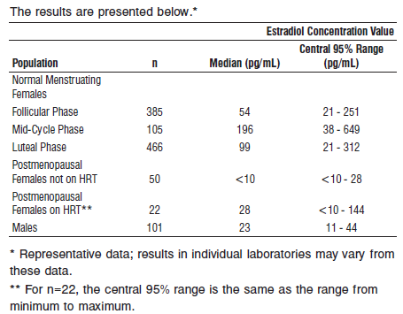

**Critical Values: NA**

**Performance Characteristics**

**Sensitivity**

The analytical sensitivity of the ARCHITECT Estradiol assay is ≤ 10 pg/mL.

The functional sensitivity of the ARCHITECT Estradiol assay is ≤ 25 pg/mL.

**Dilution:**

Specimens with an estradiol value exceeding 1,000 pg/mL are flagged with the code “>1000” and may be diluted with the Automated Dilution Protocol.

**•** If using the Automated Dilution Protocol, the system performs a 1:5 dilution of the specimen and automatically calculates the concentration of the undiluted specimen and reports the result.

**•** Specimens with an estradiol value exceeding 5,000 pg/mL are flagged with the code “>5000” when run using the Automated Dilution Protocol. These specimens may be diluted with the Manual Dilution Protocol.

**•** Manual dilutions should be performed as follows:

**•** The suggested dilution for estradiol is 1:10.

**•** For example, add 20 μL of the patient specimen to 180 μL of ARCHITECT Estradiol Manual Diluent.

**•** The operator must enter the dilution factor in the patient or control order screen. The system will use this dilution factor to automatically calculate the concentration of the specimen before dilution. This will be the reported result. The concentration of the diluted specimen (before dilution factor is applied) should be greater than 100 pg/mL.

**•** For detailed information on ordering dilutions, refer to the ARCHITECT System Operations Manual, Section 5.

**Precision:**

The ARCHITECT Estradiol assay precision is ≤ 5 pg/mL (total SD) for concentrations in the range of the low control (target 45 pg/mL), and ≤ 7% (total CV) for concentrations in the range of the medium control (target 190 pg/mL) and the high control (target 600 pg/mL).

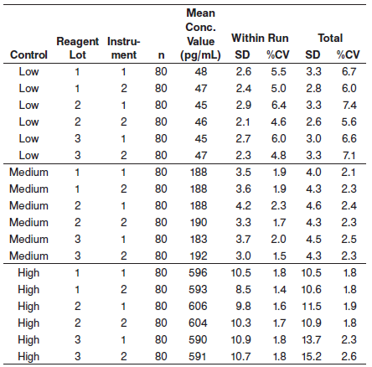

#### Limitations of Procedure

* Specimens from patients who have received preparations of mouse monoclonal antibodies for diagnosis or therapy may contain human anti-mouse antibodies (HAMA). Specimens containing HAMA may produce anomalous values when tested with assay kits that employ mouse monoclonal antibodies.
* Heterophilic antibodies in human serum can react with reagent immunoglobulins, interfering with *in vitro* immunoassays. Patients routinely exposed to animals or to animal serum products can be prone to this interference and anomalous results may be observed. Additional information may be required for diagnosis. Immunoassays are nonspecific and cross react with metabolites.
* Specimens from patients with adrenal tumors or congenital adrenal hyperplasia may exhibit elevated levels of DHEA-S

**Specificity**

The specificity of the ARCHITECT Estradiol assay was determined by studying the compounds listed below in either the absence or presence of estradiol using guidance from CLSI protocol EP7-A.

**Table A\***

A study was performed in which synthetic specimens containing essentially no residual estradiol were supplemented with potential cross reactants at the concentrations listed and tested for estradiol. The percent cross reactivity is shown below:

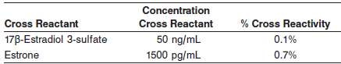

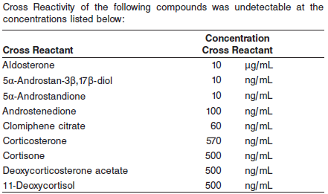

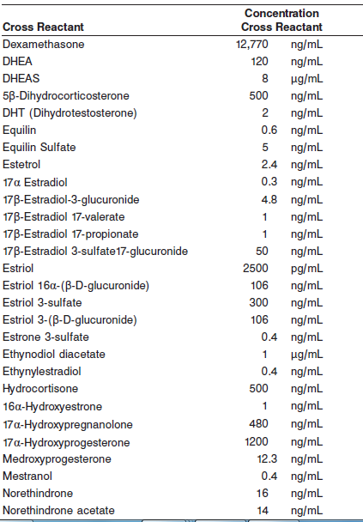

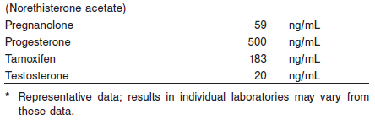

**Table B\***

The ARCHITECT Estradiol assay recovery in the presence of the following compounds is 100 +/- 40% at the concentrations listed below:

A study was performed in which synthetic specimens containing estradiol (600 pg/mL) were supplemented with potential interferents at the concentrations listed and tested for estradiol. The percent recovery is shown below:

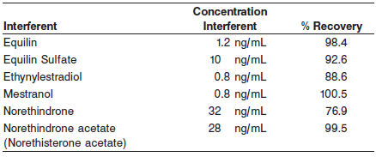

The ARCHITECT Estradiol assay recovery in the presence of the following compounds is 100 +/- 10% at the concentrations listed below:

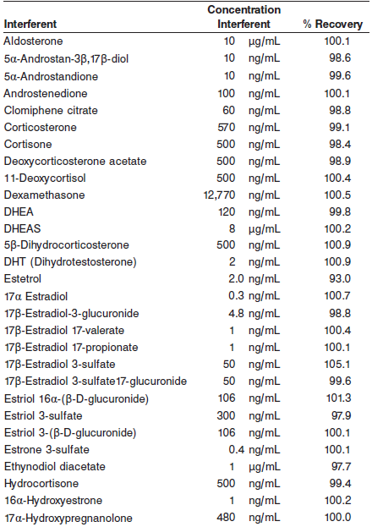

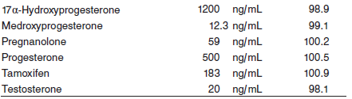

**Table C\***

The ARCHITECT Estradiol assay recovery in the presence of the following compounds is 100 +/- 10% at the concentrations listed below:

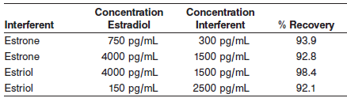

**Interference**

Potential interference in the ARCHITECT Estradiol assay from hemoglobin, bilirubin, triglycerides, protein, and cholesterol at the levels indicated below is ≤ 10%. Interference was evaluated in a study based on guidance from CLSI protocol EP7-A.

**•** Hemoglobin at 500 mg/dL

**•** Bilirubin at 20 mg/dL

**•** Triglycerides at 1000 mg/dL

**•** Protein at 4 and 12 g/dL

**•** Cholesterol at 240 mg/dL

**References:**

1. ABBOTT ARCHITECT Estradiol package insert

Abbott Laboratories

Diagnostics Division

Abbott Park, IL 60064

June 2015 G5-6536/ R06

1. ABBOTT ARCHITECT Estradiol Calibrator package insert

Abbott Laboratories

Diagnostics Division

Abbott Park, IL 60064

1. Abbott ARCHITECT Operator’s Guide