**TITLE:** ELGA MEDICA Pro EDI

**Principle:** The Department of Chemistry at Rush Copley Medical Center will use Type 1 water supplied by two ELGA Medica Pro EDI water units for the operation of the Abbott ci8200 chemistry analyzers. The Elga units will be monitored daily for quality in addition to being sanitized and cultured monthly. When the water quality begins to deteriorate the filters will be replaced as needed.

The Medica Pro EDI units supply the analyzers with quality water using UV and microfiltration together with recirculation and ion exchange. A bypass loop allows for continual supply of water to both Abbott analyzers even if one of the Medica units is non-operable.

**Specimen requirements: N/A**

**Reagents and Supply Requirements:**

|  |  |
| --- | --- |
| **CONSUMABLES** | **REPLACEMENT FREQUENCY** |
| LC105 (UV LAMP) | 12 months |
| LC109 (ULTRA MICRO FILTER UMF) | 12 months |
| LC136 M2 (VENT FILTER) | 6 months |
| LC207 (DI CARTRIDGE) | 2 months |
| LC206 (CONDITIONING CARTRIDGE) | 2 months |
| LC177 (PROTEK L2) | As needed |
| LC193 (RO CARTRIDGE) | 3 years |
| EFFERSAN SANITATION TABLETS  CHGUGU328092 | monthly |
| 5um SEDIMENT FILTER  CFCBYO200416 | As needed |
| CARBON BLOCK (Chloramines removal)  CFCBZD308747 | As needed |

**Operation of Medica Pro EDI Water Unit:**

The Medica Pro EDT control panel has a range of control icons. General icons are as described below.

 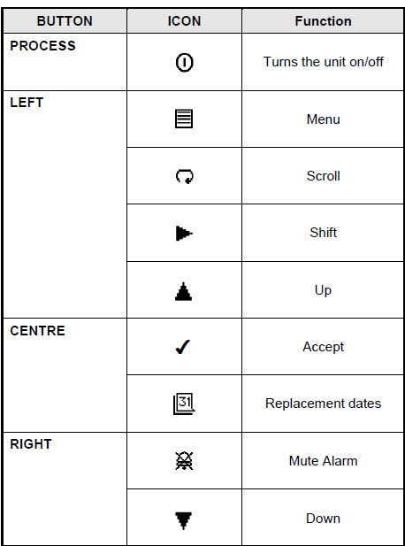

1. Each Medica unit will run continuously without any operator intervention. The units are circulating properly when the arrows on the display window are moving
2. A reading above >15 MΩ.cm indicates good water quality
3. The results of the Daily System check are recorded on the Maintenance log sheet

**USER RECOGNITION KEYS** (Keys are located on a ring inside the front door of each unit)

1. A master key (black) allows for the highest level of access (to be used by service engineer)
2. User key (blue) only have access to customer preference screens (operators can changed settings if necessary)
3. Sanitization key (green) starts the sanitization process and stops the general user from accidentally starting the sanitization cycle (this key will be used by the Technologist during the monthly sanitization procedure)
4. For more detailed information on the use of the keys refer to the Operator’s Manual.

**Maintenance:**

**Daily:**

* + - 1. Pre-filter check: check gauges on the pre-filters, there should be less than 12 psi difference on each set pressure gauges. If the difference is >12psi follow instructions for replacing the 5um Sediment filter and Carbon Block filters.
      2. Check water quality: >15 MΩ.cm is desired. An alarm will sound when water quality is <10 MΩ.cm. Alarm can be silenced by pressing the alarm icon on the display window. Follow instructions for changing specific filters types.

**Monthly Sanitization of the RO Tank:**

Sanitization of the RO is essential to ensure the system is properly commissioned and capable of achieving the bacteriological control required for a typical application.

1. Present Green sanitization key to reader (key is located inside the door of the unit).

2. Press √ to enter sanitization.

3. Press √ to enter RO sanitization.

4. Unscrew the large white lid on the left of the unit.

5. Add ½ Effersan Sanitation tablet and replace lid.

6. Present Green sanitization key to the reader to confirm the Effersan tablet has been added.

1. The system enters a period of automatic sanitization lasting approx. 32 minutes.
2. Once complete, the unit will go straight into process and continue to fill the recirculation reservoir.
3. Using the Black Master key; update the calendar icon to indicate the sanitization has been completed. This will also reset a reminder to the unit when the sanitization is past due.

**Monthly Water Cultures:**

* + - 1. Ensure Medica system is in recirculation mode.
      2. Locate the port on the right side of each Medica Pro EDI water unit.

3. Wipe off the gray tip using 70% isopropyl alcohol.

**Sampling Method**

* + - 1. Turn knob until water begins to flow out and allow water to drain into a large bucket for 2-3 minutes.
      2. Open sterile container and collect 20-30 mls of Medica water, ensuring not to contaminate the sample.
      3. Turn off sample port and replace gray tip.
      4. Repeat process for the 2nd Medica Pro EDI unit.
      5. Order cultures in Soft Laboratory software: Patient Name is Chemistry DI Water; order-culture environmental; source- water; site- free text the Medica Unit#
      6. Properly label samples.
      7. Deliver to the Microbiology department for processing.
      8. Record final results on log sheet.

**Culture Results and Interpretation**

1. Expected result for a water culture is < 10 cfu/mL.
2. For unacceptable results:
   * + - 1. Repeat the culture using a fresh sample
         2. If the culture comes back >10 cfu/mL the 2nd time turn off the unit
         3. Call Elga Hotline for service 630-296-0850

**Bi-Monthly Maintenance**

1. Replacing Purification Cartridge (LC207) and Conditioning Cartridge (LC206)
   * 1. To be replaced every 2 months or when the purity of water from the unit starts to deteriorate as indicated by the consumable alarm. These filters are to be change simultaneously.
     2. Ensure process is OFF.
     3. Open right door and locate the Purification cartridge (shorter pack on the right) or Conditioning cartridge (longer pack located next to the purification pack).
     4. Push purification or conditioning cartridge forward and lift then pull to remove the used cartridge and discard.
     5. Remove the sealing plugs on the new cartridge and wet o rings and slide the new cartridge into position pushing upwards and against pack reader contacts.
     6. Ease back and ensure the pack is fully engaged in the retainers.
     7. Switch on power and follow screen prompts to accept the new cartridge replacement date.
     8. Start unit and allow water to circulate until acceptable quality is achieved
     9. Reset reminder by pressing the √
     10. Write the date of replacement on the new filter as well as document the filter type and date replaced on the Maintenance log

**Semi-Annual Maintenance-to be performed by Elga**

1. Change Inline 0.05µ Ultra-Microfilter (LC109)
2. Change composite Vent Filter (LC136M2)

**Annual Maintenance- to be performed by Elga**

1. Change UV Lamp (LC105)
2. Change Recirculation Pump (PUMP35942)
3. Sanitize of the entire system.

**Every 2-3 year Maintenance-to be performed by Elga**

1. Replace RO Membrane (LC180)
2. Replace Degasser Membrane (LC181)

**As needed maintenance -to be performed by RCMC Chemistry Department**

1. Replacing the Protek L2 20” 5 micron Filter (LC177)

* + 1. Filter should be replaced when indicated by the alarm code 75 or after replacement of RO modules.
    2. Stop the process and shut off the power to the unit.
    3. Open front door and locate Protek filter (Blue canister located on the left side of unit).
    4. Place absorbent towels under filter to minimize spills.
    5. Remove canister by turning clockwise, discard the water in the canister.
    6. Remove and discard the old filter and replace it with a new.
    7. Inspect “O” rings and ensure they remain in place.
    8. Screw the canister containing the new filter into its housing; it is not necessary to fill with water.
    9. Return power to the unit and check for leaks, if unit leaks turn off the power and re-seat the canister.

1. Replacing the 20” Carbon Pre-filter and Internal Sediment Pre-filter Cartridge (to be replaced when there is a >12 psi difference between the two-as indicated on the pressure gauges).
   * 1. Ensure both Medica Pro EDI units have >30 liters of water in their tanks (reading can be found on display window of Medica Unit).
     2. Power off unit corresponding to the filters being replaced.
     3. Turn off the main valve to the set of filters (valve is located on the inlet tubing).
     4. Push the red button on the top of the filter to release the pressure (pressure should read 0 psi before unscrewing canister).
     5. Place a large bucket or garbage can under the filters.
     6. Using the hand tool unscrew cartridge housing, discard water in the canister.
     7. Replace filters.
     8. Inspect the “O” rings, replace them if they appear worn or clean and lightly grease them with Lubrication grease.
     9. Screw canister back into place ensuring it is seated correctly in the housing.
     10. Turn valve to the on position and press the red button to return water to the canister.
     11. Check for leaks (if filters are leaking repeat steps c-i).
     12. Turn the main power back on to the Medica Pro EDI unit.

**Emergency Bypass**

Contact your local service provider before putting the unit into emergency bypass. The emergency bypass is to be used only if there is a complete loss of power or the pumps fail on both units. When put into bypass mode the operator will still have access to distilled water.

1. Ensure the process is off
2. Disconnect the electrical supply
3. Open the doors
4. Close valves 1 and 2
5. Remove plastic cover 3
6. Open valve 3
7. Close valve 3 when there is no requirement for purified water and monitor water purity independently by installing a new LC207 cartridges to guarantee water purity

**Control Panel**

The control panel key is as follows:

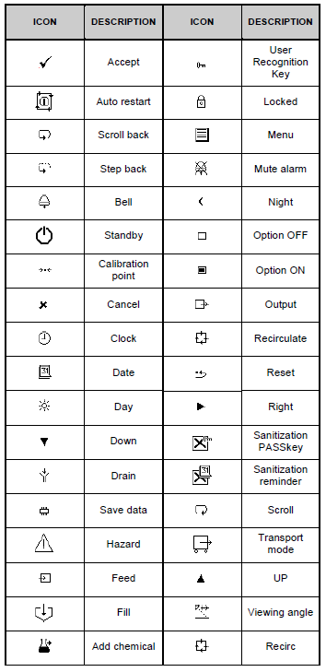

**Troubleshooting**

If a problem occurs, the unit will normally sound an alarm and the respective icon will flash. The audible alarm can be silenced by pressing the mute button. The unit will shut-off automatically when a leak is detected by the brass sensors located on the floor inside each unit or when there is a pump failure.

The appropriate action to take is shown on the quick reference guide located on the inside door of the unit. An alarm code will appear on the tip right corner of the display panel. Document all troubleshooting and service calls on the Elga Medica Pro-EDI maintenance log. Below is an alarm summary:

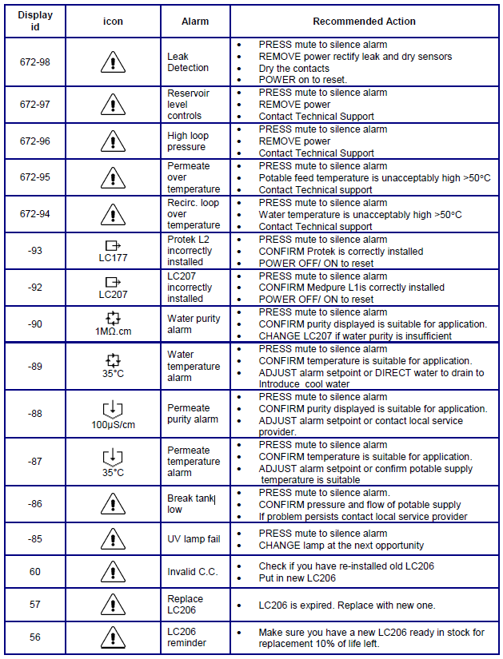

**References**

1. Medica Pro EDI Operator Manual: Version 1-05/12
2. Medica Pro EDI – US Quick Start Manual: MANU40683 Ver. 1-02/15