TITLE: Aerospray Hematology Pro Use and Maintenance

PRINCIPLE:

The Aerospray Hematology Pro Slide Stainer/Cytocentrifuge (Model 7152) is a dual-purpose, microprocessor-controlled slide staining and cell preparation system. In use, atomizing spray nozzles apply fresh reagents onto microscope slides prepared with blood or other body fluid specimens. The slides are mounted in a rotating carousel for processing.

Staining options include a Rapid stain mode, a longer Wright-Giemsa mode and a May Grünwald Giemsa (MGG) mode. These modes allow variation in the eosin/thiazin ratio and the spin time (see Appendix D). A fully programmable Custom stain mode is also available. Near the end of the staining cycle, after purging the lines and rinsing the slides with methanol, the slides are rapidly dried by high-speed carousel rotation.

Personnel:
Medical Technologist

SPECIMEN:
Patient Preparation: No special preparation by laboratory personnel necessary.
Type of Specimen: Well mixed blood and body fluids
Handling precautions: Handle all specimens using Standard Precautions

REAGENTS:
A - Rinse
B – Thiazin Stain (Blue)
C – Eosin Stain (Red)
D – Methanol or Aerofix®
Note: Methanol must be 99.5% pure no more than 0.5% water.

EQUIPMENT
Aerospray, glass slides,

CALIBRATION
No calibration required.

QUALITY CONTROL
A daily QC slide is run at the beginning of each day shift.

STEPWISE PROCEDURE

- Loading and Unloading the Carousel
Caution: Never load chipped or cracked slides into the instrument. Slides in poor condition may break during the staining cycle. If a slide breaks in the bowl, see Aerospray Applications Manual: Cleaning Broken Slides (Section 5.4)
Caution: Keep small ferrous metal objects away from the lab bench. These objects can be attracted to the magnets on the bottom of the carousel and cause damage if spun free during instrument operation.
Caution: Load slides in balanced pairs. If staining an odd number of slides, use a blank slide to balance carousel.

- Remove the carousel from the bowl and place it on a solid, level surface.
- Remove the carousel lid by pressing the button and lifting the lid.
- Place blocking slides in position 11 and 12, these slides are to remain in the carousel unless performing maintenance.

- Insert the slides to be stained into the carousel with the first slide in position 1.
- Load slides in balanced pairs (directly opposite one another) to balance the carousel. If staining an odd number of slides, use a blank slide to balance the carousel.
- Load slides with the labels toward the center of the hub of the carousel.
- Always load slides with the specimen facing clockwise (side with arrow).
- Always place the first slide in position 1, the second in position 2, and so on.
- If carousel is not full, blank slides should be used as blocking slides in the slots after the last slide to be stained (make sure slides are balanced)
- Replace the carousel lid by pressing the button and lowering the lid over the indexing posts. Note: For best results, place smear with the feathered edge toward the outer edge of the carousel.
- Release the button and press the lid handle until it is firmly closed and locked.
- Insert carousel back into instrument and close the instrument lid.
- Select the number of slides to be stained (Do not include blocking slides in the total number of slides). Slide selection defaults to full carousel if no number is selected.
- The desired program appears on the display. If you need to change the program select Programs then select the desired program.

- Press Start. The display shows the progress of the program, and a signal tone indicates the end of the cycle.
- Remove the carousel from the bowl and place it on a solid, level surface.
- Remove the carousel lid by pressing the button and lifting the lid.
- Carefully remove each slide and observe the specimen using a microscope.

Monitoring and Changing Reagents
- Monitor reagent level on the display and by direct inspection of the bottles. The monitor will show the approximate level of each reagent.
- Never allow a reagent to run dry.
- When reagent is blinking on display, change the reagent to a new bottle.
- Remove the empty reagent bottle from its tray but do not disconnect the dip tube.
- Open the new bottle, date and initial it.
- Open reagent information menu by pressing the reagent bottle icon on the right side of the Main menu.
- Select the desired reagent and then press Change.
- Unscrew the cap and remove the dip tube from the empty bottle. Insert the dip tube into the new reagent bottle and screw on the cap.
- Place new bottle in the tray.

Daily Maintenance
- Check reagent levels and expiration dates.
- Once a day or as needed, use a squirt bottle filled with methanol or ethanol to spray the stainer interior. With a clean paper towel or gauze, wipe the nozzle faces and interior surfaces. Use a fine bristled brush as necessary to clean the nozzle orifices.
- Run the Carousel Clean (the icon with the carousel image) followed by a System Clean (image shown below) cycle at the end of each shift or as required to keep the stainer clean.
- Spray the exterior case using methanol or ethanol. Wipe all surfaces clean with a paper towel.
- Initial completion of daily procedure on preventive maintenance chart.

Weekly Maintenance
- Perform the HUB PATTERN (See Page 4) and VOLUME (See Page 5) tests. Record the volume collected from each Reagent on the PM chart.
- If volume trends lower, or if the spray pattern is abnormal, clean the nozzle orifice with a fine-bristled brush or disassemble and clean the affected nozzle(s).
- Wipe down the nozzles, carousel tray and carousel lid, using methanol or ethanol in a squirt bottle and a paper towel.
- Slowly pour 200-300 mL of alcohol or SS-230 into the instrument drain to prevent buildup of fibers, precipitates, etc. Verify drain is flowing properly and not allowing fluid to back up in a bowl or flow out of air vent.
- Initial completion of weekly PM.

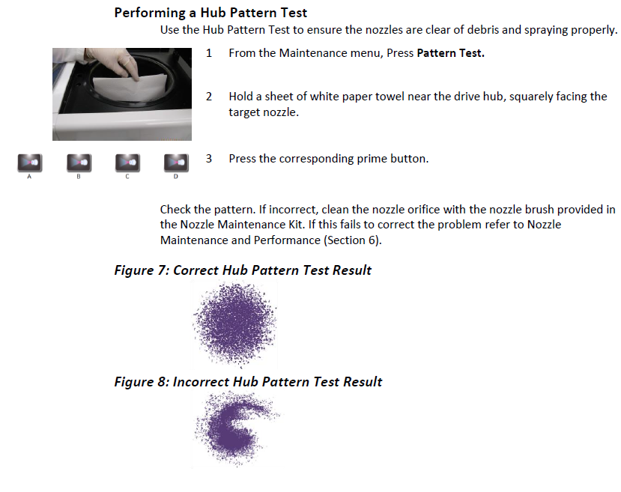

Performing the Volume Test
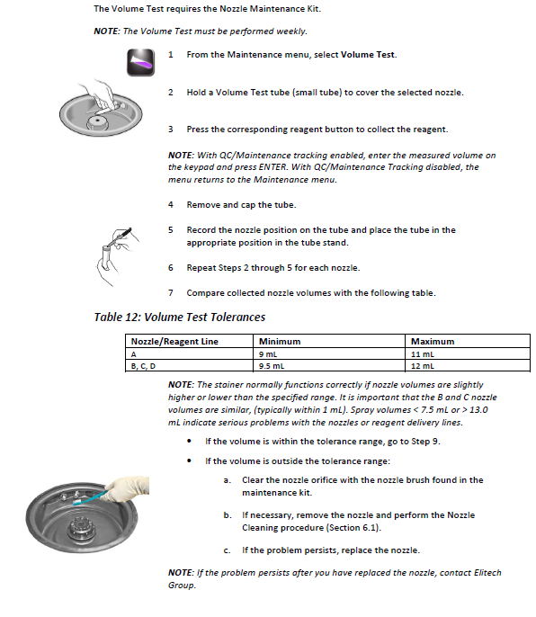

Monthly Maintenance
- Disassemble and clean both nozzles. (see Aerospray Applications Manual: Nozzle Disassembly and Cleaning Section 6.1) Do not mix or interchange nozzles or nozzle parts.
- Reinstall nozzles. Always return nozzles to the same location in stainer.
- Perform HUB PATTERN and VOLUME tests. Record results of end of month VOLUME test on preventive maintenance chart.
- Disinfect reusable rinse (Reagent A) bottle with a 1/10 dilution of bleach. Allow to stand in bottle for 10 minutes. Rinse thoroughly with deionized water.
- Initial completion of monthly PM.

Annual Maintenance
- Clean the B & C reagent lines with prepared SS-029C, methanol, or ethanol. This procedure may be used whenever volume test shows declining values with a clean nozzle.
- Check internal and exterior tubing and fittings for cracks, leaks, or any type of deterioration. Replace as needed.

REFERENCES
- Aerospray Hematology Pro Model 7152, Applications Manual, ELITechGroup, Inc., 2015.

