TITLE: SENDOUT ID/MIC

PURPOSE:

To provide instruction to staff for ordering and resulting of isolates that are sent to RML for further identification and or susceptibility testing.

PERSONNEL:

Medical Technologists

PROCEDURE:

- On the day you are sending an isolate to RML for further ID and or MIC testing, click on Add Test and enter test Code SENDO in the Code: entry box. This new test will be added to the same order number. It must be resulted separately as an individual test. SENDO must be added to every order that has an isolate sent to RML for further testing.

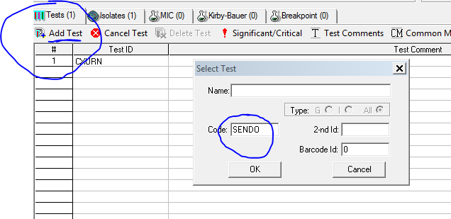

- Issue a preliminary result for SENDO: Choose the P key from the resulting keypad and enter the Date at the end of the comment. Issue a Prelim result and Save. SENDO results are not chartable so you will not see the result on the instant report. SENDO is used for tracking and billing purposes only.

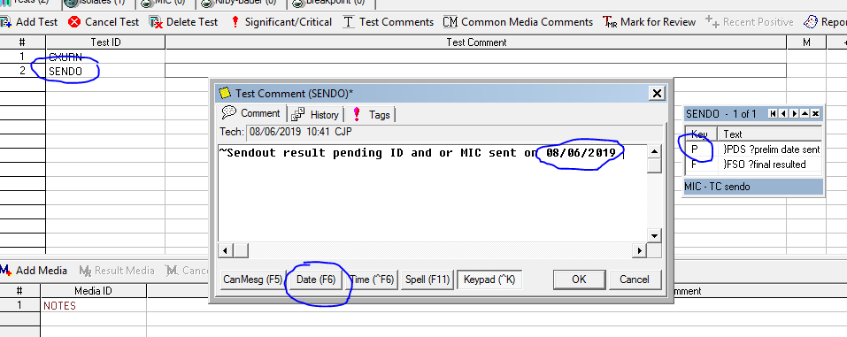

- After final results are received from RML and entered into the original culture results, update the SENDO test using the resulting keypad selecting the F key. Issue a final report for SENDO when no further sendout results are pending from RML for the culture.

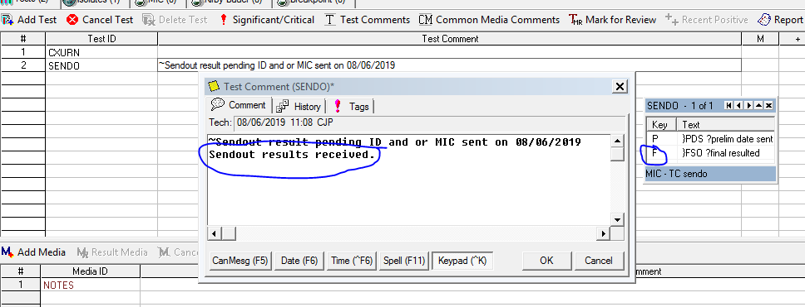

QUALITY CONTROL:

N/A

