**TITLE:** Chemistry SOFT 4840-CH 401

**Personnel:** Medical Technologists, Medical Laboratory Scientists and Medical Technicians

**Specimens:**

Specimens delivered to chemistry will have the collection label on the tube or urine container.

The label has the following information on it:

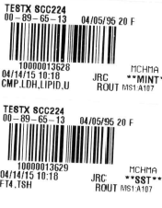

Patient Name

MRN Birthdate Age Sex

BARCODE

Barcode number Department

Date Time Initials of Phleb Tube

Tests on the barcode Patient Location

There may be more than one test listed on the label. If there is a + at the end of the tests on the label, there are more orders on that barcode for Chemistry.

The stars on each side of the container mean that no aliquoting is required. The tests are to be run on the collection container.

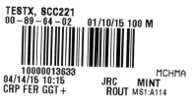

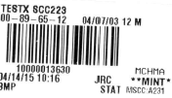

There are several ways to enter results: Instrument Menu, Resulting Worklist, and Result Entry. We will be using Primarily Instrument Menu and Resulting Worklist.

**Resulting from the Instrument Menu:**

Choose the Instrument Menu:

From the menu choose the analyzer which you are running

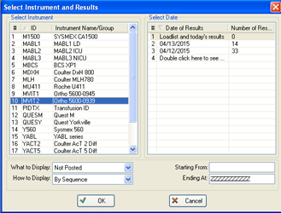

The Date of results defaults to the current date. If for some reason you need results from an earlier day, you can just click on the date. The Default for What to Display is Not Posted, which means all you will see in the interface is results that are not Auto verified. We will auto verify results that are Normal or Abnormal. If the results, for example for the Basic, have a Critical, a Delta Check, or a Test that is diluting the entire panel will not Auto-verify. If there is nothing in the Queue the screen will be blank.

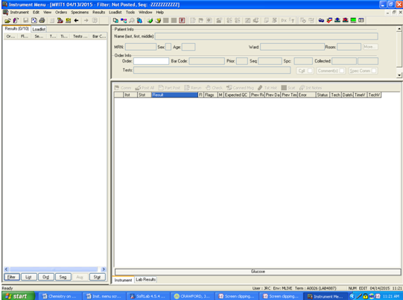

If you want to see everything in the queue Click on the Filter button at the bottom left of the screen and a box will pop up.

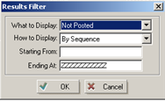 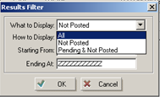

Click on the down arrow and change to All Click OK

You will then see everything that has been sent to the instrument for that entire day. This includes QC as well as patients.

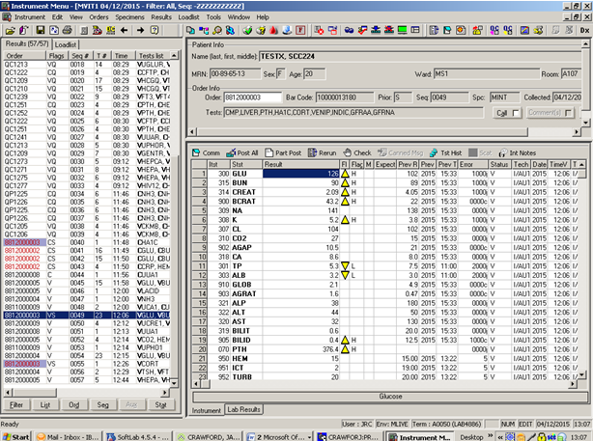

The left side of the screen has the following:

Order No. , Flags, Sequence No., # of Tests on the Order, Time and a list of the tests on that order.

Flags are Q = QC, V = Verified, R= routine, S = Stat, C= Cancelled – In the instrument Menu the “Cancel” means that that result has been cancelled, because it is Absurd or a “No Result” or is a > result waiting for a dilution.

The right side of the screen has the following:

Test order number, test name, result, flags(arrows up or down in yellow or red), Flags H,L, Expected QC if you are looking at a QC result, Previous result, Previous Date, Previous Time, Status, Tech who verified, Date and Time Verified.

I/AUTO – Means Autoverified from Instrument menu.

NOTE : This specimen did not Auto Verify because the Glucose has a Delta check It appears as a % sign by the H Flag on the Glucose result.

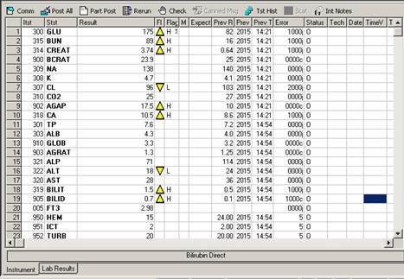

Once the tech determines the result is good, he/she can then click on the “Post All” icon.

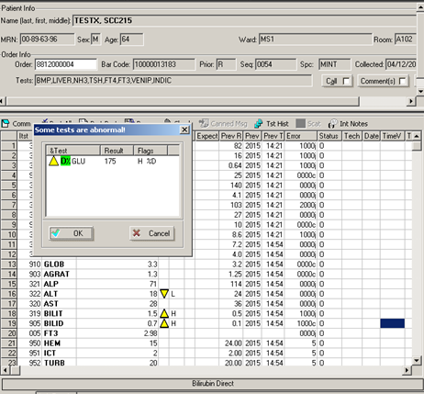

The box shown above appears to remind the tech that ‘Some tests are Abnormal”. It lists anything that is Critical or a Delta Check. If what you see in the box is OK, just click OK the order will then be verified and the menu will go to the next sample that needs to be verified. At this time the system will add the GFR calculation on to any order that includes a Creatinine. It will not add it to an order for a person less than 18 years of age.

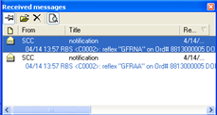

**Resulting from the Resulting Worklists.**

Choose Resulting Worklist

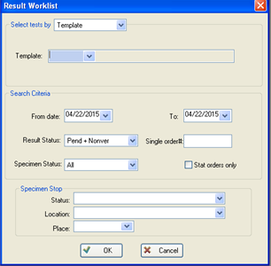

The Result Worklist will open and you will need to select a Template from the drop down.

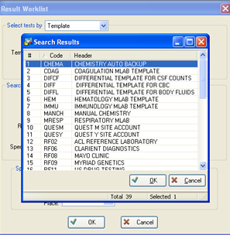

Choose the worklist you want and click OK. The Chemistry Auto Backup has all the tests that can be run. We will use this primarily for downtimes.

The date defaults to the current date.

We only want to see orders that are Pending and Non-verified.

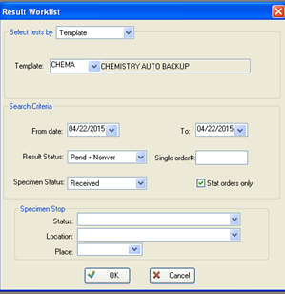

We will primarily be using the Manual Chem Worklist.

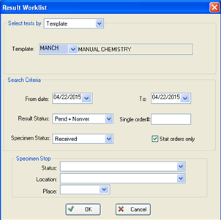

Click OK. The computer will then bridge you to TQC to enter QC if it is required. Only pH, Ketones and Rom Plus have to be entered into TQC, everyt other tests is resulted through the BioRad Unity Real-Time QC program. Once you have entered the required QC, the system will then bridge you back to the resulting work-list.

If QC has already been done for the day, you will just go the work-list.

A keypad for resulting will appear in the upper right corner. Choose the correct result from the keypad or just type in the result.

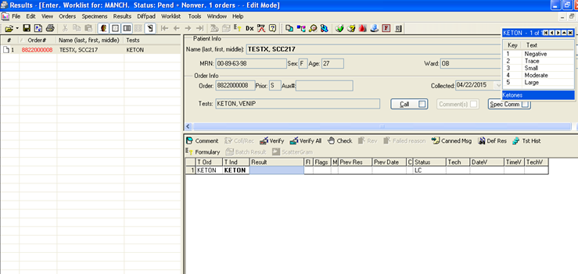

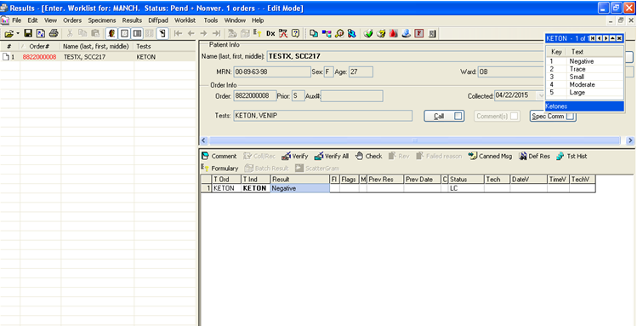

After you enter your result you can click verify. As always the system will then ask if you want to save.

Say Yes or No as needed.

**To check the status of pending tests go to:**

**Oder Status Monitor:**



Click on the Order Status Monitor Icon

At the bottom of the page Choose TAT Monitor



Open the first drop down in Search By and choose Department.



Open the second drop down and choose the department you want.





Click in the box, for Automatic Updates

Then Click on Search



I list will open up with the specimens that have been received .

We also need to do a Pending Report.

Open up the pending however you want to.. Tree, Menu, or Icon.

.

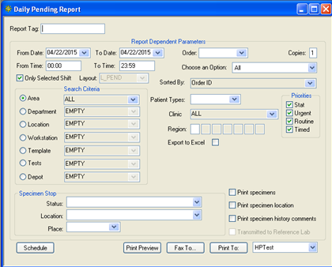

Sort by Department When the search box opens up, double click on Chemistry and it will move to the top, then click OK

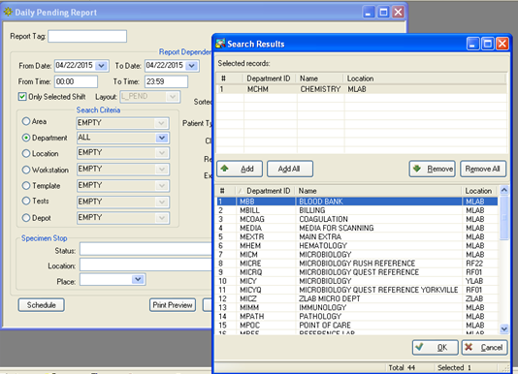



Select Collected from the Choose an Option drop down and then click Print . specimens

You can then either print preview the list or print it to one of the lab laser printers.

**NOTE: At least once per shift print the Pending and check off that you have all your specimens.**

**This may required some investigation if you have a specimen that is collected, but not**

**received.** You may see specimens that have been collected in Yorkville, but have not yet been

received by us.

**Reference:**

Soft Lab 4.5