TITLE: Order Entry - LIS

PRINCIPLE:
Patient Test Orders can either be entered in Hospital Information System (HIS) or entered directly into Laboratory Information System (LIS). This procedure provides guidance for entering orders into LIS, as well sending results to an additional Healthcare Agency other than the requesting provider.
PERSONNEL:

All Laboratory Staff

STEPWISE PROCEDURE:
- General Laboratory Orders
- Login to the LIS, SoftLab, if not already logged in.
- Click on the Order Entry icon (Clipboard with pencil). 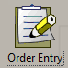
- Enter the patient’s name or identifying information in the appropriate fields, then click Next. Select the correct patient.
- Click “Add New Order” under the correct Billing Number.
- Required fields are highlighted in yellow.
- If the requesting provider is the same as the Att. Dr., click in the ID field, if not, select the appropriate requesting provider.
- The Priority field defaults to Routine. If Stat or Timed is needed, modify the field appropriately.
- The Collect Date and Time will default to the current time. Modify this field if necessary.
- In the ID field, enter the test code you wish to order, or select “Insert” to search for the test. Another option would be to click on the Keypad to select from frequently ordered test list.
- Enter any Order Comment that you need to convey in the Order Comment field.
- Mark the Call box, if the results need to be called to the requesting provider.
  - See Section D.
- If the results need to be sent to an additional Healthcare Agency:
  - Locate the PRN field, and click the drop down.
  - The Reporting Destination window will open, select the drop down at the end of the empty field.
  - From the list, select Modem
  - The Modem Browser will open. You can sort by the column headers to locate the Provider (Location Column) or by Phone, which is the fax number on file.
  - Or, in the Phone field at the bottom of the window, start typing the number you want to send to. Make sure you enter it in the correct format 9,1XXXXXXXXXX
    - Once you start typing you will see the phone list look for the number you are entering.
  - If the number is there, select it and click OK
  - If the number is not listed, verify the Modem Browser window does not have a blue highlighted location because that will override the number entered in the phone field. Click Ok.
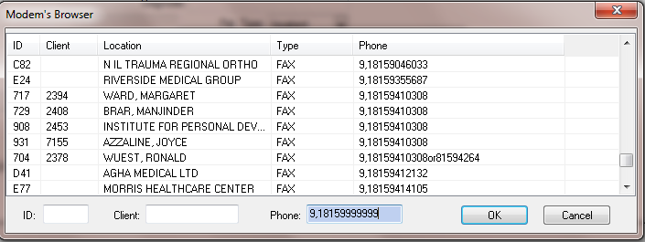

  - The location selected or the Phone number entered will appear in the Reporting Destination Box. If correct, click OK.
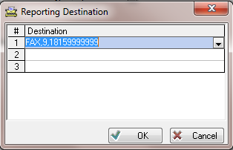

  - If you have more than 1 number to send to, repeat steps 2 thru 8.
* If you find a fax number for a Healthcare Agency that you have to add frequently to the PRN field, let the LIS Analyst know so they can be added to the database. See Auto Fax Setup and Testing, Procedure 4840-LIS-237.
- Save the order.
- Microbiology Orders
  - The procedure for entering Microbiology orders is the same for General Laboratory, except that the system will prompt you to enter the Source and/or Site which can be selected from the drop-down field on the Micro tab.
  - If the patient is on any known antibiotics, enter them in the Current antibiotic therapy drop-down field on the Micro tab. 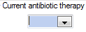
  - Save the order
- Blood Bank
  - Blood Bank orders are the same as General Laboratory, except for blood product orders. Blood product orders such as RBC’s or FFP have required fields in addition to those for General Laboratory.
    - Enter the number of units on the BBank tab.
    - Enter the reason for the transfusion on the BBank tab.
  - Save the order.
- Marking a Test to be Called
In the event that the requesting provider wants to be called with test results, the order or specific test can be marked to be called during Order Entry.

- At Order Entry, click the Call box
- The Call window will open.
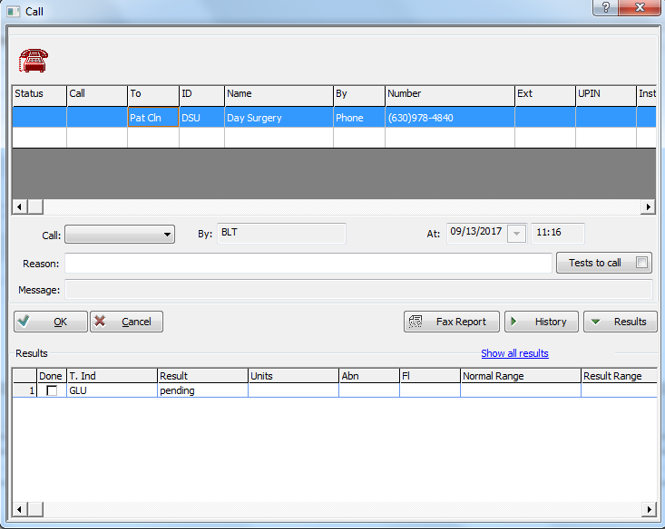
- In the “To” field, from the drop down menu, select the corresponding Provider. If the provider is not listed, select the appropriate “Other” option.
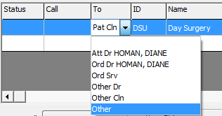
- If the information exists in the LIS, the phone number will populate in the Number field.
  - If “other” was selected, enter the Name and Number.
- In the “Call” field, from the drop down, select “Requested”.
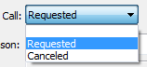
- Enter the Reason for the call.
- Click the “Tests to call” button.
  - By default, the system will select all tests on the order. If only 1 of the tests needs to be called, uncheck “ALL” and check the corresponding test to be called.
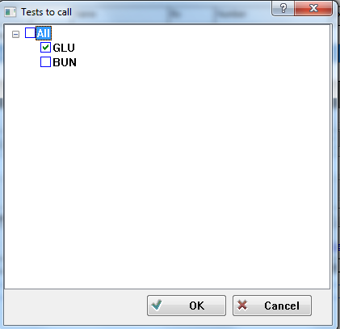
  - Click OK.
- When all the required fields are completed, click Ok.
- Once the results are verfied, the test(s) will qualify to the Call List to be called by the corresponding Department.

