TITLE: Autoverification Suspension

PRINCIPLE: To provide guidance for suspending autoverification.

PERSONNEL: LIS Analyst, Medical Technicians

STEPWISE PROCEDURE:

In the event of a problem with a test method, analytic instrument, or the autoverification program, laboratory personel should be able to suspend autoverification.

- From Instrument Menu, click the Start/Stop Autoposting icon
- The Autoposting window will open and display the current status.
  - 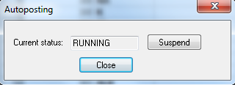
- To stop Autoposting, click “Suspend”.
- When ready to start Autoposting again, click the Start/Stop Autoposting icon
- The Autoposting window will open and display the current status.
  - 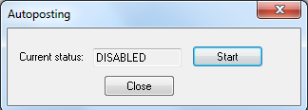
- To start Autoposting, click “Start”

