## TITLE: Interface Restarting - LIS

## PRINCIPLE:

There are times when a System or Instrument Interface may need to be restarted.

**PERSONNEL:** LIS Analyst, Senior Technologists

## STEPWISE PROCEDURE:

**Instrument Interface:**

1. Login to SoftLabMic, if not already done.
2. Click Setup
3. Click Interface
4. Double click Interface Setup
5. The Interface categories will display
   1. 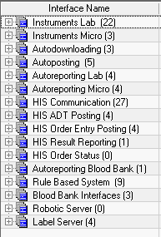
6. If an Instrument needs to be restarted, click the plus (+) sign next to the corresponding category, Instruments Lab or Instruments Micro.
7. Click the appropriate instrument so it is highlighted
   1. 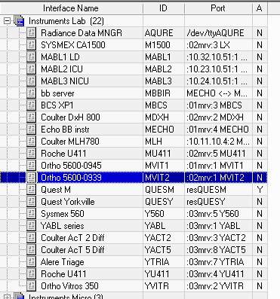
8. Right click and select “Start Interface”. **Do not click Stop Interface.**

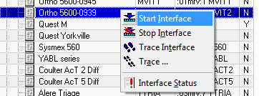

1. An Action Window will open and display the process was killed and restarted. Click Ok.

**Quest Interface**

1. If there is an issue with the Quest Interface and it needs to be restarted:
   1. There are 3 interfaces associated with Quest.
      1. Quest Receiving, Quest Sending and Quest M.
      2. Quest Receiving and Sending should be restarted first. They can be found under the “HIS Communication” category.
      3. 
      4. After they have been restarted, Go to the “Instruments Lab” category and restart the Quest M instrument.
      5. 
2. Highlight the appropriate interface, right click, and then select “Start Interface”.
   1. An Action Window will open and display the process that was killed and restarted. Click Ok.

**ADT Interface**

1. If there is an issue with the ADT (Admission, Discharge, and Transfer) information not flowing to Lab or Blood Bank and the corresponding interface needs to be restarted:
   1. Under the “HIS ADT Posting” category, highlight the corresponding interface
   2. 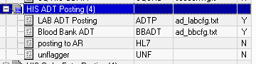
   3. Right click the interface, select “Start Interface”.
   4. An Action Window will open and display the process that was killed and restarted. Click Ok.

**HIS Communication**

1. If there is an issue with communication to or from the HIS and the corresponding interface needs to be restarted:
   1. Under the HIS Communication category, highlight the corresponding interface.
      1. If orders are not transmitting into LIS, restart the “Epic RCV” interface.
      2. If order statuses or results are not transmitting from LIS, restart the “Epic SND” interface.
   2. Right click the interface, select “Start Interface”.
   3. An Action Window will open and display the process that was killed and restarted. Click Ok.
   4. See Screen shot below.
   5. 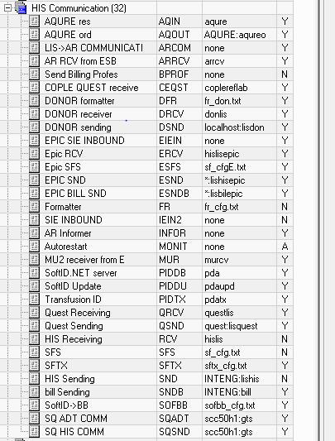

If restarting any of the interfaces does not resolve the issue, please notify the LIS Analyst for further investigation, which may require involving SCC Soft Computer Technical Support or an RCMC Interface Programmer/Engineer.