## TITLE: Auto Fax Setup and Testing

## PRINCIPLE:

Healthcare Agencies (i.e. Home Health Agency) can have their lab reports set up to automatically fax throughout the day from the Laboratory Information System (LIS). This is set up in the Remote Printing setup. Once a fax is setup, a test fax is sent and the healthcare agency is called to verify receipt of the report. The faxing setup is tested with the healthcare agency to ensure that the patient’s results are received successfully and HIPAA is followed.

**PERSONNEL:** LIS Analyst

## STEPWISE PROCEDURE:

1. Login to the SoftLab application.
2. Click on the Remote Printing icon. 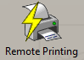
3. Click on the Remote Printing Setup icon. 
4. Click the the“Add” button. 

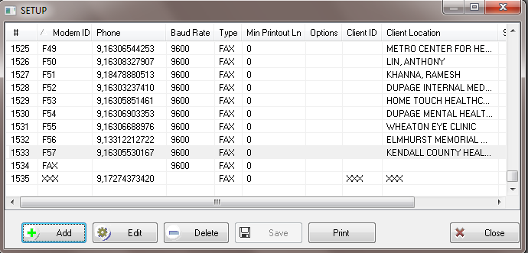

1. Assign a Remote Modem ID, using the next sequential ID. Enter the fax number in the Phone Number field, using the following format: 9,1XXXXXXXXXX. The Baud Rate is always 9600. The Printer Type is FAX; select it from the drop down menu. In the Client Location field, enter the Healthcare Agency name. Click OK. Then click Save.

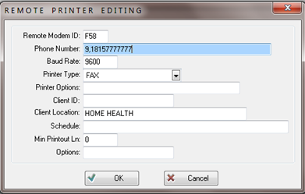

1. To test, manually expedite the fax to the healthcare agency.
   1. In Order Enter, pull up one of the orders for out test patient, ISTEST1 TESTX.
   2. Click the printer icon , then select Instant Report
   3. In the Instant Report window, click the “Fax To” button. Then, click the “Remote Printers” tab.
   4. In the ID field, enter the Remote Modem ID that was created for the healthcare agency, make sure the Fax Cover sheet box is checked, and then click ok. The fax has now been sent.
2. Contact the healthcare agency to confirm they received the fax.
   1. If they did not receive the test fax, review the fax number or setup and make corrections if necessary and retest.
   2. If the fax is received by the healthcare agency, the setup is finished.
   3. The LIS Analyst retains the testing records.
3. Faxes can now be automatically generated to the healthcare agency. See Procedure 4840-LIS-213, section 12.