## TITLE: Fetal Screen Slide (Kleihauer-Betke)

**PRINCIPLE:**

To define a procedure to test for the presence of erythrocytes containing fetal hemoglobin in maternal blood.

The procedure is based on the resistance of fetal hemoglobin to be eluted by a buffer. This resistance is contrasted to adult hemoglobin which is easily eluted from the erythrocytes.

**CLINICAL SIGNIFICANCE:**

There are three main reasons for quantifying fetal red blood cells in maternal circulation.

One is for proper Rhogam quantity administration. The second is detection of a fetal bleed due to placental injury or other uterine trauma. Lastly, it is part of our Intrauterine Fetal Demise order set. The Kleihauer-Betke is ordered along with many other labs to assist providers in diagnosing potential causes for the demise.

Unlike the fetal screening technique, Kleinhauer-Betke staining reacts directly with the fetal hemoglobin and is unaffected by the RH status of the patient or baby.

### PERSONNEL:

Medical Technologists

### EQUIPMENT:

1. Fetal cell stain (0.1% Erythrocin B) - SIMMLER FETAL STAIN KIT.

2. Fetal cell fixing solution (80% reagent alcohol) -- SIMMLER FETAL KIT.

3. Fetal cell buffering solution (citrate buffer, 0.081M) -- SIMMLER STAIN KIT. (Note: all reagents are stable at 8-30C for the period indicated on each kit and on each reagent bottle.

4. Staining jars or staining rack

1. Slides
2. Microscope
3. 0.85 saline solution

**SPECIMEN COLLECTION:**

Maternal blood sample should be collected in EDTA (purple top) tube as soon after delivery as possible. (Cord blood is not acceptable for this procedure). Store sample at 2-4C until it can be processed. The blood smear should be processed within 24 hours of collection.

### STEPWISE PROCEDURE:

A. Patient: Mother’s Blood

B. Quality Control POS Control: Mix 0.1 ml of cord blood and 0.9 ml of normal

adult male blood. Process in same manner as patient sample.

NEG. Control: Use normal male patient as negative control.

C. Procedure: 1. Mix sample well. Place 3 drops of 0.85% saline and 2 drops

of sample into tube - mix gently.

2. Make thin monolayer smear-

Air dry and process immediately.

3. Place smears in Coplin jar containing Fetal Cell Fixing Solution to cover the smears for 5 minutes at room temperature.

4. Remove smears and rinse with distilled H2O. Air dry at room temperature.

5. Place smears in Coplin jar of buffer to cover the smears at room temperature for 8-10 minutes.

6. Immediately place slides in Fetal Cell Stain for 3 minutes.

7. Wash slides and dry at room temperature.

8. Read smears within 24 hours.

9 Place sample in daily rack allowing for 21 day storage. .

### INTERPRETATION:

Slides may be examined either dry or using oil-immersion. Fetal cells will stain a dark reddish-pink while adult cells will appear white to light pink with a darker center. Staining intensity of adult cells may vary slightly within lots of reagents, however, fetal and adult cells will be easily differentiated.

The common means of reporting fetal cells is as a ratio of normal adult cells. This ratio is achieved by randomly observing 8-10 fields of cells. Count the number of adult cells in each field and total them, with a MINIMUM of 2000 cells counted. Count the number of fetal cells in each of the same fields and total the fetal cells. Determine the ratio of fetal cells to adult cells by dividing the total number of fetal cells counted by the number of adult cells counted. If you multiply this number by 100 it will give you the percent bleed. If you multiply this number by 5000 it will give you the total bleed in mL. Then take the total fetal bleed and divide by 30, the number obtained should be rounded down if .4 or lower and rounded up if .5 or higher. Then add 1 and this will be the total number of rhogam vials needed.

Example: Total # Fetal RBC’s Counted 26

Total # Adult RBC’s Counted 4435

Fetal RBC’s/Adult RBC’s Ratio 0.0058

0.0058 X 100 = 0.58%

0.0058 X 5000 = 29 mL fetal whole blood

29 mL / 30 =0.96 round up to 1 and add 1

2 vials of Rhogam recommended

###### An ABORh Type and antibody screen must have been performed on the patient during this admission to release Rhogam.

The number of vials of RhoGAM necessary to protect against Rh immunization is based on the fetal/adult RBC ratio calculated.

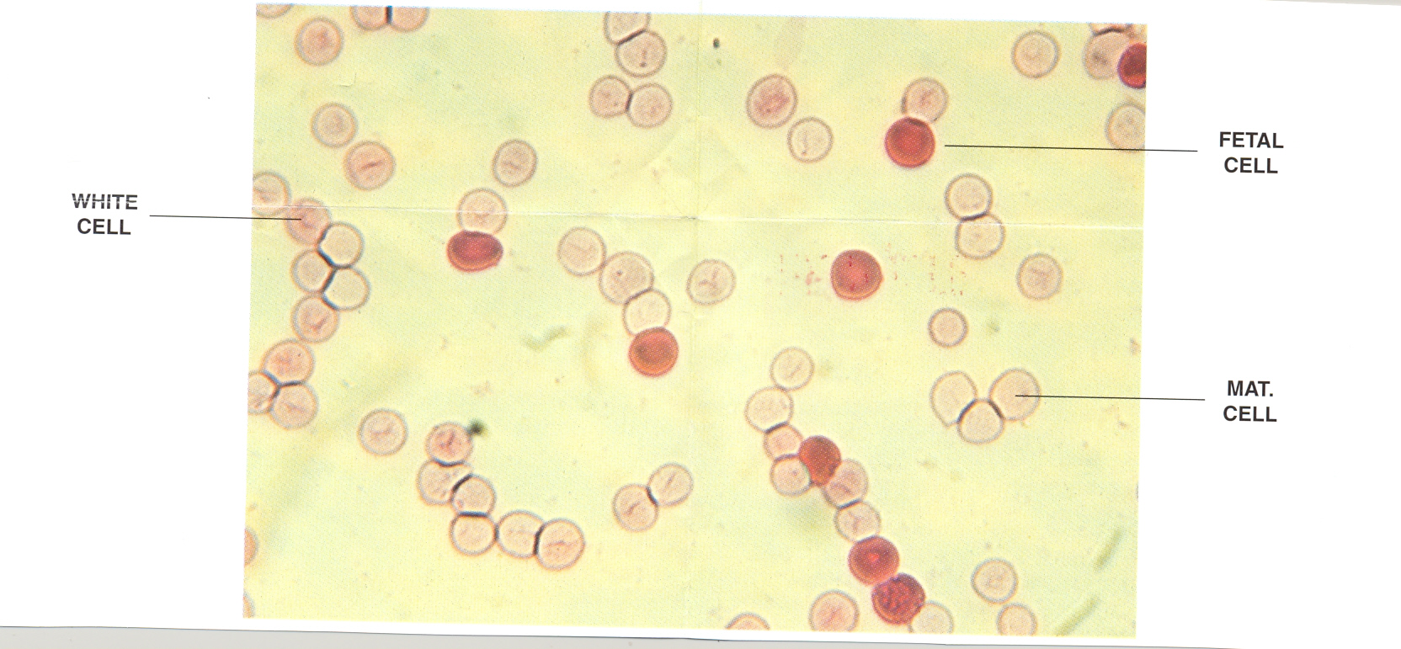

Source of Error

1. Hematological disorders in adults may produce increased levels of fetal-type cells.
2. The degree of elution of the adult hemoglobin may vary from patient to patient.
3. Normal adult blood contains less than 1.0% of fetal-type hemoglobin.
4. Lymphocytes may take up stain in varying degrees, but less than fetal cells (see picture above).

### REPORTING RESULTS:

Report all results through the LIS (Laboratory Information System).

Enter number of fetal cells and number of adult cells, ratio and results for K/B will appear

See Blood Bank Computer Manual for more information.

Enter results as non-detected for negatives and in volume of fetal-maternal bleed, 0-15, 15-30, etc. (see example #2) for positives.

**NOTE:** Anytime your bleed exceeds 75mL you will need to add a comment in the “See Text” box indicating the mL of fetal bleed using the calculations listed above.

**REMEMBER:**

Each vial of Rhogam is enough to neutralize 30mL of whole blood or 15mL of packed RBCs. If a patient received 250mL unit of packed RBCs

250mL / 15 = 16.7 vials, round up to 17 + 1 = 18 vials of rhogam

### REFERENCES:

Fetal Cell Stain Kit Package Insert 01/19

SIMMLER, INC, 2115 59th St., St. Louis, MO 63110

In Missouri 636/376-8347 Collect

Toll Free – 1-800-325-0786