## TITLE: Test Result Routing

## PRINCIPLE:

This policy defines the process for routing of patient laboratory and pathology results to providers and healthcare agencies. Results are routed through the Hospital Information System (HIS) based on Provider. Providers must have an Active Epic User Account with In-Basket Security. All ambulatory (RCMG) providers will have Com Pref set to In-basket by default if/when above applies. All Non-ambulatory (RCMC) providers will be given a Com Pref of Fax by default. Upon request, the provider can be given a non-ambulatory in-basket as long as they have an active user account.

If an additional provider requests a copy of laboratory results, see procedure Order Entry – LIS , 4840-LIS-213, section 12.

If a provider group requests pathology reports to be sent directly from the Laboratory Information System (LIS), see procedure listed below.

## PERSONNEL:

All Laboratory Staff

## STEPWISE PROCEDURE:

1. In SoftLabMic, assign each physician in the group the same courier route in the Doctor Setup under Printer and Reports tab. For example, Dreyer Physicians are assigned a courier route of “DREY”.

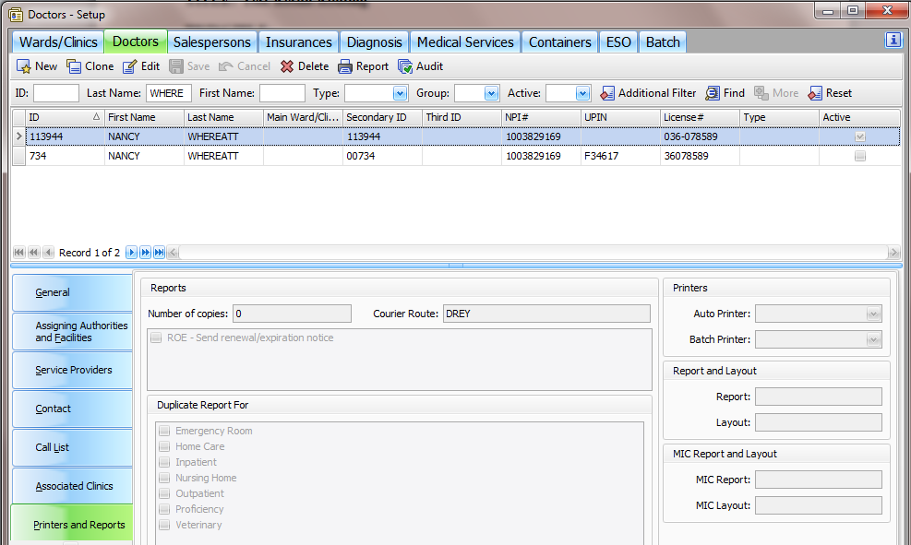

1. In SoftPathDx32, from the shortcut bar, select Shared Reporting Profile. Click New Doctor Reporting Profile.
2. In the Route field, select the courier route created in step 1. Then check the allow CC box.



1. Under the Reporting Rules section, check the Active box and indicate the name of the new profile in the Name section. Assign the effective date.

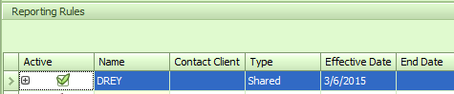

1. In the Delivery Methods section, check the Active box and indicate the fax number that the reports should go to.

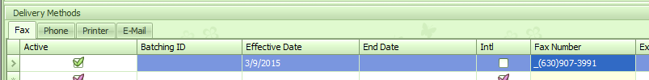

1. Click Save.