TITLE: Security Levels for Users – LIS

PRINCIPLE:
Security levels for all Laboratory Information System (LIS) applications are established by the LIS Implementation Team to secure the database from inappropriate access. These security levels permit access only to those subtasks deemed necessary for the individual user through use of an ID, password and associated position. The user cannot access functions that they are not authorized to use.
PERSONNEL:

All Laboratory Staff

STEPWISE PROCEDURE:
All Laboratory and Respiratory employees have access to the Laboratory Information System (LIS). The patient care areas have access to laboratory results through Hospital Information System (HIS). The patient care areas also have access to SoftID for the collection of specimens.
- The LIS Analyst is responsible for maintaining appropriate levels of access to functions within the LIS modules. Refer to Table A, “Security Level Guidelines” for details. These privilege levels are identified in the Security Management application, under Roles.
  - From the SCC Application Launcher, select Security Management. Only users with a database administrator (RCADMIN) position can login to this module.
  - Click on Role.
  - Search for the Role in the ID field and click Find.
  - The Available System Modules are on the left side and the Options are on the right.
    - If a Module or Option needs to be removed, click Edit, then uncheck the specified module and/or option and save.
    - If a Module or Option needs to be added, click Edit, then check the module or option and save. Any modification to the Role must be thoroughly tested using a test ID that is activated just for the testing.
  - Exit the Security Management application when finished.
- Information Services sets up the user IDs and initial passwords. The position level assigned to the user will be determined by the Lab Manager or Senior Tech. A Confidentiality Statement is signed by the user in orientation that agrees to patient confidentiality to ensure HIPAA (Health Information Portability and Accountability Act) compliance. They also agree to not share their password.
- When the user logs on to the LIS, the ID and password must match against what was entered in Active Directory/Soft Security Management. Access will be denied if they do not match. After the third failed attempt, a message pops up on the screen, “System does not allow more than three tries.” Users are to contact IS if they are locked out of the system or need their password changed.
- To keep the system secure, the user must logoff when they are finished to prevent someone else from using their ID. If the user is stepping away from the computer for any length of time, especially in non-secure areas (i.e. Outpatient Lab), the user must logoff or lock the computer.
  - To lock the computer, press Control, Alt, and Delete at the same time and select Lock this Computer.
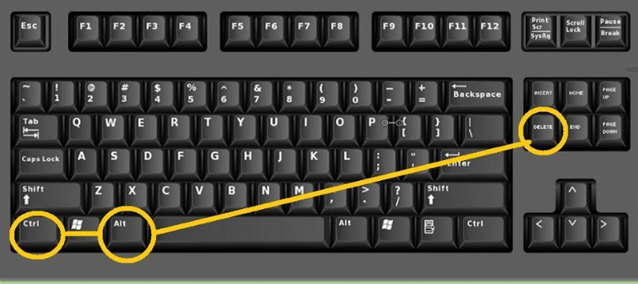

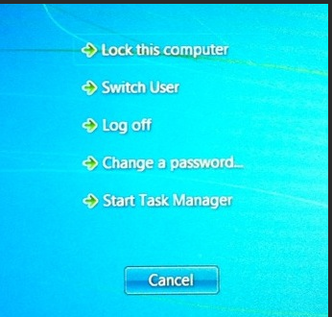
  - Another way to lock the computer is to press the Windows Key and the letter L at the same time.
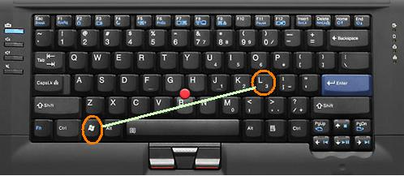
- Depending on their assigned role, the system will automatically lock their application after a specified amount of inactivity. Med Techs will log off after 30 minutes, Yorkville Phlebotomist after 10 minutes, and 3 minutes for Main Lab Phlebotomists.
- If the user finds that they are logged on under someone else’s ID, they must immediately logoff and logon under their own ID. If a user documents under another person’s log-in, the person must follow 4840-G-308, “Laboratory Quality Management Program” to complete a QA Form recording the incident as “post-analytic” and “other.”
Table A, Security Level Guidelines
Position Title(s) | Security Level Name | Access Definition
LIS Analyst, System Administrator, Laboratory Manager, Laboratory Director, and Build Team | RC Administrator | Access to all functions within the LIS modules
Laboratory Senior Technologist | RC Senior Tech | This level can access SoftLabMic, SoftBank, enter results and verify them, change results, change or enter patient demographics and orders, build QC tables and materials and certify QC. Has access to Setup and Management Reports.
Blood Bank Lead or Senior Technologist | RC BB Tech Senior | This level can access SoftLabMic, SoftBank, enter results and verify them, change results, change or enter patient demographics and an order, review QC, access SoftMedia for scanning, and have access to all Blood Bank applications and reports.
Medical Technologist | RC Med Tech 2 | This level can access SoftLabMic, enter results and verify them, change results, change or enter patient demographics and orders, review QC.

Table A, Security Level Guidelines (continued)
Position Title(s) | Security Level Name | Access Definition
Blood Bank Medical Technologist | RC BB Tech | This level can access SoftBank, SoftLabMic, enter results and verify them, change results, change or enter patient demographics and an order, review QC, access SoftMedia for scanning, and has access to all Blood Bank applications.
Medical Technologist | RC Med Tech 1 | This level can access SoftLabMic, enter results and verify them, change results, change or enter patient demographics and orders, review QC.
Micro Technologist | RC Micro Tech 1 | This level can access SoftLabMic, enter results and verify them, change results, change or enter patient demographics and orders, review QC.
Micro Technologist | RC Micro Tech 2 | This level can access SoftLabMic, enter results and verify them, change results, change or enter patient demographics and orders, review QC.
Respiratory Tech | RC Resp Tech | This level can access SoftLabMic, SoftID for specimen collection, can enter and verify results, and change results.
Phlebotomist | RC Phleb | This level can access SoftLabMic, enter results, and verify them, change or enter patient demographics and orders, print patient reports, access SoftID for specimen collection, access SoftMedia for scanning.
Nurse | RC Nurse | This level can access SoftID for specimen collection.
Pathologist | RC Pathologist | This level can access SoftPathDx, result and sign out cases, place orders, gross specimens, add specimens, prepare specimens, panel setup, access reports access SoftMedia for viewing documents.
Pathology Assistant | RC Path Asst | This level can access SoftPathDx, place orders, gross specimens, add specimens, prepare specimens, panel setup, access reports, and access SoftMedia for viewing documents.
Pathology Associate | RC Path | This level can access SoftPathDx, place orders, add specimens, prepare specimens, panel setup, access reports, and access SoftMedia for viewing documents.
Pathology Secretary | RC Path Sec | This position can access SoftPathDx, view and print cases, fax reports, and access SoftMedia for viewing and scanning documents.
Clinical Associate | RC Clin.Associat | This level can access SoftID for specimen collection.
Perfusionist | RC Perfusionist | This level can access SoftBank for viewing and printing Blood Transfusion reports
Help Desk | RC Help Desk | This level can access SoftLabMic, has access to Interfaces and can restart them. Can review printer queues and restart them.

