TITLE: Printing of Collection Labels for Scheduled LIS Downtime

PRINCIPLE: To provide guidance for the printing of collection labels prior to a scheduled extended downtime of the Laboratory Information System (LIS).

PERSONNEL: LIS Analyst, Lead Technologists/Technicians, Laboratory Manager

STEPWISE PROCEDURE:

- Log into SoftLab
- Click on Phlebotomy
- Double click Assign Collection
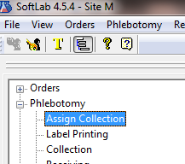

- Click the 2nd tab, Ad Hoc Assignment
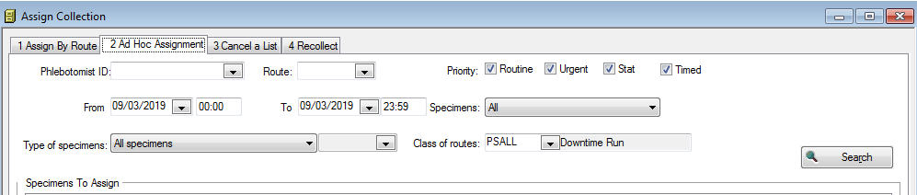
- The Phlebotomist ID field leave empty.
- In the Class of Routes box, pull up the corresponding class: PSALL(for Main), PSALY (For Yorkville)
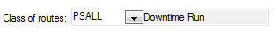

- Indicate the From and To date and time, depending on the length of downtime.


- Click the drop down arrow for Specimens, select All
- Click the drop down arrow for Type of Specimens, select All Specimens
- Click Search, the list of specimens to assign will appear.
- Select All and click Save
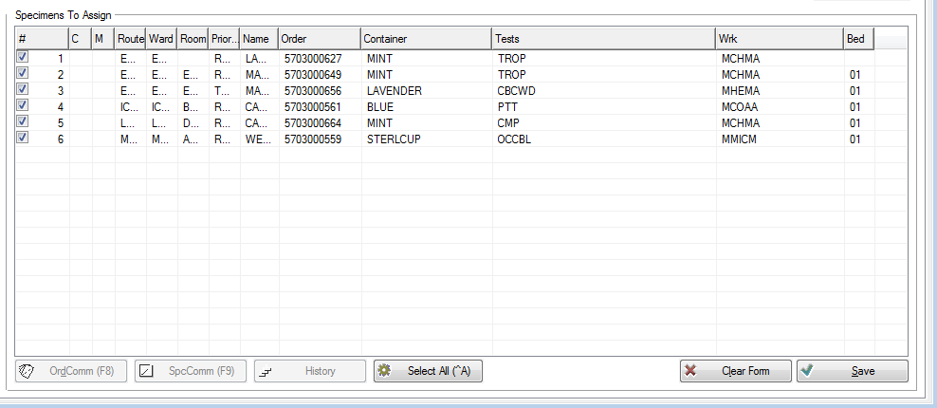

- The system will prompt to print labels. Print 2 sets of labels to your selected barcode printer. One set is distributed to the corresponding floors and phlebotomists. The other set is used for the downtime log in the LCC area.
- The system will prompt to print the Collection List. Print the Collection List to your selected printer.
- Repeat steps 4 thru 11 just before the system is taken down, to capture any orders placed after the first run.
- Running a Pending report with the same date and time range is a helpful check and balance to assure all labels have been printed. See Procedure 4840-LIS-308 for distribution and downtime procedures.

