TITLE: Critical Microbiology Value Notification

PURPOSE:
Critical patient laboratory values must be relayed to an appropriate patient caregiver immediately upon confirmation of the result to ensure quick action in response to the patient’s condition, diagnosis and clinical picture. Many pathogenic organisms isolated in the Microbiology Laboratory shall be reported to Infection Prevention for the purpose of preventing nosocomial transmission and for reporting to appropriate local and state health agencies. All values in the following table require caregiver notification. The top section lists values also requiring immediate notification of Infection Prevention by calling x4831. Voicemail messages are acceptable. Infection Prevention periodically reviews messages. The LIS system will prompt Microbiology Technologists when calls are required. Called to information shall be documented in the LIS. Infection Prevention will review epidemiology reports in EPIC.

CRITICAL POSITIVE RESULTS REQUIRING IMMEDIATE INFECTION PREVENTION AND CAREGIVER NOTIFICATION.

Positive AFB Smears | Positive cerebrospinal fluid gram stains and cultures
Positive AFB Cultures | Bacillus anthracis
Brucella species | Bordetella pertussis
Corynebacterium diptheriae | Carbapenem Resistant Enterobacteriaceae (CRE)
Haemophilus influenza - invasive | Mycobacterium tuberculosis (complex)
Salmonella typhi, paratyphi | Neisseria meningitidis or gonorrhoeae - invasive
Shiga-Toxin producing or E coli 0157:H7 | Streptococcus pyogenes (Grp. A) - invasive
Yersinia pestis | Tularemia (Francisella tularensis)
Vanco Resistant Staph Species Isolates
CRITICAL POSITIVE RESULTS REQUIRING CAREGIVER NOTIFICATION
Blood culture gram stains | Blastomyces dermititidis
Campylobacter species | ESBL/MDRO isolates
Clostridium difficile toxin
Histoplasma capsulatum | MRSA
Listeria species | Neisseria gonorrhoeae
Nursery Patient Positive Gram Stains | Positive Group B Strep (OB or NSY pt.)
Nursery Patient culture growing any potential pathogen. | Positive tissue/sterile body fluid gram stains and cultures
Respiratory panel pathogen | Positive ova and parasites
Strep Pneumoniae Penicillin I or R
Streptococcus pyogenes (Grp A.) non-invasive
Salmonella, Shigella or Yersinia | Pseudomonas aeruginosa in the eye
VRE

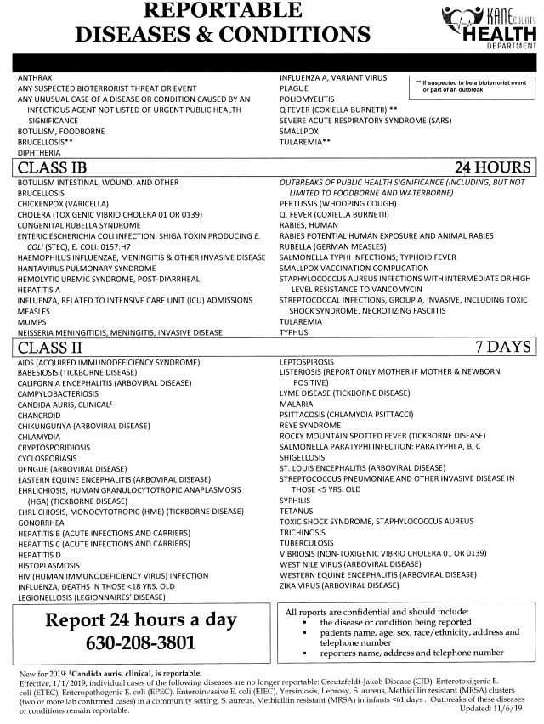

Critical Value Notification

- Technologist shall call caregiver (RN or MD) and Infection Prevention when appropriate.

- Request results and patient name be read back to you.

- Document all “Called To” information in the LIS Callbox. Include full name and title of who was called, date, time, technologist initials and read back.

- For MRSA, VRE, ESBL and MDRO isolates, automatically included in the culture result is the coded comment “Contact”- Hospital policy requires contact precautions for the duration of patient’s stay.
- When a critical result arises after the patient has been discharged, the Medical Technologist will be responsible for contacting the ordering Physician or a Physician involved in care of the patient.

S: Lab Policies and Procedures/Micro/4840-MB-0700.05242019

