## TITLE: Manual Body Fluid Cell Counts

### PRINCIPLE:

This policy encompasses the procedure for obtaining in vitro quantitative results for WBC’s and/or RBC’s in all fluids; CSF, serous body fluids and synovial fluids performed by hemocytometry. The pericardial, peritoneal and pleural fluid cavities are formed by double-layered serous membranes that separate the heart, abdomen and lungs respectively from their surrounding environment. In the absence of disease, these serous membranes are separated by a minute amount of fluid that allows for movement. An accumulation of fluid between the membranes is an indication of disease.

Synovial fluid occupies the synovial cavity to lubricate the joint space and provide nutrients to the cartilage. Cell enumeration is indicated to aid in the diagnosis and treatment of joint disease, as well as the classification of the disease as septic, inflammatory, or non-inflammatory.

Cerebrospinal fluid (CSF) is present in the subarachnoid space between the arachnoid mater and pia mater and circulates over the cerebral hemispheres and downward over the spinal cord.

The examination of cerebrospinal fluid can help in determining whether a patient has meningitis, encephalitis, subarachnoid hemorrhage, central nervous system syphilis, spinal cord tumor or multiple sclerosis. When a subarachnoid hemorrhage or intracerebral hemorrhage has occurred, the fluid is often bloody in all tubes or xanthochromic after centrifugation. Clotting of a spinal fluid can occur with a traumatic tap; elevated CSF protein is associated with meningeal or CNS disease. The WBC is elevated in meningitis, usually normal in multiple sclerosis and spinal cord tumors. The presence of crenated RBC’s is not useful in differentiating a traumatic tap from a pathologic bleed.

**CLINICAL SIGNIFICANCE**:

Grossly hemorrhagic serous fluid can be due to malignancy, pancreatitis, pulmonary infarction, pleural infection, closed chest trauma, tuberculosis and the postmyocardial infarction syndrome. A cloudy-turbid fluid can be due to large numbers of leukocytes. Inflammation either septic or nonseptic is suggested when the WBC is over 1,000/mm3 or over 50% neutrophils. Cell enumeration is indicated to aid in the diagnosis and treatment of a number of clinical conditions, such as infections, cardiovascular disease, malignancies, pulmonary embolism, cirrhosis and trauma.

In CSF, an elevated WBC is a neutrophilic reaction. Meningitis due to pyogenic organisms such as Neisseria meningitides, Haemophilus influenza, Pneumococcis streptococci, staphylococci, or coliforms is usually indicated. A mixed reaction (neutrophils, lymphocytes, and monocytes) can occur with tuberculous or mycotic meningitis, subacute bacterial meningitis, viral meningoencephalitis, or aseptic meningeal reaction. A monocytic and/or lymphocytic reaction is

typical of viral meningo-encephalitis, multiple sclerosis and tuberculosis, and fungal and syphilitic meningitis.

### PERSONNEL:

Medical Technologists and Technicians

### SPECIMEN:

Patient Preparation: No patient preparation by Laboratory personnel.

Type of Specimen: **All** **Body fluids**: Unclotted, preferably anticoagulated

with EDTA. **If any specimen contains clots, cellular**

**clumps or debri, note in the LIS system: “Specimen contains**

**clots, cell count may be inaccurate”.**

We do not perform cell counts on wounds or abcesses.

Document and call the floor. Cancel the order with a reason for

cancellation in the LIS.

**CSF:** A completely clotted specimen needs to be rejected for the cell count. Check with the other departments to verify if they will accept the specimen. Order the cell count in the LIS and cancel it with the reason. The floor needs to be notified and document that in the LIS.

**All Body Fluids are to be counted manually on the hemocytometer, both sides of the hemocytometer.**

Handling Precautions: Handle all specimens using Standard Precautions.

**In cases of suspected Creutzfeldt-Jacob disease, special handling applies**:

(If a Protein 14-3-3 is ordered, investigate a diagnosis or suspected diagnosis from the

patient care area). This is one of the tests ordered to diagnose CJD.

Gloves, mask and disposable gown over your lab coat must be worn. Wear double gloves. PPE can be obtained in Histology. *7/12/2016: per Dr. Abraham:*

If the clinician is highly suspicious of CJD and insists we send out the Protein 14-3-3.

Go no further, we are not to touch or process anything in the lab. Send out all tests. Don’t touch, send out all tests.

**IF WE DO RECEIVE FLUID** **AND MUST** **DO IT HERE**:

1. Specimens should not be centrifuged to avoid the creation of aerosols.
2. Use of disposable hemacytometers for cell counts must be used, upon completion of the count, the hemocytometer, petri dish and slides are double bagged in biohazard bags and labeled as “Infectious Agent”, sealed and disposed of in a red biohazard garbage bin for incineration. Should an unknown case be discovered, all glass hemocytometers must be disposed of as well for incineration as indicated above. Questions should be referred to the Infection Prevention manager.
3. Storage of the specimen must be double bagged in Biohazard bags and labeled as Highly Infectious; proper disposal is in the red container for incineration.

### REAGENTS:

Act 5/Act 2 diluent or similar diluent

Thrombo-tic vials for WBC determination

###### Wright Giemsa stain

22% Albumin

### EQUIPMENT:

Disposable Hemocytometers

Microcapillary tubes

Slides

Immersion oil

MLA Pipettes, petri dish containing moistened filter paper, automated slide stainer,

cytocentrifuge, 12 x 75 mm test tubes, LIS label for slide.

### QUALITY CONTROL:

Background checks are performed on the diluent daily and with each new container put on the analyzer. Each lot of Thrombo-tic vials is checked for background counts as it is put into use. Stain quality is also checked each day of use.

**Manual Body Fluid Count QC:** Streck Cell-Chex is a body fluid procedural control for RBC and WBC counts used to verify the accuracy of hemocytometer cell counts and to comply with the CAP standard: HEM.35340 *(At least one cell count control specimen is analyzed, or a procedural control used, for each 8 hours of patient testing).*

**Two (2) levels of control material are available and will ran with each patient testing.** Cell-Chex is stored in the hematology refrigerator at 2-10 degrees and stable to the expiration date until opened. **Open vial stablility is 30 days.**

1. Remove the controls from the refrigerator. It is not necessary to warm the controls to room temperature before using.
2. To Mix: **Do not mix mechanically**.
   1. Hold the vial horizontally between the palms of the hands and roll the vial back and forth for 30 seconds.
   2. Hold the vial on cap end and mix by rapid inversion, using 20 quick flicks of the wrist, to ensure the cells are completely re-suspended.
   3. Vials stored for an extended period of time may require extra mixing by repeating steps above.
   4. Invert the vials 8 to 10 times immediately before sampling.
3. Samples must be removed using a clean capillary tube or pipette tip. The vial must be closed immediately after sampling is complete. Wipe the threads of the vial or cap if there are obvious droplets. **Return the QC vial to the refrigerator immediately to maintain maximum stability.**
   1. **Yorkville lab will run both levels of QC with each patient testing.**
   2. Level 2 can be counted undiluted, it is concentrated enough to perform a dilution and calculate your results.
   3. Plate both sides of the hemocytometer with your control, allow the hemocytometer to settle in the dampened petri dish and then count both sides of the chamber. Calculate and record your results on the QC sheet **and** enter your results in the LIS.
   4. **Body fluid** orders will automatically generate LIS QC orders, these will appear before you result patient in LIS.
   5. **Spinal Fluid** orders DO NOT automatically generate LIS QC orders. An order will need to be manually generated in TQC to results them. The QC will also be entered in TQC. Refer to policy 4840-LIS-244 on the steps to generate and result these orders.
   6. Assay ranges are based on +/- 2SD for the RBC/WBC parameters; these are assayed controls.
   7. QC results are tracked monthly in the TQC quality control program in Soft. QC is reviewed by the Sr. Tech on an ongoing basis in the LIS.

As an additional procedural means of quality control for cellular material counted on the hemocytometer, our standard protocol for close comparison between the hemocytometer count and the fluid estimate from the slide is to follow our cytospin policy. No cell count is to be verified in the computer until the cytospin smear has been examined for the presence of WBC’s, RBC’s and Nonhematopoetic cells. A correlation between the cells counted and the cytospin stained smear is verified for accuracy and documented on the worksheet for each fluid as a procedural control.

### STEPWISE PROCEDURE:

1. Verification of the fluid orders.
2. Technologist receives all fluids for documentation and dispersal to testing areas.
3. Verify the orders from the request form, LIS and in HIS to avoid delay in testing and to preserve the integrity of the sample. Check with the nurse in charge of the patient if discrepancies or questions arise with the orders. Many tests cannot be added on later if they are missed. All fluids must have a MT review the orders to verify computer order entry. Cytology orders cannot be put into HIS to cross the interface to the LIS. A manual requisition for Cytology must accompany the fluid and be filled out properly at this time.
4. After testing is completed at Yorkville Lab send sample to main lab for send outs and testing performed there. Spinal Fluid should be sent over with a STAT courier.

I. Gross Examination: record the following on our worksheets and in the LIS System:

1. Color - **Example**: colorless, yellow, bloody

2. Appearance/Clarity - **Example**: clear, cloudy, turbid

3. Total Volume received in the Lab (from one or all containers)

4. Xanthochromia (refers to pink, orange or yellow color

after the CSF has been centrifuged). Record as: Absent or Present.

1. Color and clarity are included as a part of the report, decision support will prompt

you if you enter any color other than colorless. If the tube you are performing the

cell count on is colorless and clear but other tubes are not, you need to “add a

test” in **OE** to the Order# of the CSF Cell Count called, “CSF Color and

Clarity”. You will get color and clarity for tubes #1, 2, 3.

Should the count be performed on #2 or 3, make sure you enter the same results as you

did in the original profile. No tube #3: “NA”.

**NOTE:** If all tubes received are colorless and clear, you do not have to add the test to reflect that.

Ideally, the CSF specimen should be divided into three to four samples placed in sterile tubes, which are labeled sequentially. Only one cell count is performed unless specifically requested to determine a hemorrhage.

Tube #1 should be used for chemical and immunologic studies.

Tube #2 for microbiology examination

Tube #3 or #4 for cell counts.

II. Cell Count:

A. For clear and colorless fluids:

1. Thoroughly mix the specimen. Using a capillary tube or 10uL pipette,

charge **both sides** of a hemacytometer being sure not to overflow the sides. Place the hemacytometer in a Petri dish moistened with a damp filter paper and allow the cells to settle for 10

minutes. Counts must be performed within 3 hours.

2. Examine under low power. If the cells are overlapping a dilution must be made.

3. **Count both red cells and white cells on both sides** of the

chamber for CSF’s. Take the average of the two counts. Sides should

match within 10%. Replating and recounting the fluid if the counts are not

within limits. Document the resolution on the worksheet. Only WBC’S

are counted for Body Fluid’s other than CSF. RBC’s are reported as Present or Absent for serous fluids.

B. For cloudy fluids:

1. Make a 1:10 dilution using Act2/Act5 diluent for

slightly cloudy fluid or a 1:20 dilution for a moderately cloudy fluid. For grossly bloody fluids a 1:100 dilution may be necessary. For very cloudy fluids a Thrombo-tic vial may be used for the 1:100 dilution of WBC’s.

a. 1:10 dilution

Using MLA pipettes, aspirate 1 part fluid and mix with

9 parts diluent.

EX: 100 μL fluids; 900 μL diluent

b. 1:20 dilution

Using MLA pipettes, aspirate 1 part fluid and mix with 19 parts diluent.

EX: 10 μL fluid, 190 μL diluent

2. Continue with steps A #1 through #3 from above.

C. Counting the fluid:

1. If there are numerous red cells in the Fluid, count cells in the five small

squares in the center of the chamber. (See diagram figures 1,2,3,4,5).

2. If the cells are less numerous the larger four WBC squares should be counted. (See diagram figures A,B,C,D).

3. When only a few cells are present, the entire chamber of 9 squares should

be counted on both sides.

**CSF Note:** If there are crenated cells present on your hemocytometer; at the RBC

field in the LIS, enter your RBC count result, and then use a canned

message to state few, mod, many crenated RBC’s present.

Canned Messages are found by clicking on the “Canned Message” at

the top of the result screen or Right clicking while you are in the

result field.

|  |  |  |  |  |  |  |  |  |  |  |  |  |
| --- | --- | --- | --- | --- | --- | --- | --- | --- | --- | --- | --- | --- |
|  |  |  |  |  |  |  |  |  |  |  |  |  |
|  |  |  |  |  |  |  |  |  |  |  |  |  |
|  |  | A |  |  |  |  |  |  |  |  | B |  |
|  |  |  |  |  |  |  |  |  |  |  |  |  |
|  |  |  |  | **1** |  |  |  | **2** |  |  |  |  |
|  |  |  |  |  |  |  |  |  |  |  |  |  |
|  |  |  |  |  |  | **5** |  |  |  |  |  |  |
|  |  |  |  |  |  |  |  |  |  |  |  |  |
|  |  |  |  | **4** |  |  |  | **3** |  |  |  |  |
|  |  |  |  |  |  |  |  |  |  |  |  |  |
|  |  | D |  |  |  |  |  |  |  |  | C |  |
|  |  |  |  |  |  |  |  |  |  |  |  |  |
|  |  |  |  |  |  |  |  |  |  |  |  |  |

D. Calculate the number of cells/cmm.

**AVG. # of cells counted x depth factor x dilution factor = cells/cmm**

**# squares counted**

The Neubauer chamber consists of NINE squares. If the WBC

corner squares are counted, then divide by four. If only the

inner five small squares are counted, do not divide but multiply

the entire equation by “five” since this is only 1/5 of a square.

The depth factor is always 10.

Dilution factors are the reciprocal of the dilution. EX: 1:20

dilution, multiply by 20.

E. LIS Calculations of WBC’s and RBC’s:

* Go to “**Resulting Worklist**”, Search for test by “**Template**”, choose **YDIFC** for

CSF Fluids, and choose pending and non-verified tests. A worklist for resulting

pops up.

* Enter your profile results, mostly by keypad entry (similar to our old dropdowns).

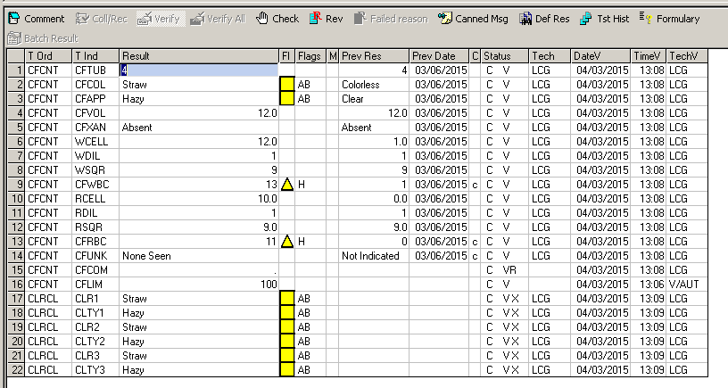

* Enter the Average WBC count from the 2 sides of the hemacytometer in the **WCELL** field.
* Enter the Dilution used; no dilution is entered as 1 in the **WDIL** field.
* Enter the number large WBC squares counted in the **WSQR** field. The LIS calculates your final **CFWBC** count that is reported out.
* Repeat for the **CFRBC**’s. If you have counted 5 of the RBC small squares in the center squares, then enter 0.2 as the number of squares counted.
* The LIS calculates the final **CFRBC** count that is reported out. Entering in the **RCELL**, **RDIL, RSQR** fields.
* Greater than 10 CFWBC’s, count your 3 part diff on the keypad. We will be reporting **Seg’s, Lymph’s and Mono’s** along with any **CFUNK** (Non-Hematopoietic Cells CSF).
* “Verify all” and refresh your screen, it will ask you if you want to save, yes…..if you didn’t already.
* The “**CLRCL**” fires and you can now enter the color/clarity for the remaining tubes.
* If the color/clarity is not received, a pop up box will let you know, so you can receive that in to the lab.
* We are doing CSF differentials only on WBC counts that are greater than 10, no matter the age or diagnosis of the patient.

**Less than or equal to 10 WBC’s**, a rule fires and fills in the differential parts with “Not Indicated”. You have to make sure the **CFUNK** field has “Not Indicated” there, and then **verify all**.

* Should a physician add a differential on to a CSF count that is verified because it did not need one, you can order a CFCNT on the patient, just **not on the same Order Number**.
* You can answer with @NA the parameters except the differential and put a canned message or comment on the first test in the profile, CFTUB that will chart. See example.

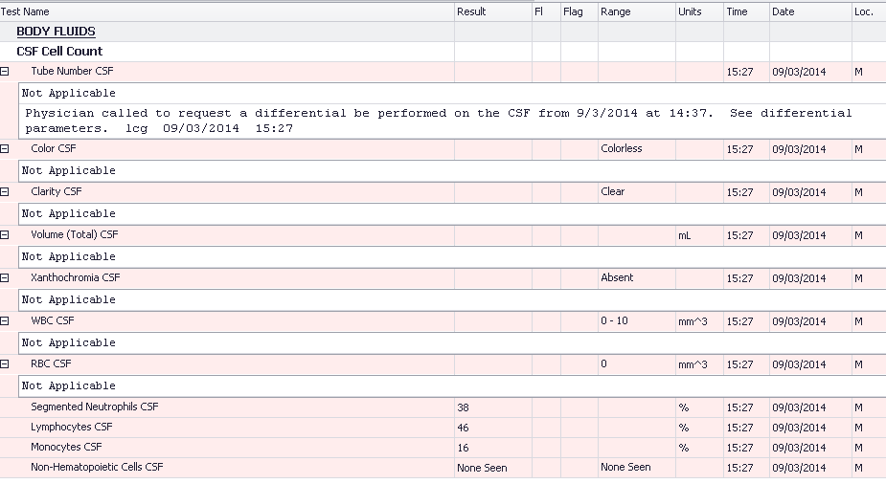

**Body Fluids:**

* Go to “Resulting Worklist”, Search for test by “Template”, choose **YDIFB** for Body Fluids, and choose **Pending and Non Verified** tests. A worklist for resulting pops up.

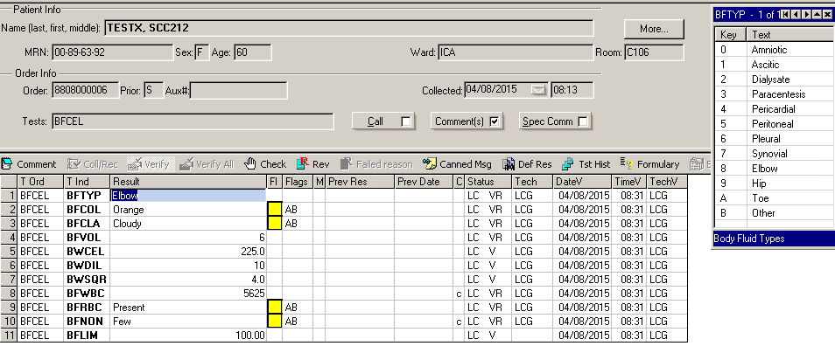

Keypad with BF types pops up.

* Enter your profile results, mostly by keypad entry (similar to our old dropdowns).
* Enter the Average WBC count from the 2 sides of the hemacytometer in the **BWCEL** field .
* Enter the Dilution used; no dilution is entered as 1 in the **BWDIL** field.
* Enter the number large WBC squares counted in the **BWSQR** field. The LIS calculates your final **BFWBC** count that is reported out.
* Enter in the **BFRBC** field “Absent or Present” for the RBC counts.
* The cytospin smears are sprayed with fixative and allowed to dry, then stained on the stainer.
* Results are recorded on the worksheets and entered into the LIS; any critical results are called to the floor and documented in the computer by using the call list.
* If there are **few than or equal to** **10 BFWBC’s**, a rule fires and fills in the differential fields as “**Not Indicated**”.
* If there are **greater than 10 BFWBC’s**, count your 3 part differential on the diff keypad on the PC, and then fill in the appropriate answer for the ‘Non-Hematopoietic Cells” (**BFNON**).
* Verify all, will verify your results for the BF Cell Count. Then “Save”.
* If there is Cytology ordered, we still need to print a chart copy of the general lab results for comparison between departments and take it to Histology, the pathologists cannot look the results up from Soft Path Dx.
* The specimen is delivered to all departments in the lab that are involved with testing.

III. **Differentials:** A differential should be performed on WBC cell counts **over**

**10 cells/cmm** on Wright-Giemsa stained smears. All smears are to be

made using the cytospin. Make 2 cytospin smears; stain at least one of them.

(Refer to procedure 7180-HE-0570: Routine Use and Maintenance of the Cytocentrifuge

for complete instructions and standard protocol for making cytospin smears).

**Specimen sample volumes for Cytospin:**

These volumes have been determined to be our standard protocol and must be

followed to ensure consistency and accuracy in validating our cell counts. This

method has been established to be a means of procedural control for

hemocytometer fluid counts.

Depending on the appearance and type of fluid, the number of drops will be different:

Clear fluid: 3 drops per holder

Cloudy fluid: 2 drops per holder

Bloody fluid: may be diluted with isotonic diluent for better identification of the

cellular material present

For cloudy specimens, a better dispersion of cells on the smear may be obtained by diluting small volume samples with isotonic diluent.

Grossly bloody fluid: should have a push smear made and stained.

**CSF**: A drop of 22% albumin should be added to your cytospin funnel to enhance the

adherance of cells to the glass slide. It is kept in the back Hematology

refrigerator. Add 3 drops of clear, colorless CSF, 2 drops of cloudy fluid.

**NOTE**: **\*Do a cytospin on all CSF’s except cases of suspected CJD**. Make push slides for these cases.

If the count does not require a diff, you still need to scan the cytospin smears as a means means of QC. Save all stained slides in the Body Fluid/CSF slide drawer in the storage cabinet. You only need to stain one of them. Store both smears in the slide storage cabinet.

**Synovial Fluid:** Better distribution of cells on the smear can be obtained by

pre-treatment of the viscous fluid prior to loading the fluid into the chamber.

1. **Hyaluronidase** is used to treat synovial fluids, a small amount (5mg) should work, use 2 clean, dry applicator sticks dipped in the hyaluronidase and mix well, let the tube set for approximately 5 minutes. Mix the tube again prior to use.
2. If the fluid is hazy or cloudy and dilutions have been used to perform the cell counts; 2 drops of this diluted fluid can be used for the cytocentrifuge prepared slide.

Spin all fluids at 1000 RPM for 5 minutes.

Fix all smears with the Cytofix fixative (from Histology) while the cytospin is still wet.

Cells which may be encountered in serous fluids include: neutrophils,

eosinophils, lymphocytes, monocytes, plasma cells, histiocytes, tumor cells, mesothelial cells.

Cells which may be encountered in cerebrospinal fluid include: lymphocytes, monocytes, neutrophils, ependymal cells, choroid plexus cells.

**If your count of PMN’s includes more than10% of eosinophils, add a comment to the BFWBC field that the % PMN’s includes “x” % eosinophils.**

Non-hematopoietic cells are reported as None seen, Few, Moderate or Many in the LIS.

Yorkville will send suspicious cells to main lab for review.

Use of the double-headed microscope with a Pathologist for any suspicious or unknown cells is necessary prior to reporting.

If malignant or suspected malignant cells are present, the smear must be reviewed by a

pathologist prior to reporting results in the computer. Call the patient care area involved

to let them know there will be a delay in the reporting of the cytospin differential. Order

a “**SMEAR**” request in the LIS and add any comment that the pathologist makes with

regards to the cells. Pathology may take the fluid and do thin preps in Histology for

positive cell identification.

Record on the worksheet, if the Pathologist has reviewed the cytospin smear.

\***Any presence of possible organisms on a cytospin, needs a comment added to the**

**differential: “Cytospin exhibits presence of intra and/or extracellular organisms. Refer to Microbiology for identification”.**

Reference materials for fluid cellular material may be found in the 2 volumes of “Body Fluids” by Carl R. Kjeldsberg and Joseph A. Knight. Editions 1 & 2 and the “Body Fluids Benchtop Reference Guide” by CAP, 2013

Proficiency Kodachromes and photograghs from CAP are kept and available for review and as a means of proficiency and consistency among personnel.

IV. * **Polyethylene analysis:** For knee fluids (especially), this can be done in Histology, it is not a send out test. Histology makes 2 direct smears and then stains them with H & E

stain, followed by polarizing microscopy. We need to fill out a Cytology Requisition for them, with the source of the specimen and write in: “Polyethylene Analysis” on the requisitions.

### CALCULATIONS:

See: Stepwise Procedure above.

**REPORTING RESULTS:**

Document all results on the provided worksheets, show your calculations.

**CSF’s**: **Report out WBC’s and RBC’s.**

**Serous and Synovial fluids**: Report out WBC’s and use the alpha responses of **“Absent” or “Present” for RBC’s.**

**For CSF’s**: We report neutrophils, lymphs and mononuclear cells. Report all results through the LIS.

Cytology requisitions accompany those body fluids and need to have the total volume, color and clarity filled in as we documented for Hematology on our worksheets.

Cytology has Soft PathDx and has access to the GenLab reports for intra-laboratory comparison of data for diagnosis purposes.

### NORMALS:

Normal body fluid is clear, colorless or pale yellow and scanty in amount (under 20 mL).

CSF: No red cells

Clear and colorless

0-10 WBC/cmm- usually mononuclear

Serous Fluids: Reference Ranges have not been established for cell counts on all fluids.

### PROCEDURAL NOTES:

1. If cell populations cannot be completely identified:

a. Preparation of direct smears, thin preps or cytospins for Papanicolaou or other

stains should be performed with the aid of the cytology staff and consultation

with pathologist.

b. Use of the Thrombo-tic vials to lyse RBC’s can be used to count only WBC’s.

2. Fluids are retained for 2 months in the refrigerator where patient samples are kept in rack labeled fluids and then incinerated.

3. Body fluid slides are stored in the fluid drawer in the slide box labeled fluid slides.

4. All MLA pipettes are checked annually for accuracy and precision.

### LINEARITY:

Not Applicable for Manual Counts

### REFERENCE:

1. Kjeldsberg C, Knight J. Body Fluids, 3rd Edition, ASCP Press, 1993

2. Henry, John B., Clinical Diagnosis by Laboratory Methods, Vol 7, W.B. Saunders, Philadelphia, 1979, pp. 1173-1175(pleural fluids).

3. Kjeldsberg, Carl and Knight, Joseph A., Body Fluids, ASCP, 1986,

Second Edition

4. CAP Today, Q & A, January 2012; Kiechle, Fredrick L., MD, PhD

5. Streck Cell-Chex package insert, 2013-11

6. Jones CD, Cornbleet PJ. Wright-Giemsa cytology of body fluids. Techniques for optimal

cytocentrifuge slide preparation. *Lab Med* 1997;28: 713-716