TITLE: Automated Body Fluid Analysis

PRINCIPLE:
The Automated Body Fluid Analysis procedure is for obtaining in vitro quantitative determinations of total nucleated cells (TNC) and erythrocytes (RBC) in serous fluids, and synovial fluids, using the DxH 800 Analyzer.

The body fluid is aspirated into the DxH 800 instrument via the Single Presentation Mode and is diluted in separate WBC and RBC baths. The Coulter Method of counting cells is used to detect and measure changes in electrical resistance when a cell, suspended in a conductive diluent, passes through a small aperture. Each suspended cell acts as an insulator. As the cell passes through the aperture, it momentarily increases resistance of the electrical path between submerged electrodes, one located on each side of the aperture. The resistance generates an electrical pulse. The accumulation of electrical pulses are channelized, processed for coincidence correction, and multiplied by a calibration factor, yielding the TNC and RBC counts.

All Body Fluid samples and Body Fluid Controls must be run in the Single Tube presentation mode. *ALL CSF cell counts will be performed manually.

The TNC (total nucleated cell) count generated by the DXH 800 represents the WBC count and the non-Hematology cells in the analysis of body fluids. This count differs from the manual count as it includes macrophages and mesothelial cells.

PERSONNEL:
Medical Technologists and Technicians

PATIENT PREPARATION:
No patient preparation by Laboratory Personnel

SPECIMEN:
Type of Specimen:
- Serous Fluids (pleural, pericardial, peritoneal)
- Synovial Fluid.
- Unclotted, preferably anticoagulated with EDTA. If any specimen contains clots, cellular clumps or debris, note in the LIS system: “Specimen contains clots, cell count may be inaccurate”. Remove clots prior to running on instrument as this will clog the apertures.
- Minimum volume is 200ul.
- To reduce viscosity, synovial fluids should be pre-treated with hyaluronidase before running on an instrument. Using 2 wooden sticks, take a couple of flakes of the hyaluronidase, mix with 1 ml synovial fluid and let stand for approximately 5 to 30 minutes. Fluids must drop freely using a plastic pipette. Be sure to mix well before aspirating into the DxH.
- Bronchial wash

Handling Precautions:
Handle all specimens using Standard Precautions

In cases of suspected Creutzfeldt-Jacob disease, refer to the Manual Body Fluid Cell Count procedure Proc. #4840-HE-0340. These samples are not to be run in Automation.

Reagents:
DxH Series Diluent
Hyaluronidase, frozen (in the back of the Chemistry freezer)
DxH Body Fluid Controls

EQUIPMENT:
DxH 800
Wooden Sticks
Blood Collection tube purple black 4mL K2EDTA
Blood collection tube white- 3 mL no additive
Plastic pipettes

QUALITY CONTROL:
- A minimum of two levels of DxH Body Fluid controls are run once every 24 hours when there are patient samples for Body Fluid counts.
- Prior to performing the Body Fluid counts, the tech is required to check under the QC icon on the DxH to verify the date and time that the body fluid QC was performed and if it was within range.
- If QC was not performed within the last 24 hours, run the Body Fluid QC first followed by the patient specimen.
- A background count of the diluent must be performed and found acceptable prior to analyzing body fluid specimens.

Background Count on Diluent:

Obtain diluent from the DxH 800 to use as a body fluid blank to check the background count:
- Enter the Single Tube presentation mode by selecting the icon on the workstation
- A box will pop up for the single presentation. At the lower left corner this box is a button stating, “Dispense Diluent”. Touch or click this button.

- The workstation will prompt you to place an empty tube in the carrier. Place a Capped White Top 3ml tube in the front left position of the carrier, the same side you would place the EDTA Lavender tube.
- When complete the analyzer will ask if more diluent is desired. Answer Yes or No. When completed, the carrier will move forward again and you are to remove the tube from the carrier.
- Run the diluent as a patient sample to obtain the background count:
- From the Workstation select single tube presentation.
- In the Specimen Type identification box select the body fluid type you will be running from the drop down box by clicking on the arrow (all body fluid types are run in the same manner, this serves to specify the body fluid type on the instrument report)
- In the “Specimen Identifier” box type the body fluid blank identification: BACKGROUND. Press Enter.
- If a box pops up stating “Test order not found….” Click OK.
- Click “Submit”.
- Place tube of diluent into the left side of the Single Tube carrier (lavender insert). The carrier will be pulled into the analyzer and the background count run.
- Results will print on the appropriate printer.
- Verify that the background counts are acceptable and proceed with patient testing.
- Acceptable background counts are as follows:
- TNC:< or = 20 cells/mm³
- RBC:< or = 1000 cells/mm³
- Background counts exceeding the above limits must be repeated.
- Repeated failed background count will require a manual count to be performed.

- Analyzing COULTER Body Fluid Cell Controls:
- Store Body Fluid Cell Controls refrigerated at 2-8ºC.
- Sealed control vials are stable until the expiration date.
- Open Body Fluid Control Vials are stable for 16 days or 18 uses. When opening a Body Fluid Control ensure expiration date is also marked on the vial.
- Set a timer for 30 minutes to ensure QC is returned to refrigeration within 30 minutes.
- QC vials should be brought to room temperature (15.5 to 32ºC) for 10-15 minutes.
- Roll the tube slowly between the palms of the hand 8 times in an upright position. Invert the tube and slowly roll between the palms of the hand 8 times. Then gently invert the tube 8 times. Repeat.
Note: Do not place controls on mechanical rocker.
- Enter the single tube presentation mode by selecting the icon on the workstation.
- Check the DXH Control box. Scan the QC vial barcode into the specimen identifier and press ENTER.
- NOTE: Body Fluid Controls must be run in consecutive order, beginning with Level 1. Place the Body Fluid control on the bar-code reader platform of the Single-tube presentation station with the bar code facing the SPM to allow the bar-code reader to scan the specimen label. Alternatively type in the accession number or another identifier into the “Specimen Identifier” box. Press Enter.
- Place control into the appropriate side of the single-tube carrier.
- The carrier will sense the presence of the tube and retract inside for analysis.
- When the analysis is complete the results will print and the carrier will return to the front of the analyzer. Remove the tube and evaluate the results.
- Continue to analyze subsequent QC in the same manner, running a diluent between all samples.
- Return the control tubes to the refrigerator within 30 minutes. Ensure the results fall within the expected range of values.

STEPWISE PROCEDURE:

Refer to 4840-HE-0340 Manual Body Fluid Cell Counts for order verification, distribution of fluids, etc.

- Analyzing the patient body fluid specimen:
- Automated body fluid analysis must be performed in purple top EDTA blood collection tubes.
- All patient body fluids are checked macroscopically for clumps of cells that may give spuriously low cell counts by the instrument, or debris that may give spuriously high cell counts. If marked clumping or clots are present, this may preclude reporting a formal automated count. Check the specimen for clots with the use of wooden sticks. Specimen for analysis on the DxH must be clot free.
- If clots are able to be removed, remove the clots, run the sample and include a comment: “specimen is clotted – results may be inaccurate.” The limited accuracy of cell counts in these situations must be included in the laboratory report, with a description of the specimen problem.
- Instrument generated flags and findings on microscopic examination that suggest the presence of debris, may require a manual count.
- Viscous Fluids: To reduce body fluid sample viscosity, use hyaluronidase to treat synovial fluids prior to analysis. A ratio of 5mg hyaluronidase to 1mL of synovial fluid. Pre-treatment of the viscous fluid prior to running the fluid on the analyzer will be required.

- Hyaluronidase is used to treat synovial fluids, a small amount (5mg) should work, use 2 clean, dry applicator sticks dipped in the hyaluronidase and mix well, let the tube set for approximately 5-30 minutes. Mix the tube again prior to use. Check periodically to ensure the fluid flows freely using a pipette (one unobstructed drop at a time)

- A “Cellular Interference” flag for the TNC, as well as any ‘R’ flag for both the TNC and RBC will require a manual count to be performed. Refer to Proc. #4840-HE-0340 Manual Body Fluid Cell Counts.
- At the DxH workstation, select Single-Tube Presentation.
- A background count of the diluent must be performed and found acceptable prior to analyzing body fluid specimens and analyzed between each patient specimen. Failed background check will require a manual count to be performed.
- Enter the single tube presentation mode by selecting the icon on the workstation.
- Verify that the specimen type selected is the type of body fluid specimen you will be running. Use the arrow next to the “Specimen Type” box to change fluid type if necessary.
- Verify that the test to be run if BFC (body fluid count).
- Place the specimen on the bar-code reader platform of the Single-tube presentation station with the bar code facing the SPM to allow bar-code reader to scan the specimen label. You may also type in the accession number or another identifier into the “Specimen Identifier” box. Press Enter.
- If a box pops up stating “Test order not found…” click OK.
- Press “Submit”.
- Mix the specimen thoroughly.
- Place the specimen into the left side of the single-tube carrier (lavender insert).
- The carrier will sense the presence of the tube and retract inside for analysis.
- When analysis is complete the results will print and the carrier will return to the front of the analyzer. Remove the tube and proceed with evaluating results.

NOTE: If you have two patient body fluid specimens to run at the same time, you must perform another background diluent after running the first patient. The background should meet the criteria mentioned under QUALITY CONTROL, SECTION D. If acceptable, proceed with running another body fluid specimen.
- Run a sample of diluent through the instrument after running patient specimens.

RESULTING IN SOFT:
- TNC and RBC will populate the appropriate fields in the Instrument Menu:
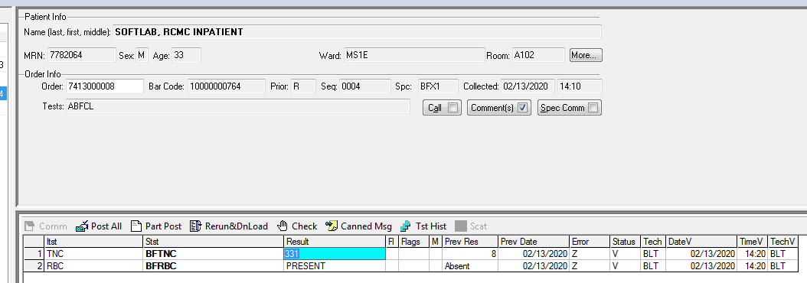

- Click: SAVE. Do not click: POST ALL.

- After running on the DXH800, in resulting worklist, choose BODY FLUID AUTO DIFFERENTIAL TEMPLATE:

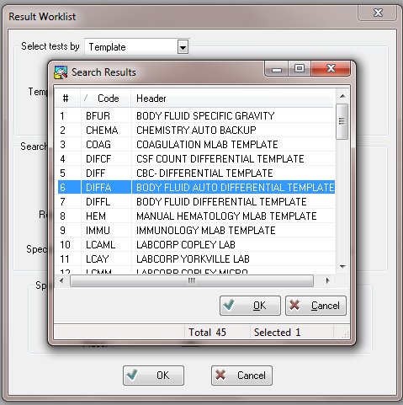

- Result GROSS examination. Refer to Proc# 4840-HE-0340 Manual Body Fluid Cell Counts.
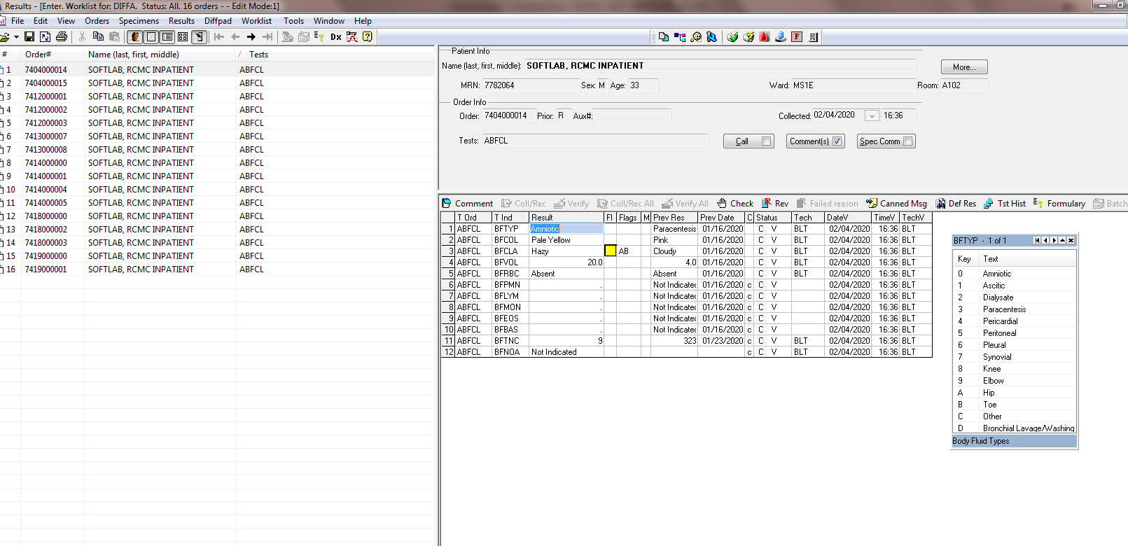

- Perform the manual differential. Refer to Proc # 4840-HE-0340 Manual Body Fluid Cell Counts.
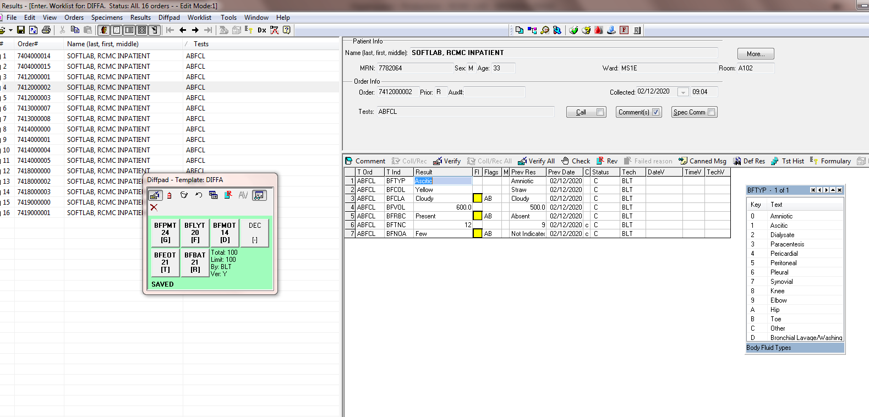

- Click: VERIFY.

INTERPRETATION/RESULTS/ALERT VALUE
- Results:
- Equivalent units: cmm (cubic millimeters) = mm³ = uL (microliters)
- Measuring and Operating Ranges:
A.
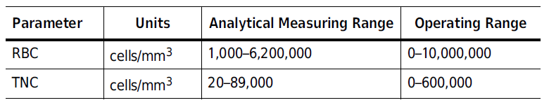
- Any results that are greater than the linearity will give a ++ error and should be diluted with DxH diluent. Run in Single Tube presentation and multiply the result of TNC and RBC by the dilution factor and report that number.

- Cerebrospinal Fluid (CSF)
- CSF is a clear, colorless, non-cellular fluid that circulates over the brain and spinal cord. Cell enumeration is indicated to aid in the diagnosis and treatment of meningeal infections, subarachnoid hemorrhage, and central nervous system malignancies.

- Cell counts will be performed manually on ALL CSFs. Refer to Proc. #4840-HE-0340 Manual Body Fluid Cell Counts.

- Serous Fluids
- The pericardial, peritoneal, and pleural cavities are formed by double-layered serous membranes that separate the heart, abdomen, and lung respectively from their surrounding environment. In the absence of disease, these serous membranes are separated by a minute amount of fluid that allows for movement.

- An accumulation of fluid between the membranes is an indication of disease.

- Synovial Fluid
- Synovial Fluid occupies the synovial cavity to lubricate the joint space and provide nutrients to the cartilage.

- Cell enumeration is indicated to aid in the diagnosis and treatment of joint disease, as well as the classification of the disease as septic, inflammatory, or non-inflammatory.

REFERENCE VALUES

- Synovial Fluid:
- Appearance – clear, yellow
- RBCs: 0 RBC/mm³
- TNCs: 0-200/mm³

- CSF
- Appearance – clear, colorless
- RBCs: 0 RBC/mm³
- TNCs – Adults: 0-5/mm³
- TNCs – Neonate: 0-30/mm³

- No Known Normals:
- Pericardial Fluid
- Peritoneal lavage
- Pleural fluid/Thoracentesis

Differentials: A differential should be performed on WBC cell counts over 10 cells/cmm on a Wright-Giemsa stained smear. Refer to Proc. #4840-HE-0340 Manual Body Fluid Cell Counts.

METHOD PERFORMANCE SPECIFICATIONS/LIMITATIONS:
- WBC Limitations: nRBC’s, giant platelets, platelet clumps, malarial parasites, precipitated elevated proteins, microlymphoblasts, very small lymphocytes, fragmented WBC’s, cryoglobulins, agglutinated WBC’s, lyse resistant RBC’s, unlysed particles >35 fL in size may affect the accuracy of the WBC count.
- RBC Limitations: Very high WBC count, high concentration of very large platelets and auto agglutination may affect the accuracy of the RBC count.
- All Fluids:
- Clotted specimens may lead to misleading or erroneous results. Follow standard laboratory operating procedure for inspecting specimens for clots.
- Improperly mixed specimens may lead to misleading or erroneous results.
- Cellular debris may lead to misleading or erroneous results.
- Delays in processing may lead to misleading or erroneous results.
- Results should be interpreted in light of the total clinical presentation of the patient, including clinical history, data from additional tests, smear review, and other appropriate information.
- Synovial Fluids
- Fat globules may lead to misleading or erroneous results.
- Crystals may lead to misleading or erroneous results.
- Highly viscous synovial fluids may trap cells leading to misleading or erroneous results.

REFERENCES:
- Coulter Unicel DxH Series System Manager: Instructions for Use, Beckman Coulter, October 2018.
- College of American Pathologists. Laboratory Accreditation Checklists, www.cap.org, retrieved January 2020.

