RUSH-COPLEY MEDICAL CENTER RECOMMENDED POLICY/PROCEDURE

TITLE: ROM Plus (Rupture of Fetal Membranes)

NUMBER: 4840-CH-250

DEPARTMENT: Pathology and Laboratory Medicine

PREPARED BY:

Shirley A. Frasca MT (ASCP)

REVISION DATE: REVISION NO:

DATE INITIATED: 5/08/2012 PAGE: 7

##### PURPOSE PURPOSE/PERSONNEL

This policy and procedure establishes guidelines for professional staff at RCMC that either collect the

sample or perform the test for rupture of fetal membranes using the ROM Plus test. These employees have been properly trained and have successfully demonstrated the skills required for this testing.

POLICY

The ROM Plus assay detects AFP (alpha-fetoprotein) and PP12 (placental protein 12 or insulin growth

factor binding protein) from amniotic fluid in vaginal secretion. The ROM Plus is a self-contained test kit that provides qualitative results for rupture of fetal membranes (ROM). A speculum is not needed to obtain a sample. The test is non-invasive, with only a simple vaginal swab sample required. The sample is collected by placing the swab on the vaginal mucosal lining for 15 seconds. The swab is then mixed into a vial containing 400uL of buffer solution, and the diluted sample is applied to the sample pad of the test strip via the sample well on the cassette. A built-in timer is then activated and visualized as a convenient feature to indicate the time of the test. The liquid moves chromatographically and unidirectionally towards the absorbent pad.

During migration, the sample reacts with mono/polyclonal antibodies bound to the test strip membrane. These antibodies are immunoreactive to a combination of proteins, PP 12 and AFP, which are markers of amniotic fluid. As the membrane absorbs the liquid sample, a control line will appear, indicating a sample was applied. If the sample contains the PP 12 and/or AFP markers of amniotic fluid, it binds to the antibody of the test line, causing the test line to appear and indicating a positive result. If the sample does not contain the PP12 and/or AFP markers of amniotic fluid, only the control line will be visible, indicating a negative result.

CLINICAL SIGNIFICANCE

The ROM Plus Test is a definitive, non-instrumented, qualitative test for the detection of amniotic fluid in vaginal secretions to aid in the detection of rupture of fetal membranes in pregnant women in

conjunction with other signs and symptoms.

S:Laboratory Policies and Procedures/POC/ROM Plus

RECOMMENDED PROCEDURE

##### SPECIMEN

1. Positive patient identification: Refer to hospital policy, Patient Identification and Banding for

Inpatient and Outpatient. PC.5.10,810-V-62.

1. Specimen Collection:
   1. Label vial at time of sample collection with patient chart label, which includes patient's

full name and account number for positive specimen identification.

* 1. Record date, time and initials on patient chart label.
  2. Collect sample of vaginal secretions using sterile vaginal swab provided in kit. (Positio

patient flat on back).

* 1. Remove swab from packaging using care not to touch anything prior to insertion into

vagina.

* 1. Collect sample from surface of vagina, holding swab in the middle of the stick while patient is lying flat on back.
  2. Carefully insert the polyester tip of the swab into the vagina until fingers contact the skin

no more than 2-3 inches (5-7 em) deep.

* 1. Withdraw the swab after a minimum of 15 seconds.
     + Place swab tip into the vial.
     + Swirl the swab in the buffer for a minimum of 15 seconds.
     + Holding vial firmly, break off the swab tip at the scored mark and leave the tip in the vial.
     + Replace cap on the buffer vial. Note: Be sure to use solid shipping cap so that sample will not leak from vial.
     + Dispose of the remaining swab stick.
     + Transport extraction vial to laboratory via pneumatic tube system.
     + Sample must be tested within 6 hours after collection.
  2. Transport vial to laboratory.
     + Place labeled vial in original packaging and reseal.
     + Place in sealed biohazard bag.
     + Place in zippered vinyl pouch.
     + Send to lab via pneumatic tube system.

REAGENTS AND EQUIPMENT

1. Materials
   1. ROM Plus kit- 5 test packs each containing

• ROM Plus test cassette with timer

• Sterile polyester vaginal swab

• Specimen extraction buffer solution (phosphate-buffered saline) in plastic vial

* 1. ROM Plus Controls
     + Negative control vial (glass ampoule of buffer)
     + Positive control vial (glass ampoule of buffer)

1. Storage and handling
   1. ROM Plus kits
      * Store kits in dry location at room temperature 4-24 °C (40-75°F)
      * Kits may be used until printed expiration date when stored in the foil pouch

at the recommended temperature.

* Use ROM Plus within six (6) hours after opening foil pouch.
* Use ROM Plus within six (6) hours of collecting the vaginal swab sample and placing swab into the buffer vial.
* Allow pouch containing ROM Plus to reach room temperature prior to test.
* ROM Plus test kits will function properly with trace amounts of blood in the sample.

Significant amounts of blood discharge may cause the test to malfunction and is not recommended.

* Safety precautions should be observed when collecting, handling, and disposing of test

samples. Used test kits are biohazardous.

1. Quality Control kit
   * Store kit in dry location at room temperature 4-24°C (40-75°F)
   * Do not use past expiration date
   * Opened vial is stable for 6 hours after opening
   * Treat the control material as a human specimen in terms of handling.

**QUALITY CONTROL**

A. External Quality Control must be performed on each new shipment and/or lot number of ROM Plus tests or if there is suspicion of improper storage. Internal controls must be verified and documented with each test performed.

#### Internal Controls

* + ROM Plus cassette contains built-in reagent and procedural controls to assure accurate reading of the results.
  + The appearance of one or two red lines in the test area verifies the integrity of the test procedure. The appearance of the red control line assures that adequate sample volume was present and that adequate capillary migration (lateral flow) of the sample has occurred.
* It also verifies proper assembly of the test strip by manufacturer.

#### External Controls:

* + External Positive Control: contains human PP12 and human AFP amniotic fluid proteins.
  + External Negative Control: does not contain PP12 or AFP proteins
  + External controls will also be run whenever there is suspicion that product performance is compromised or whenever kits have not been stored according to its labeling instructions.
  + The laboratory will perform the testing of the External Controls and will document that the box is "Ready for Use".
  + Product should be considered potentially infectious and handled with appropriate biosafety practices.

#### External Quality Control Procedure

1. Label two test cassettes, one for the Positive Control and one for the Negative Control

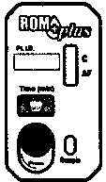



1. Positive Control
   * Open foil pouch and remove vial
   * Gently bend or squeeze the Positive Control Vial, breaking the glass ampoule inside
   * Mix the buffer with the lyophilized sample until completely dissolved
   * Be careful not to let the sample drip out of the vial.

®

®

1. Negative Control

..._ + .....,.1.1....:::1

@

## ++

* + Prepare sample the same as the Positive Control

@ + -

-

11:::1

## ,

®

1. Perform test

\\ *I I* +

C---..*b

++

* + Add 4-6 or more drops of the Positive Control solution to the appropriately labeled cassette.
  + Add 4-6 or more drops of the Negative Control solution to the appropriately labeled cassette.
  + Start the timers on each cassette by firmly pressing and rolling thumb over the timer button from left to right.
  + Wait 5-20 minutes for test result to manifest in test window.

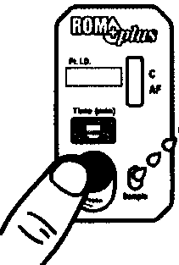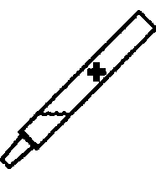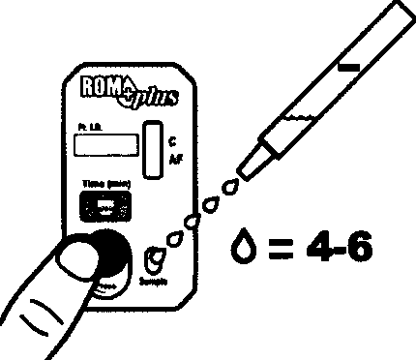<!> >I*oo=as=oo* I < I*oo=2D=ao* I

***o"***

**0:4-6**

1. Interpreting control test
   * Read test from 5-20 minutes
   * Only a red control line should be visible for the negative control.
   * Both the red control line (C) and the red test line (AF) should be visible for the positive control.
   * Test is positive even if the red stripes are faint. Do not interpret result based on darkness of the red stripes.
   * Do not read test after 20 minutes.

## c

AF

1. Product contains human sourced and/or potentially infectious components. Treat as potentially infectious.

##### STEPWISE PROCEDURE

Patient test procedure

1. Standard precautions must be followed when performing ROM Plus test.
2. Test must be performed within 6 hours of time written on vial.
3. Remove cassette from foil pouch. Label cassette with patient ID number.
   * Add 4-6 or more drops of buffer solution to the sample well of the cassette.
   * Set the timer by firmly pressing and rolling thumb over the timer button from left to right.

Note: Patient sample vials can deliver different sized drops. Fill sample well with 4large drops or 6

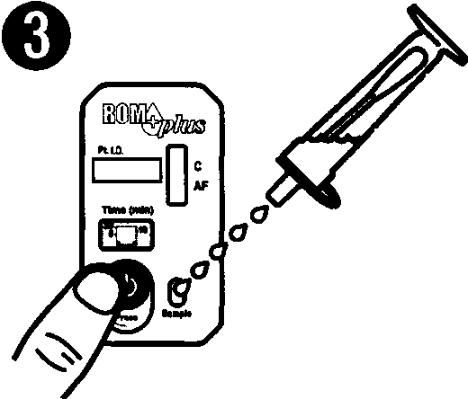(or more) small drops. There will be enough sample left in the sample vial to retest if needed.

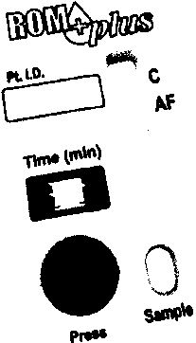>I*OD:DS:OD* I

<I*OD:C'CJ:OD* I

0=4-6

1. Wait 5-20 minutes for test result to manifest in test window (C/AF).
   * A positive test result may be visible early (within 1-3 minutes) or may take the full 20 minutes.
   * Darkness of the red stripes may vary.
   * The test is valid even if the red stripes are faint.
   * Do not interpret test result based on darkness of the red stripes
   * Must wait 20 minutes to report negative result.

INTERPRETATION OF TEST RESULT

1. Report results in SCM as

Negative Only a red control line (C) is visible.

Positive Both the red control line (C) and red test line are visible.

Invalid No lines are visible, or just the test line (AF) is visible. Test should be repeated.

c c

# AF AF

+

c

# AF

ego

1. ROM Plus results are qualitative. No quantitative interpretations should be made.
2. If patient result is not consistent with medical evaluation, further alternate diagnostic testing is suggested.
3. Test may report positive results in patients with intact membranes and therefore decisions to induce labor should not be based solely on the ROM Plus test results.

### LIMITATIONS

1. Significant amounts of blood discharge may cause the test to malfunction. Use of ROM Plus is not recommended in these instances. Trace amounts of blood on the swab are acceptable.

1. Test may report positive results in patients with intact membranes and therefore decisions to induce labor should not be based solely on the ROM Plus test results.
2. Elevated fetal serum, urine, cord blood and amniotic fluid as well as maternal serum levels of AFP have been reported in various developmental disorders such as neural-tube defects, hypothyroidism, autoimmune states, congenital heart defects, cystic fibrosis, etc. ROM Plus has not been evaluated for potential interference in these conditions.
3. ROM diagnoses should not be based on any single test.
4. Test performance in patients without signs or symptoms of ROM is unknown.
5. Bleeding, placenta previa, and performing digital exams prior to sample collection can lead to inaccurate test results.
6. Failure to detect membrane rupture does not assure the absence of membrane rupture.
7. Women may labor spontaneously despite a negative test result.

### INTERFERENCE

1. Tylenol and aspirin at a final concentration of 0.1% showed no interference.
2. KY Gel at a final concentration of 0.1% showed no interference.
3. Bath products (Lever soap, Noxema Cream and Pert shampoo) showed no interference at a final concentration of 0.1%.
4. Semen, urine and blood showed no interference at a final concentration of 10%.
5. The PP12/IGFBP-1 assay does not cross react with IGFBP-2. IGFBP-3, and IGFBP-4 based on Western Blot results.
6. There was no interference when tested with specimens that were positive for bacterial

vaginosis and other sexually transmitted diseases.

1. Testing for two protein markers increases sensitivity.
   * PP 12 is 100 to 1000 times higher in amniotic fluid than that in maternal serum.
   * AFP is approximately 85 times higher in amniotic fluid than in maternal serum.
2. Clinical Study Results
   * Sensitivity - 99%.
   * Specificity- 91%
   * Positive predictive value - 95%
   * Negative predictive value- 99%

### PROCEDURAL NOTES

1. Safety precautions should be observed when collecting, handling, and disposing of test samples. Used test kits are biohazardous and should be disposed of in a hospital approved container.
2. Test must be performed according to manufacturer's instructions.
3. Each ROM Plus test kit is single use and disposable and cannot be reused.

### REFERENCES

1. ROM Plus Fetal Membranes Rupture Test, package insert, Clinical Innovations, LLC, 747 West 4170 South, Murray, UT 84123, USA, *PIN* 050-0642 Rev A

2. ROM Plus Quality Control Kit package insert, Clinical Innovations, LLC, 747 West 4170 South, Murray, UT 84123, USA, *PIN* 050-0649 Rev B