## TITLE: Convalescent Plasma for the Treatment of COVID-19 (SARS-CoV-2)

**PRINCIPLE:** One of the ways patients fight off infectious diseases is by developing antibodies that lead to the destruction of the invading microorganism. Patients who have recovered from COVID-19 have developed in their blood, substances called antibodies; which are capable of fighting the virus that causes the illness. Giving people the liquid portion of blood (plasma), obtained from those who have recovered from the virus, leads to more rapid improvement of the disease. Patients with COVID-19 *may* improve faster if they receive plasma from those who have recovered from COVID-19, because it *may* have the ability to fight the virus that causes COVID-19. This has worked in previous outbreaks of respiratory diseases like influenza. Initial data available from studies using COVID-19 convalescent plasma for the treatment of individuals with severe or life-threatening disease, indicates that a single dose of 200 mL showed benefit for some patients, leading to improvement. COVID-19 convalescent plasma has not yet been demonstrated to provide clinical benefit in patients affected by this disease. It's not known if this treatment will or will not help those with COVID-19 or if it will have any harmful effects, but this is one of the only treatments that we have at present.

### PERSONNEL

Medical Technologists

### SPECIMEN

One 7mL pink top tube

### EQUIPMENT

COVID-19 Convalescent Plasma Request Form

Copy of Email with patient approval number

### STEPWISE PROCEDURE

1. Blood Bank receives an order for Convalescent Plasma (Order code is COVFP) via the EPIC printer or is notified by phone that an order will be put in.
2. Technologist will look up patient history in SoftBank, if patient DOES NOT have an ABORH on file, one must be ordered and collected on the patient requiring the transfusion.
3. Blood Bank will request a copy of the email with the patient’s approval number (The physician must register the patient and be approved via the Mayo Expanded Access Protocol in order for the patient to be eligible to receive convalescent plasma). This copy can be faxed to the Laboratory, Attention Blood Bank or sent via the tube system.
4. Technologist will then fill out the COVID-19 Convalescent Plasma Request Form (example at the end of this procedure), this along with the copy of the email will need to be **submitted to Aurora Hospital Services via fax** **(630-892-0965)**
5. Orders are received by Hospital Services

* Call Aurora Hospital Services at **630-892-7091** with questions about the order or to confirm receipt of order.

1. **If product is available:**

* Versiti will deliver product in a separate container marked convalescent plasma

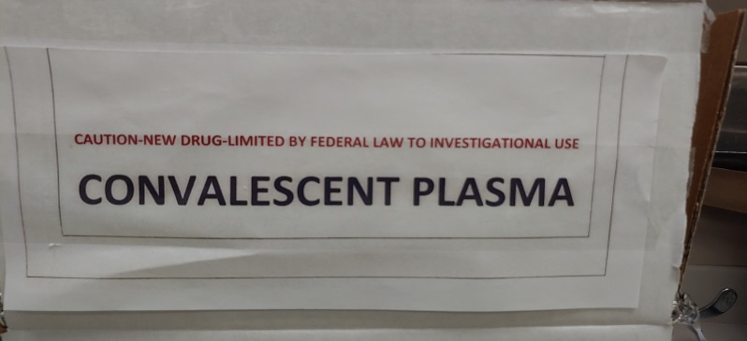

1. **If product is not available**:

* The order will be held as a backorder.
* When product does become available, Hospital Services staff will call the Transfusion Services to confirm product is still needed prior to filling the order.

1. When product arrives in the specially marked container it will be entered into inventory in the same manner as other frozen products, please be mindful of the collection center in the top left hand corner. It may not always be Versiti, so select the appropriate collection location when receiving in product.
2. Product will have a tie tag with a 9 digit number written on it, the last 4 digits are the patient’s approval number:

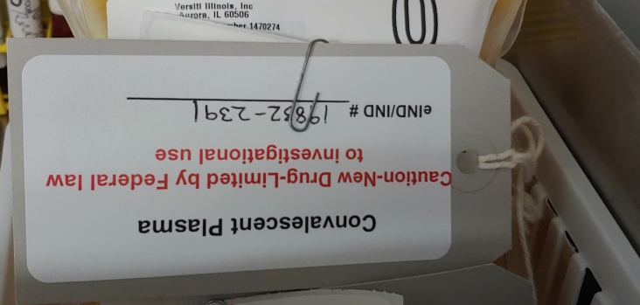

This number will need to be matched up to the requisitions in the Convalescent Plasma Binder. Once you know which patient it is you can contact the patient’s nurse or physician and let them know the plasma has arrived.

1. Once you receive a product release via the EHR or downtime pink slip during a downtime, you may begin thawing the plasma.
2. Thaw the plasma in the same manner as any other frozen plasma (only thaw for 18-20min due to smaller volume). Make sure when the gray box pops up after you F12 the changes in SoftBank, that you put in label printer name M59_BLOODBANKISBT to print the 4x4 label to relabel the plasma.
3. After the label prints Soft will ask to verify the label, apply the new label to the thawed product and scan all 4 quadrants; F12 to verify/2nd label check the unit.
4. Fill out the bottom of the orignal Versiti Convalescent plasma request verifying that patient identity, ABORH and tag accuracy between unit and patient have been checked. Staple all orders and release to orginal orders faxed to Versiti and place in back pocket of Convalescent Plasma Binder for Senior Technologist Review.
5. Select unit for patient, send the unit immediately to the floor.

NOTE: Orders waiting to be filled should be kept in the front pocket of the Convalescent Plasma Binder, Blank Versiti order forms are in a plastic sleeve inside the binder, completed unreviewed orders should be placed in the back pocket of the binder. If at any time a patient is no longer able to receive the product due to discharge or death notify Versiti and place order in Senior Technologist mailbox. Completed and reviewed orders will be placed at the back of the Convalescent plasma binder.

**REFERENCE:**

[WWW.USCOVIDPLASMA.ORG](http://WWW.USCOVIDPLASMA.ORG)

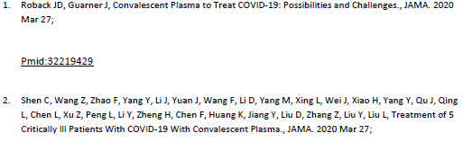

Versiti/Aurora Hospital Services, Aurora, IL

