**TITLE: Xpert® Xpress SARS-CoV-2**

**Principle:**

**For use under the Emergency Use Authorization (EUA) only.**

The Xpert Xpress SARS-CoV-2 test is a rapid, real-time RT-PCR test intended for the qualitative detection of nucleic acid from the SARS-CoV-2 in upper respiratory specimens (such as nasopharyngeal, oropharyngeal, nasal, or mid-turbinate swab and/or nasal wash/ aspirate) collected from individuals suspected of COVID-19 by their healthcare provider.

Testing of nasopharyngeal, oropharyngeal, nasal, or mid-turbinate swab and nasal wash/aspirate specimens using the Xpert Xpress SARS-CoV-2 test run on the GeneXpert Dx and GeneXpert Infinity systems is limited to laboratories certified under the Clinical Laboratory Improvement Amendments of 1988 (CLIA), 42 U.S.C. § 263a, to perform high and moderate complexity

tests.

Testing of nasopharyngeal, nasal, or mid-turbinate swab specimens using the Xpert Xpress SARS-CoV-2 test run on the GeneXpert Xpress System (Tablet and Hub Configurations) is authorized to be distributed and used in patient care settings outside of the clinical laboratory environment.

Results are for the detection of SARS-CoV-2 RNA. The SARS-CoV-2 RNA is generally detectable in upper respiratory specimens during the acute phase of infection. Positive results are indicative of active infection with SARS-CoV-2; clinical correlation with patient history and other diagnostic information is necessary to determine patient infection status. Positive results do not rule out bacterial infection or co-infection with other viruses. The agent detected may not be the definite cause of disease. Laboratories within the United States and its territories are required to report all positive results to the appropriate public health authorities.

Negative results do not preclude SARS-CoV-2 infection and should not be used as the sole basis for treatment or other patient management decisions. Negative results must be combined with clinical observations, patient history, and epidemiological information.

Testing with the Xpert Xpress SARS-CoV-2 test is intended for use by trained operators who are proficient in performing tests using either GeneXpert Dx, GeneXpert Infinity and/or GeneXpert Xpress systems. The Xpert Xpress SARS-CoV-2 test is only for use under the Food and Drug Administration's Emergency Use Authorization.

An outbreak of respiratory illness of unknown etiology in Wuhan City, Hubei Province, China was initially reported to the World Health Organization (WHO) on December 31, 2019.1 Chinese authorities identified a novel coronavirus (2019-nCoV), which has resulted in thousands of confirmed human infections in multiple provinces throughout China and exported cases in several Southeast Asian countries and more recently the United States. Cases of severe illness and some deaths have been reported. The International Committee for Taxonomy of Viruses (ICTV) renamed the virus SARS-CoV-2.2

The Xpert Xpress SARS-CoV-2 test is a molecular *in vitro* diagnostic test that aids in the detection and diagnosis SARS-CoV-2 and is based on widely used nucleic acid amplification technology. The Xpert Xpress SARS-CoV-2 test contains primers and probes and internal controls used in RT-PCR for the in vitro qualitative detection of SARS-CoV-2 RNA in nasopharyngeal swab specimens and/or nasal wash/aspirate specimens.

The term “qualified laboratories” refers to laboratories in which all users, analysts, and any person reporting results from use of this device are proficient in performing real-time RT-PCR assays.

The Xpert Xpress SARS-CoV-2 test is an automated *in vitro* diagnostic test for qualitative detection of nucleic acid from SARS-CoV-2. The Xpert Xpress SARS-CoV-2 test is performed on GeneXpert Instrument Systems.

The GeneXpert Instrument Systems automate and integrate sample preparation, nucleic acid extraction and amplification, and detection of the target sequences in simple or complex samples using real-time PCR assays. The systems consist of an instrument, computer, and preloaded software for running tests and viewing the results. The systems require the use of single-use disposable cartridges that hold the RT-PCR reagents and host the RT-PCR process. Because the cartridges are self-contained, cross-contamination between samples is minimized. For a full description of the systems, see the *GeneXpert Dx System Operator Manual* or the *GeneXpert Infinity System Operator Manual*.

The Xpert Xpress SARS-CoV-2 test includes reagents for the detection of RNA from SARS-CoV-2 in nasopharyngeal swab specimens. A Sample Processing Control (SPC) and a Probe Check Control (PCC) are also included in the cartridge utilized by the GeneXpert instrument. The SPC is present to control for adequate processing of the sample and to monitor for the presence of potential inhibitor(s) in the RT-PCR reaction. The SPC also ensures that the RT-PCR reaction conditions (temperature and time) are appropriate for the amplification reaction and that the RT-PCR reagents are functional. The PCC verifies reagent rehydration, PCR tube filling, and confirms that all reaction components are present in the cartridge including monitoring for probe integrity and dye stability.

The nasopharyngeal swab specimen and/or nasal wash/aspirate specimen is collected and placed into a viral transport tube containing 3 mL transport medium. The specimen is briefly mixed by rapidly inverting the collection tube 5 times. Using the supplied transfer pipette, the sample is transferred to the sample chamber of the Xpert Xpress SARS-CoV-2 cartridge. The GeneXpert cartridge is loaded onto the GeneXpert Instrument System platform, which performs hands-off, automated sample processing, and real-time RT-PCR for detection of viral RNA.

**Reagents and Instruments**

**Materials Provided**

The Xpert Xpress SARS-CoV-2 kit contains sufficient reagents to process 10 specimens or quality control samples. The kit contains the following:

**Xpert Xpress SARS-CoV-2 Cartridges**

**with Integrated Reaction Tubes 10**

• Bead 1, Bead 2, and Bead 3 (freeze-dried) **1 of each per cartridge**

• Lysis Reagent **1.5 mL per cartridge**

• Binding Reagent **1.5 mL per cartridge**

• Elution Reagent **3.0 mL per cartridge**

**Disposable Transfer Pipettes 12 per kit**

**CD 1 per kit**

• Assay Definition File (ADF)

• Instructions to import ADF into GeneXpert software

**Flyer 1 per kit**

• Directions to locate the Product Insert on www.cepheid.com

**Note** Safety Data Sheets (SDS) are available at www.cepheid.com or www.cepheidinternational.com under the SUPPORTtab.

Note The bovine serum albumin (BSA) in the beads within this product was produced and manufactured exclusively from bovine plasma sourced in the United States. No ruminant protein or other animal protein was fed to the animals; the animals passed ante- and post-mortem testing. During processing, there was no mixing of the material with other animal materials.

**7 Storage and Handling**

• Store the Xpert Xpress SARS-CoV-2 cartridges at 2-28°C.

• Do not open a cartridge lid until you are ready to perform testing.

• Do not use a cartridge that is wet or has leaked.

**8 Materials Required but Not Provided**

• GeneXpert Dx or GeneXpert Infinity systems (catalog number varies by configuration): GeneXpert instrument, computer, barcode scanner, operator manual.

For GeneXpert Dx System: GeneXpert Dx software version 4.7b or higher

For GeneXpert Infinity-80 and Infinity-48s systems: Xpertise software version 6.4b or higher

**9 Materials Available but Not Provided**

SeraCare AccuPlex™ Reference Material Kit, catalog number 0505-0126 (Order Code CEPHEID)

**10 Warnings and Precautions**

**10.1 General**

• For *in vitro* diagnostic use.

• For emergency use only.

• Positive results are indicative of presence of SARS-CoV-2-RNA

• Laboratories within the United States and its territories are required to report all positive results to the appropriate public health authorities.

• Performance characteristics of this test have been established with the specimen types listed in the Intended Use Section only. The performance of this assay with other specimen types or samples has not been evaluated.

• Treat all biological specimens, including used cartridges, as if capable of transmitting infectious agents. Because it is often impossible to know which might be infectious, all biological specimens should be handled using standard precautions. Guidelines for specimen handling are available from the U.S. Centers for Disease Control and Prevention3 and the Clinical and Laboratory Standards Institute.4

• Follow safety procedures set by your institution for working with chemicals and handling biological specimens.

• Consult your institution’s environmental waste personnel on proper disposal of used cartridges, which may contain amplified material. This material may exhibit characteristics of federal EPA Resource Conservation and Recovery Act (RCRA) hazardous waste requiring specific disposal requirements. Check state and local regulations as they may differ from federal disposal regulations. Institutions should check the hazardous waste disposal requirements within their respective countries.

**10.2 Specimen**

• Maintain proper storage conditions during specimen transport to ensure the integrity of the specimen (see Section 12, Specimen Collection, Transport, and Storage). Specimen stability under

**10.3 Assay/Reagent**

• Do not open the Xpert Xpress SARS-CoV-2 cartridge lid except when adding specimen.

• Do not use a cartridge that has been dropped after removing it from the packaging.

• Do not shake the cartridge. Shaking or dropping the cartridge after opening the cartridge lid may yield non-determinate results.

• Do not place the sample ID label on the cartridge lid or on the barcode label on the cartridge.

• Do not use a cartridge with a damaged barcode label.

• Do not use a cartridge that has a damaged reaction tube.

• Each single-use Xpert Xpress SARS-CoV-2 cartridge is used to process one test. Do not reuse processed cartridges.

• Each single-use disposable pipette is used to transfer one specimen. Do not reuse disposable pipettes.

• Do not use a cartridge if it appears wet or if the lid seal appears to have been broken.

• Wear clean lab coats and gloves. Change gloves between the handling of each specimen.

• In the event of a spill of specimens or controls, wear gloves and absorb the spill with paper towels. Then, thoroughly clean the contaminated area with a 10% freshly prepared household chlorine bleach. Allow a minimum of two minutes of contact time. Ensure the work area is dry before using 70% denatured ethanol to remove bleach residue. Allow surface to dry completely before proceeding. Or, follow your institution’s standard procedures for a contamination or spill event. For equipment, follow the manufacturer’s recommendations for

decontamination of equipment.

• Biological specimens, transfer devices, and used cartridges should be considered capable of transmitting infectious agents requiring standard precautions. Follow your institution’s environmental waste procedures for proper disposal of used cartridges and unused reagents. These materials may exhibit characteristics of chemical hazardous waste requiring specific disposal. If country or regional regulations do not provide clear direction on proper disposal, biological specimens and used cartridges should be disposed per WHO [World Health Organization] medical waste handling and disposal guidelines.

**11 Chemical Hazards**13,14

• **Signal Word: Warning**

• **UN GHS Hazard Statements:**

• Harmful if swallowed.

• May be harmful in contact with skin

• Causes eye irritation.

• **UN GHS Hazard Statements:**

• **Prevention**

• Wash thoroughly after handling.

• **Response**

• Call a POISON CENTER or physician if you feel unwell.

• If skin irritation occurs: Get medical advice/attention.

• IF IN EYES: Rinse cautiously with water for several minutes. Remove contact lenses, if present and easy to do. Continue rinsing.

• If eye irritation persists: Get medical advice/attention.

**12 Specimen Collection and Transport**

Proper specimen collection, storage, and transport are critical to the performance of this test. Inadequate specimen collection, improper specimen handling and/or transport may yield a false result. See Section 12.1 for nasopharyngeal swab collection procedure, Section 12.2 for nasal swab collection procedure , and Section 12.5 for nasal wash/aspirate procedure. Nasopharyngeal, nasal, and nasal wash/aspirate specimens can be stored at room temperature (15-30°C) for up to 8 hours and refrigerated (2-8 °C) up to seven days until testing is performed on the GeneXpert Instrument Systems. For oropharyngeal swab specimen transport and storage requirements and additional information, refer to the CDC Interim Guidelines for Collecting, Handling, and Testing Clinical Specimens from Persons Under Investigation (PUIs) for Coronavirus Disease 2019 (COVID-19) using the link provided below.

<https://www.cdc.gov/coronavirus/2019-nCoV/lab/guidelines-clinical-specimens.html>

**12.1 Nasopharyngeal Swab Collection Procedure**

Insert the swab into either nostril, passing it into the posterior nasopharynx (see Figure 1). Rotate swab by firmly brushing against the nasopharynx several times. Remove and place the swab into a viral transport tube 3 mL or 3 mL of saline. Break swab at the indicated break line and cap the specimen collection tube tightly.



**Figure 1. Nasopharyngeal Swab Collection**

**12.2 Nasal Swab Collection Procedure**

1. Insert a nasal swab 1 to 1.5 cm into a nostril. Rotate the swab against the inside of the nostril for 3 seconds while applying pressure with a finger to the outside of the nostril (see Figure 2).



**Figure 2. Nasal Swab Collection for First Nostril**

2. Repeat on the other nostril with the same swab, using external pressure on the outside of the other nostril (see Figure 3). To avoid specimen contamination, do not touch the swab tip to anything other than the inside of the nostril.

3. Remove and place the swab into the tube containing 3 mL of viral transport medium or 3 mL of saline. Break swab at the indicated break line and cap the specimen collection tube tightly.

**12.5 Nasal Wash/Aspirate Procedure**

Using a clean transfer pipette, transfer 600 μL of the sample into the tube containing 3 mL of viral transport medium or 3 mL of saline and then cap the tube.

**13 Procedure**

**13.1 Preparing the cartridge**

**Important:** Start the test within 30 minutes of adding the sample to the cartridge.

1. Remove a cartridge from the package.

2. Check the specimen transport tube is closed.

3. Mix specimen by rapidly inverting the specimen transport tube 5 times. Open cap on the specimen transport tube.

4. Open the cartridge lid.

5. Remove the transfer pipette from the wrapper.

6. Squeeze the top bulb of the transfer pipette completely and then place the pipette tip in the specimen transport tube (see Figure 2).



**Figure 2. Transfer Pipette**

7. Release the top bulb of the pipette to fill the pipette before removing from the tube. After filling pipette, excess sample will be seen in the overflow reservoir bulb of the pipette (see Figure 2). Check that the pipette does not contain bubbles.

8. To transfer the sample to the cartridge, squeeze the top bulb of the transfer pipette completely again to empty the contents of the pipette into the large opening (Sample Chamber) in the cartridge shown in Figure 3. Dispose of the used pipette



**Sample Chamber (Large Opening)**

**Figure 3. Xpert Xpress SARS-CoV-2 Cartridge (Top View)**

**Note** Take care to dispense the entire volume of liquid into the Sample Chamber. False negative results may occur if insufficient sample is added to the cartridge.

9. Close the cartridge lid.

**13.2 External Controls**

External controls described in Section 9 are available but not provided and may be used in accordance with local, state, and federal accrediting organizations, as applicable.

To run a control using the Xpert Xpress SARS-CoV-2 test, perform the following steps:

1. Mix control by rapidly inverting the external control tube 5 times. Open cap on external control tube.

2. Open the cartridge lid.

3. Using a clean transfer pipette, transfer one draw of the external control sample into the large opening (Sample Chamber) in the cartridge shown in Figure 3.

4. Close cartridge lid.

**Starting the Test**

**Note** Before you start the test, make sure that the system contains modules with GeneXpert Dx software version 4.7b or higher or Infinity Xpertise software 6.4b or higher, and that the Xpert Xpress SARS-CoV-2 Assay Definition File is imported into the software.

This section lists the default steps to operate the GeneXpert Instrument System. For detailed instructions, see the *GeneXpert Dx System Operator Manual* or the *GeneXpert Infinity System Operator Manual*, depending on the model that is being used.

**Note** The steps you follow may be different if the system administrator has changed the default workflow of the system.

1. Turn on the GeneXpert InstrumentSystem:

If using the GeneXpert Dx instrument, first turn on the instrument and then turn on the computer. Log into the Windows operating system. The GeneXpert software may launch automatically or may require double- clicking on the GeneXpert Dx shortcut icon on theWindows® desktop.

2. Log on to the System software. The login screen appears. Type your username and password.

3. In the GeneXpert System window, click **Create Test** (GeneXpert Dx).

4. Scan or type in the Patient ID (optional). If typing the Patient ID, make sure the Patient ID is typed correctly. The Patient ID is shown on the left side of the ViewResults window and is associated with the test result.

5. Scan or type in the Sample ID. If typing the Sample ID, make sure the Sample ID is typed correctly. The Sample ID is shown on the left side of the View Results window and is associated with the test result.

6. Scan the barcode on the Xpert Xpress SARS-CoV-2 cartridge. Using the barcode information, the software automatically fills the boxes for the following fields: Reagent Lot ID, Cartridge SN, Expiration Date and Selected Assay.

**Note** If the barcode on the Xpert Xpress SARS-CoV-2 cartridge does not scan, then repeat the test with a new cartridge.

7. Click **Start Test** (GeneXpert Dx)

**For the GeneXpert Dx Instrument**

A. Locate the module with the blinking green light, open the instrument module door and load the cartridge.

B. Close the door. The test starts and the green light stops blinking. When the test is finished, the light turns off and the door will unlock. Remove the cartridge.

C. Dispose of used cartridges in the appropriate sample waste containers according to your institution's standard practices.

**Note** Do not turn off or unplug the instruments while a test is in progress. Turning off or unplugging the GeneXpert instrument or computer will stop the test.

**14 Viewing and Printing Results**

This section lists the basic steps for viewing and printing results. For more detailed instructions on how to view and print the results, see the GeneXpert Dx System Operator Manual.

1. Click the View Results icon to view results.

2. Upon completion of the test, click the Report button of the View Results window to view and/or generate a PDF report file.

**15 Quality Control**

**15.1 Internal Controls**

Each cartridge includes a Sample Processing Control (SPC) and Probe Check Control (PCC).

**Sample Processing Control (SPC) –** Ensures that the sample was processed correctly. The SPC verifies that sample processing is adequate. Additionally, this control detects sample-associated inhibition of the real-time PCR assay, ensures that the PCR reaction conditions (temperature and time) are appropriate for the amplification reaction, and that the PCR reagents are functional. The SPC should be positive in a negative sample and can be negative or positive in a positive sample. The SPC passes if it meets the validated acceptance criteria.

**Probe Check Control (PCC) –** Before the start of the PCR reaction, the GeneXpert System measures the fluorescence signal from the probes to monitor bead rehydration, reaction tube filling, probe integrity, and dye stability. The PCC passes if it meets the validated acceptance criteria.

**15.2 External Controls**

SeraCare AccuPlex™ Reference Material Kit, catalog number 0505-0126 (Order Code CEPHEID)

Positive and Negative Controls will be performed following New lot/shipment QC protocols.

**16 Interpretation of Results (Order Code CVD19)**

The results are interpreted automatically by the GeneXpert System and are clearly shown in the

**View Results** window. The Xpert Xpress SARS-CoV-2 test provides test results based on the detection of two gene targets according to the algorithms shown in Table 1.

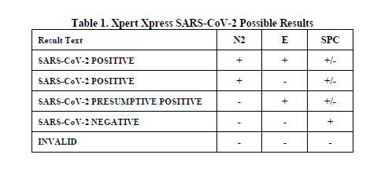

See Table 2 to interpret test result statements for the Xpert Xpress SARS-CoV-2 test.

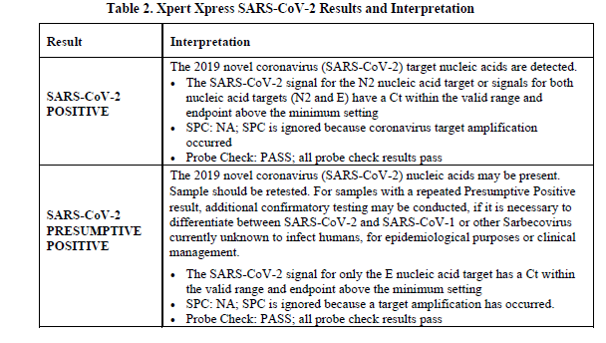

Presumptive Positive result must be repeated.

If second run is “Presumptive Positive” report as “Presumptive Positive”

If second run is “Positive” report as ”Positive”

If second run is “Negative” report as “Negative”

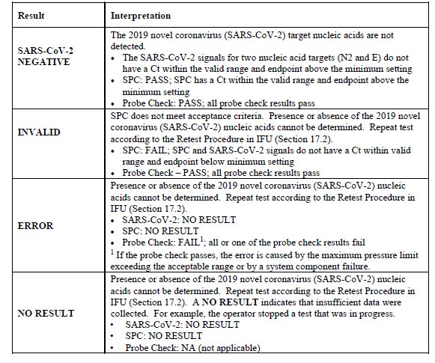

**POSITIVE REPORTING**

Auto posted/ Manually verified result –POSITIVE **(Critical value-Call to Caregiver)

SARS-CoV-2 RNA: DETECTED

?Internal QC OK

Comment: The 2019 novel coronavirus (SARS-CoV-2) target

Nucleic acids are detected. Positive results are indicative

of active infection with SARS-CoV-2.

Methodology: Detection of SARS-CoV-2 RNA is based upon the

real-time detection amplification of nucleic targets in

the SARS-CoV-2 viral genome.

Performance characteristics for the Xpert Xpress SARS-CoV-2

assay have been determined by Cepheid, Inc. as part of

the Emergency Use Authorization. Provider and patient fact

sheets are available at <https://www.fda.gov/medical-devices>

/emergency-situations-medical-devices/emergency-use-authorizations#coronavirus2019

**PRESUMPTIVE POSITIVE REPORTING**

Auto posted/ Manually verified result –PRESUMPTIVE POSITIVE (Critical value-Call to Caregiver)

**Test must be repeated before verifying result.**

**Presumptive Positive result must be repeated.**

If second run is “Presumptive Positive” report as “Presumptive Positive”

If second run is “Positive” report as ”Positive”

If second run is “Negative” report as “Negative”

SARS-CoV-2 RNA: PRESUMPTIVE POSITIVE

?Verify by repeat testing.

?Internal QC OK

Comment: The 2019 novel coronavirus (SARS-CoV-2) target

nucleic acids may be present.

Methodology: Detection of SARS-CoV-2 RNA is based upon real-

time detection and amplification of nucleic acid targets in

the SARS-CoV-2 viral genome.

Performance characteristics for the Xpert Xpress SARS-CoV-2

assay have been determined by Cepheid, Inc. as part of the

FDA Emergency Use Authorization. Provider and patient fact

sheets are available at https://www.fda.gov/medical-devices

/emergency-situations-medical-devices/emergency-use-

authorizations#coronavirus2019

**NEGATIVE REPORTING**

Auto posted/ Auto verified result - NEGATIVE

SARS-CoV-2 RNA: Not detected

?Internal QC OK

Comment: The 2019 novel coronavirus (SARS-CoV-2) target

nucleic acids are not detected. Negative results do not

preclude infection with the SARS-CoV-2 and should not be

the sole basis of a patient treatment/management or public

health decision. Follow up testing should be performed

according to the current CDC recommendations.

Methodology: Detection of Sars-CoV-2 RNA is based upon the

real-time detection and amplification of nucleic acid targets

in the SARS-Cov-2 viral genome.

Performance characteristics for the Xpert Xpress SARS-CoV-2

assay have been determined by Cepheid, Inc. as part of the

FDA Emergency Use Authorization. Provider and patient fact

sheets are available at https://www.fda.gov/medical-devices

/emergency-situations-medical-devices/emergency-use-authorizations#coronavirus2019

**INVALID REPORTING**

Auto posted Results after initial test failure shown below. If the repeated test obtains results they must be manually verified even if Negative.

CV: ?Test error. Repeat Test

If the repeated test also fails the above results will be listed twice. The keypad must then be used to manually choose the QC Fail result. }QCFR ?QC fail recollect

CV: ?Test error. Repeat Test

?Test error. Repeat Test

Possible interfering substance present. Recollection required.

?Mult internal QC failure. Call for recollection and reorder.

?Call for recollection and reorder

Document call to caregiver

**17 Retests**

**17.1 Reasons to Repeat the Assay**

If any of the test results mentioned below occur, repeat the test once according to instructions in Section 17.2, Retest Procedure.

• A **PRESUMPTIVE POSITIVE** indicates the 2019 novel coronavirus (SARS-CoV-2) nucleic acids may be present.

• An **INVALID** result indicates that the control SPC failed. The sample was not properly processed, PCR is inhibited, or the sample was not properly collected.

• An **ERROR** result could be due to, but not limited to, Probe Check Control failure, system component failure, or the maximum pressure limits were exceeded.

• A **NO RESULT** indicates that insufficient data were collected. For example, cartridge failed integrity test, the operator stopped a test that was in progress, or a power failure occurred.

If an External Control fails to perform as expected, repeat external control test and/or contact Cepheid for assistance.

**17.2 Retest Procedure**

To retest a non-determinate result **(INVALID**, **NO RESULT**, or **ERROR**), use a new cartridge.

Use the leftover sample from the original specimen transport medium tube or new external control tube.

1. Put on a clean pair of gloves. Obtain a new Xpert Xpress SARS-CoV-2 cartridge and a new transfer pipette.

2. Check the specimen transport tube or external control tube is closed.

3. Mix the sample by rapidly invert the specimen transport medium tube or external control tube 5 times. Open the cap on the specimen transport tube or external control tube.

4. Open the cartridge lid.

5. Using a clean transfer pipette (supplied), transfer sample (one draw) to the sample chamber with the large opening in the cartridge.

6. Close the cartridge lid.

**18 Limitations**

• Performance of the Xpert Xpress SARS-CoV-2 has only been established in nasopharyngeal swab specimens. Specimen types other than nasopharyngeal swab may give inaccurate results.

• A false negative result may occur if a specimen is improperly collected, transported or handled. False negative results may also occur if inadequate numbers of organisms are present in the specimen.

• As with any molecular test, mutations within the target regions of Xpert Xpress SARS-CoV-2 could affect primer and/or probe binding resulting in failure to detect the presence of virus.

• This test cannot rule out diseases caused by other bacterial or viral pathogens.

**19 Conditions of Authorization for Laboratory and Patient Care Settings**

The Cepheid Xpert Xpress SARS-CoV-2 Letter of Authorization, along with the authorized Fact Sheet for Healthcare Providers, the authorized Fact Sheet for Patients and authorized labeling are available on the FDA website: https://www.fda.gov/MedicalDevices/Safety/EmergencySituations/ucm161496.htm

However, to assist clinical laboratories and/or Patient Care Settings using the Xpert Xpress SARS-CoV-2 (referred to in the Letter of Authorization as “Your Product”), the relevant Conditions of Authorization are listed below.

• Authorized laboratories1 and patient care settings using your product will include with result reports of the Xpert Xpress SARS-CoV-2 test, all authorized Fact Sheets. Under exigent circumstances, other appropriate methods for disseminating these Fact Sheets may be used, which may include mass media.

• Authorized laboratories using your product will use your product as outlined in the Xpert Xpress SARS-CoV-2 Instructions for Use - For Use with GeneXpert Dx or GeneXpert Infinity systems. Deviations from the authorized procedures, including the authorized instruments, authorized extraction methods, authorized clinical specimen types, authorized control materials, authorized other ancillary reagents and authorized materials required to use the Xpert Xpress SARS-CoV-2 test are not permitted.

• Patient Care Settings using your product will use your product as outlined in the Xpress SARS-CoV-2 Instructions for Use - For Use with GeneXpert Xpress System and associated Quick Reference Instructions for Xpert Xpress SARS-CoV-2 and GeneXpert Xpress System (Hub configuration), and Quick Reference Instructions for Xpert Xpress SARS-CoV-2 and GeneXpert Xpress System (Tablet configuration). Deviations from the authorized procedures, including the authorized instruments, authorized extraction methods, authorized clinical specimen types, authorized control materials, authorized other ancillary reagents and authorized materials required to use your product are not permitted.

• Authorized laboratories and patient care settings will have a process in place for reporting test results to healthcare providers and relevant public health authorities, as appropriate.

• Authorized laboratories and patient care settings that receive your product will notify the relevant public health authorities of their intent to run your product prior to initiating testing

• Authorized laboratories and patient care settings using the Xpert Xpress SARS-CoV-2 test will collect information on the performance of the test and report to DMD/OHT7-OIR/OPEQ/CDRH (via email: CDRH-EUA Reporting@fda.hhs.gov) and Cepheid (+1 888.838.3222 or techsupport@cepheid.com ) any suspected occurrence of false positive or false negative results and significant deviations from the established performance characteristics of the test of which they become aware.

• All operators using your product must be appropriately trained in performing and interpreting the results of your product, use appropriate personal protective equipment when handling this kit, and use your product in accordance with the authorized labeling.

• You, authorized distributors, and authorized laboratories and patient care settings using your product will ensure that any records associated with this EUA are maintained until otherwise notified by FDA. Such records will be made available to FDA for inspection upon request.

1 The letter of authorization refers to, “United States (U. S.) laboratories certified under the Clinical Laboratory Improvement Amendments of 1988 (CLIA), 42 U.S.C. § 263a, to perform moderate or high complexity tests” as “authorized laboratories.”

**20 Performance Characteristics**

**20.1 Clinical Evaluation**

The performance of the Xpert SARS-CoV-2 test was evaluated using contrived clinical nasopharyngeal (NP) swab specimens in viral transport medium obtained from individuals with signs and symptoms of respiratory illness. The samples were prepared by spiking each individual clinical NP swab sample with AccuPlex SARS-CoV-2 (a quantitated reference material – recombinant Sindbis virus particle containing target sequences from the SARS-CoV-2 genome) at concentrations approximate to 2x LoD, 3x LoD and 5x LoD. The NP swab samples were determined to be negative for SARS-CoV-2 prior to spiking the specimens. Negative NP swab samples were also tested in the study.

Table 3 shows the samples with the target concentrations of the AccuPlex SARS-CoV-2, the number of concordant results and total number tested as well as the percent agreement with the 95% confidence interval (95% CI) where appropriate. The results show 100% agreement with the expected results in the AccuPlex SARS-CoV-2 spiked samples and 100% agreement with the expected results in the negative samples.

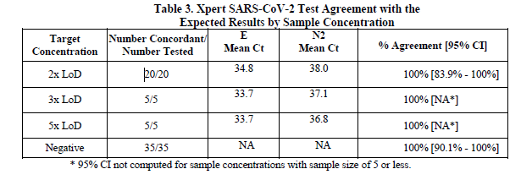

**21 Analytical Performance**

**21.1 Analytical Sensitivity (Limit of Detection)**

Studies were performed to determine the analytical limit of detection (LoD) of the Xpert Xpress SARS-CoV-2. The LoD of Xpert Xpress SARS-CoV-2 was established using one lot of reagent and limiting dilutions of AccuPlex SARS-CoV-2 prepared in simulated background matrix and nasopharyngeal swab clinical matrix. Verification of the estimated LoD claim was performed on one reagent lot in replicates of 35 prepared in nasopharyngeal swab clinical matrix. The LoD is the lowest concentration (reported as copies/μL) of AccuPlex SARS-Cov-2 recombinant viral sequence that can be reproducibly distinguished from negative samples ≥ 95% of the time with 95% confidence. The claimed LoD for the assay is 250 copies/mL (Table 4).

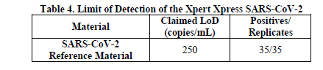

**21.2 Analytical Reactivity (Inclusivity)**

The inclusivity of Xpert Xpress SARS-CoV-2 was evaluated using *in silico* analysis of the assay primers and probes in relation to 324 SARS-CoV-2 sequences available in the GISAID gene database for two targets, E and N2.

For the E target, Xpert Xpress SARS-CoV-2 had 100% match to all sequences with the exception of 4 sequences that had a single mismatch. For the N2 target, Xpert Xpress SARS-CoV-2 had 100% match to all sequences with the exception of 2 sequences that had a single mismatch. None of these mismatches found for both targets are predicted to have a negative impact on the performance of the assay, given the location of the mutations in the primer and probe regions respectively for the two variants. These mutations are not predicted to adversely affect the probe and primer binding to the sequences or reduce assay efficiency.

**21.3 Analytical Specificity (Exclusivity)**

An *in silico* analysis for possible cross-reactions with all the organisms listed in Table 5 was conducted by mapping primers and probes in the Xpert Xpress SARS-CoV-2 test individually to the sequences downloaded from the GISAID database. E primers and probes are not specific for SARS-CoV-2 and will detect Human and Bat SARS-coronavirus. No potential unintended cross reactivity with other organisms listed in Table 5 is expected based on the *in silico* analysis.

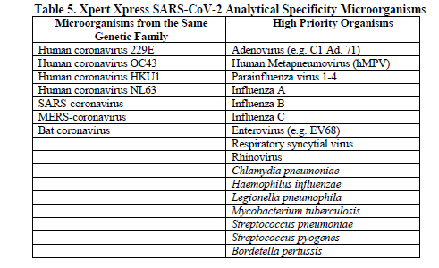

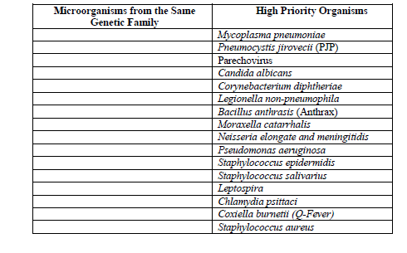

**22 References**

1. Centers for Disease Control and Prevention. https://www.cdc.gov/coronavirus/2019-ncov/index.html. Accessed February 9, 2020.

2. bioRxiv. (https://www.biorxiv.org/content/10.1101/2020.02.07.937862v1). Accessed March 3, 2020.

3. Centers for Disease Control and Prevention. *Biosafety in Microbiological and Biomedical laboratories* (refer to latest edition). http://www.cdc.gov/biosafety/publications/

4. Clinical and Laboratory Standards Institute. *Protection of Laboratory Workers from Occupationally Acquired Infections; Approved Guideline*. Document M29 (refer to latest edition).

5. REGULATION (EC) No 1272/2008 OF THE EUROPEAN PARLIAMENT AND OF THE COUNCIL of 16 December 2008 on the classification labeling and packaging of substances and mixtures amending and repealing, List of Precautionary Statements, Directives 67/548/EEC and 1999/45/EC (amending Regulation (EC) No 1907/2007).

6. Occupational Safety and Health Standards, Hazard Communication, Toxic and Hazard Substances (March 26, 2012) (29 C.F.R., pt. 1910, subpt. Z).

