**TITLE: Using the LabCorp Test Directory**

**PRINCIPLE:** The LabCorp Test Directory provides all the information needed on test requirements for LabCorp referred testing. It is expected that laboratory personnel will use the test directory to ensure the correct specimen is collected and sent to LabCorp for patient testing.

**Personnel:**  Phlebotomists and Medical Technologists

**Referred Laboratory:** Laboratory Corporation of America (LabCorp)

**STEPWISE PROCEDURE:**

1. The LabCorp test menu can be accessed more than one way.
   1. The first is by double-clicking the “LabCorp Test Menu” icon on the computer’s desktop:

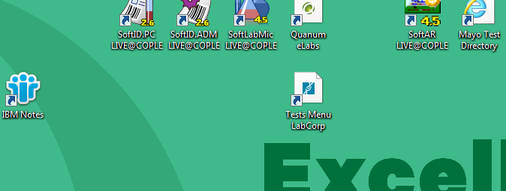

* 1. The second way to access the test menu is by opening Internet Explorer and typing [www.labcorp.com](http://www.labcorp.com) into the address bar:

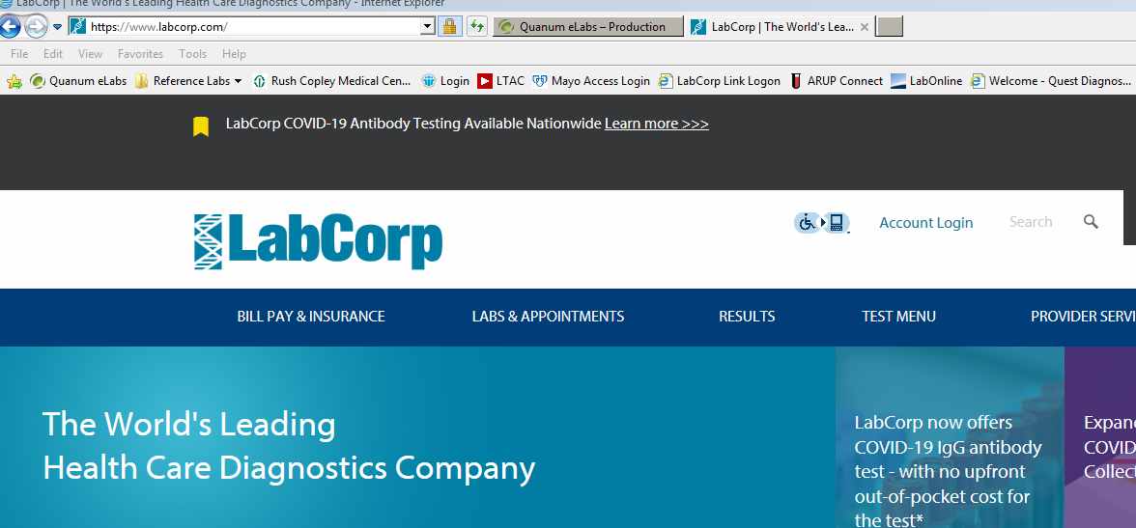

* 1. You may then click on “Test Menu”.

1. You will search for a test by typing the test name or number into the search box.

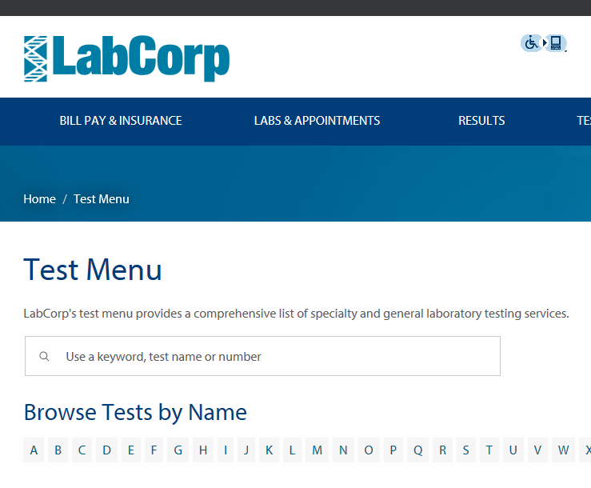

Enter Test Name or Number here

1. Using the test name will provide a list of tests that contain the letters that you typed:

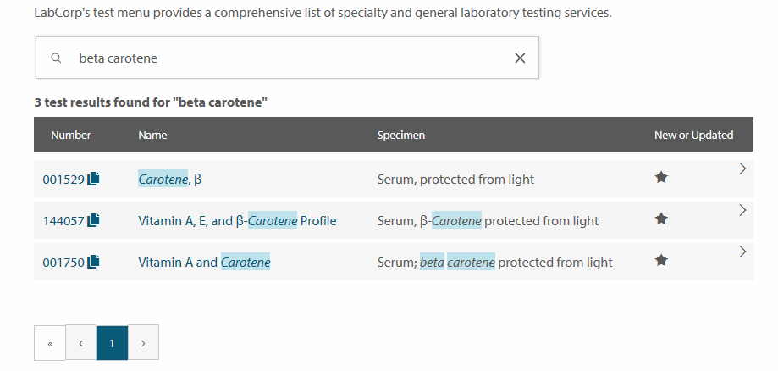

1. Using the test code will also provide you with a list of tests, however the test code you typed in will be the first test listed. To review the test information, click on the test name.

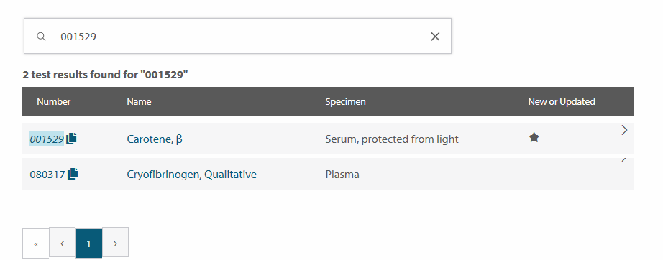

Click Here

1. You can scroll through the test information to find the information you need, such as test requirements, specimen type, patient preparation, and turn-around time. The information can be printed by using the “Print” icon at the top of the page. **It is highly recommended to print the test information, especially when there are specific patient preparation instructions or collection instructions.** Give this information to the personnel collecting the specimen(s) and leave a copy in the send out department for processing.

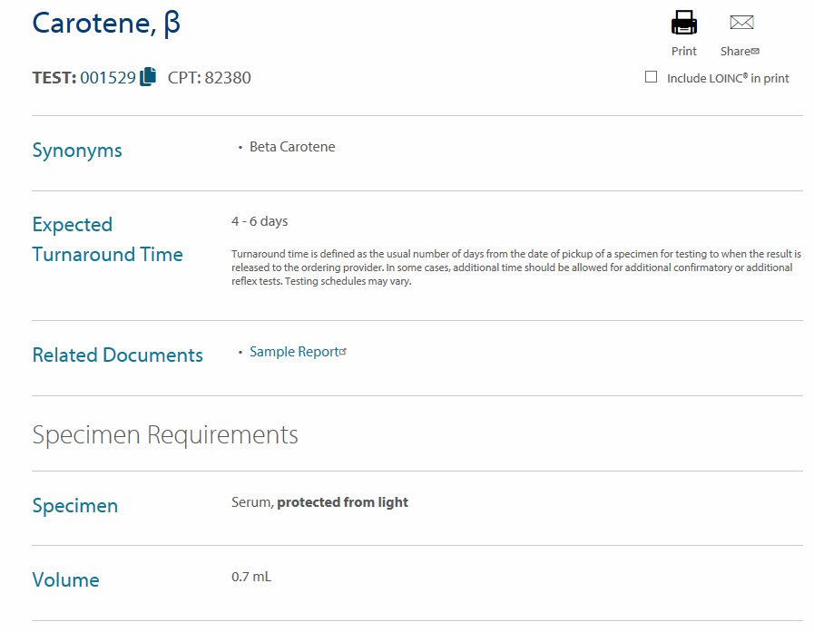

To Print the Test Information

1. For any test that does not appear in the test directory or if there are questions about a test, you can call LabCorp’s Hospital Account Services at (800) 399-4461. Rush Copley’s account number is 12070310. The customer service representative can help find a test that may not be in the directory and answer any questions you may have about a test.