**TITLE: Preparation of Platelet-poor Plasma for Referred Coagulation Testing**

**PRINCIPLE:** Lupus anticoagulants (LA) are nonspecific antibodies that extend clot-based coagulation assays as the result of their interaction with phospholipid in the reaction mixture. Platelets in plasma samples can act as a source of phospholipid and mask the effects of LA. For this reason, it is important to prepare platelet-poor plasma (PPP) for LA testing and other coagulation testing.

**Personnel:**  Phlebotomists and Medical Technologists

**STEPWISE PROCEDURE:**

1. Specimens for coagulation testing have a limited stability. Plasma must be separated from the cells as soon as possible after collection.
2. Upon receipt of blue-topped sodium citrate tubes, check all tubes for appropriate fill volumes. Any tubes that do not meet the fill requirements will need to be recollected.
3. Check the collection tube(s) for clots by opening the tube and stirring the tube with two applicator sticks. Discard the sticks after checking the tube and replace the cap on the tube when done. Repeat for all tubes collected. If any clotted tubes are found, they must be recollected.
4. Receive the specimens into the LIS using the computer in SendOuts. When the pop-up box for labels appears, change the number of copies to “2”.
5. Centrifuge the blue-topped tubes using the refrigerated centrifuge at 3700 RPM for 10 minutes.
6. Using one set of aliquot labels that were printed during the receiving process, label an aliquot tube for each blue top tube collected. For example, if 5 blue top tubes are collected, label 5 aliquot tubes.
7. When centrifugation is complete, pipet 3/4 of the plasma from the blue top tube into its corresponding aliquot tube. Be careful not to disturb the cells when pipetting. Place the cap on the aliquot tube.

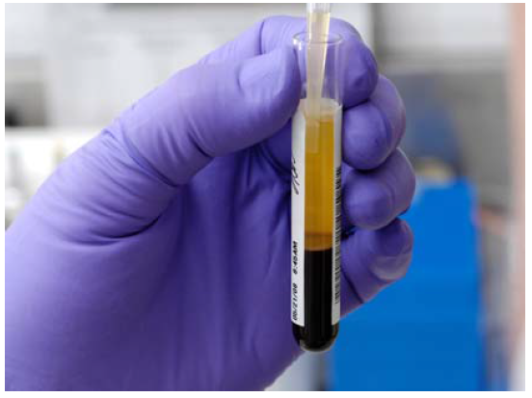 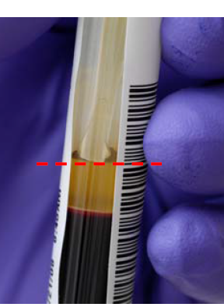

Recommended pipet tip placement.

1. Repeat this process for each blue top tube.
2. Once all blue top tubes have been aliquoted, centrifuge the aliquot tubes using the refrigerated centrifuge at 3700 RPM for 10 Minutes.

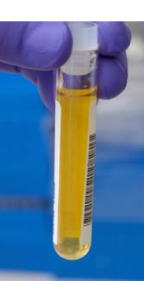

Spin Aliquot Tubes

1. Using the second set of aliquot labels that were printed when the specimens were received, label a second set of aliquot tubes for the specimens.
2. When the aliquot tubes have completed the second centrifugation, pipet the top 3/4 of the plasma in the aliquot tube to the newly labeled second tube. Do not pipet from or disturb the bottom of the tube.

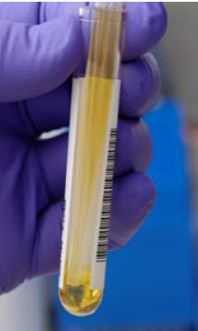 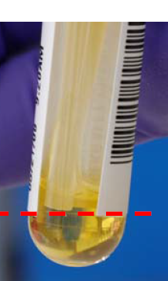

1. Repeat this process for the remaining specimens.
2. Once completed, freeze the specimens immediately.

Visual Aide for the complete process:

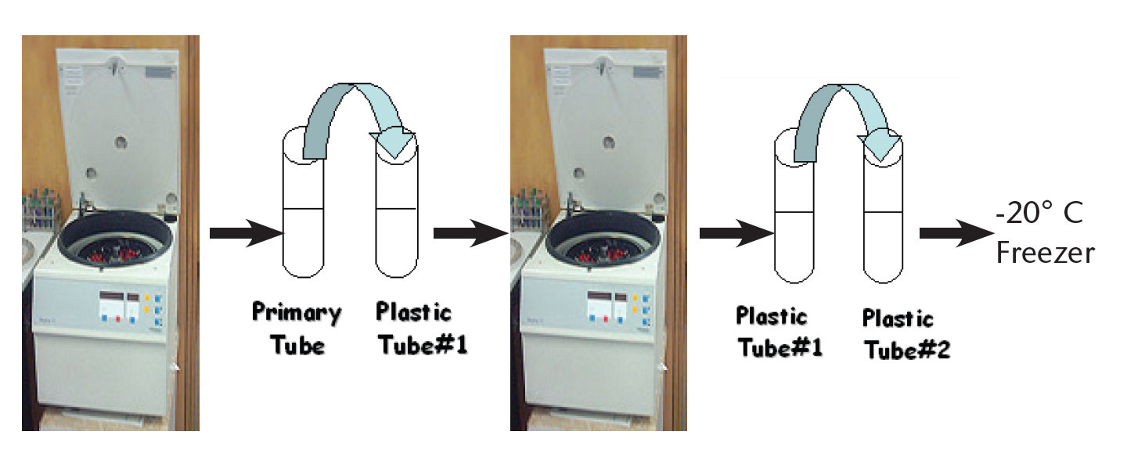

Centrifuge Aliquot Tube #1

¾ of plasma – do not disturb bottom of tube!

¾ of plasma – do not disturb cells!

Aliquot Tube #2

Aliquot Tube #1

Aliquot Tube #1

Blue Top

Centrifuge Primary Tube

DO NOT pipet from here!