**TITLE: Processing LabCorp Referred Labs Using LabCorp Link (Beacon)**

**PRINCIPLE**: To properly process testing that is not performed at Rush Copley Laboratory and processed manually through LabCorp’s online ordering system.

**STEPWISE PROCEDURE:**

1. When specimens arrive in the send out processing area, **ALL** specimens must be received into send outs following the same procedure as receiving into LCC using the computer in the send out area. After receiving all specimens, a pop up box for printing aliquot labels will appear, click on OK. Labels will print on the Zebra printer in the send out area. Only specimens that require a pour off will print labels. Pay attention to special instructions that may print with the aliquot labels.
   1. **Note:** *Miscellaneous orders will always print an aliquot label, so be sure to check specimen requirements before centrifuging and aliquoting any LMISC test.*

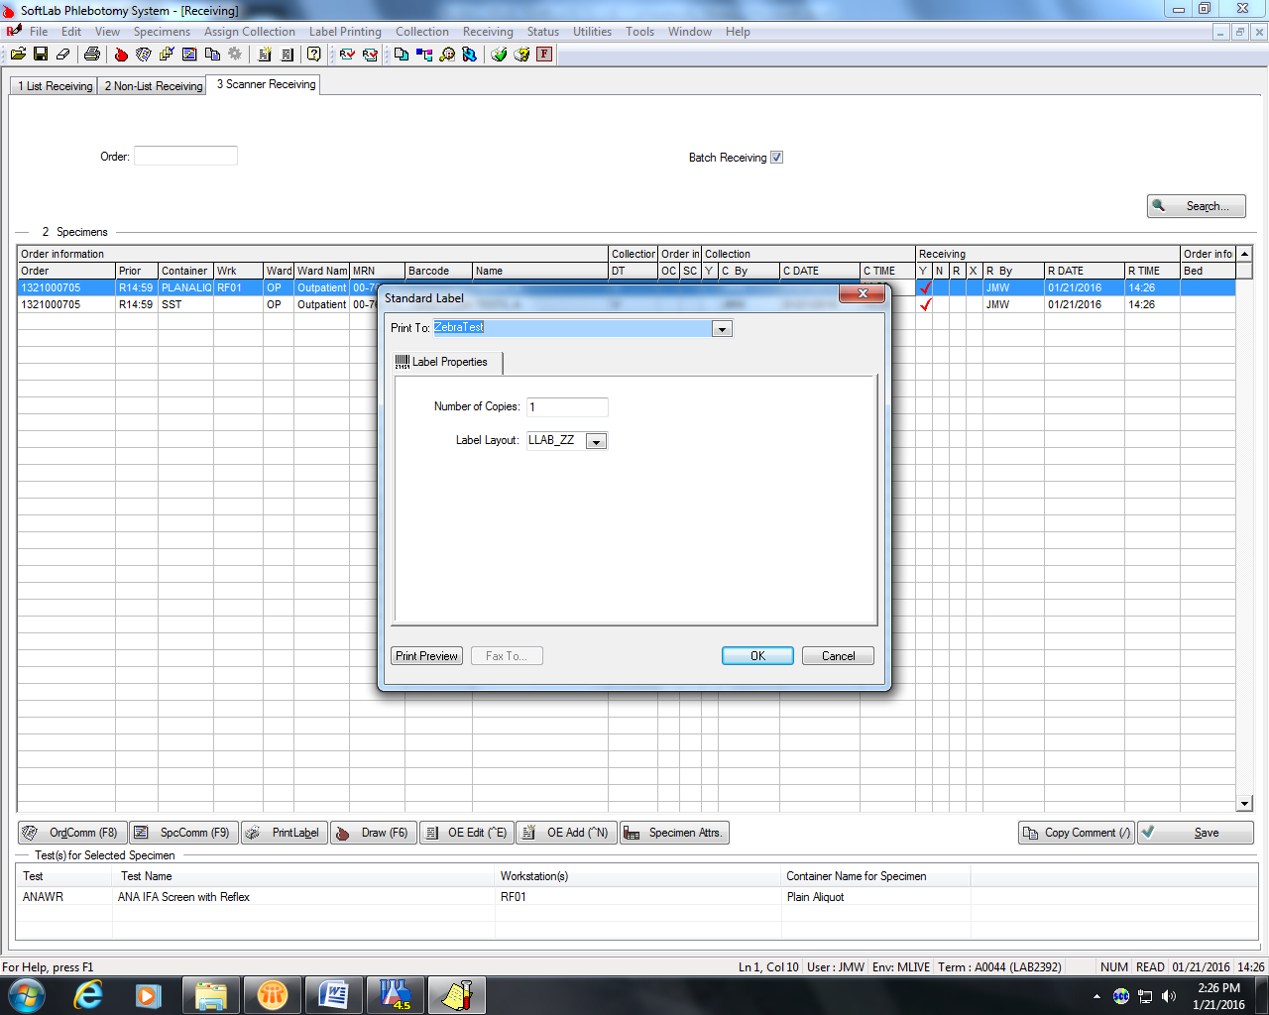

1. After receiving the specimen(s) into Soft, sign into LabCorp Link (Beacon) using your log-in information.

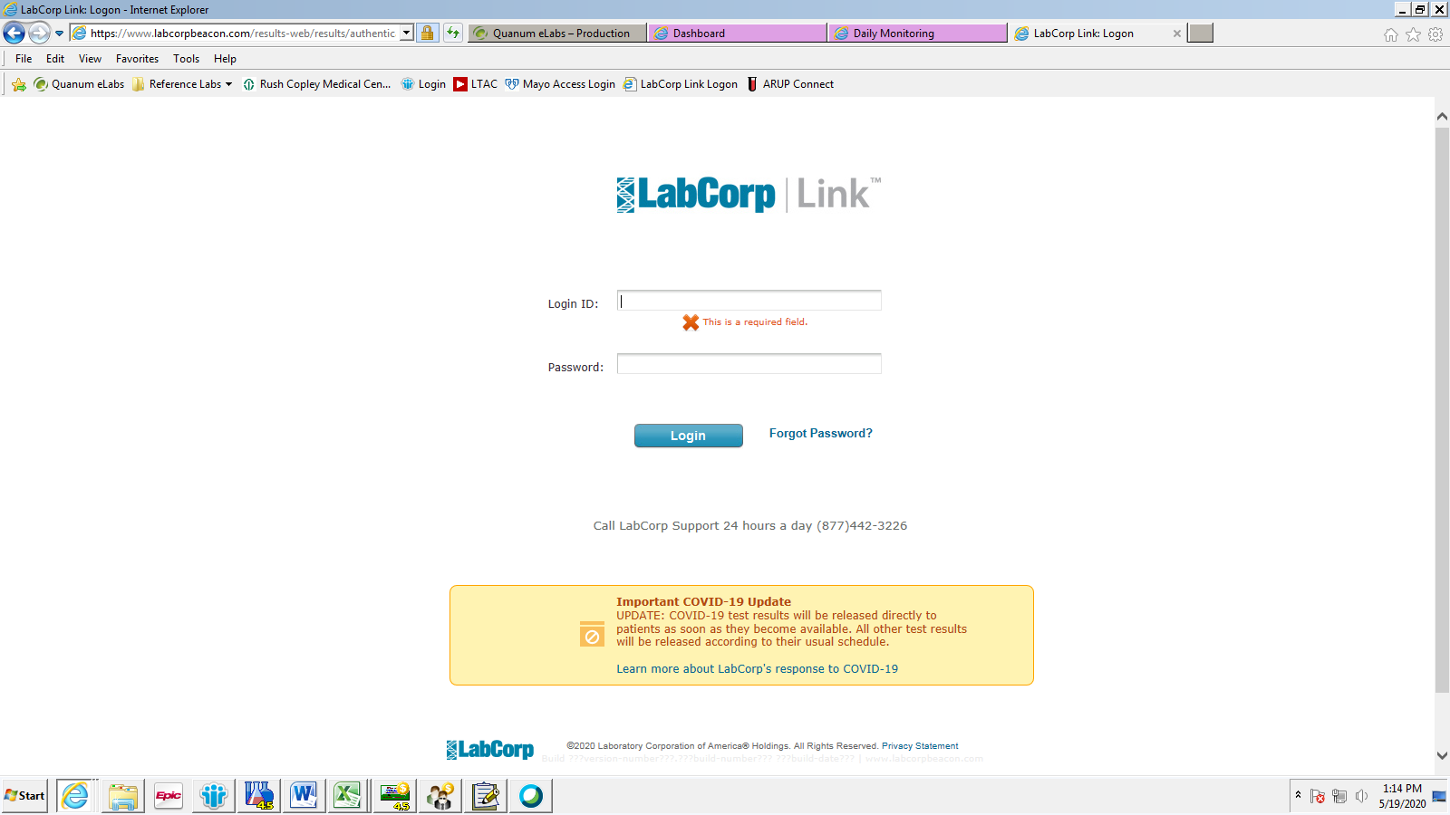

1. When logging in for the first time, you must change the ordering location. Labs must be sent under the Rush Copley Interface Account. In the upper right corner under your name, click on “Change Location”. De-select “Rush Copley Medical Center 12069380” and click “Save”.



Click “Change Location”

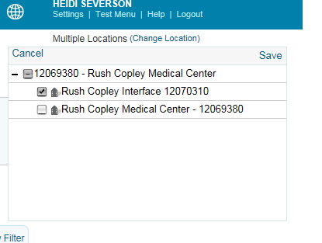

De-select “Rush Copley Medical Center”, Then click “Save”.

1. Click on the “Orders” link at the top of screen

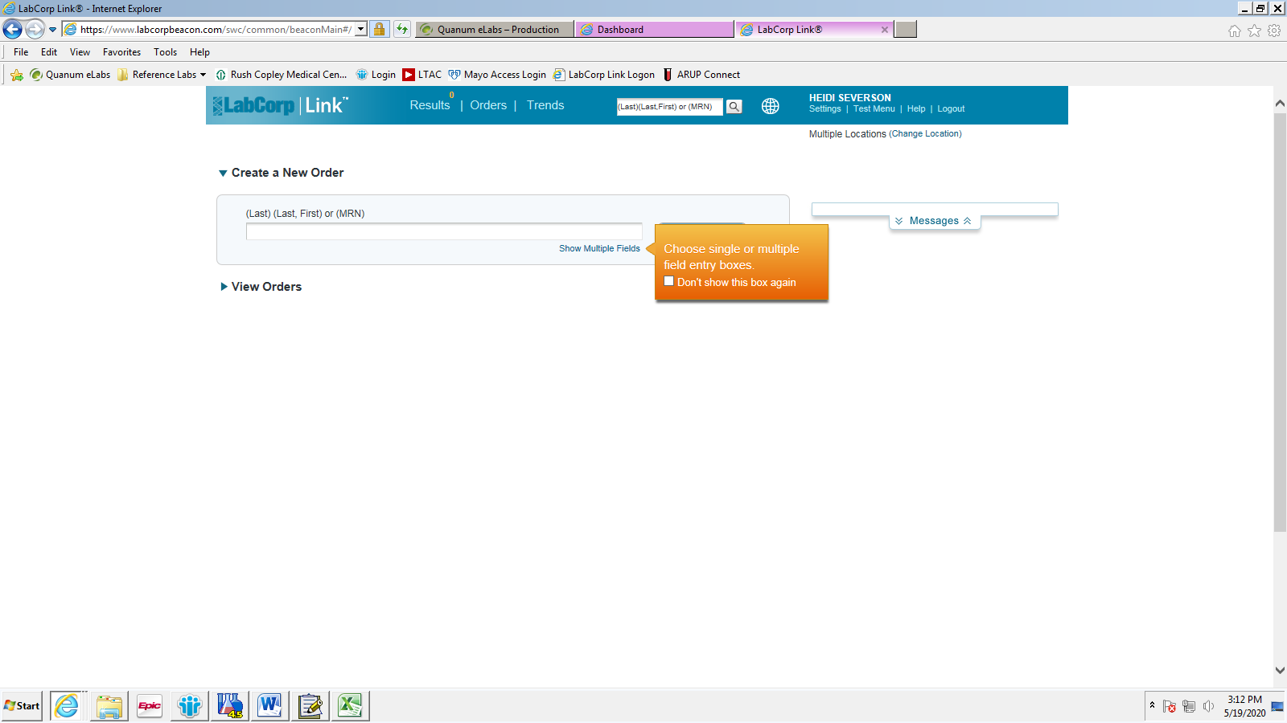

1. Enter the Patient Information, Last Name, First Name or MRN to search for the patient. Click “Create Order”. 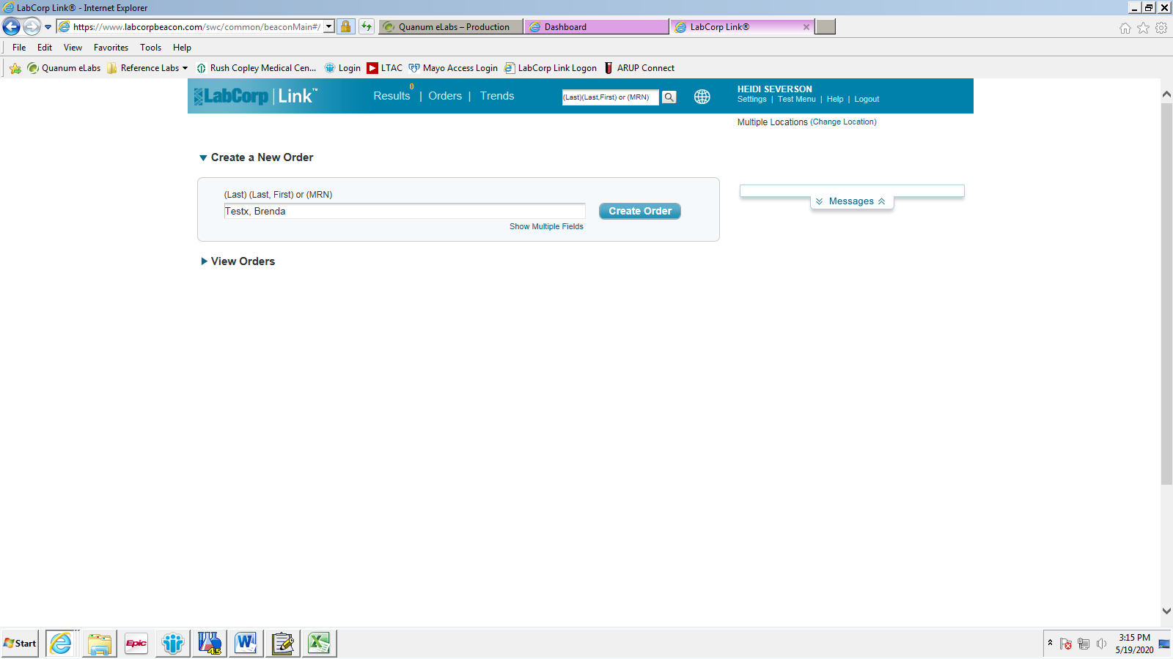
2. If the patient has been created in LabCorp Link previously, their name will appear under “Confirm Patient Information”. If no patient appears, click “Create New Patient”.

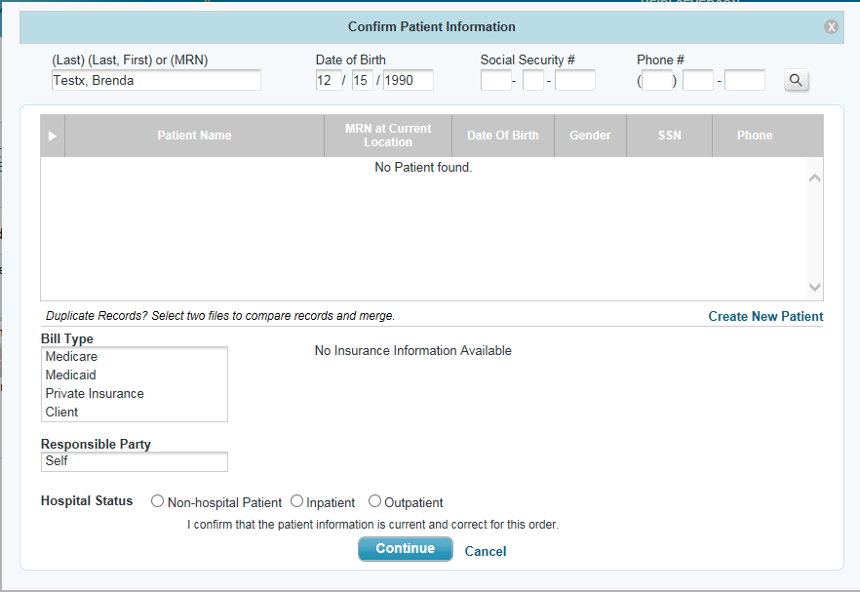

If the patient has been previously created in LabCorp Link by Rush Copley Lab, the patient information will appear here. Verify all information matches before selecting the patient.

If no patient appears above, click here.

1. To Create a New Patient: 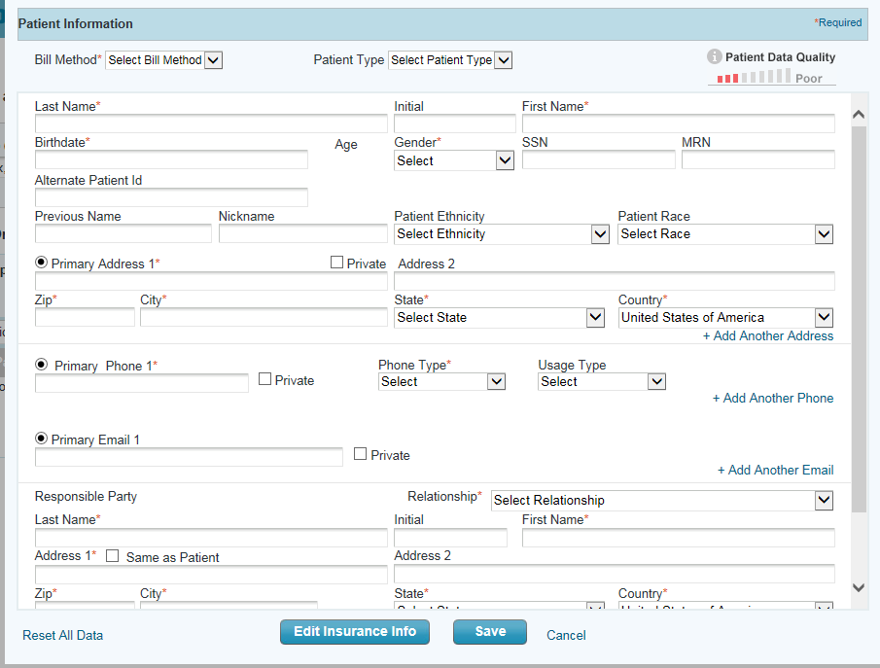

b. Enter the patient’s Last Name, First Name, Birthdate, Gender, and MRN

1. Change “Bill Method” to “Client”

c. Click “Save”.

* 1. Change the Bill Method to “Client”.
  2. Enter the patient’s Last Name, First Name, Birthdate, Gender, and MRN
  3. Click “Save”.
  4. Since our account is client bill, the other information with red stars is not necessary.

1. Once the patient has been created or selected, the order screen will appear. It will default to the “Patient” tab. Again, verify the patient information is correct and the bill type is “client” on the patient tab.
   1. NOTE: At any time during this process, up to “Submit Order”, you may save the order by clicking “Save & Close”. This will save the current progress without sending the information and you can pick up where you left off.

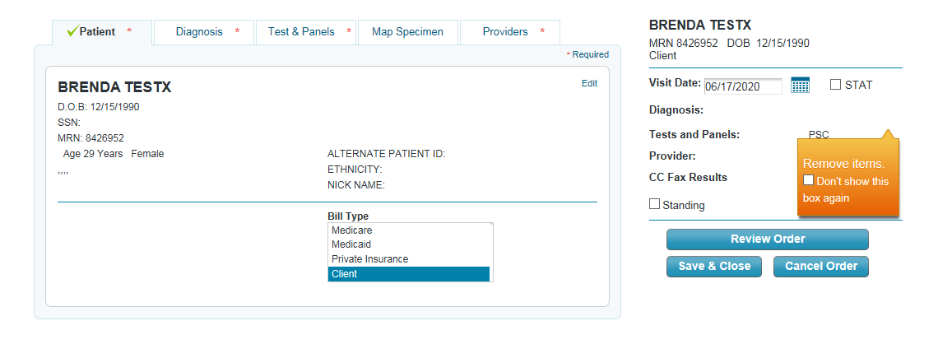

Must be “Client”

Verify patient information is correct!

1. After verifying the patient information, click on the “Test & Panels” tab. Under the “Test & Panels” tab, you may search for the test to be performed by typing in the LabCorp test code or the name of the test in the first box. **It is highly recommended that the LabCorp test code be used to search, as it ensures the correct test is ordered.**

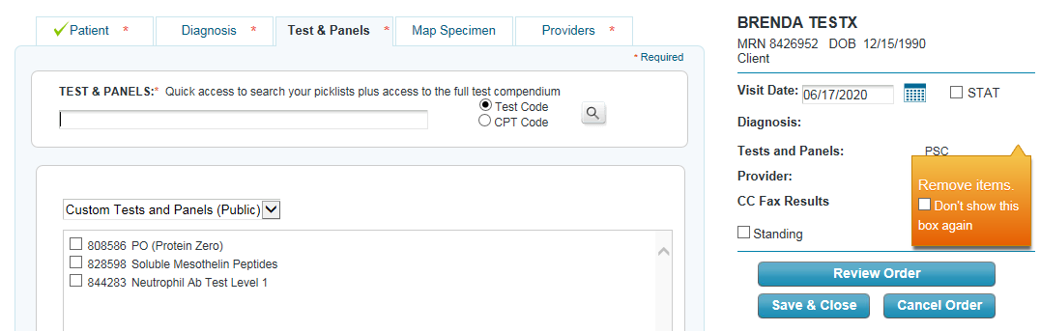

Search by test code or test name.

1. After typing the test code or test name into the box, the search results will appear in a drop down box below the search box. Select the correct test by clicking on the test. The test you are selecting will highlight light blue.

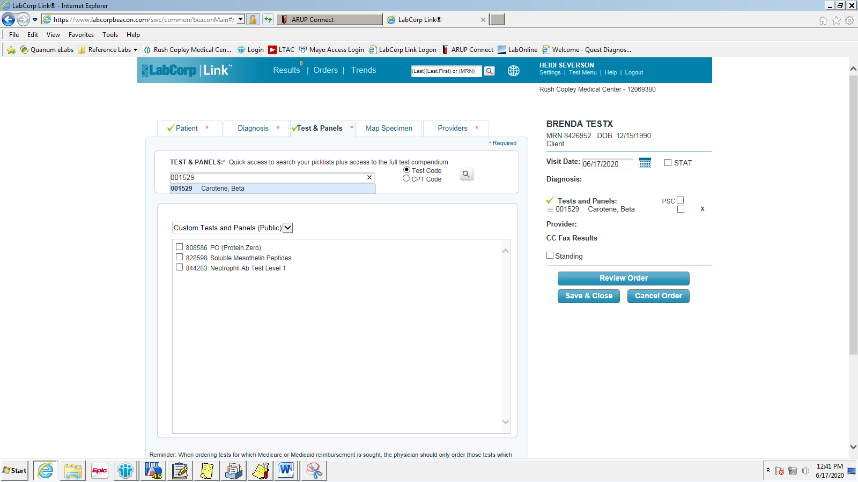

1. Once the test is selected, it will appear on the right of the screen under the patient name.

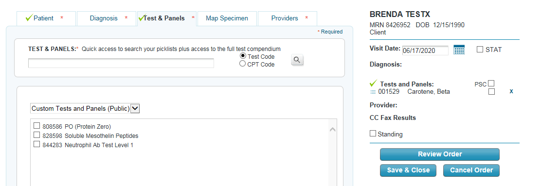

1. Click on the “Providers” tab to enter the ordering provider’s information. Enter the provider’s last name to search for the provider. If the provider’s name does not appear, click “+Add Temporary Provider”.

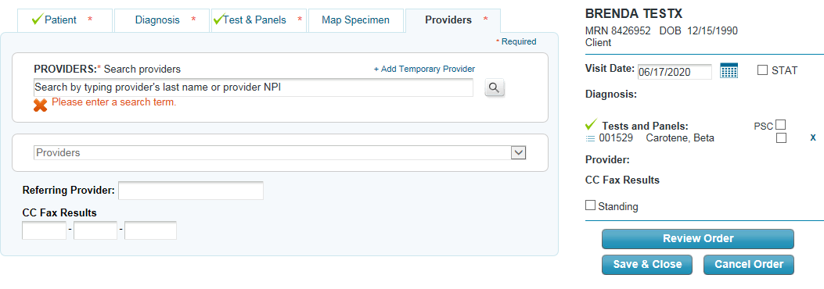

1. When adding a temporary provider, enter the provider’s Last Name, First Name, and NPI number. Then click “Save”.

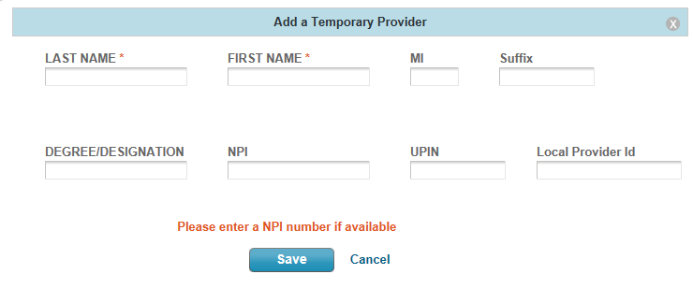

1. Once the provider has been entered and saved, their name will appear in a box below. Click on the provider’s name and it will add it to the order.

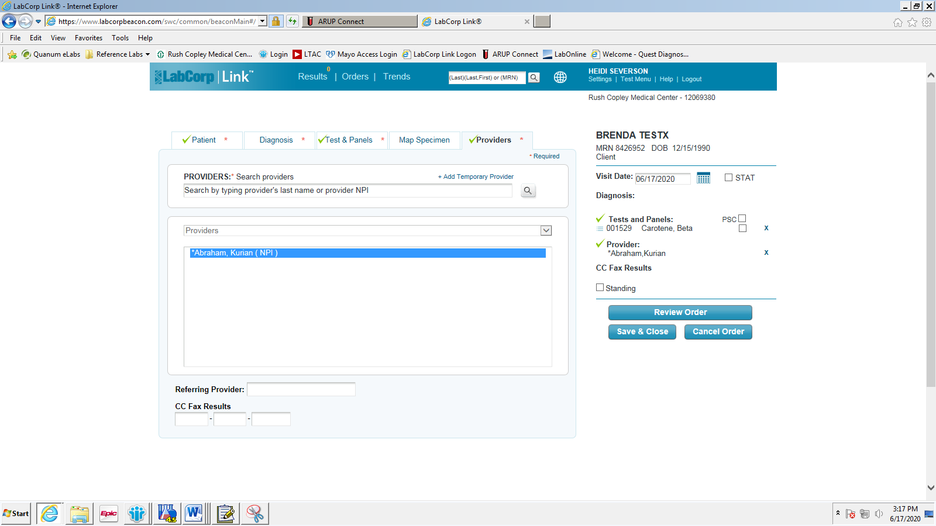

1. Review all information to verify the order is correct, and then click “Review Order”.

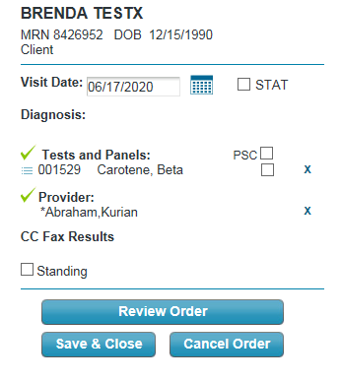

1. A “Clinical and Specimen Information” page will appear where you can enter if the patient was fasting, your initials, and any clinical information needed. You must enter your initials then click “Continue”.

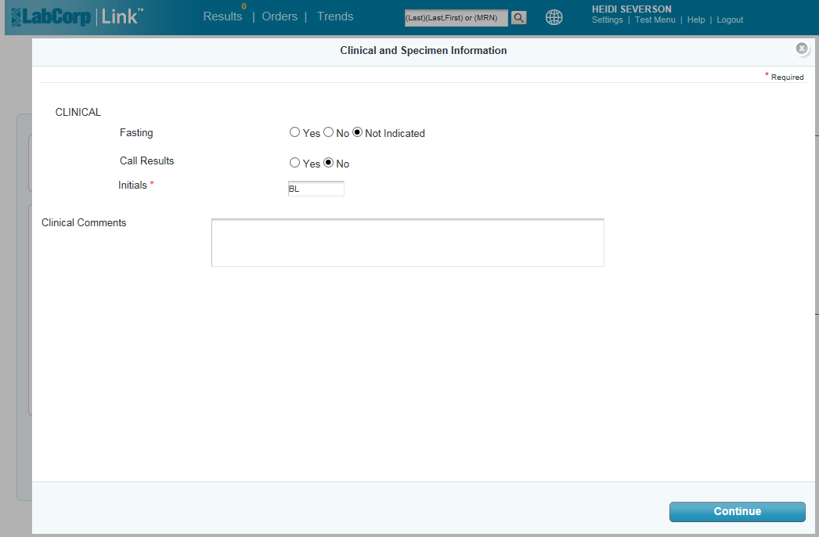

1. A “Collection Instruction” page will then load, giving collection and processing instructions. This is where you will enter the collection date and time for the sample being sent. Be sure to check the processing instructions tab to make sure the specimen is processed properly before sending.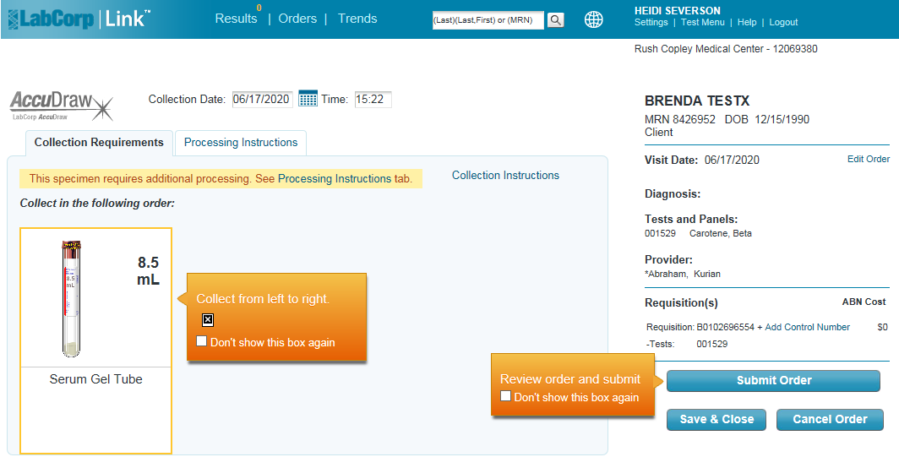 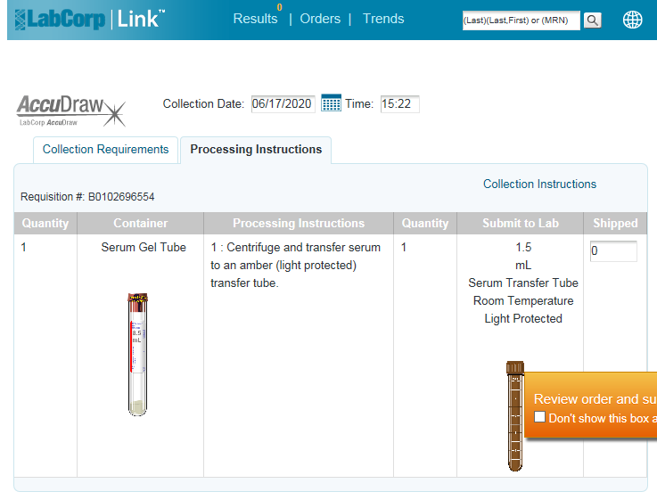

Collection instructions appear here including a picture of the tube type.

Processing instructions appear here including pictures of the collection and aliquot tubes.

1. Once complete, click on “Submit Order

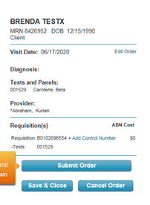

1. A pop up screen will appear with a PDF of the requisition. To print the requisition, click on the printer icon at the bottom of the page **or** click on “File” then “Print”. Change the number of copies to “2” and click on “Print”.

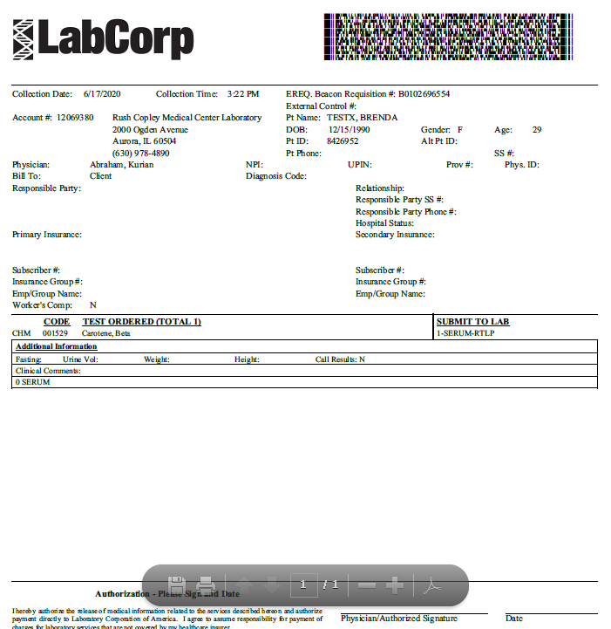 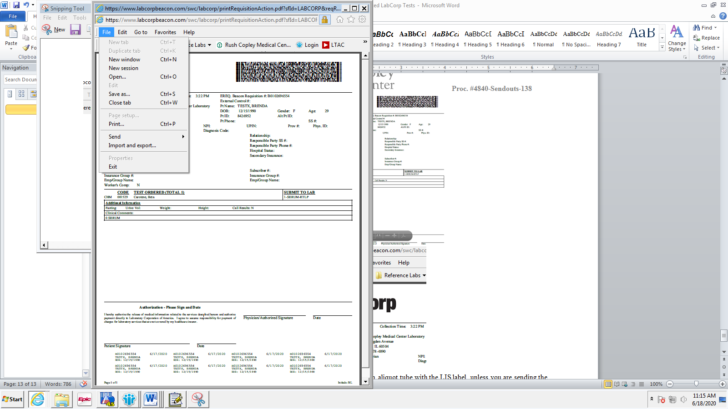

OR

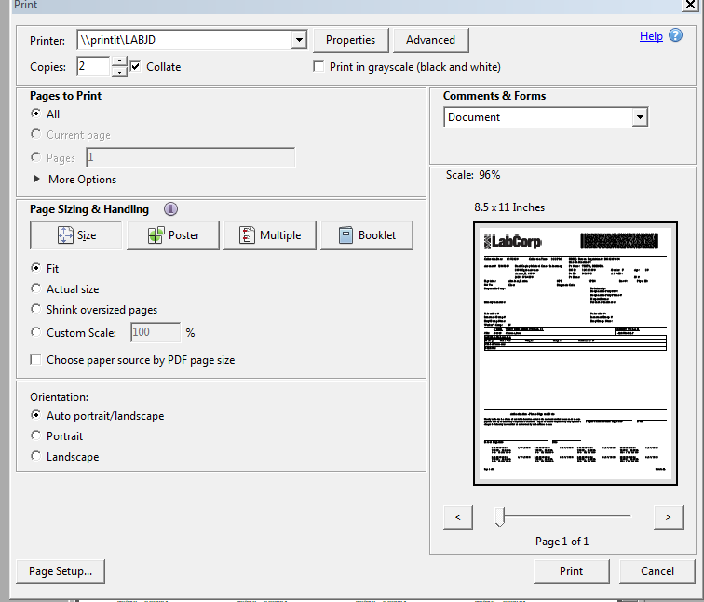

1. Label the correct specimen aliquot tube with the LIS label, unless you are sending the collection tube.
2. Transfer the specimen into the labeled aliquot tube.
3. Place the specimen to be sent in a LabCorp bag with one copy of the requisition.
4. Mark the appropriate transport temperature and place the bagged specimen in appropriate temperature holding area, freezer, refrigerator or room temperature.
5. Three-hole punch the second copy of the requisition and place it in the three-ring binder on the counter.