**TITLE: Preparing Referred Lab Specimens to be Sent to Referred Lab**

**PRINCIPLE:** Referred lab specimens must be re-received into the laboratory information system (LIS) for sending to the appropriate testing laboratory and stored at the correct temperature until picked up or shipped.

**Personnel:**  Phlebotomists and Medical Technologists

**Referred Laboratory:** All Referred Labs

**STEPWISE PROCEDURE:**

1. When specimens that are to be sent to referred labs arrive in the send out processing area, ALL specimens and specimen labels must be received into the LIS using the send out computer following the same procedure as receiving specimens into LCC.
   1. Log into the LIS using your log-in credentials
   2. Open the “Receiving” function of the LIS by either:
      1. double clicking on the icon 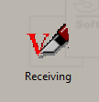

OR,

* + 1. using the drop down menu on the left side of the screen, click on “Phlebotomy” and then double click on “Receiving”.

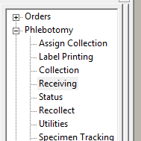

* 1. Once the receiving screen appears, ensure that “Batch Receiving” is selected at the top of the screen. This will ensure more than one specimen can be received at a time.

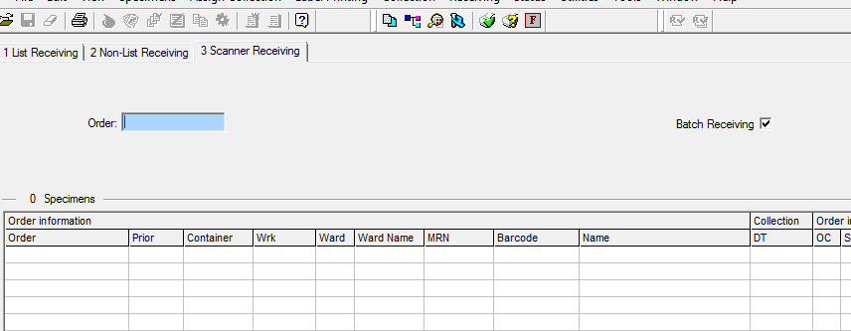

* 1. Ensure that the cursor is in the “Order” box, then using the barcode scanner; scan the barcodes of the specimens that are to be sent out for testing.
  2. Once all the specimens are scanned, click on the “Receive All” checkmark in the tool bar. 

Receive All

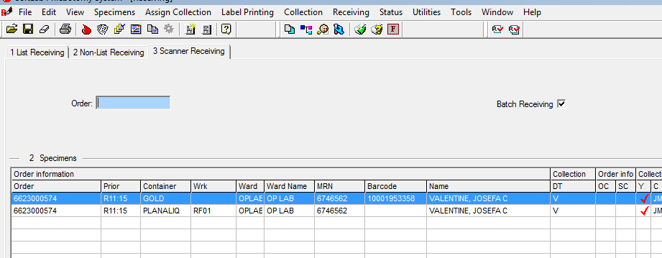

* 1. A pop-up box with your initials and receive time and date will appear. Click “OK”. 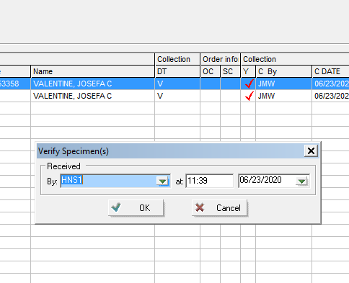

1. After completing the receiving process, a pop up box for printing aliquot labels will appear, click on OK. Labels will print on the Zebra printer in the send out area. Only specimens that require a pour off tube will print aliquot labels. Be sure to review any processing notes that print with the aliquot labels.
   1. **NOTE:** Miscellaneous orders (MISC and LMISC) will ALWAYS print an aliquot label. The MISC test comment indicating the test to be performed will print with the aliquot label. It is extremely important to look up the test and specimen information using the specified lab’s test directory before centrifuging and aliquoting any miscellaneous test.

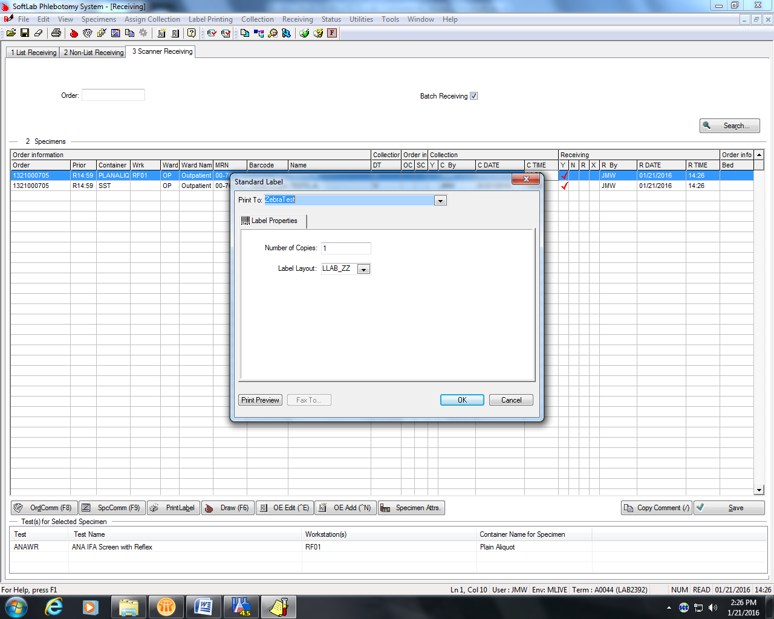

1. Label the aliquot tubes and pipet the sample from the correct specimen tube into the aliquot container.
2. Place the labeled aliquot specimen(s) in the appropriate temperature storage location until the requisitions can be prepared and the specimens can be sent to the referred laboratory.
3. Save the original collection tube in the appropriate rack for stored specimens.