**TITLE: Processing Interfaced LabCorp Miscellaneous Labs**

**PRINCIPLE:** To properly prepare and send interfaced miscellaneous tests to LabCorp via the laboratory information system (LIS) interface.

**Personnel:**  Phlebotomists and Medical Technologists

**Referred Laboratory:** Laboratory Corporation of America (LabCorp)

**STEPWISE PROCEDURE:**

**Rush Copley and Yorkville Laboratory Staff:**

1. When specimens arrive in the send out processing area, ALL specimens must be received into send outs following same procedure as receiving into LCC. After receiving all specimens, a pop up box for printing aliquot labels will appear, click on OK. Labels will print on the Zebra printer in the send out area. All Miscellaneous tests will print aliquot labels. **It is important to check label notes and specimen requirements before centrifuging any Miscellaneous test.**

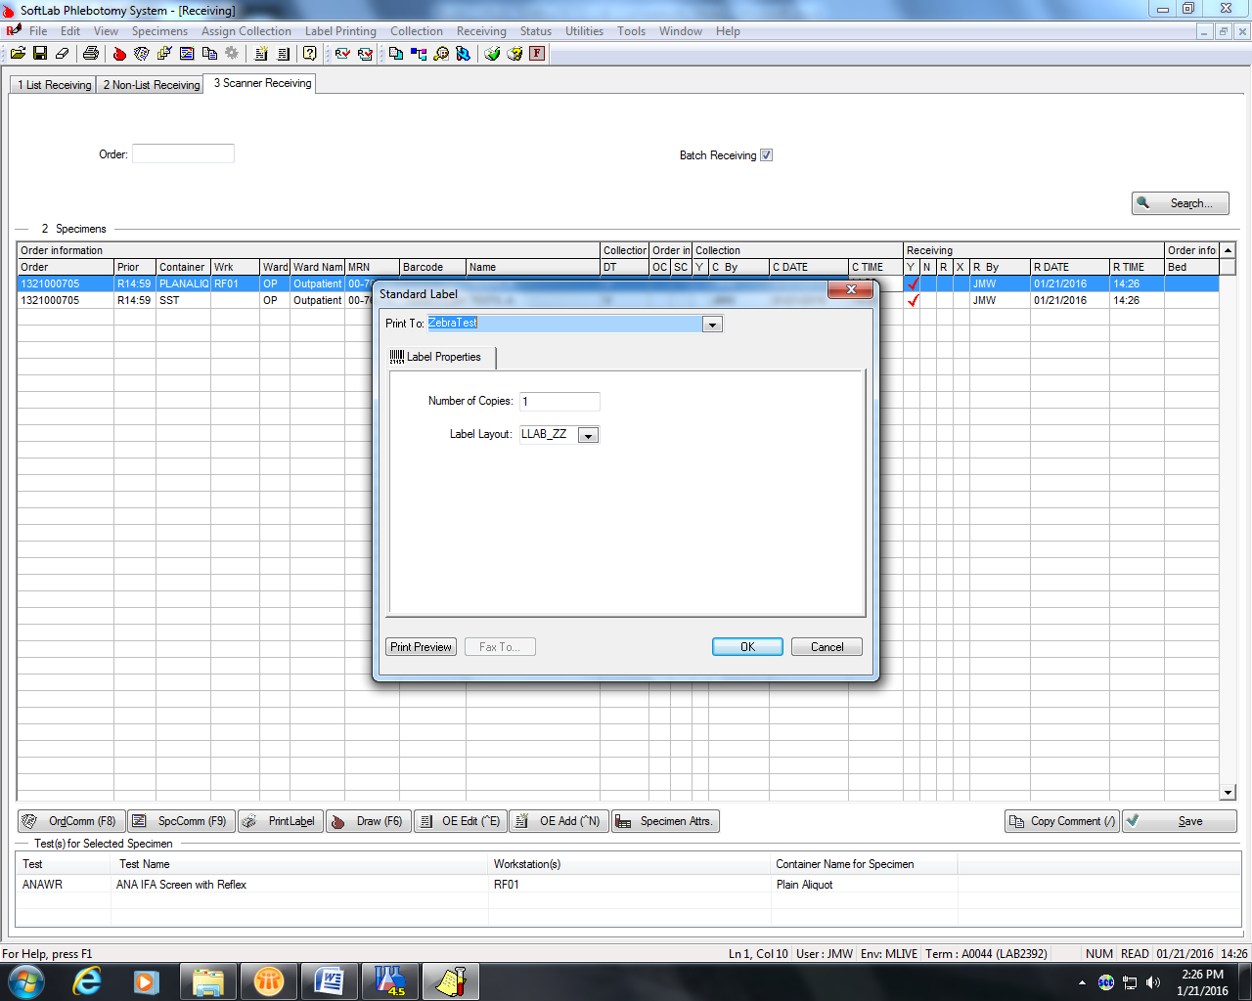

1. For any Miscellaneous test that needs to be sent to a lab other than LabCorp, the test will need to be changed to **MISC** “Miscellaneous Test” in the LIS. See Procedure 4840-SendOuts “Collecting Miscellaneous Tests”.
2. Upon collecting and receiving the specimen, a pop-up box will appear that asks for the following:
   1. Test Code – Enter the **6 digit** LabCorp test code for the test being ordered. If the test code has leading zeros, you must use them.
   2. Test Name – Enter the name of the test as it appears in the LabCorp directory
   3. Total Volume (mL) – Enter the amount of sample being sent for testing.
   4. Source – Enter the specimen type, i.e. serum, plasma, urine, whole blood, etc., transport temperature and any special requirements.

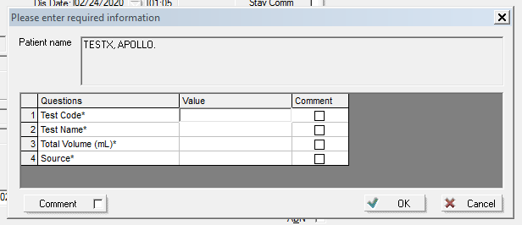

Example:

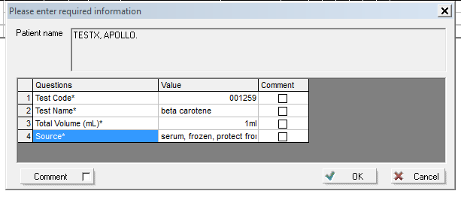

1. Label the appropriate aliquot tube with the LMISC aliquot label and pour off correct specimen tube into the appropriate aliquot container.
2. Place the specimen in the appropriate temperature storage rack to await the creation of the send out Manifest.

**LabCorp Processors and Yorkville Laboratory Staff:**

1. **Each LabCorp miscellaneous specimen will need to be on a separate manifest.**
2. To create a send out Manifest for the LabCorp Miscellaneous:
   1. Using the drop-down menu at the left of the screen, click on “Results”, then on “Reference Lab.”

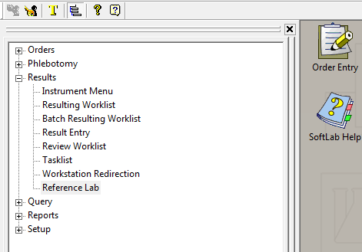

OR

* 1. Click on the “Reference Lab” icon.

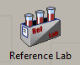

* 1. To start a new manifest, click on “File” then “New” OR using the toolbar, click on “New” (looks like a white single sheet of paper).

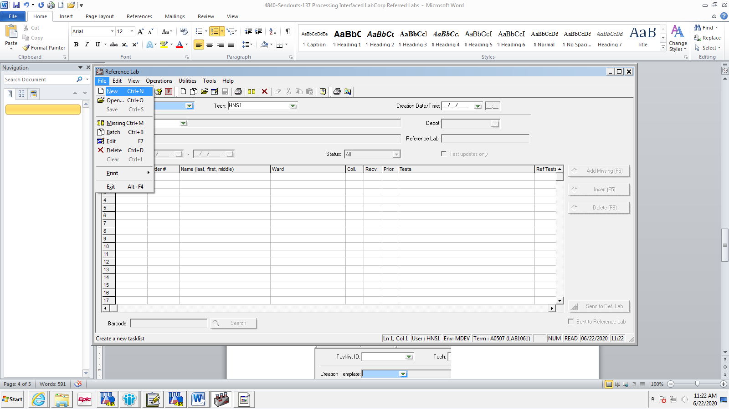 **OR** 

* 1. Go to “Creation Template” and using the drop down arrow, choose appropriate site from drop down box. **For Labcorp Miscellaneous tests, you must choose LCMIS.** Once your site is selected, click “OK”.

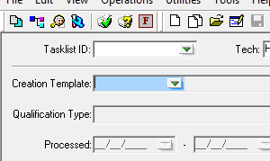

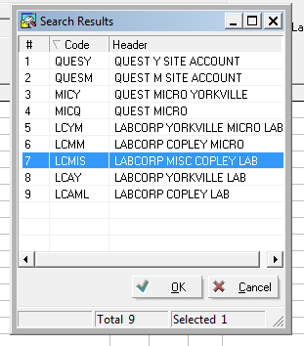

* 1. Move the cursor to the “Barcode” box on bottom left, by clicking inside the box.

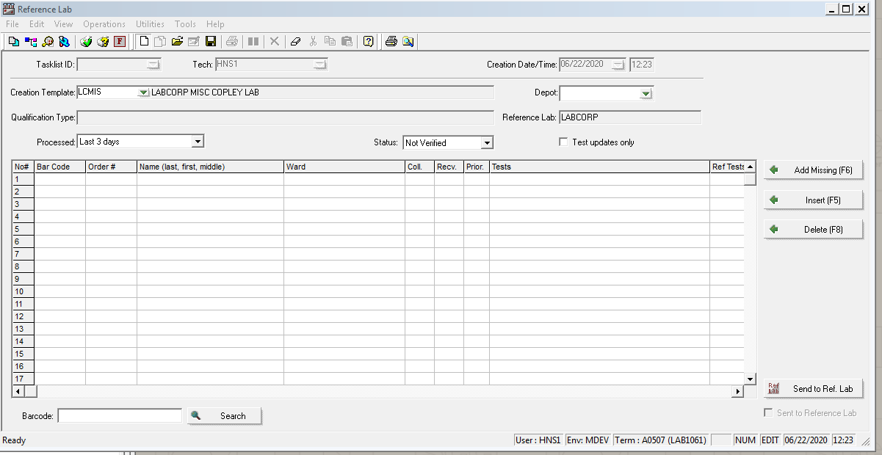

* 1. Scan the label on the tube you are sending for the miscellaneous test. Due to the questions that are asked upon receipt of the specimen into the LIS, a pop-up box will appear after scanning:

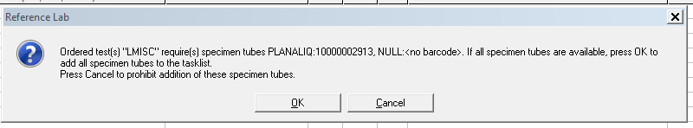

Click “OK” to continue.

* 1. After the specimen has been scanned, the patient information and test information will appear on the list. Then click on “Send to Ref. Lab” at the lower right corner of the window.

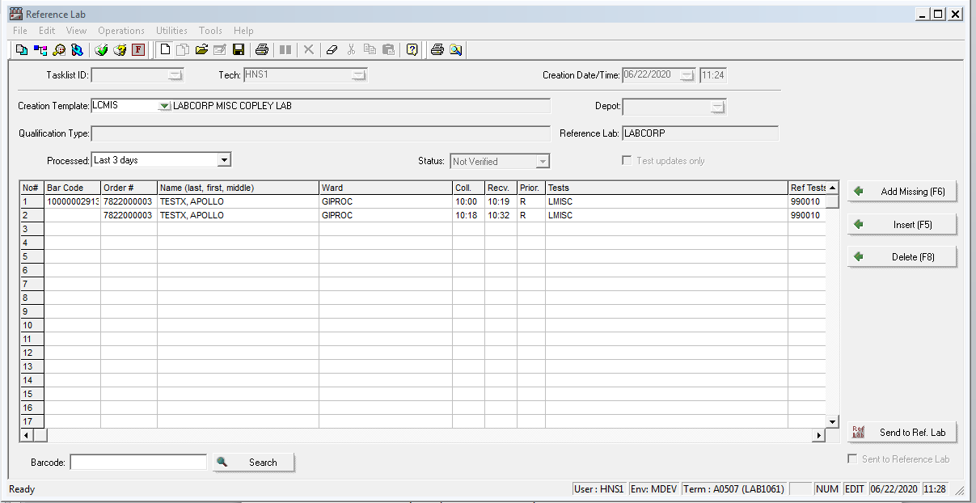

* 1. A pop up box will appear that says “Do you want to save the tasklist?” click on yes.

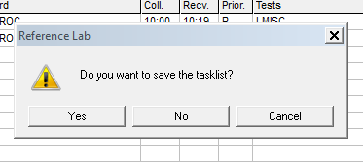

* 1. A pop up will appear that tells you the tasklist number, click on OK.

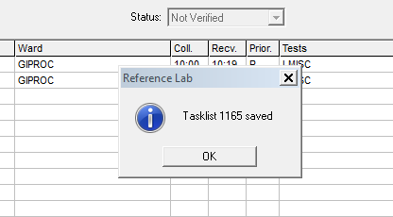

* 1. Another pop up box will appear to print the Reference Lab Manifest. On the line that says “Print to:” select the printer you want the manifest to print to, make sure the number of copies is “2”, and Manifest Layout: RLAPM. Click “OK”.

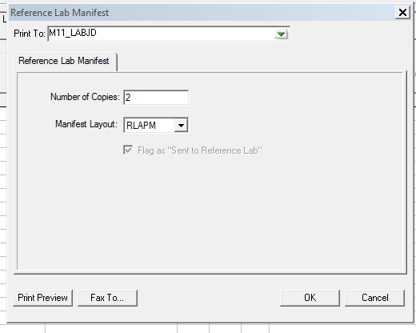

* 1. Pop up will appear that will tell you how many specimens were found, click OK.

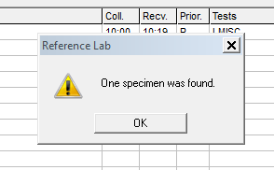

1. Since this is for a Miscellaneous test order, no temperature will print on the Manifest. The transport temperature should be indicated under “source”. Verify this information using the test directory.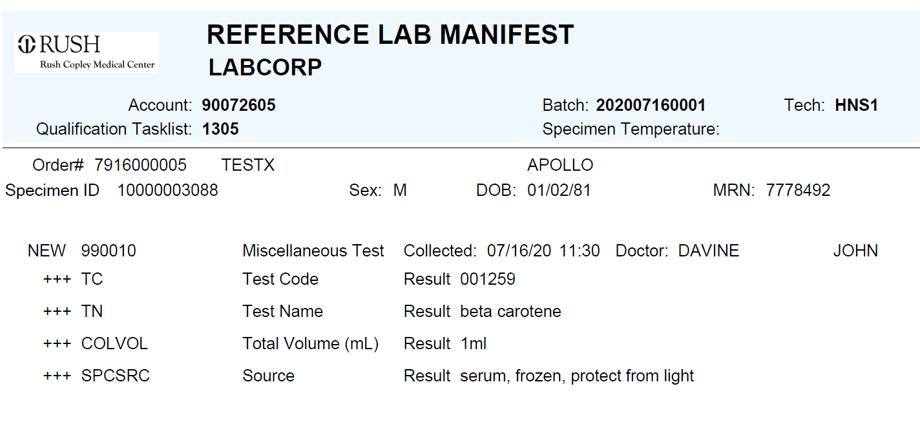
2. Three-hole punch second manifest copy and place in reference lab log book.
3. Package the specimen in a LabCorp Specimen Bag with the manifest and place it in the appropriate temperature storage location for courier pick-up.