## TITLE: Cobas u411 Urine Analyzer Maintenance and Calibration

## PRINCIPLE/PURPOSE:

A few simple steps a day will help you maintain your Roche Cobas u411urine Chemistry analyzer. These maintenance procedures will help protect key areas that are exposed to urine, and keep reagent strips moving properly on the fixed platform and under the readheads.

The areas that need your attention must include:

-Waste area

-Test strip tray

-Test strip pusher

-Test strip transporter

**PERSONNEL:**

###### Medical Technologists

## SPECIMEN COLLECTION/TREATMENT:

###### None necessary

## REAGENTS AND EQUIPMENT:

1. Water and dish soap (under urinalysis counter)
2. Kimwipes

**CALIBRATION:**

**NOTE:** Do not touch the elevated plastic gray areas on the CHEMSTRIP Calibration Strips. Use each Calibration Strip only once.

1. Touch **Utilities** and then **Tools**.
2. Touch **Calibration**.
3. Touch **CalibrateCalibrate**.
4. The displayed message reads, “Please press OK first and then place the calibration strip!”. Touch √ to prepare the instrument for calibration.
5. Place the Calibration Strip, with the elevated plastic gray areas facing up, on the strip loading area of the Test Strip Tray.
6. Upon completion of the first calibration, the displayed message reads” Please press OK

first and place an additional calibration strip!”. Touch √ to prepare the instrument for the second calibration.

1. Place the second Calibration Strip on the strip loading area of the Test Strip Tray.
2. Once the calibrations are completed the following message is displayed, “Instrument calibration is finished! New calibration is valid!”.

Touch √ to confirm the message.

When the initial calibration is successful (variation is within 15% in comparison with the Internal Calibration strip and the two initial calibrations are within 1% of each other) then:

* Initial calibration is complete.
* Calibrations are stored and can be printed upon request.
* Always run quality controls after calibrating.

**Print Stored Calibrations (if necessary)**

1. Touch **Utilities** and then **Tools.** The **Tools 1** screen is displayed.
2. Touch **Calibration**.

3. Touch **Calibrate**Calibrate.

4. Touch **SendSen**d**Send**

1. Enter the date range of the calibrations that require printouts.

6. Touch **Print Print**

1. Touch **X** to return to the **Tools 1 > Calibration** screen.

Additional actions for unsuccessful calibration:

* Repeat calibration with a new calibration strip.
* If additional calibration is not successful, check to ensure that the Calibration Strip is not damaged. Then recalibrate the analyzer.
* If the calibration is still not successful, replace the Internal Calibration strip. Refer to the Operator’s manual for the procedure on replacing the Internal Calibration strip.
* If the calibration is still not successful, contact Roche Technical Support at 1-800-428-2336.

## QUALITY CONTROL:

Positive and negative control will be run once on the 11-7 shift. Please see Quality Control in Urinalysis Procedure No. 4840-UA-4 for more information.

## STEPWISE PROCEDURE:

### To be done Daily on EVERY Shift

**I. Emptying the test strip waste area**

The test strip tray is a complete plastic tray that can be removed for cleaning. It has an integrated waste area.

Empty the waste area at least at the end of daily measurements, or when an alarm message is generated. When there are 90 test strips in the waste container, an alarm will sound. When there are 100 test strips in the waste container, no further test strips will be analyzed. Empty the waste container. If you don’t empty the test strip waste container, no further measurements are possible.

**NOTE:**

**If the front cover is opened during analysis, results will be lost!**

*If you open the front cover during urinalysis, the analyzer will stop immediately and switch over to Stop mode. The results for the test strips that are still being processed will be lost.*

*Do not open the front cover during operation!*

### When you take out the test strip tray, you must empty the waste area!

### *When you remove and re-insert the test strip tray, the waste counter will be reset to zero. You must empty the waste area of the test strip tray whenever you remove it from the unit!*

### To empty the test strip waste container

* 1. Wait until the Cobas u411 analyzer is in Stand-by state.
  2. Open the front cover (**A**).

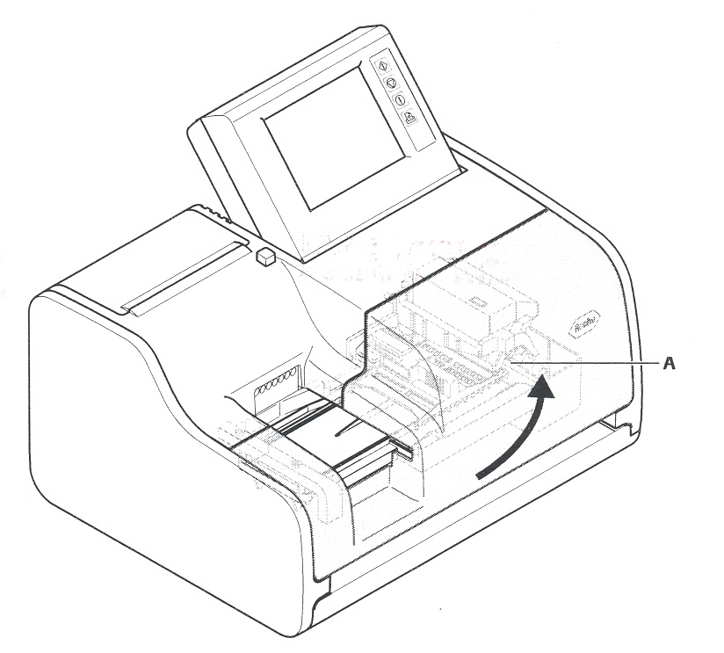

* 1. Pull out the test strip tray (**A).**

The test strip tray is locked in its working position.

* 1. Empty the waste area (**B**) of the test strip tray.
  2. Re-insert the test strip tray.

The test strip tray will snap into its working position. This will reset the waste counter to zero.

* 1. Close the front cover of the Cobas u411 analyzer.

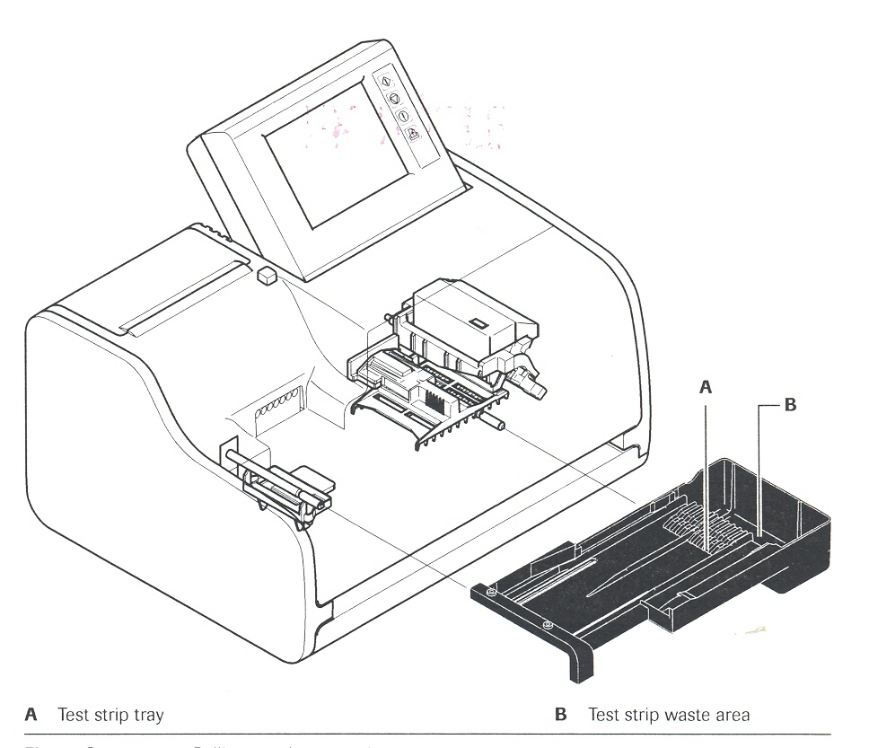

### Cleaning the test strip transfer system

### When cleaning the test strip transfer system, the analyzer must be in the stand-by- state.

The test strip transfer system must be cleaned every day to prevent contamination and

deposits, and to ensure that test strips are processed accurately.

**To clean the test strip transfer system**

1. Open the front cover (**A**) of the Cobas u411 analyzer.
2. Pull out the test strip tray (**B**).

The test strip tray is locked in its working position.

1. Empty the waste area of the test strip tray.

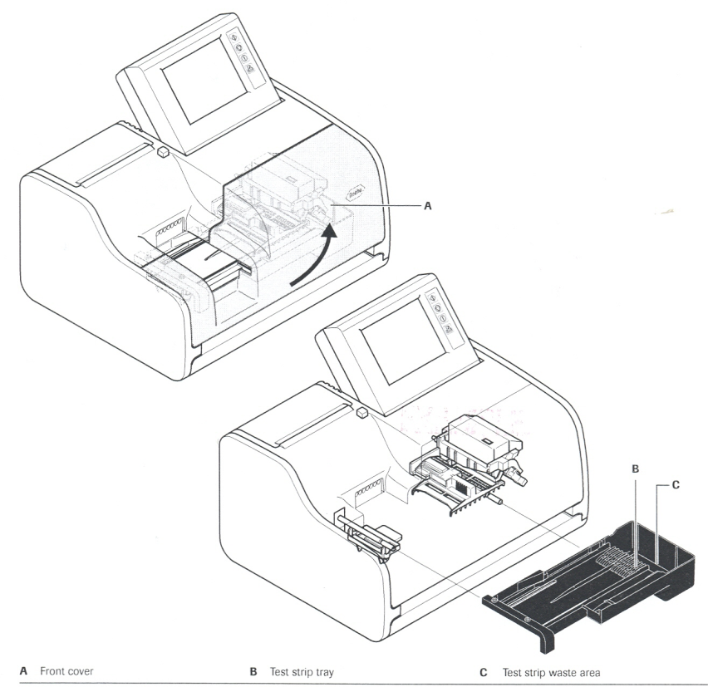

The test strip tranporter (**A**) is locked in its working position.

1. Squeeze sides to release the test strip transporter and pull it out.
2. Raise the test strip pusher (**B**) slightly and pull it out
3. Clean the parts under running water. If necessary, wipe them with a cloth or gauze moistened with a neutral detergent. Wipe the grooves with a cotton swab. Apply a disinfectant if necessary.

**NOTE:**

**Acid or alkaline detergents can corrode the parts of the test strip transfer system.**

Do not use acid or alkaline detergents. Do not scratch the surface of the test strip transfer base.

**7.**  Dry the parts with a lint-free cloth if analysis is to continue immediately after

cleaning.

**8.** Re-insert the test strip pusher first, then the test strip transporter, and finally

the test strip tray.

1. Close the front cover of the Cobas u411 analyzer.

**The test strip tray, test strip pusher and test strip transporter should always be cleaned together**

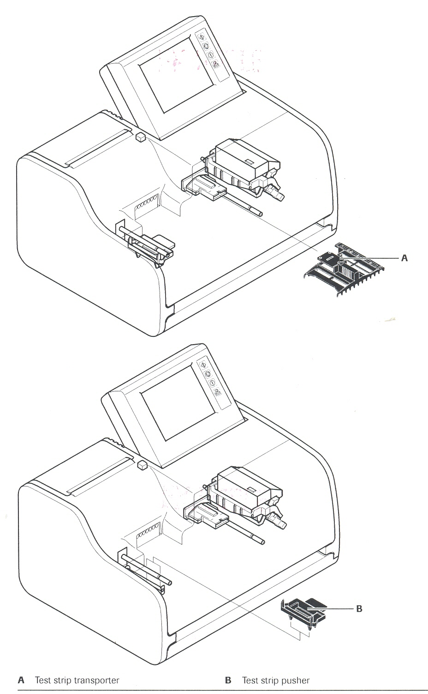

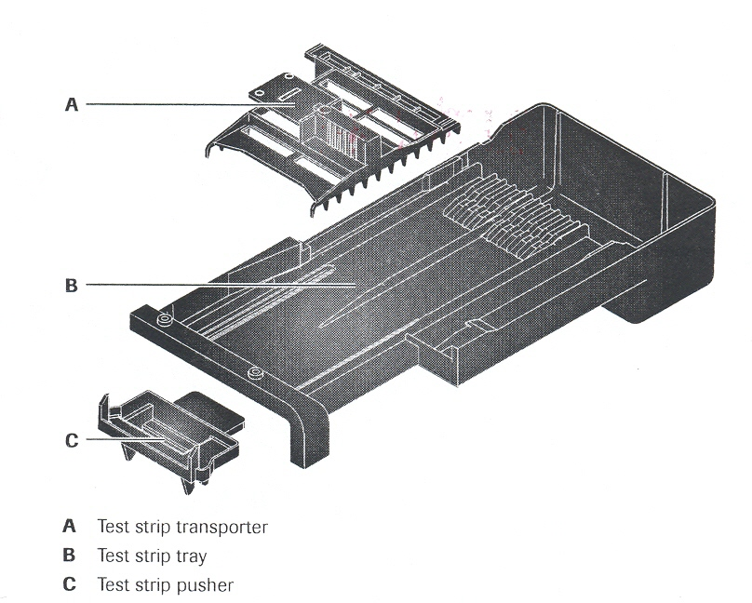

**B. Monthly**

Perform the following maintenance tasks monthly:

* Clean the interior of the analyzer.
* Clean the outer parts of (housing) of the anlyzer.

### Cleaning the interior of the analyzer

You must wipe down the interior of the analyzer once a month, or more often where there is heavy contamination.

Perform the daily cleaning as described, but do not re-insert the test strip transfer system parts yet. This will give you better access to the other parts in the interior of the analyzer.

**NOTE: Risk of short-circuit by the use of liquids for cleaning the analyzer!**

**The photometric unit and the switch in the interior of the analyzer are not splash-proof.**

**Use only a moistened cloth to clean the interior of the analyzer.**

**To clean the interior of the analyzer**

1. Before cleaning the analyzer, turn off the power switch on the rear of the

analyzer.

1. Remove the parts of the test strip transfer system during daily cleaning.
2. Wipe down the interior of the analyzer.
   * Bottom of unit
   * Sides
   * Other contaminated parts

Use a cloth moistened with water or with a liquid cleansing agent to clean

the outer surface of the analyzer. Use a disinfectant when necessary.

1. Re-insert the test strip pusher first, then the test strip transporter, and finally

the test strip tray.

1. Close the front cover of the Urisys 1800 analyzer.

### Cleaning the exterior of the anlyzer

**To clean the exterior of the analyzer**

**1.** Before cleaning, turn off the power switch on the rear of the analyzer.

**2.** Wipe down all exterior parts of the analyzer except for the touch screen with a

damp cloth.

Use a cloth moistened with water or with a liquid cleaning agent to clean the

outer surface of the analyzer. Use a disinfectant when necessary.

**To clean the touch screen.**

1. Before cleaning, turn off the power switch on the rear of the analyzer.
2. Wipe the touch screen with a dry cloth.

If contamination is heavy, clean with a cloth moistened with a neutral

detergent.

**NOTE: Risk of danger to the touch screen.**

**Do not use volatile solvents such as benzene.**

**Do not scratch the surface of the touch screen.**

### Yearly

**Replacing the internal calibration strip**

The internal calibration strip must be replaced at least once a year or if the Cobas

U411 analyzer cannot be calibrated despit several attempts.

### 

1. Open the front cover (**A**) of the Cobas u411 analyzer.
2. Remove the protective cover (**B**) from the calibration strip.
3. Remove the calibration strip (**C** ).
4. Insert a new calibration strip with the measuring field side up.
5. Put the protective cover back over the calibration strip.
6. Close the front cover of the Cobas u411 analyzer.
7. Recalibrate the analyzer.

### D. As required

**Replacing the main fuse**

The main fuse must be replaced when the analyzer can no longer be turned on

and the fuse is defective.

**To replace the main fuse**

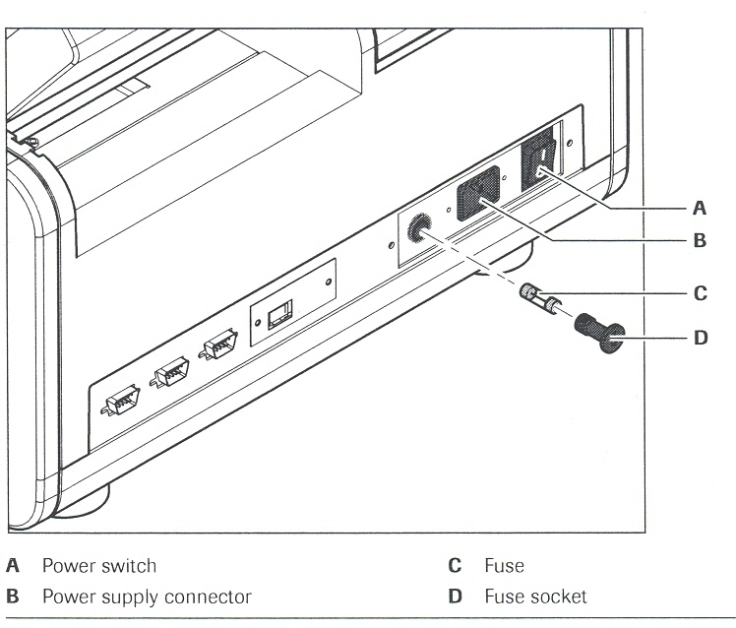

1. Turn off the power switch (**A**) on the rear of the analyzer
2. Unplug the power cord at the analyzer’s power supply connection (**B**)
3. Unscrew the fuse socket (**D**) with the multi-tool.
4. Replace the fuse (**C**) if it is defective.
5. Screw the fuse socket back in.
6. Reinsert the power cord into the power supply connection of the analyzer and set the main switch ON.

**Risk of damage to the analyzer!**

**Using fuses designed for other capacities may damage the unit.**

**Use only fuses that are specified in the Operator Manual.**

### Inserting printer paper

The Urisys 1800 analyzer is equipped with an internal thermal for 112 mm

paper rolls.

**To insert the paper into the printer**

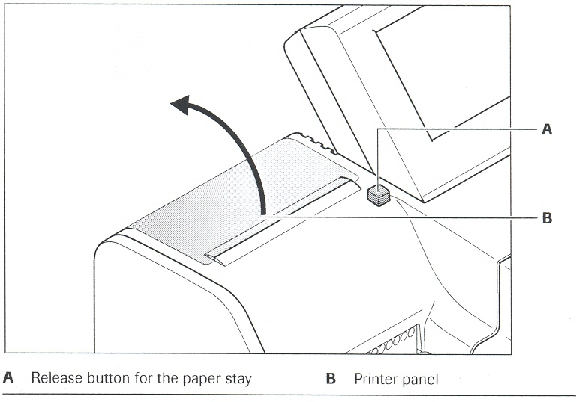

1. Press the release button (**A**) to open the printer panel and release the

paper stay

2. Open the printer panel (**B**) by hand.

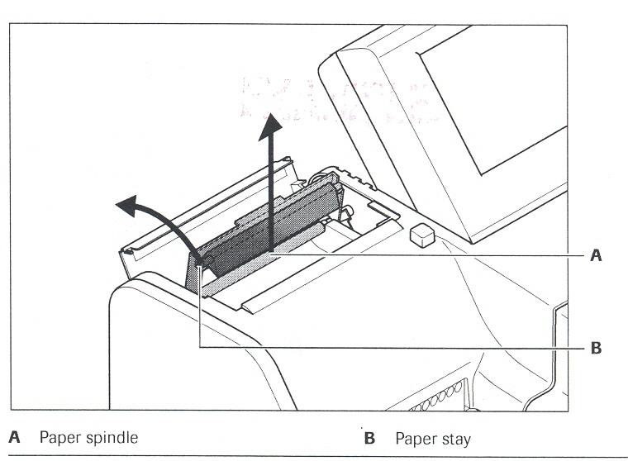

3. Fold back the paper stay (**B**).

4. Lift up and remove the spindle (**A**) for the paper roll.

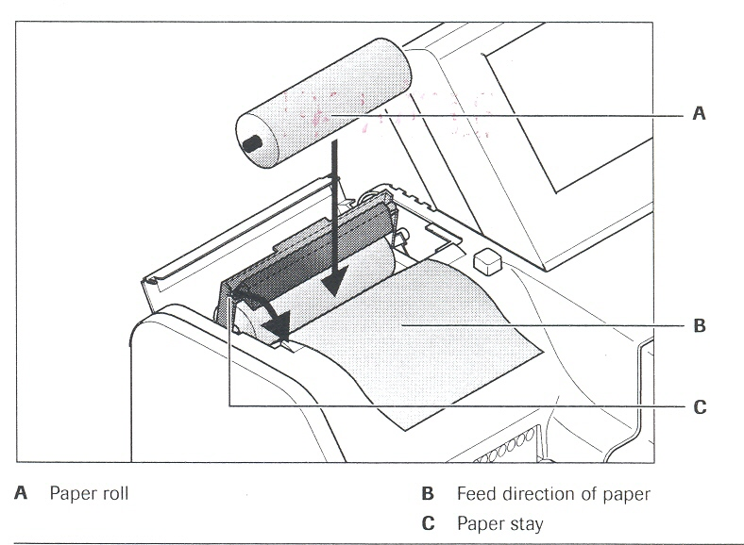

5. Slide the paper roll (**A**) onto the spindle and replace the spindle in its mount. The paper feed (**B**) must be as indicated.

6. Let the paper hang over in the front about 10 cm (4 in.)

7. Fold down the paper stay (**C**) forward and press it down until it

snaps into place. The paper is automatically transported (self check)

if the analyzer is switched on.

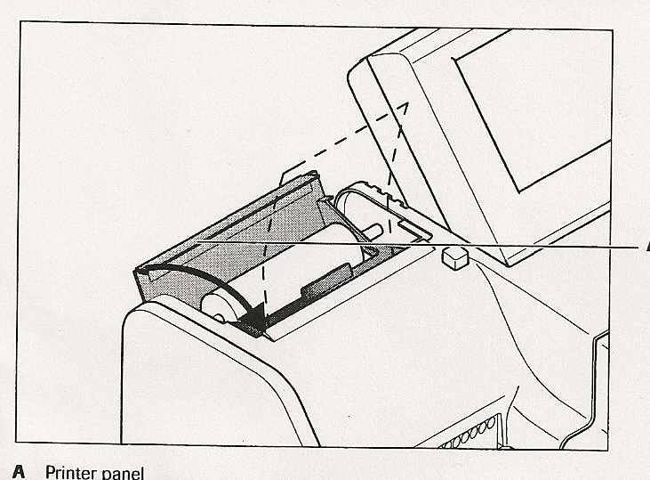

8. Close the printer panel (**A**).

The printer is now ready to use.

**REFERENCE:**  Cobas u411 Operator’s Manual, Version 2.1 2009-2013 Roche Diagnostics Indianapolis, IN. 46250-0457

S:Laboratory P&P/Urinalysis/4840-UA-1014/ch