TITLE: Cobas u411Urine Analyzer Operation

PRINCIPLE/PURPOSE:

The Roche Diagnostic Cobas u411 urine analyzer is a semi-automated analyzer intended for in-vitro semi-quantitative determination of urine analytes. The analyzer is designed to interpret results of the CHEMSTRIP® 10 UA urine Test Strips. These urine test strips are multiparameter strips used for the determination of specific gravity, pH, leukocyted, nitrite, protein, glucose, ketones, urobilinogen, bilirubin and blood in urine.

CLINICAL SIGNIFICANCE:

Macroscopic urinalysis is a screening test utilized to rule out or identify infection and to provide information regarding the status of carbohydrate metabolism, kidney and liver function and acid-base balance.

PERSONNEL:

Medical Technologists

SPECIMEN COLLECTION/TREATMENT:

Random or clean catch, freshly collected urine sample. If a specimen cannot be examined within 2 hours of collection, it must be kept refrigerated. Remember to warm urine to room temperature before testing.

EQUIPMENT AND REAGENT PREPARATION:

Roche Cobas u411

Roche Chemstrip 10 UA Test Strips

Store CHEMSTRIP 10 UA Urine Test Strips at temperatures between +2 °C and 30 °C (86 °F). Do not freeze.

Opened CHEMSTRIP 10 UA Urine Test Strips are stable until the expiration date on the vial label when stored in the original capped vial. The vial must be closed tightly and immediately after use, using the original cap.

CALIBRATION:

The Cobas u411 Urine Analyzer must be calibrated every four weeks, or when indicated by the analyzer.

The CHEMSTRIP Urina Analyzer Calibration Strip should remain in the vial until just before use. Do not touch the elevated gray areas on the strips.

The calibration strips should be used only once.

See CALIBRATION – Cobas u 411 Procedure # 4840-UA-1014 for more information.

QUALITY CONTROL:

Biorad Quantify Plus Level I and Level II Controls will be run once a day. Enter these results into the LIS Quality Control Program. See Quality Control in Urinalysis Procedure No. 4840-UA-4 for more information.

STEPWISE PROCEDURE:

Instrument Operation

Daily Checks

The following daily checks are performed by the operator before the analyzer is powered ON. If the power is already on, the checks can be performed any time during a 24-hour period but are most effective when performed before the first major run of the day.
  - Check paper supply
  - Check test strip tray waste area
See Cobas u 411 Analyzer Maintenance Procedure # 4840-UA-1014 for more information.

Operator Control Panel

The operator control panel of the Cobas u 411 analyzer consists of
a built-in computer with touch screen and global action buttons.

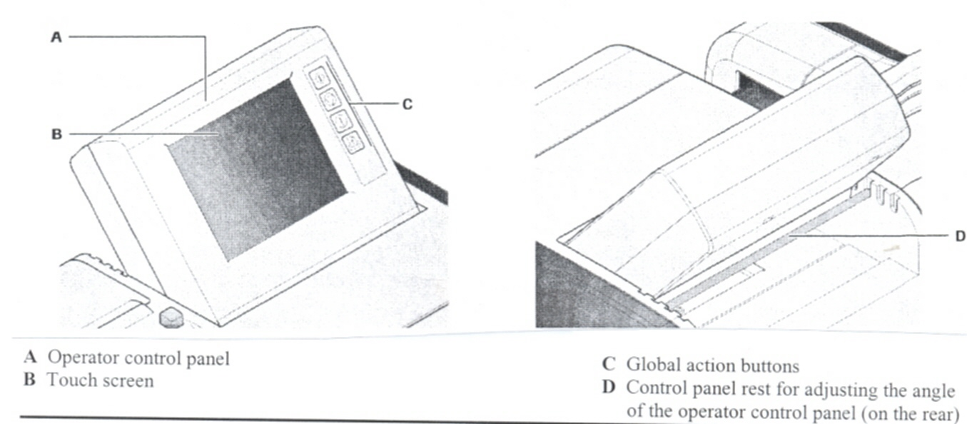

Operator control panel

The touch screen allows for the easy operation of each screen.
Press the buttons on the touch screen once to perform the various
functions. Operators wearing gloves can easily use the touch
screen. The included touch pen can be used to operate the
keyboard displayed on the touch screen, if necessary. The
angle of the operator control panel can be adjusted using
control panel rest on the rear of the unit.

Global action buttons

The Cobas u 411analyzer has 4 global action buttons. These
global action buttons display the operating states. Alternatively,
you can use them to execute functions directly.

Start The LED of this key lights up green when the analyzer is ready for
operation.

Stop The LED of this key lights up red when a system error occurs and
the analyzer cannot continue operations or when the operator

presses this key.

When this key is pressed, the analysis stops immediately.
All test strips on the test strip tray are disposed in the waste
area. The corresponding samples, controls and calibrators
are deleted.

Alarm The LED of this key lights up when an alarm has been triggered.
It lights up yellow or red depending on the severity of the alarm.
Press this key to display a list of alarms.

Line Feed Press this key to move the printer paper forward (not in
operation state).

Overview of structure and functions

The [Overview] tab appears when you log onto the analyzer.

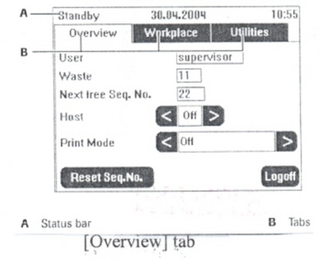
(A) Status bar Displays information such as date, time and operating state
(Initialization, Stand-by, Operation, Utilities, Stop).

- The Cobas u 411 analyzer software in divided into three
workspaces:
  - Overview
  - Workplace
  - Utilities

You can call up each of these workspaces by simply pressing
the required tab.

The main screen of the Workplace and Utilities tabs
each contain buttons to call up more screens or start
functions.

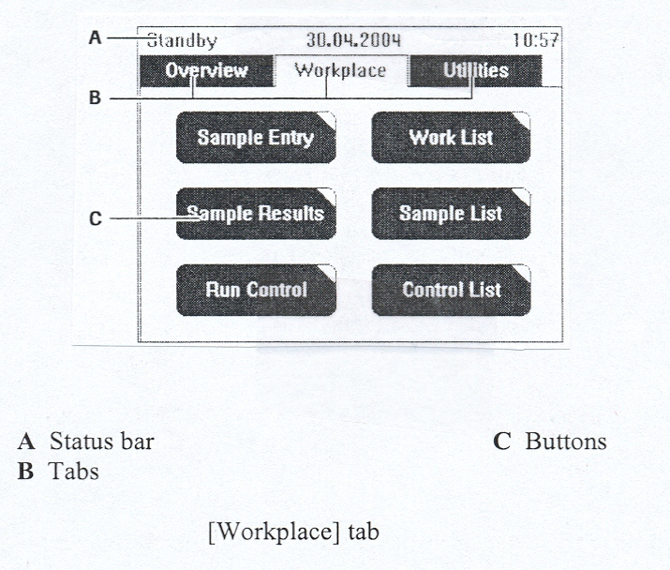

(C) Buttons Since the Cobas u 411 analyzer has a touch screen, we refer to
the control elements as buttons. You can select buttons by
touching them or, to put it another way, by pressing them.

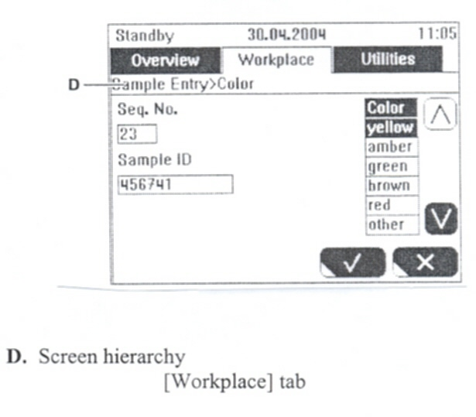

(D) Screen hierarchy Below the tabs, the screen hierarchy is displayed. The screen
hierarchy indicates the name of the screen and the menu
hierarchy of the screen.

To call up a different workspace (tab)

To switch workspaces, press the tab of another workspace. The
analyzer notices which screen is displayed for each tab. If you
press the tab of another workspace and then return to the initial
tab, the last screen of this tab is displayed again.

Example You have called up the Sample Entry screen in the Workplace tab.
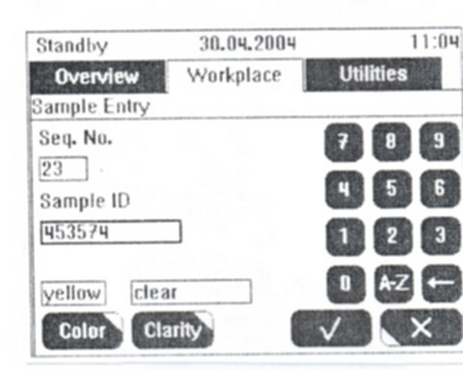

Sample Entry Screen

- Press the Utilities tab to call up the corresponding workspace.

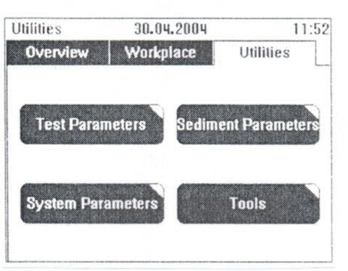

Utilities Tab

The main screen of the [Utilities] tab is displayed.

2 To switch workspaces again, press the workplace tab.
The Sample Entry screen in the Workplace tab is
displayed again

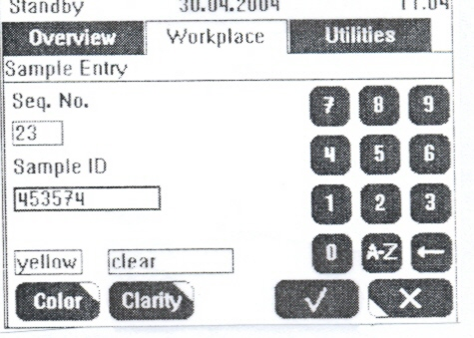
Sample Entry Screen

To access screens by pressing the buttons in a tab or another screen.

Example You have called up the Sample Entry screen in the Workplace tab.
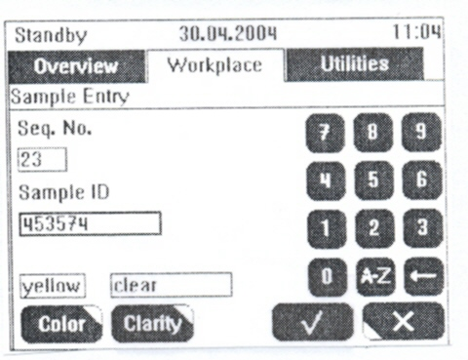
Sample Entry Screen

You can call up a new screen by pressing the <Color> or <Clarity>
buttons.

- Press <Color> to display the corresponding screen.

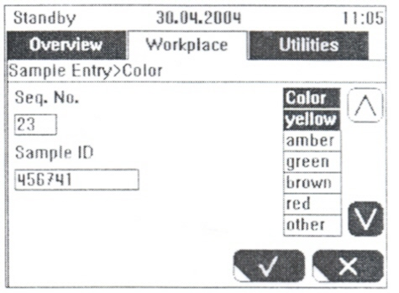

[Sample Entry>Color] screen

- Press √ to accept your entries and close the screen
Or
Press X to reject the entries and close the screen.

Starting the analyzer

To start Cobas u 411 analyzer

The power switch is located on the rear of the analyzer. The OFF position is represented by O.

1. Turn the power switch to the ON (|) position.

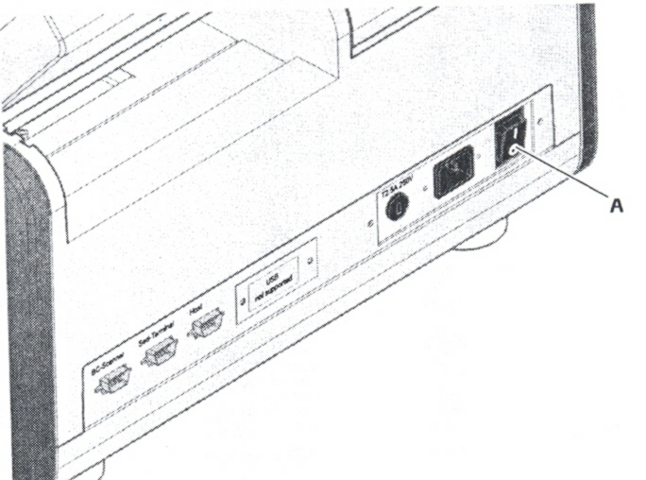

- Power switch
Power switch on the rear of the analyzer

  - The [Login] screen appears once the analyzer software has been loaded. The analyzer is initialized and enters into stand-by state.
stay on the supervisor line.

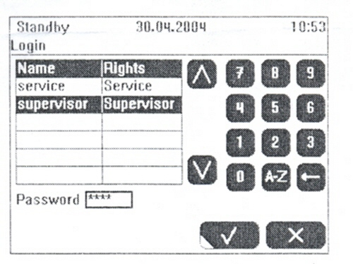
Login Screen

  - Enter the password (aura) and confirm your entry by pressing √.

  - The overview screen is displayed.

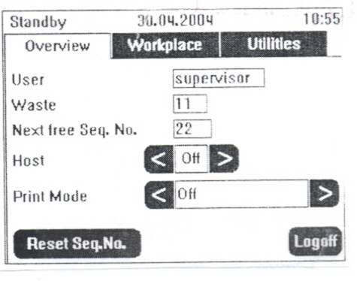
Overview Screen

The overview screen displays important information, e.g. user, next available
sequence number, host status, and print mode.

  - Host: By pressing < or > you can change the host status.

  - Print Mode: By pressing < or > you can change the print mode:

•Automatic result printout is performed if you select:

- All
- Abnormal
- Sieve
- Sieve and Abnormal
- Normal

•No automatic result printout is performed if you select:
- Off

If the host status is <On> and any print mode except <Off> is selected, the results will be printed and sent to the host automatically.

Preparing Samples
_________________________________________________________________
Risk of infection from contaminated samples
The analyzer processes urine (including control urine) samples.
Wear protective gloves when preparing samples and placing samples onto the
analyzer.
If the sample contacts the operator’s skin, wash the affected area immediately
with a large volume of water.
_________________________________________________________________
_________________________________________________________________
Analyze samples within two hours of the time that the urine samples were
obtained.
Do not expose samples to direct sunlight.
Do not add any preservatives to the samples.
Samples should be at room temperature.
_________________________________________________________________
_________________________________________________________________
Use fresh urine that has not been centrifuged. The urine specimen should not
stand for more than two hours before being analyzed. In case of longer standing,
refrigerate sample, remember to warm sample to room temperature mix the
sample before use.
_________________________________________________________________
_________________________________________________________________
Observe the instructions in the test strip package insert.
_________________________________________________________________

To prepare a sample for analysis

- Remove the test strip from the vial and close the vial with the vial cap
containing the desiccant.
- Always dip all test pads of the test strip completely in the sample and wipe
off excessive urine on the edge of the sample tube.

You can now position the test strip on the test strip tray for analysis.

C. Analyzing Samples

There are various workflows for analyzing samples
The following procedures are described in the next sections:
- Quick analysis using sequence numbers
- Analyzing samples using sample ID numbers
• Analyzing individual samples
• Analyzing samples from a work list
- Analyzing barcoded samples downloaded from a host

Quick analysis using sequence numbers

For quick analysis of samples, samples are processed without any further entries in
the analyzer.
You can position the sample once the Cobas u 411 analyzer is ready for operation. The
analysis starts automatically.
The analyzer must be in stand-by state or operations state.
You can enter details about the sample, e.g. color and clarity on the [Sample Result]
screen.

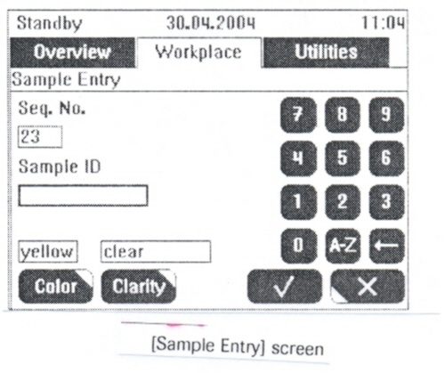

For quick analysis of samples you can only work with the sequence number.
The sequence number is used to allocate the samples to the results.
If the host staus is <On> and print mode except <Off> is selected, the results will
be printed and sent to the host automatically.
You can also view the results of the analysis on the [Samples Results] screen.

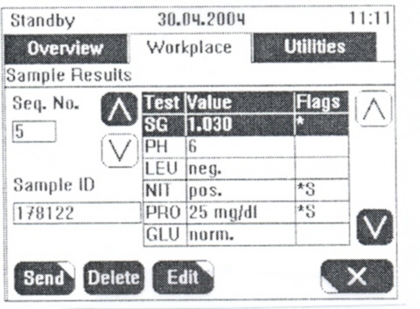
Sample Results Screen

To perform a quick sample analysis
1. Dip a test strip in the sample.
2. Position the test strip on the corresponding area of the test strip tray.
_____________________________________________________________________
Do not remove a test strip after you have positioned it on the test strip tray!
When the analyzer has recognized the test strip, a new sequence number (e.g.23) is
assigned to it. If you remove the test strip and them put it back, the next new sequence
number (24) will be assigned to the test strip. The previous sequence number (23) will
nevertheless be processed and consequently produce a T-flag.
______________________________________________________________________

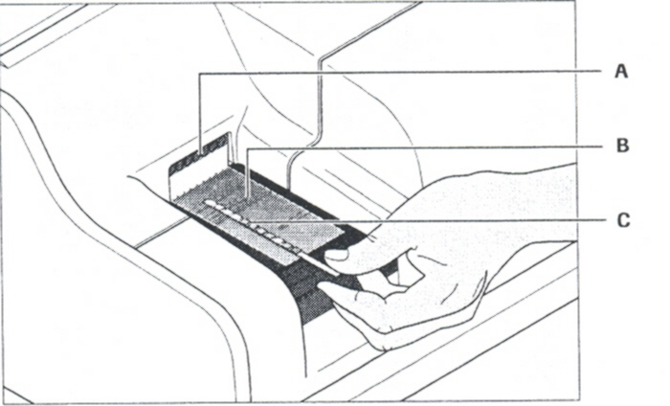

- Test strip sensor C. Test strip
- Area for test strips on the test strip tray

______________________________________________________________________________

Do not open the front cover of the analyzer during the analysis of the test strips!
If you open the front cover, processing of the test strips is interrupted. The results of all test strips in process are lost.
- The sample is drawn into the analyzer for analysis. The next available sequence number will automatically be used for the sample.
- Repeat steps 1 through 2 for the next samples.
The next sequence number will be used for the next sample.

Analyzing samples using sample ID numbers
When analyzing samples using sample ID numbers, you can process a series of
samples from a work list. The Urisys 1800 analyzer also allows you to process
individual samples with sample barcodes.

Analyzing individual samples

Using Sample ID Numbers
To analyze individual samples using sample ID numbers, enter the
Sample ID number for every sample in the sample entry screen.
      - Call up the sample entry screen from the workplace tab.
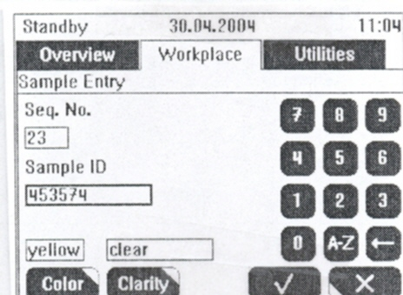
[Sample Entry] screen

<Seq. No>, the next available sequence number, will now be displayed.
    - If requested, select the input field for the sequence number and
enter a new sequence number.
You can only enter a sequence number which is not used by another
sample. You can use this function to remeasure a sample in case of a
faulty measurment (e.g. if you have forgotten to dip the test strip).
then you must first delete the sample of the faulty measurement.
___________________________________________________________

    - Enter the <Sample ID> using the touch screen keyboard.
    - If requested, enter the data for color and clarity.
    - Store the sample data by pressing √
    - Dip a test strip in the sample.
    - Position the test strip on the test strip tray area.

A. Test strip sensor C. Test strip
- Area for test strips on the test strip tray
Positioning samples

The sample is drawn into the analyzer for analysis.
8. Repeat steps 1 through 7 for the next samples.

If the host status is <On> and any print mode except <Off> is selected, the results will
be printed and sent to the host automatically.

You can also view the results of the analysis on the sample results screen from the
workplace tab.

To enter the color and clarity of a sample

You have the option of entering the color and clarity of the sample.
1. Call up the [Sample Entry>Color] or [Sample Entry>Clarity] screen.

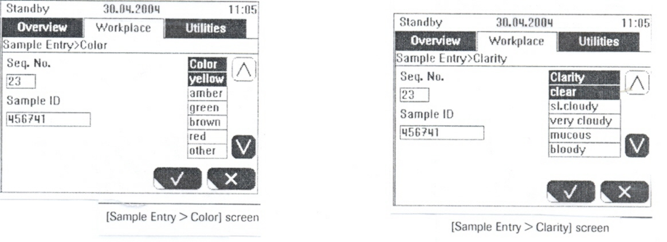

2. Select the color or clarity of the sample using ∧ or ∨.

3. Apply your selection by pressing √.

This closes the screen and displays the selected color and clarity on the sample entry screen.
The selected color and clarity is only adopted by the analyzer if a sample ID has been entered on the [Sample Entry] screen.

Color and clarity can also be entered via [Sample Result] screen or via [Sample List] screen

The analyzer usually determines the color of the sample using the compensation pad on the test strip. If you want to enter the color of the sample manually, you have to enable the corresponding function.

Analyzing samples from a work list

To analyze samples from a work list, first enter the samples that you want to process into
a work list.
You have several options to enter samples into a work list:
Entering samples manually into the work list via [Sample Entry] screen.
Scanning the samples into a work list using a barcode scanner

To enter samples manually into the work list

To add samples to the work list manually, enter each sample in the sample entry
screen.
From here, the sample is automatically added to the work list.

1. Call up the sample entry screen from the workplace tab.
<Seq. No>, the next available sequence number, will now be displayed.

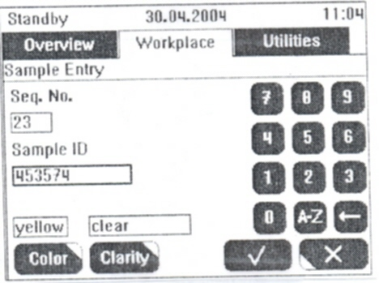

Sample Entry Screen

2. If requested, select the input field for the sequence number and enter a new sequence
number.
______________________________________________________________________
You can only enter a sequence number which is not used by another sample. You can use
this function to remeasure a sample in case of a faulty measurement (e.g. if you have
forgotten to dip the test strip). Then you must first delete the sample of the faulty
measurement.
______________________________________________________________________

3. Enter the <Sample ID>.
4. If necessary, enter the data for color and clarity.
5. Store the sample data by pressing √.
The sample is added to the work list. The next sequence number will be used for
the next sample and so on.
- Repeat steps 3 through 5 for the next samples.
- Once you have entered all of the samples, you can close the screen with Χ and
start the analysis.

To scan samples into a work list using a barcode scanner

If you scan a sample ID, the sample is added to the work list. The next available sequence
number is allocated to the sample and the scanned barcode is entered.
To keep an overview of which samples have already been scanned, use the Work List
screen while scanning the samples.

- Call up the Work List screen from theWorkplace tab.

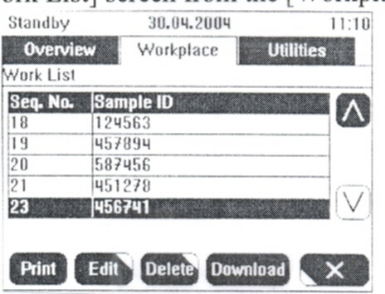

Work List Screen

- Scan the sample ID numbers using the barcode scanner.
- If you want to enter color and clarity, press <Edit> and then <Color> or
<Clarity>.
Once you have entered all of the samples, you can start the analysis.

If you scan the sample barcode of a sample that already exits in the work list again, the sample ID is put to the top of the list.

To analyze samples from a work list
Please observe the order of samples when performing the analysis.
If you analyze samples from a work list, number the samples in a suitable manner to avoid mixing up the samples. It is the operator’s responsibility to ensure the samples are analyzed in the correct order.
· Print out the work list before starting the analysis and sort the samples in the order of the
work list to avoid mixing up samples.
· Analyze the samples in order given on the work list.

- Call up the work list screen from the workplace tab.

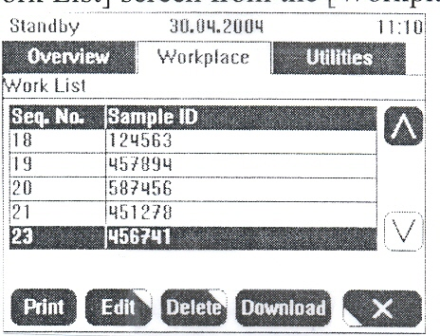
Work List Screen

The screen shows all samples that have not yet been analyzed.
Use ∧ or ∨ to scroll up and down the list to display more samples.
- Dip a test strip in the first sample displayed in the list.
- Position the test strip on the test strip tray area.
The test strip is allocated to the first sample on the list. The sample is now being
processed and disappears from the work list.

A Test strip sensor C Test strip
B Area for test strips on the test strip tray
Positioning samples

The sample is drawn into the analyzer for analysis. The sample ID number of the next sample
that must be positioned on the test strip tray now appears at the top of the work list.

4. Repeat steps 2 through 3 for all samples in the work list.

Work list must be complete

If you enter new samples, they will be added to the end of the work list. This means that you cannot enter a sample to be processed between two existing samples.

Note:

The analyzer can be set in such a manner that the sequence numbers automatically start again with 1 after the date has changed.

The analyzer cannot reuse a sequence number until the results have either been printed or transmitted to the host. In this case, an error message will appear on the screen. When this happens, you must either print the results or transmit them to the host before continuing.

If the host status is <On> and any print mode except <Off> is selected, the results will be printed and sent to the host automatically.

You can view the results of the analyses on the sample results screen.
.

Working with results

This section contains the following information on working with results.
Working from the sample results screen (individual results)
Working from the sample list screen

From both screens the operator has the following options to work with results:
Viewing
Editing
Sending
º Printing
º Uploading
º Storing
º Deleting

Deleting

In addition the sample list screen contains a search function. Search can be performed
for:

Date
Flags
Sequence number
Sample ID
The Cobas u 411 analyzer is equipped with a memory for 1,000 entries.

This memory is used for the pending samples in the work list and for the results of already analyzed samples.

When the data base contains 950 entries (pending samples and results), a warning
message is displayed in the alarm monitor. Analysis can be continued.

When the data base contains 1,000 entries, the reported results (results, which are
printed or sent to the host) are automatically deleted. If there are unreported results,
a confirmation window is displayed, asking you to delete the unreported results.
If the option <Daily Number> is selected, the reported results are deleted after the
date has changed and the sequence number is automatically reset to 1.
Daily number on page
If there are 1,000 unreported results and pending samples in the data base, analysis
cannot be continued. You first have to delete unreported results. It is recommended
to report the results before deleting them.
The pending samples are not deleted together with the unreported results. They can
only be deleted on the work list screen.

Working from the Sample Results screen (individual results)

The sample results screen offers you a quick access to the results of the last measured sample and you can scroll through all samples. It shows you the individual results of a sample.

If you are only interested in specific sample ID’s or samples with flags it is recommended to work with the sample list screen.

a. To work with individual results

1. Call up the sample results screen from the workplace tab.

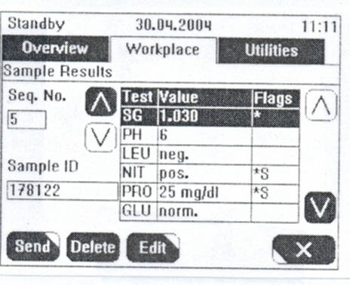

Sample Results Screen

The screen shows the results of the last sample.
You can view the results as soon as the test strip analysis is completed.

b.To view individual results

On the sample results screen use or ( to the right of <Seq. No.>) to
select the sequence number of the required sample.
The results of the sample are displayed in the table:

Test (test name/parameter)
Value of the individual result
Flags of individual result
____________________________________________________________
The displayed result value is shown in the unit, which is selected. If a
combination of two units (e.g. SI and arbitrary is selected) only the SI will be
shown.
____________________________________________________________

c. To edit individual results

1 On the sample results screen use or (to the right of the table with
results) to select the required parameter from the list.

2. Pressing <Edit> calls up the [Sample Results<Edit] screen or the [Sample
Results>Color] screen or the [Sample Results>Clarity] screen depending
on the parameter you have selected.

If you have selected any parameter except for COL (color) or CLA (clarity) from the table, the [Sample Results>Edit] screen is called up.

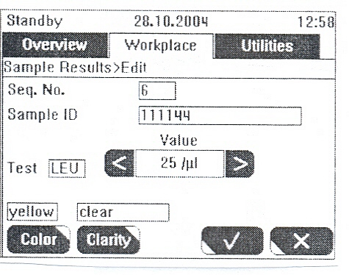

[Sample Results>Edit] screen

3. Use the <Value> selector buttons or to allocate the new result to the selected test.

4. Apply these changes by pressing √.

The screen is now closed and the modified result is displayed on the
sample results screen with a flag.

Once you have edited the result, it will be marked with an “!”. This flag indicates
that the result has been modified.

If you have edited a result, the sample is reevaluated according to the sieve and abnormal criteria.

Edit or add color or clarity If you have selected the COL (color) parameter from the table, the
[Sample Results>Color] screen is called up.

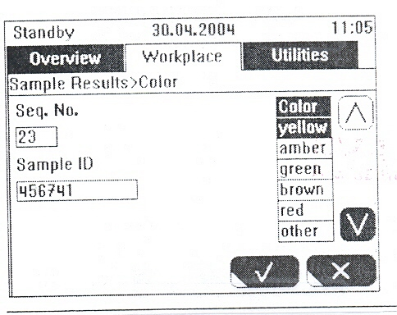

[Sample Results>Color] screen

If you have selected the CLA (clarity) parameter from the table, the
[Sample Results>Clarity] screen is called up.

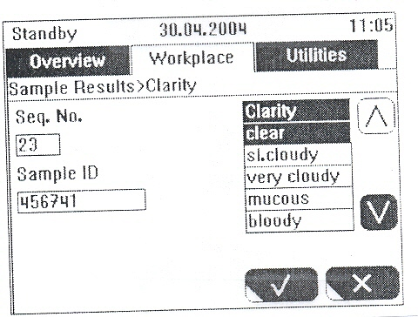

[Sample Results>Clarity] screen

- Select the color or clarity of the sample using or .
- Apply your selection by pressing √

d. Printing, uploading to the host, storing or deleting several results

If the host status is <On> and any print mode except <Off> is
selected, the results will be printed and sent to the host automatically.
You can print results, upload results to the host, store results or delete
results on the [Sample Results>Send] screen. To this end, enter the first
and last sequence number and select what you want to do with the results.

      - On the sample results screen, use <Send> to call up the [ Sample
Results>Send] screen. To this end, enter the first and last sequence number and select what you want to do with the results.

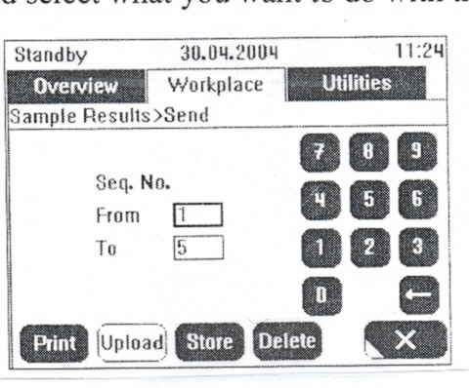

Sample Results-Send Screen

2. Select <From> and enter the first sample sequence number.

3. Select <To> and enter the last sample sequence number.

4. Select <Print>, <Upload>, <Store> or <Delete>, depending on
what you want to do with the results.
<Print> prints the results using the internal printer.
<Upload> uploads the results in the host.
<Store> stores the results on a diskette as comma
separated values (.csv-format). In this format the data
can be processed with another application for example
a spread sheet application.
<delete> deletes the results.

5. If necessary, confirm the pop-up window.

6. If you have finished your work on this screen, you can close the
screen with x and return to the sample list screen or the [Sample
List>Detail] screen.

d. Deleting individual results

You can delete the individual results on the sample list screen or
on the [Sample List>Detail] screen.

To delete samples from the Sample List Screen

1. Call up the sample list screen from the workplace tab.

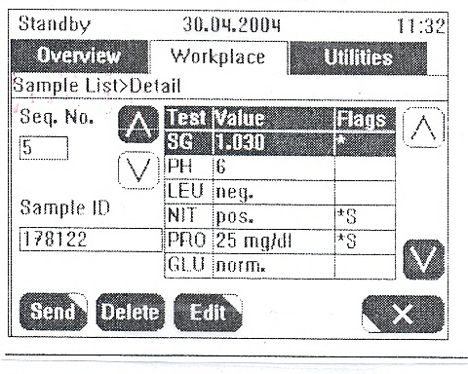
[Sample Results>Send] screen

2 Use or (to the right of <Seq.No.>) to select the sequence
number of the required sample.

3 Press <Delete> to delete all results of the selected sample and
confirm the pop-up window.

Working from the [Sample List] screen

The sample list is used to manage results. Here you can review
only the samples of your interest (e.g. flagged samples).
It is also possible to search for a specific sample for specific flags.
Once you have located the required sample, you can diplay the
results of the individual parameters.
You can also use the sample list to print, store and delete results
or upload them to the host.

a. Viewing results from the sample list

1 Call up the sample list screen from the workplace tab.
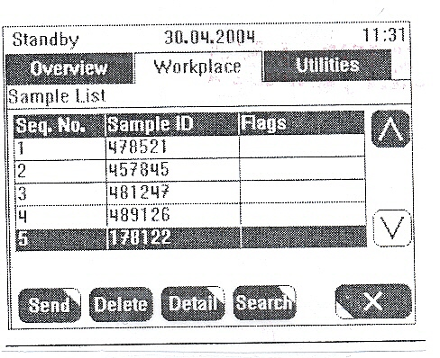
Sample List Screen

2 Use or to select the required sample.
3 Call up the [Sample List>Detail] screen by pressing <Detail>.

[Sample List>Detail] Screen

The screen shows the results of the selected sample.
The [Sample List>Detail] screen is identical to the sample results
screen.
- Use or (to the right of <Seq.No.>) to select the sequence
number of the required sample.
The results of the sample are displayed in the table:
Test (test name/parameter)
Value of the individual result
Flags of individual result
__________________________________________________________
The displayed result value is shown in the unit, which is selected. If a
combination of two units (e.g. SI and arbitrary is selected) only the SI will
be shown.
__________________________________________________________

b. Editing individual results

- On the [Sample List>Detail] screen use or ( to the right of the
table with results) to select the required parameter from the list.
- Pressing <Edit> calls up the [Sample List>Detail>Edit] screen
or the [Sample Results>Color] screen or the [Sample Results>Clarity]
screen depending on the parameter you have selected.

Edit any parameter except If you have selected any parameter except for COL (color) or CLA
For COL or CLA (clarity) from the table, the [Sample List>Detail>Edit] screen is called
up.

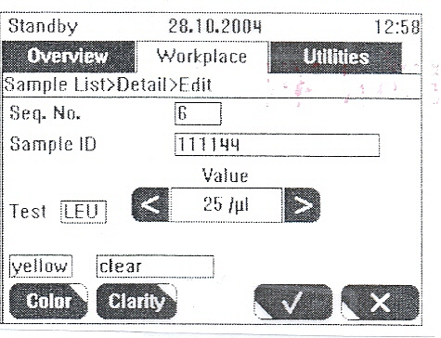

[Sample List>Detail>Edit] screen

- Use the <Value> selector buttons or to allocate the new result
to the selected test
- Apply these changes by pressing √.
The screen is now closed and the modified result is displayed on the
[Sample List>Detail] screen with a flag.

__________________________________________________________
Once you have edited the result, it will be marked with an “!”. This flag
indicates that the result has been modified.

If you have edited a result, the sample is reevaluated according to the
sieve and abnormal criteria.

Edit or add color or clarity If you have selected the COL(color) paramter from the table, the
[Sample List>Detail>Color] screen is called up

[Sample List>Detail>Color] screen

If you have selected the CLA (clarity) parameter from the table, the
[Sample List>Detail>Clarity] screen is called up.

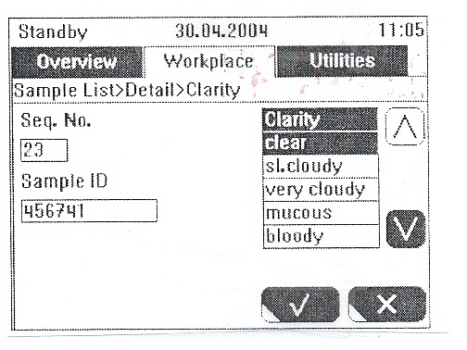
[Sample List<Detail<Clarity] screen

- Select the color or clarity of the sample using or .

- Apply your selection by pressing √.

This closes the screen and displays the selected color and clarity on the
[Sample List>Detail] screen.

e. Searching for Samples

From the sample list screen you can also search for samples.

To search for samples in the sample list

- On the sample list screen, use the <Search> to call up the [Sample
List>Search] screen
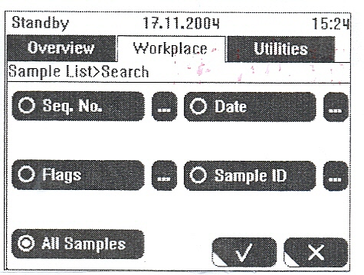

[Sample List>Search] screen

On this screen you can search for a specific sample directly without
having to scroll through the sample list.
The button of the selected search mode (<Seq.N.>, <Date>, <Flags>,
<Sample ID>, or <All Samples>) is marked (). The search criteria for
search mode (e.g. 1- 1 for <Seq.No.>, or Strip Error for <Flags> are
displayed. If “All Samples” is selected, no search criteria are displayed.
- Press the corresponding button to set the criteria for the desired
search mode.
If you press on the right of a search mode, the corresponding
screen is called up where you can define search criteria. The selected
search criteria are displayed below the corresponding button.

Sequence No. This button calls up a screen where you can set a range of
sequence numbers for searching samples.

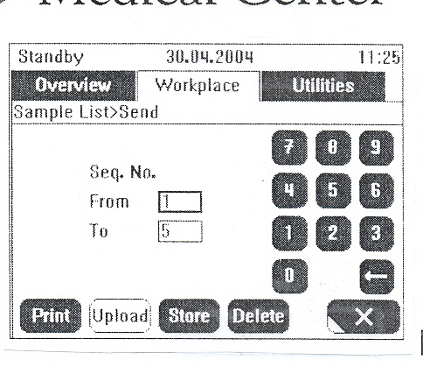
[Sample List>Search>Sequence No.] screen

Select the corresponding input field and enter the sequence
number of the first and last sample results you want to search.
Press √ to return to the [Sample List>Search] screen.

Date This button calls up a new screen where you can set a date
range for searching samples

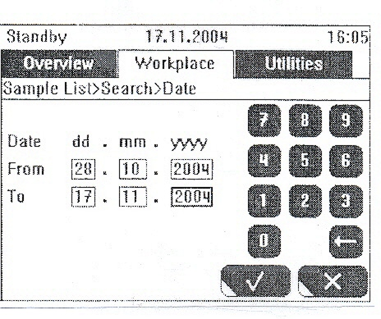
[Sample List>Search>Flags] screen

Select the corresponding input field and enter the date of the first
and last sample results you want to search.
Press √ to return to the Sample List Screen

Flag This button calls up a screen where you can set a flag for searching
samples.

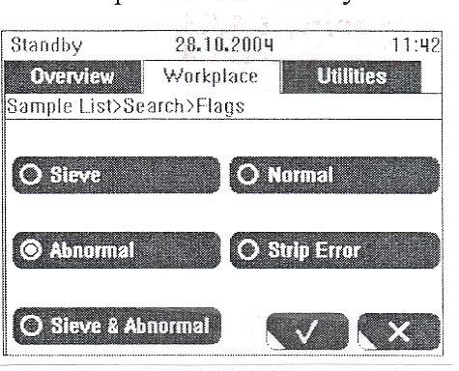
Sample List Search Flags Screen

Use the corresponding button to select the flag of the sample
results of which you want to search.
Press <Sieve>, <Normal>, <Abnormal>, <Strip error>, or
<Sieve and Abnormal> to select the flag of the results of
which you want to search.
Press √ to return to the [Sample List>Search] screen.
For more information about the search criteria, see:
Sieve and abnormal values on page
Sample flags on page

Sample ID This button calls up a screen where you can enter a single sample
I.D

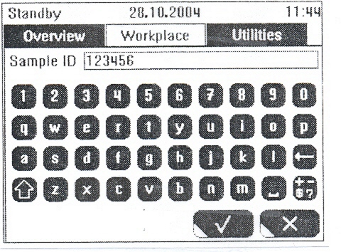

[Sample List>Search.Sequence No.] screen

Enter the sample ID of the sample you want to search.
Press√ to return to the [Sample List>Search] screen.

If you have selected the desired search mode and entered the
required criteria, you can close the [Sample List>Search] screen.

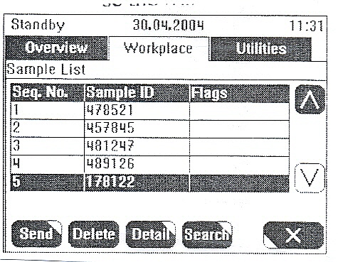

[Sample List] screen

The selected results are displayed in the sample list screen now.
To the right of the screen hierarchy line (Sample List), the search
criteria for the selected samples are displayed.

If <All Samples> is selected as search criteria on the [Sample List>
Search] screen, no search criteria is displayed to the right of the
Screen hierarchy line (Sample List) and all samples are displayed.

- Presentation of results on the printout

The operator can determine the order of the test parameters on the printout.

The operator can also enter text for the headline and determine whether
the printout should contain an empty space for microscopic results.
The printout includes the following information:
Headline
Software version
Sample sequence number
Sample ID number
User ID
Date and time of analysis
Sample flags
Test parameter results with result flags
Section for microscopic results (if enabled)

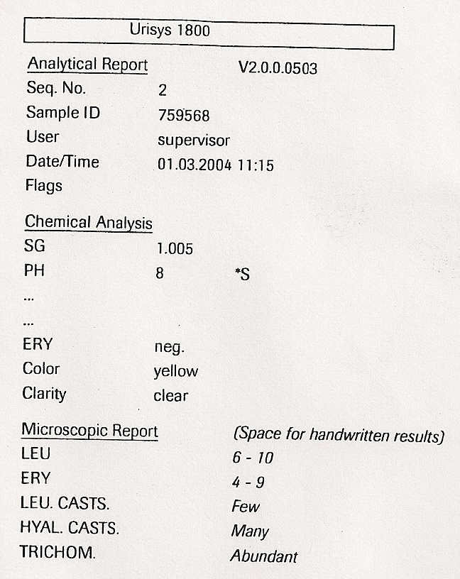

Example of a result printout for a patient sample

- Switching of the analyzer

The Urisys 1800 analyzer must be in Stand-by-state when it is switched off. Never switch off the analyzer when it is in any other operating state.

a. To complete work and switch off the analyzer
- Wait until the analysis of all test strips has been completed and all
samples have been printed. The end of the analysis is indicated by stand-by-state in the status bar.

Otherwise results for test strips which have not yet been measured will
be lost. However, results not yet printed will still be kept in the
analyzer.
- Switch off the analyzer.

For additional information on any topic see Urysis 1800 Operator’s Manual.

REPORTING AND INTERPRETING RESULTS:
None Indicated

TROUBLESHOOTING
See Troubleshooting Section of the Cobas u411 Operations Manual for Information.

REFERENCE
Cobas u411 Operator Manual 2009-2013
Software Version 3.2 3.3
Roche Diagnostics
Indianapolis, IN. 46250-0457

SCC Computer Systems
Clearwater, Florida

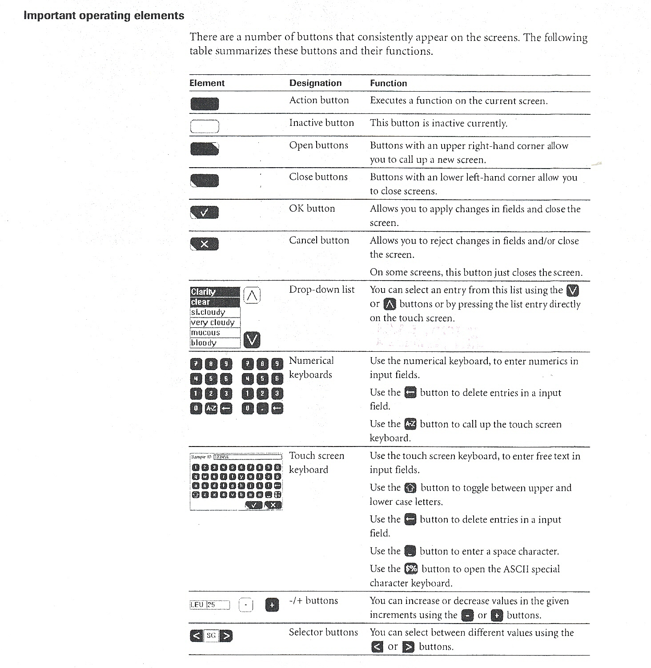
S:Laboratory P&P/Urinalysis/4840-UA-1015/ch

