### Biofire FilmArray® Respiratory Panel 2.1 Testing

### 

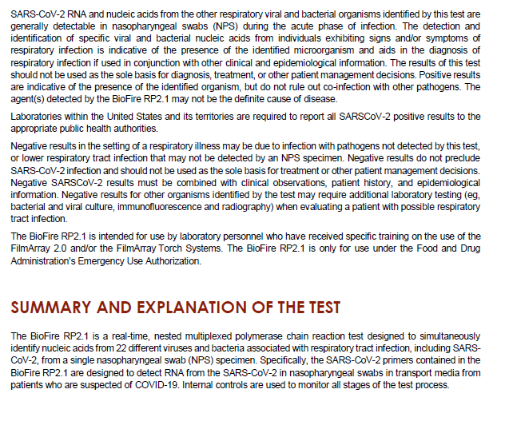

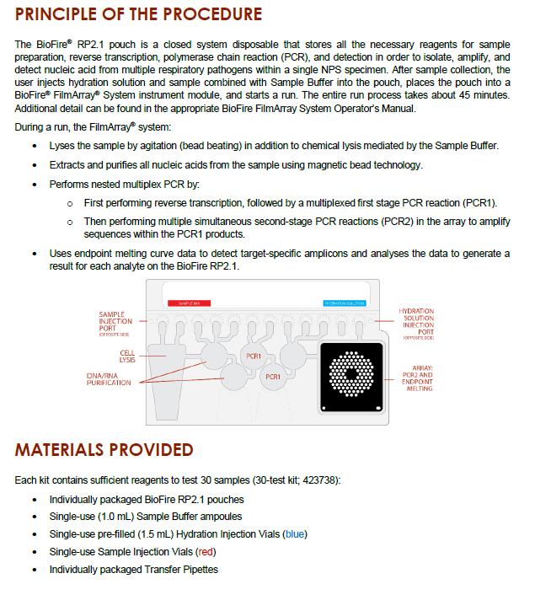

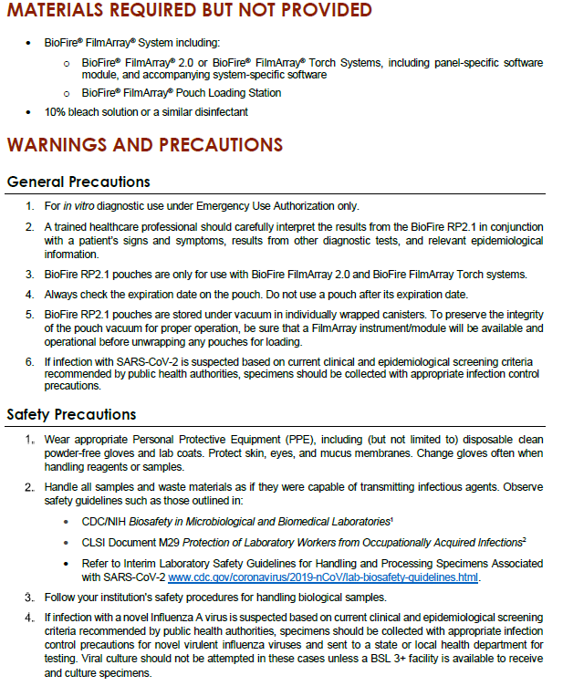

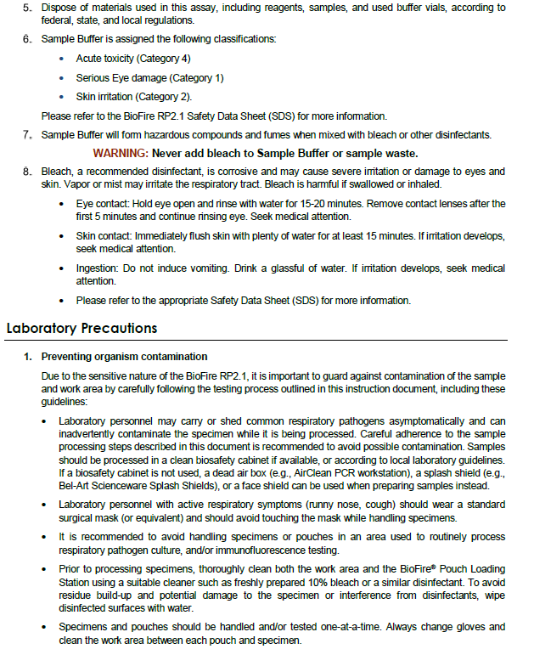

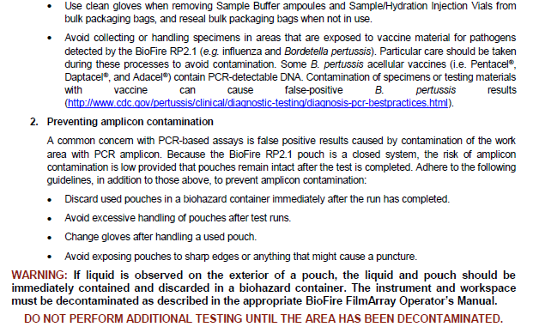

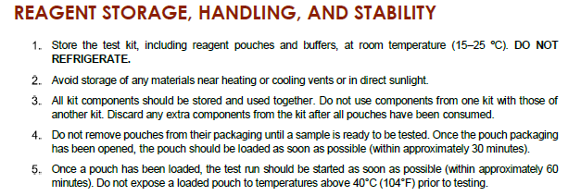

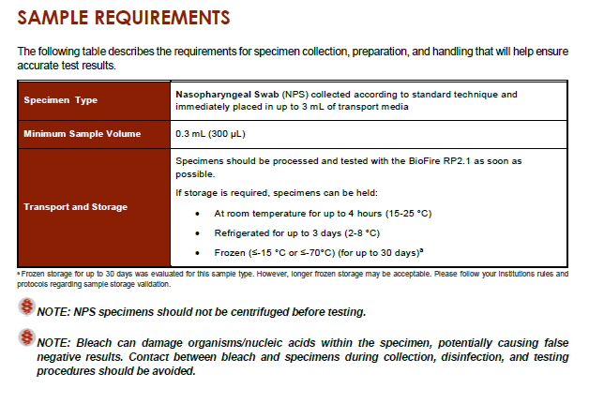

Xpert Viral Transport Media(VTM) and Phosphate Buffered Saline (PBS) are both acceptable, validated transport media.

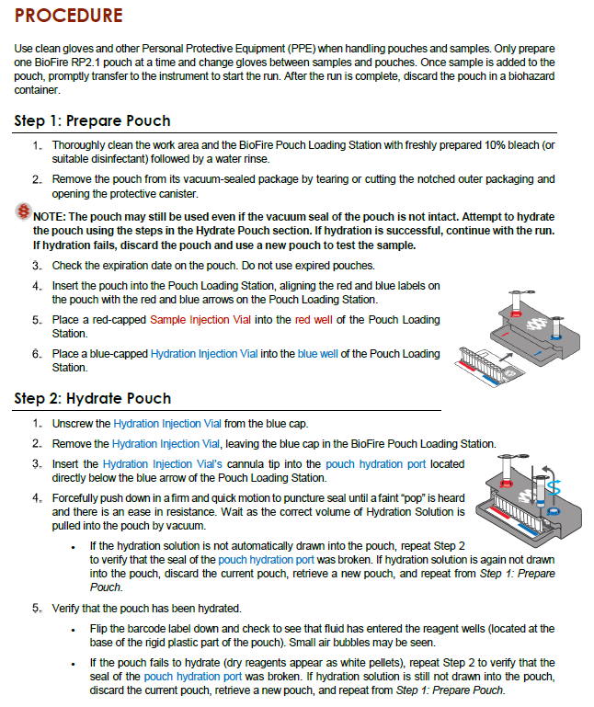

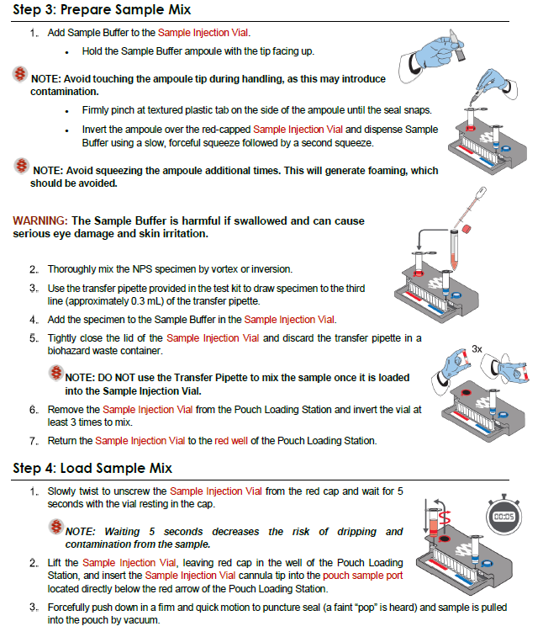

### 

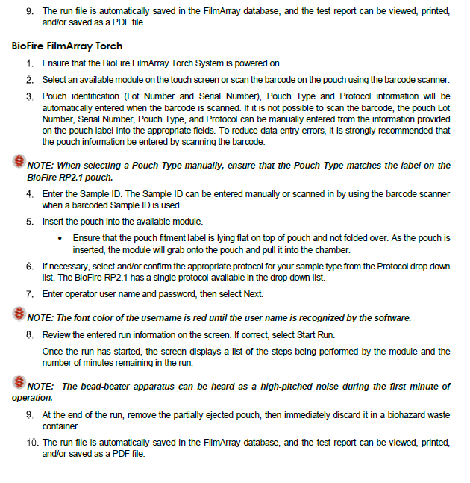

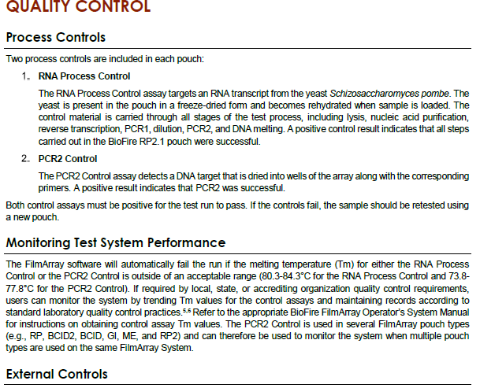

New lot/shipment QC shall be performed before patient testing using MMQCI Biofire RP2.1/RP2.1 *plus* Control Panel M441.

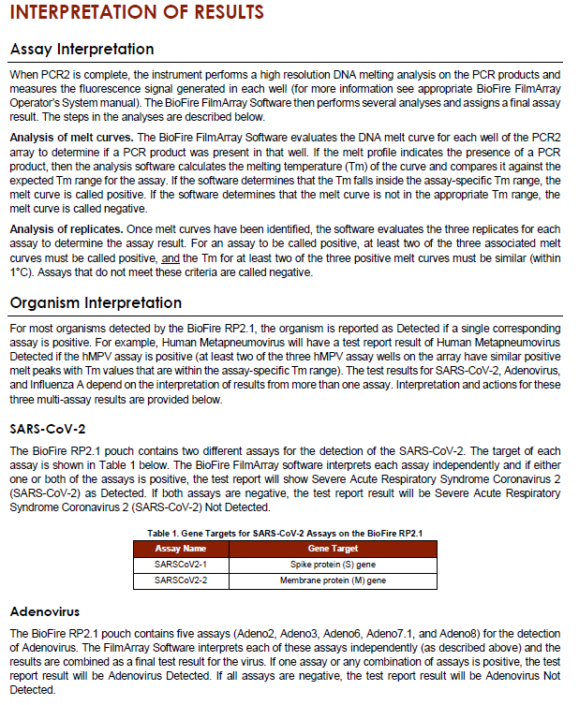

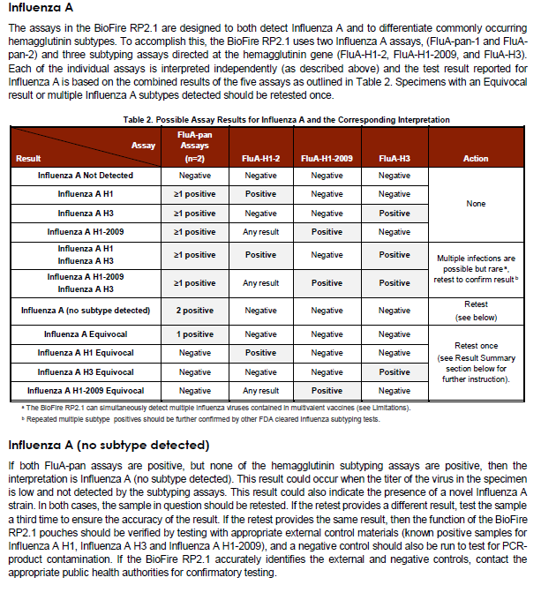

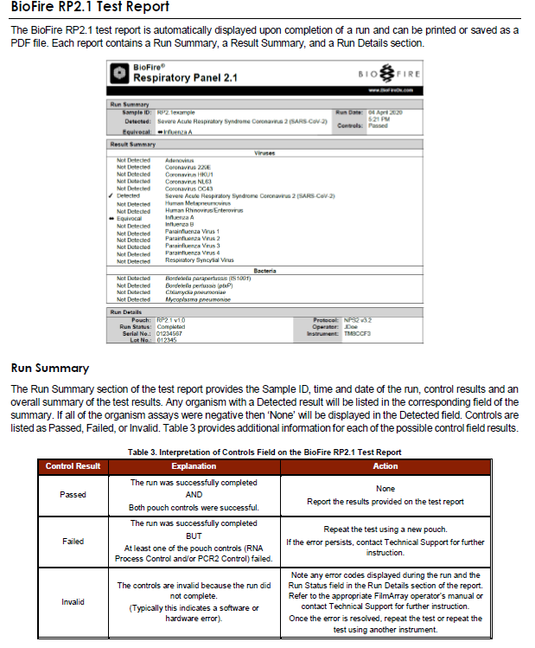

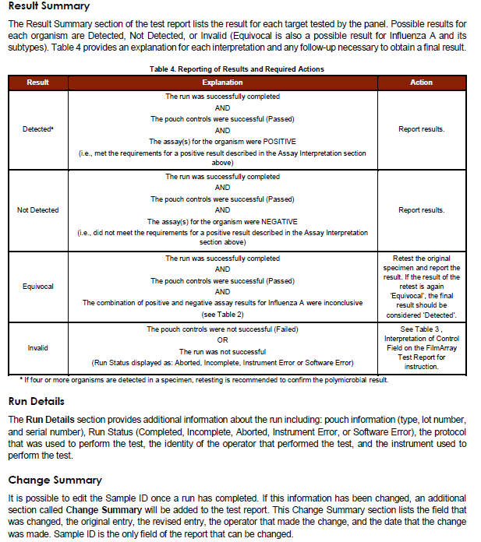 **Reporting of Results**

Test results for the organisms included in the FilmArray RP are provided in two locations on the report. The Result Summary section provides a complete list of the test results. Possible results include Detected, Not Detected, Equivocal, and Invalid. Positive (Detected) and Equivocal results are also displayed in the Run Summary section. Table 3 provides an explanation for each interpretation and any follow-up necessary to obtain a final result.

**Table 1. Interpretation of Results on the FilmArray RP Test Report**

| **Organism Result** | **Explanation** | **Action** |
| --- | --- | --- |
| Detected | The run was successfully completed  AND  The pouch controls were successful (Passed)  AND  The assay(s) for the organism were POSITIVE  (i.e., met the requirements for a positive result described in the Assay Interpretation section above) | Report results. |
| Not Detected | The run was successfully completed  AND  The pouch controls were successful (Passed)  AND  The assay(s) for the organism were NEGATIVE  (i.e., did not meet the requirements for a positive result described in the Assay Interpretation section above) | Report results. |
| Equivocal  (Influenza A only) | The run was successfully completed  AND  The pouch controls were successful (Passed)  AND  The combination of positive and negative assay results for Influenza A was inconclusive (see **Error! Reference source not found.**) | Retest the original specimen using a new pouch and report the results of the retest. |
| Invalid | The pouch controls were not successful (Failed)  OR  The run was not successful  (Run Status displayed as: Aborted, Incomplete, Instrument Error, Software Error, or Instrument Communication Error) | See **Error! Reference source not found.** , Interpretation of Control Field on the FilmArray Test Report for instruction. |

**Reporting Under mICRO rESULT eNTRY**

Reporting:

* + - 1. Choose Virus
      2. Select result from key pad for each virus
      3. Hit Final after each result
      4. Save
      5. Call box will open if results are critical

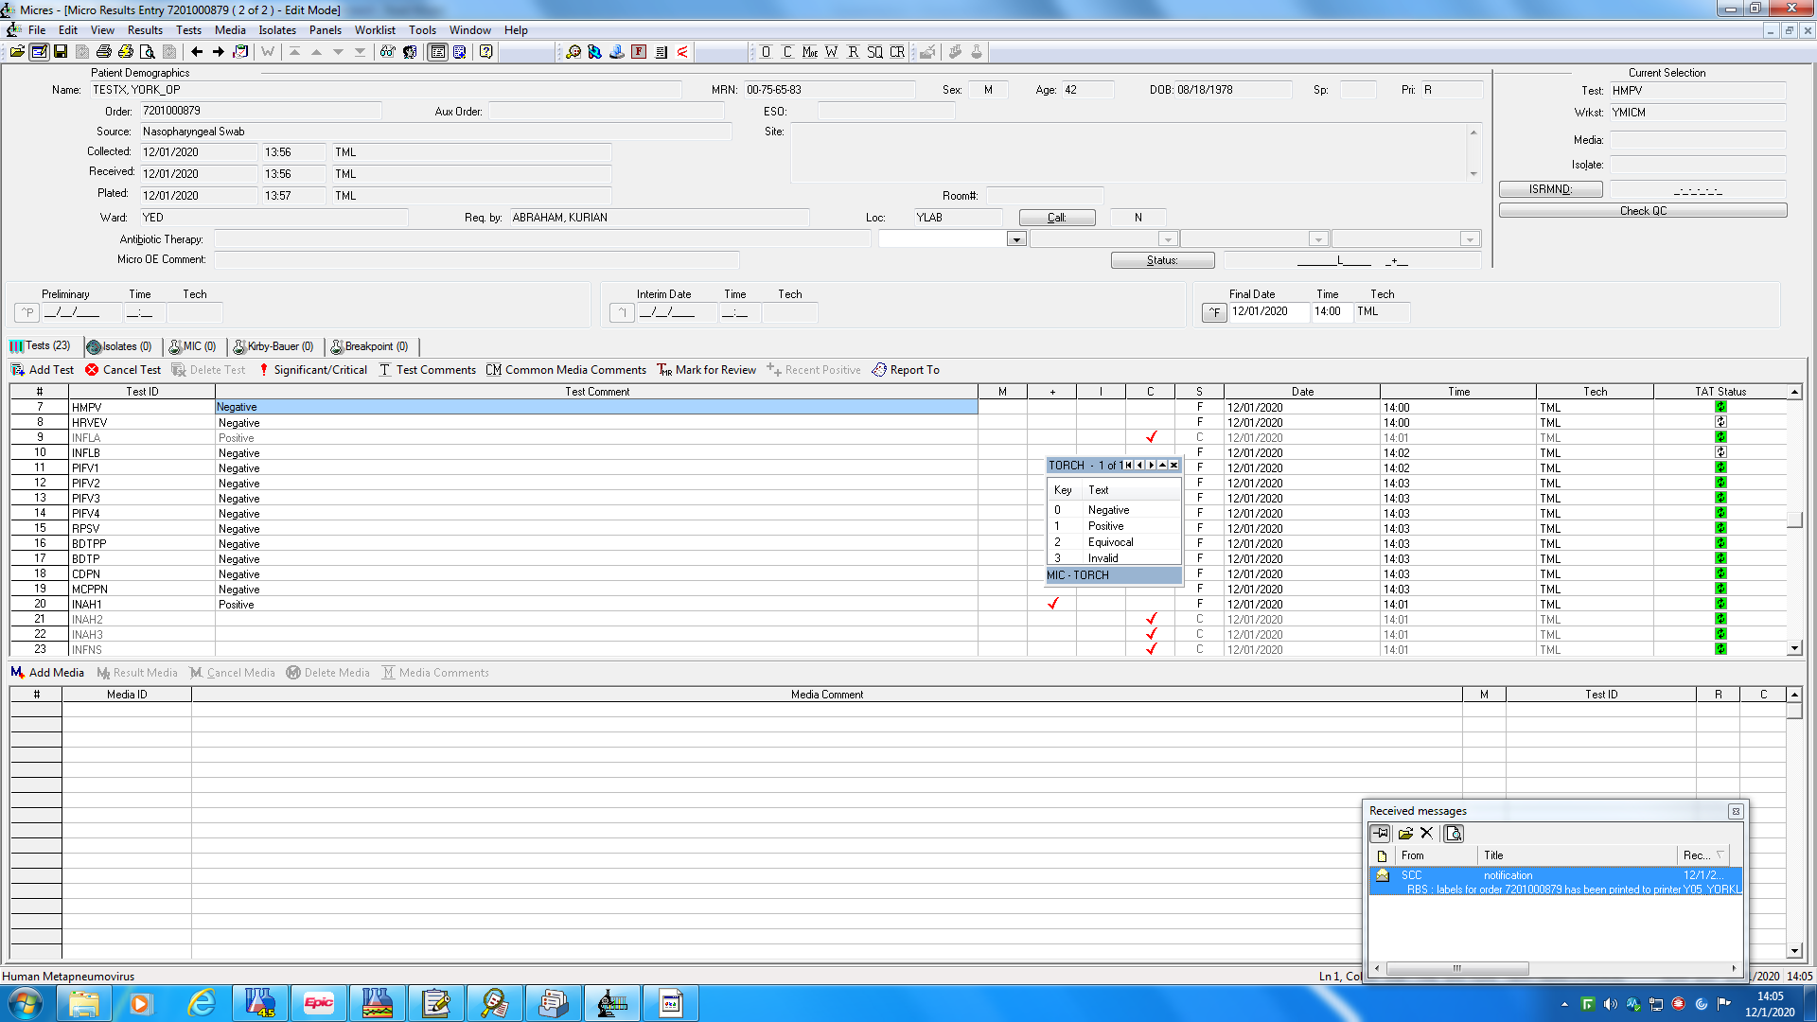

***NOTE: If Influenza A is detected, Result Positive for Influenza A then the reflex subgroups will be available to result. Result out the subgroup and the other subgroups will automatically cancel.

***NOTE: If a result of Influenza A (no subtype detected) is achieved upon duplicate testing, it can occur when the titer of the virus in the specimen is low and not detected by the subtyping assays or the result could also indicate the presence of a novel Influenza A strain. Notify Senior Technologist and promptly refrigerate the remaining specimen as the public health authorities may request further testing.

Internal QC failure

1. Repeat test using same sample on different instrument if possible.
2. If 2nd internal QC failure occurs. Cancel test using the following cancel reason “Multiple internal QC failures. Recollection required. Called to information”

SARS CoV-2 and Bordetella pertussis are critical values that must be called to a caregiver if Detected. If the interface is not functioning, results must be manually entered from the resulting keypad.

All SARS CoV-2 results both positive and negative must be reported to IDPH for reporting to HHS. This is accomplished via an electronic data transfer using the Rush system ELR.

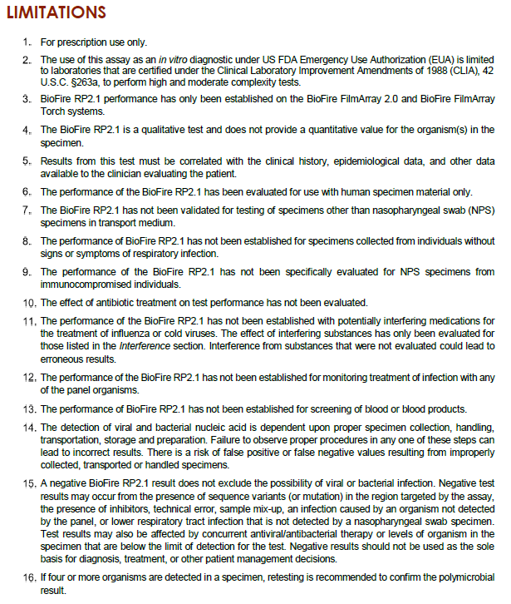

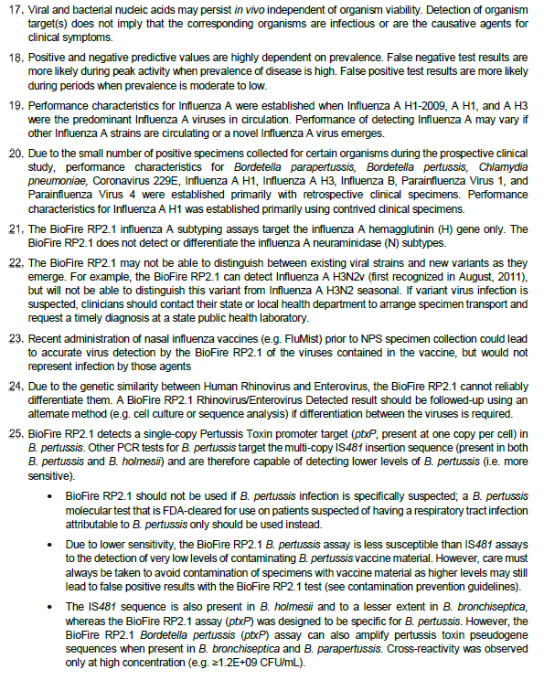

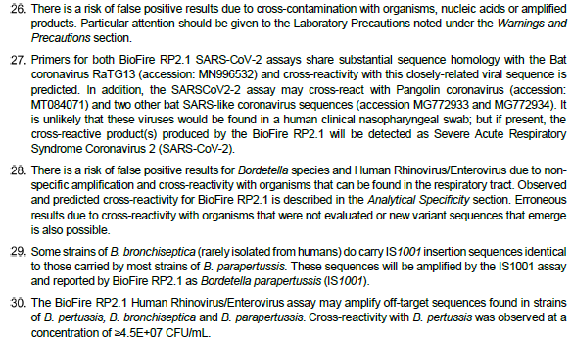



Biofire Respiratory Panel 2.1 Instructions For Use. May 2020