TITLE: ESR by the iSED Method

PURPOSE: The iSED instrument is a benchtop analyzer designed to measure the erythrocyte sedimentation rate (ESR) of 20 blood samples at the same time. The results are comparable to those obtained by the Westergren method.

PRINCIPLE: The ESR is a simple non-specific screening test that indirectly measures the presence of inflammation in the body. It reflects the tendency of red blood cells to settle more rapidly in the face of some disease states, usually because of increases in plasma fibrinogen, immunoglobulins, and other acute-phase reaction proteins. Changes in red cell shape or numbers may also affect the ESR.

The iSED erythrocyte sedimentation rate analyzer is designed to sample directly from the primary EDTA collection tube, automatically withdraw a test sample of 100uL volume and can produce a result in as little as 20 seconds, with appropriate prior homogenization. The intstrument’s micro-flow cell allows the capture of the critical kinetics of red blood cells aggregation in a highly controlled testing environment. This system eliminates handling and the associated factors that can contribute to result variability.

PERSONNEL:
Medical Technologists and Technicians

SPECIMEN COLLECTION/TREATMENT:
The instrument has been designed to accept any standard 13x75 mm size EDTA blood collection pierceable tubes, including the BD Microtainer® MAP Microtube.

Sample volume for testing is100μL whole blood (500μL dead volume); minimum volume for the MAP tube is 250uL(we would need 2 MAP tubes for a CBC and ESR).
Sample must be whole blood collected in K2-EDTA anti-coagulant tube
Sample must be neither clotted nor grossly hemolyzed (DO NOT mix vigorously)
Sample should be tested within 24 hours of venipuncture (no more than 24 hours if refrigerated at 4°C). Sample must be at room temperature for at least fifteen (15) minutes (if refrigerated).

Tube Types: 13 x 75mm tube with pierceable cap
EDTA anti-coagulant (lavender top)
BD Microtainer® MAP Microtube

REAGENTS AND EQUIPMENT:

Item  iSED Analyzer | Description | Reorder Part #
Printer Paper | 57mm x 25mm (3 pack) | DS-05233
Test Card | Preloaded smart card for iSED, available with tests in various quantities | 112-02000 (2,000 preloaded tests)  112-05000 (5,000 preloaded tests)  112-10000 (10,000 preloaded tests)  112-20000 (20,000 preloaded tests)
iWASH Fluid | 500 mL bottle with screw cap, pre-filled with instrument iWASH (4 pack) | 112-12-001
Waste Bottle | 500 mL plastic waste bottle with screw cap, (24 pack) | 112-12-002

Reagent preparation: iWASH Fluid

The instrument uses Type 1 Ultra-Pure Water as the cleansing agent during the wash cycle.
- The use of any other product could affect the performance of the instrument.
Type 1 Ultra-Pure Water: exceeds Clinical Lab Reagent Water (CLRW) specifications.

CALIBRATION:
iSED instruments are factory calibrated utilizing samples which are compared with results from a unique Reference Instrument. The Reference Instrument is correlated with the reference Westergren method. The instrument range is from 1 to 130 mm/hr. During normal operation, parameters affecting calibration are constantly monitored and, if not within expected limits, a warning is given and further testing prevented.

QUALITY CONTROL:
Two levels of quality control material purchased from Alcor specifically for the iSED; Level 1 and Level 2.
- Frequency: QC is run every 24 hours that there are patient samples to run. Both levels are run; alternating which level you put in first each day. Start with Level 1 on odd days and start with Level 2 on even days of the month. This will allow for approximate equal usage as the analyzer primes the lines if it has not been run for some time.
- Tolerance limits: Assayed controls are used and the Mean and Tolerance Limits are defined on the assay sheets.
- QC material has an 18 month shelf life prior to opening. Open stability is 60 days.
- QC material is stored at room temperature and initially put on the rocker for 20 minutes prior to testing. After the initial open date, it is stored upright and can be gently mixed by hand a couple of times and put in the analyzer. The iSED mixes QC vials for 5 minutes prior to sampling. Measuring phase for QC is 6 minutes. Approximately 16 minutes to complete the QC run of both levels.
- Record results on the QC log sheet and enter into the LIS.
- QC is routinely reviewed in the LIS and printed out monthly to be reviewed by the Sr. Tech or designee and maintained in the QC binder in Hematology.

STEPWISE PROCEDURE:
- The analyzer is turned on, and initializes itself and is ready for sample analysis.
- Barcoded Tubes: Patient samples are read and identified by the instrument’s internal barcode reader automatically as they are loaded into the instrument. All common laboratory barcodes are supported, including Code 39, UPC and Code 93 formats.
Note barcode location range:

All sample mixing, sample extraction, sample reading and sample disposal are handled automatically by the instrument. Up to 20 sample tubes may be loaded into the sample wheel at any given time. As each sample is processed (20 seconds), the sample tube is ejected from the sample wheel and retained in the external sample collection tray.
- Print small labels from the LIS Hematology printer for the patient’s ESR.

- Check the volume in the EDTA tube, 500 uL in any full draw or short draw purple top tube. MAP tubes, 250 uL in the tube.
- The first sample after a wash or the first sample of the day after being idle most of the night; the iSED primes the line and uses slightly more than the required 100 uL of blood. DO NOT put an extremely short draw sample on first.
- Mixing is only required after the blood has been sitting for many hours. The analyzer mixes each sample for 3 minutes.
- Touch the “Add a sample” icon (green +).
- The sample wheel rotates to position the next open slot in the sample entry port.
The onscreen information bar will report “waiting sample” and the instrument will beep quietly for five (5) seconds. As the five (5) second window draws to a close, beeping will become faster.
- Insert the barcoded tube with the barcode oriented to the right side. A red light will
illuminate and a distinctive beep will sound when the barcode is successfully recognized.
- Automatic sample processing then begins.
- Repeat Steps 4-7 until all samples have been loaded and/or all positions in the sample
wheel are occupied.
- The analyzer washes automatically when it has been idle for 15 minutes.
- Unless the third line starts with “iSED is Warning” or “iSED is in Error”, the operation is normal.
- In the event of a sampling error, the instrument will try to resolve it automatically up to a maximum of three (3) attempts. If after the third attempt, the instrument is unable to resolve the sampling error, an error message will be printed as follows.
Error: Abnormal Reaction

NOTE: If the five (5) second window is missed, simply select the (+) icon again to restart the
sample scheduling process.

If it is necessary to cancel an ESR, you have 3 minutes while it is mixing to click on the Red X, this will stop and eject all samples from the wheel.

For instances when patient identification cannot be read by the internal barcode reader or there is no barcode present the operator may enter data manually. Use the icon with a “pencil” to bring up the keyboard and manually enter the barcode number.

REPORTING AND INTERPRETING RESULTS:

- Reference Range:
Sedimentation Rate Reference Value (mm/hr)
Men under 50 years old | 0-15
Men over 50 years old | 0-20
Women under 50 years old | 0-20
Women over 50 years old | 0-30
Newborn to Puberty (0-12) | 0-10

- Linearity limits: 1 – 130
The instrument will report out Less than 1 and Greater than 130 if the result is outside the linearity range.
- Interfering substances:
Some interferences which increase ESR:
- Increased level of fibrinogen, gamma globulins.
- Technical factor: mechanical vibration, high room temperature.

Some interferences which decrease ESR:
- Abnormally shaped RBS (sickle cells, spherocytosis).
- Technical factors: low room temperature, delay in test performance (>24 hours), clotted blood sample, excess anticoagulant, bubbles in tube.

Method Limitations
The erythrocyte sedimentation rate is a transient phenomenon confined to fresh blood. It is not a hematic matrix component at the corpuscular or molecular level. The procedures used to determine the ESR cannot be calibrated since they are susceptible to a variety of factors, e.g. temperature, hematocrit, erythrocyte mean corpuscular volume, plasma viscosity, etc.
For this reason, it is possible to observe instrument performance deviations, compared to other procedures, when the above variables are not taken into account.
Erythrocyte sedimentation remains a confusing, partly understood phenomenon and, clinically, is a nonspecific reaction. It is highly recommended to perform other tests together with ESR since a normal ESR value is not enough to exclude that the patient is not affected by a pathological condition.
Sample mixing is performed at the beginning of the analysis with the purpose of homogenizing the sample. An inefficient homogenization can affect the results given by the instrument.

Maintenance:
- Waste bottle must be emptied on a regular basis, the analyzer will warn you when the bottle is nearly full. It will become part of the weekly maintenance, and adjusted if necessary to 2 times per week (Sunday and Wednesday). A wash cycle should be performed before emptying the waste bottle. Click on the life bouy.
- Waste container is in the top compartment. Disconnect the LUER connector from the waste bottle screw cap.
- Remove the waste bottle from the instrument and unscrew the cap.
- Dispose of the waste in the back sink on the last hematology bench. Rinse well and replace the screw top lid.
- Replace the waste bottle into the upper compartment and firmly reconnect the LUER connector on the plastic screw cap with the vent hole positioned at the top.
- Close the front door, making sure the line is not kinked.
- The iWASH is monitored and will warn the user when the iWASH is empty. “NoK”
displays if the iWASH is empty. There is a level sensor, but the analyzer uses a count based system to track the number of washes from the bottle, monitor the iWASH routinely.
- Open the front door to access the bottle compartment.
- The iWASH bottle is located in the lower compartment.
- Disconnect the LUER connector from the iWASH bottle screw cap.
- Remove the empty iWASH bottle, unscrew the cap and replace it with a new iWASH bottle, leaving the tubing with the filter/sensor attached to the cap.
- Place the new iWASH bottle in the lower compartment and firmly reconnect the LUER connector on the plastic screw cap with the vent hole positioned at top.
- Close the front door, making sure the line is not kinked.
- Open outdate for the iWASH is the same as the expiration date on the bottom of the bottle.
- Printer paper green light will blink when the paper needs to be changed. Open the paper cup lid and pull out the roll, insert the new roll with the paper unwinding from the bottom of the roll, tear off the 1st couple of inches before inserting in the analyzer.
- The analyzer tracks the number of samples used on the Test card and will display a warning when the test threshold is at 200; it will warn you with every sample until we load a new test card. Our test cards are 1000 tests per card.
- Downloading Test Credits from Test Card:
- With the arrow facing upward and forward, insert the test card into the smart card reader located on the front of the instrument, using a slightly downward motion to enter the card.
b. Once inserted, the credits will automatically download onto the instrument.
c. Total credits available will include the newly downloaded credits and any residual credits prior to download.
d. Once all credits have been downloaded onto the instrument, the test card can be dated on the card envelope and saved until the next card is received.
- The “Life Bouy” icon will force the analyzer to perform a wash cycle.
- Replace fuse as necessary. See Operator’s Manual.
- There is no special Daily Mantenance; keep the instrument free from dust for best performance. Check and wipe off the fan on the back as needed.

Monthly Maintenance: Bleach Cleaning Procedure
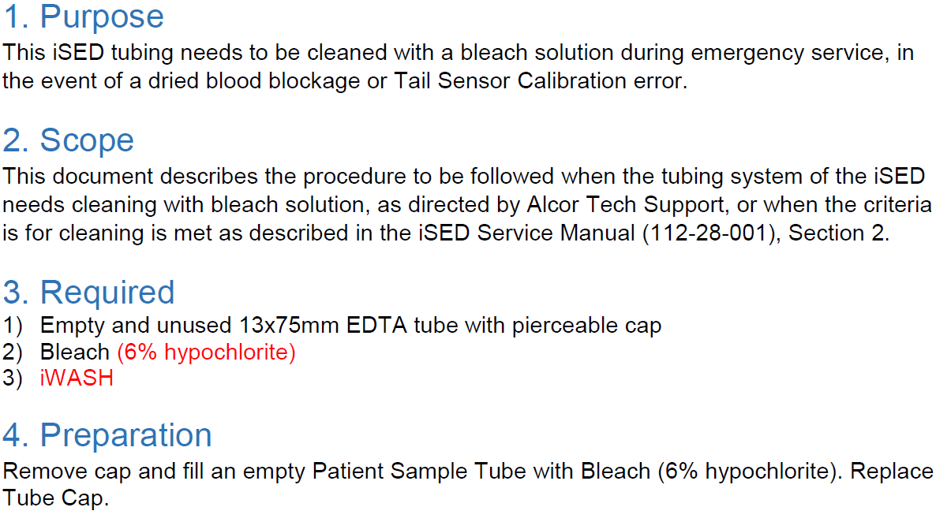
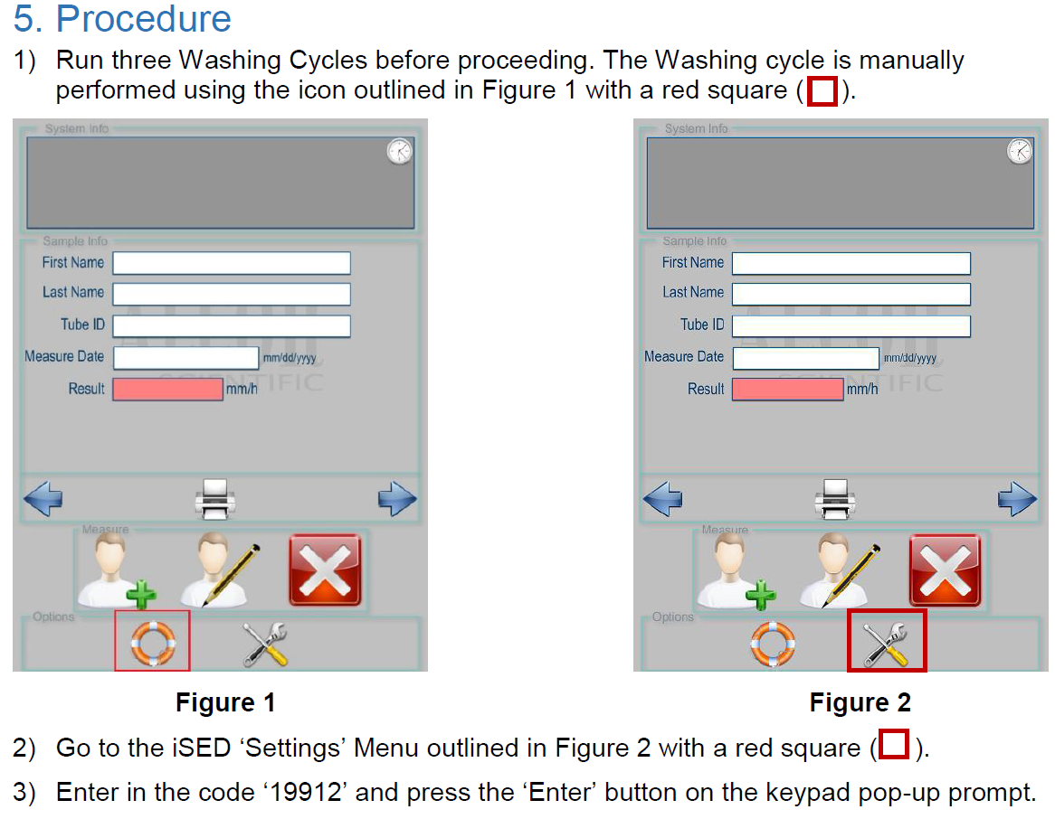
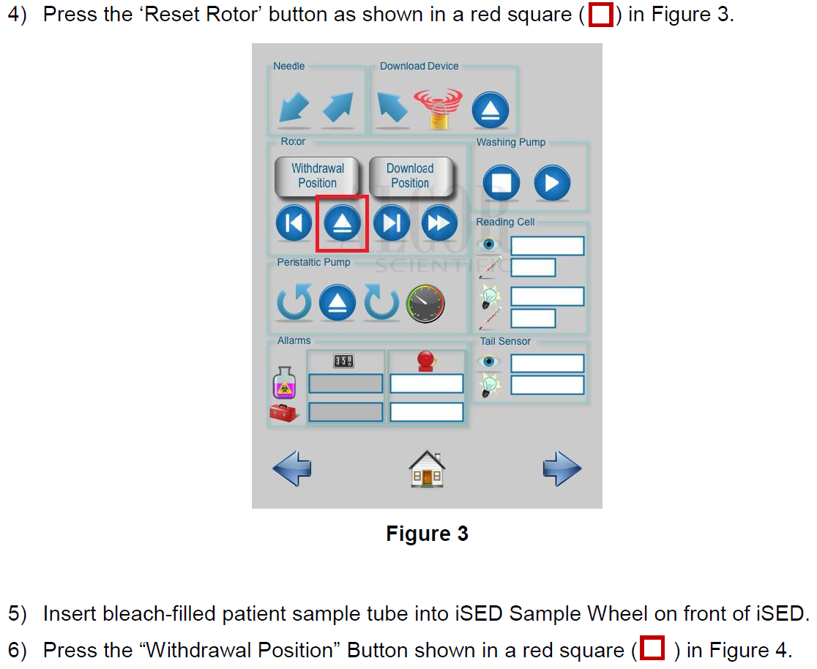
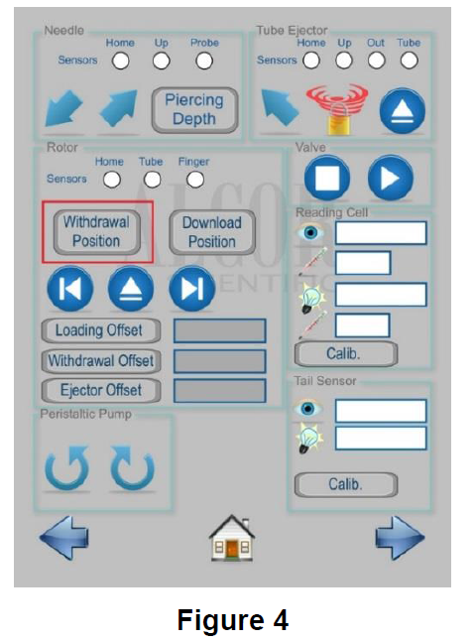
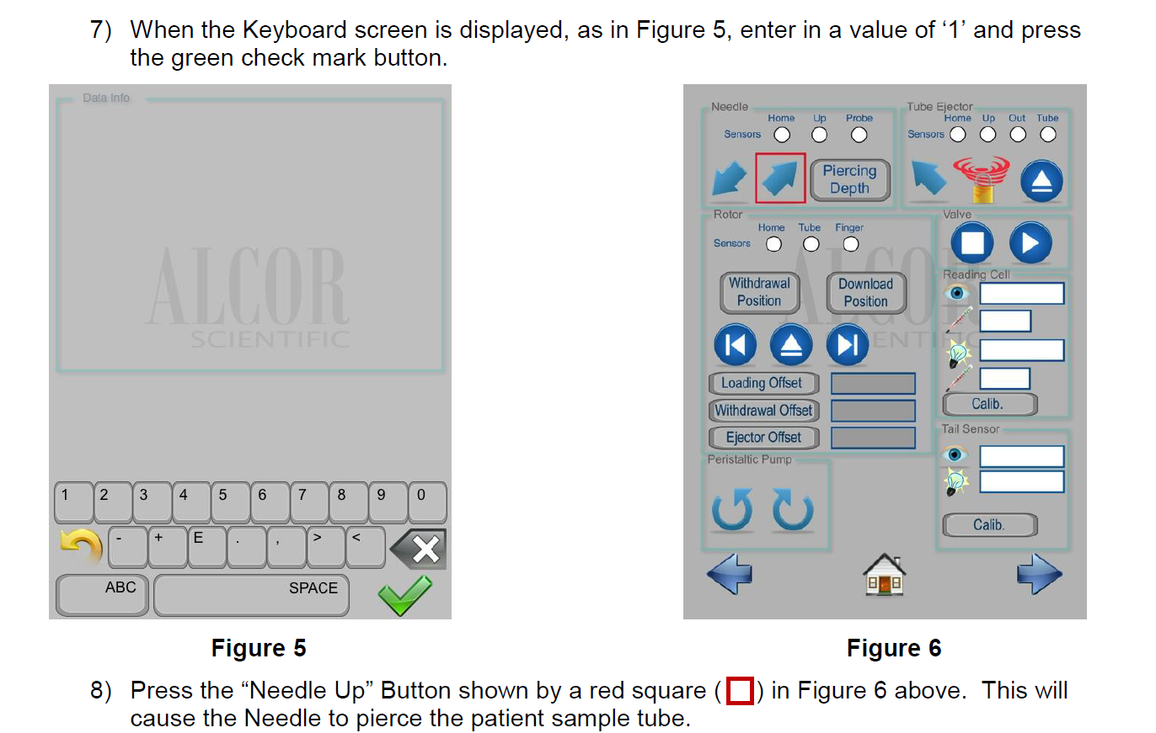
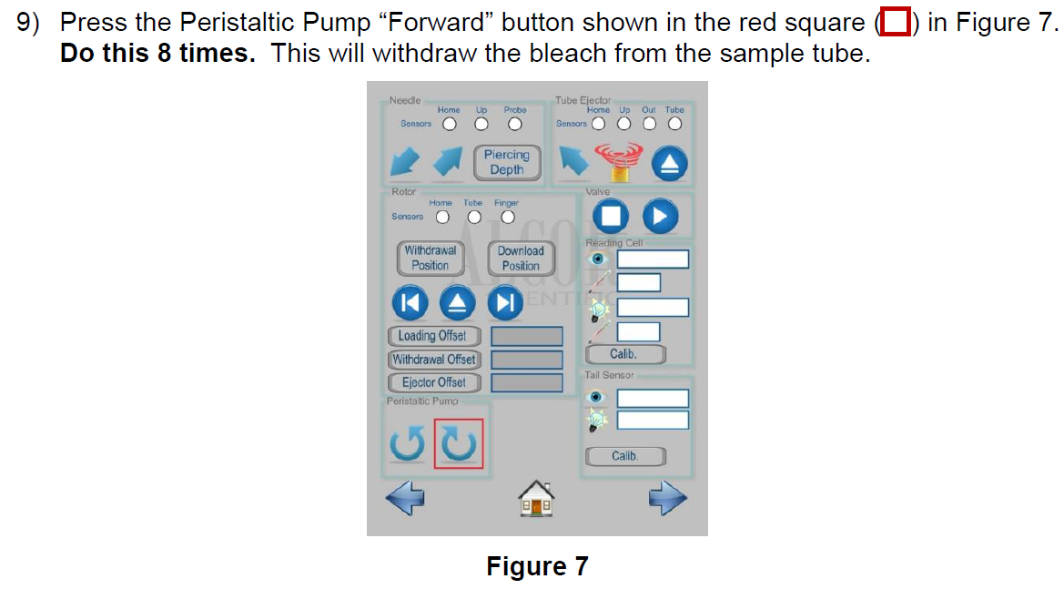
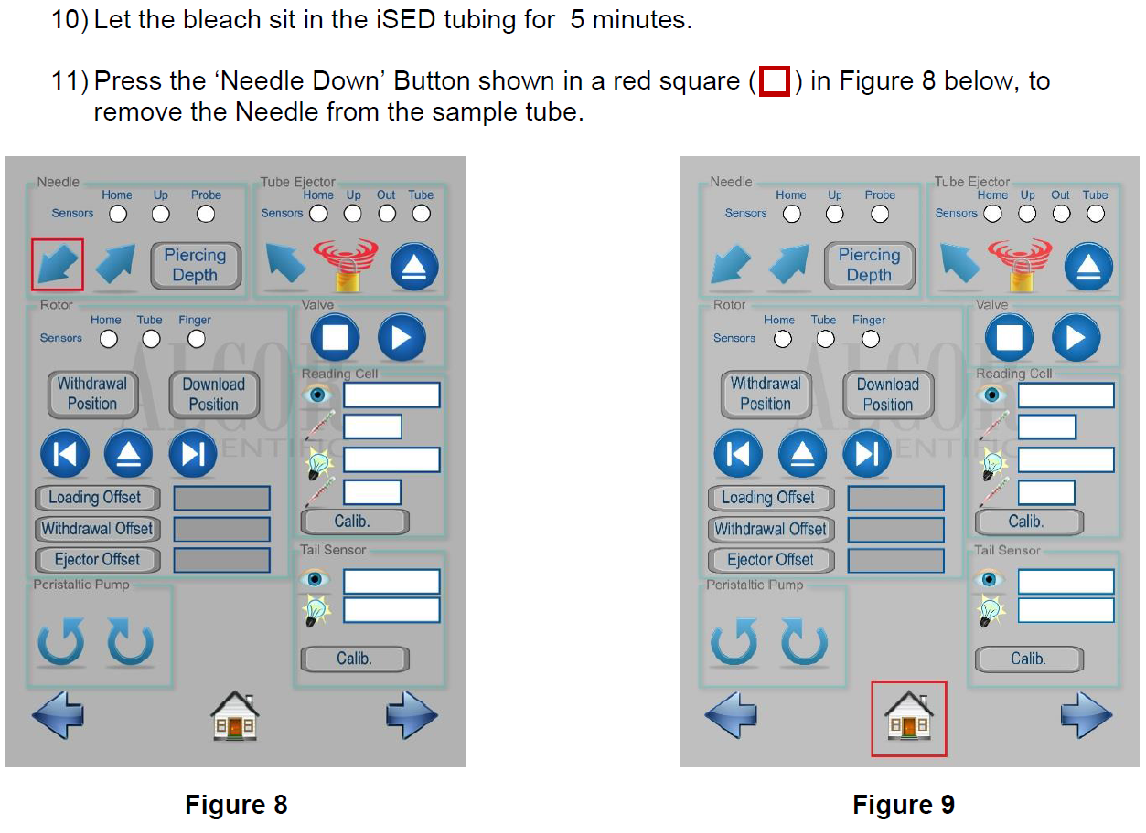

Troubleshooting:

Situation | Possible Causes | Solutions
Instrument will not power ON | Loose power connections  Bad fuse | Check all power connections at the rear of instrument, power supply, and wall outlet. Reconnect power cord at all locations. Wait 30 seconds. Plug back in.  Remove fuse cap immediately above power connection on rear of instrument. Check fuse and replace if necessary. See page 36 of Operators manual.
Sample tube stuck in the wheel | Tube dropped during sample entry | Power OFF the instrument and manually remove the tube(s) from the wheel.
Touch screen not responding | Touch screen is out of calibration | Contact Technical Support for calibration instruction.
Results are running low/high | Lipemic, hemolyzed, or clotted specimen  Pre-analytical sample handling change or system error | Verify condition of specimen.  Run controls. Once complete if results are within range, resume normal operation; if out of range, discontinue testing and contact Technical Support.
Instrument is not scanning patient barcode | Damaged, incompatible, or no barcode label  Barcode reader misaligned | Validate barcode label  Contact Technical Support for instruction.

For troubleshooting issues not covered in this manual, please contact Technical Support or an authorized ALCOR Distributor. Mon-Fri 8:30-5:00pm EST Phone: 1-800-495-5270

REFERENCE:
iSED Quick Reference Guide, Operator’s Manual: Erythrocyte Sedimentation Rate Analyzer.
Cat. 112-00101, received 2017.

