**TITLE: Umbilical Cord Segment Drug Testing Specimen Receiving**

**PRINCIPLE:**

To establish guidelines to help staff receive umbilical cord segment specimens into the lab and properly complete the chain-of-custody form.

**PERSONNEL:**

All Laboratory Personnel

**STEPWISE PROCEDURE**

1. Umbilical cord segment specimens and their chain-of-custody forms are to be walked into the lab by staff from the NICU and nursery. Umbilical cord segment specimens cannot be sent through the tube system. The nursing staff should also have with them the shipping box and specimen bag that comes in the collection kit.
2. The nursing staff is to have the umbilical cord segment cup closed, the lid sealed with a “Specimen Seal” sticker from the bottom of the chain-of-custody form, and labeled with either the SOFT-ID label or a patient chart label.
   1. Example of “Specimen Seal” from bottom of chain-of-custody form:

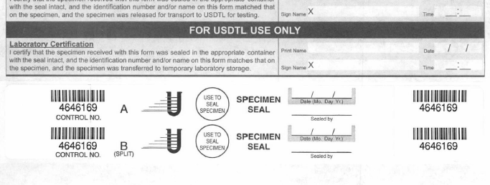

* 1. Example of how “Specimen Seal” should be placed on container:

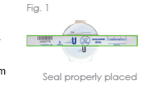

1. The chain-of-custody form must be labeled with the patient’s name, date of birth, medical record number, and time of birth. A chart label may be used on the chain-of-custody, however; there must be a chart label on all three copies of the three-part chain-of-custody form and the time of birth must be written on the form also.
2. The nursing staff must have a signature, printed name, date, and time in the “Collector Certification” box.
3. The laboratory staff member receiving the specimen will then verify the container is sealed with a “Specimen Seal” with control number over the lid of the container and labeled with a SoftID or chart label.
4. **If the seal is not placed over the lid of the container, the nursing staff member that signed for the seal on the chain-of-custody form must correct the seal before the specimen can be accepted into the lab.**
5. The nursing staff member is to verify the patient’s name, medical record number, and control number, by reading this information out loud from of the chain-of-custody form, while the lab staff checks it on the specimen container.
6. Once the patient information, control number, and specimen seal has been verified, the laboratory staff member will sign and print their name and write the time and date in the “**Sendouts Section Certification**” section on the form. THIS IS THE ONLY SECTION WHERE LABORATORY STAFF IS TO SIGN THE FORM.

Laboratory staff signs here.

Nurse/tech that collected sample and sealed container signs here.

This is for USTDL ONLY

1. The white copy (top copy) of the chain of custody form is then removed from the three-part chain of custody form by the lab staff, folded, and placed in the back pocket of the umbilical cord segment specimen bag.
2. The Laboratory staff will then scan the SOFT-ID label on the specimen container into the receiving function of the LIS and print two extra labels for the sendout department before receiving the specimen in the LIS.
3. The umbilical cord segment specimen is then placed in the front pocket of the bag (if not already done). The foil strip is removed from the bag to expose the adhesive to seal the bag. The adhesive strip is then placed over the blue diagonal stripes on the bag, sealing in the specimen cup and white copy of the chain-of-custody form. This process is to be completed in front of the nursing staff.
4. The pink copy of the form is then given to the nursing staff and they can then leave the lab.
5. The umbilical cord segment specimen bag is then placed in the shipping box.
6. The shipping box, with specimen inside, yellow copy of the chain-of-custody, and labels are then to be placed in the dark blue Meconium bucket in the send outs section of the lab.
7. To complete the processing and prepare the umbilical cord segment specimens for shipping, follow Sendouts procedure *4840-Sendouts-179 Umbilical Cord Segment Drug Testing.*

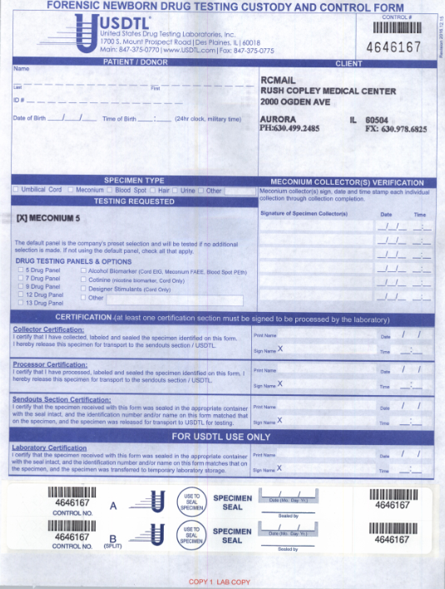

Need Pt. Name, DOB, MRN, and Time of Birth. Chart labels are acceptable.

Umbilical Cord needs marked here.

No signatures are needed in this box

Lab staff that receives umbilical cord sample signs here.

Nurse that collected umbilical cord sample signs here.